**The Labs.**

Analysis 6

Problem Identification 6

Why is it suitable for a computational approach? 7

Stakeholders 7

Stakeholder interviews/questionnaires 9

Existing solutions 12

Essential features 15

Limitations 18

Hardware/Software Requirements 19

Success Criteria 19

Design 20

Breakdown of the problem 20

Justification of the process 22

Detailed breakdown 22

Algorithms 25

User interface 30

Justification of how the algorithms form a complete solution 31

Testing methodology 32

Iterative test data 32

Post development test data 33

Test checklist 33

Development 35

Section 1: The main menu 35

Iteration 1: 35

Iteration 2: 37

Iteration 3: 39

Iteration 4: 42

Iteration 5: 44

Iteration 6: 47

Section review: 50

Section 2: The instruction menu 51

Iteration 1: 51

Iteration 2: 53

Iteration 3: 55

Iteration 4: 57

Iteration 5: 59

Iteration 6: 61

Iteration 7: 62

Iteration 8: 65

Section review: 69

Section 3: Settings Menu 70

Iteration 1: 70

Iteration 2: 72

Iteration 3: 74

Iteration 4: 76

Section review: 78

Section 4: colour changing menu 79

Iteration 1: 79

Iteration 2: 80

Section review: 81

Section 5: Start game menu 81

Iteration 1: 81

Iteration 2: 83

Section review: 85

Section 6: Actual game audio 86

Iteration 1: 86

Iteration 2: 86

Section review: 87

Section 7: Introductory text 87

Iteration 1: 87

Iteration 2: 88

Iteration 3: 89

Iteration 4: 90

Section review: 90

Section 8: The game screen 90

Iteration 1: 90

Iteration 2: 92

Iteration 3: 93

Iteration 4: 95

Section review: 96

Section 9: Teachers 96

Iteration 1: 96

Iteration 2: 98

Section review: 99

Section 10: The area class 100

Iteration 1: 100

Iteration 2: 100

Iteration 3: 101

Iteration 4: 102

Iteration 5: 103

Section review: 103

Section 11:The MCQ puzzle 103

Iteration 1: 103

Iteration 2: 105

Iteration 4: 106

Iteration 5: 108

Iteration 6: 109

Iteration 7: 110

Section review: 110

Section 11: Practical puzzle 111

Iteration 1: 111

Iteration 2: 112

Iteration 3: 113

Iteration 4: 114

Iteration 5: 115

Section review: 116

Section 12: Fill in the blanks puzzle 116

Iteration 1: 116

Iteration 2: 117

Iteration 3: 118

Iteration 4: 119

Iteration 5: 120

Iteration 6: 121

Iteration 7: 122

Iteration 8: 123

Section review: 124

Section 13: Create the correct element puzzle 124

Iteration 1: 124

Iteration 2: 125

Iteration 3: 126

Iteration 4: 129

Iteration 5: 130

Iteration 6: 131

Section review: 132

Section 14: Timer 132

Iteration 1: 132

Iteration 2: 132

Iteration 3: 133

Section review: 134

Section 15: The help command 134

Iteration 1: 134

Iteration 2: 134

Iteration 3: 135

Iteration 4: 137

Section review: 138

Section 16: Molecule map/Journal 138

Iteration 1: 138

Iteration 2: 138

Iteration 3: 139

Iteration 4: 140

Iteration 5: 141

Iteration 6: 142

Iteration 7: 142

Iteration 8: 143

Iteration 9: 145

Iteration 10: 146

Section review: 146

Section 17: Save feature 146

Iteration 1: 146

Iteration 2: 147

Iteration 3: 147

Iteration 4: 147

Iteration 5: 148

Section review: 149

Section 18: Load feature 149

Iteration 1: 149

Iteration 2: 150

Iteration 3: 150

Iteration 4: 151

Iteration 5: 151

Section review: 151

Section 19: Settings menu from main game 152

Iteration 1: 152

Iteration 2: 153

Section review: 153

Section 20: The GCSE side of things 153

Iteration 1: 153

Section review: 155

Section 21: The score 155

Iteration 1: 155

Section review: 158

Section 22: The Survey 158

Iteration 1: 158

Section review: 159

Section 23: The final assessment 159

Iteration 1: 159

Section review: 162

Section 24: The final screen 162

Iteration 1: 162

Iteration 2: 163

Iteration 3: 163

Iteration 4: 164

Section review: 164

Section 25: The text skip functionality 165

Iteration 1: 165

Iteration 2: 165

Iteration 3: 166

Iteration 4: 167

Section review: 168

Evaluation 168

Post development testing & robustness video 168

Success criteria 168

Usability features 169

Limitations 170

Maintenance issues 170

Full Code 170

# Analysis

## Problem Identification

The problem that I will be trying to solve is the issue that most students want to study and have fun at the same time ,as when they have to sacrifice enjoyment for study or to sacrifice study for enjoyment. This leads to a decrease in productivity when enjoyment is sacrificed or it leads to a decrease in the student’s motivation to keep completing work. This is especially true if they are doing something that is not mandatory as students on average would choose to enjoy themselves instead of doing the non-mandatory work.

This is a problem that I have identified which can be solved using computational methods. By virtue of creating a fun educational game focusing on teaching and engaging students with a fun world and gameplay. The project may also contain a few horror elements for more mature audiences to further engage them with the topics that will be discussed and questioned about in the game.

The game will take form as a text based game with visual and auditory elements which will be used to help teach the students or people playing the game focus and explain elements of the topics included using the two different aspects.

## Why is it suitable for a computational approach?

The problem is suited to be solved using a computational approach because of the features present within the problem.

One of these features is that there are many definitions that students must learn or single mark answers which just have to be learnt. This lends itself to be solved using a computational approach because the definitions and subsequent topics can be added to a two dimensional array or a dictionary where the questions and topics are held in one side being the key and then the definition or answer is kept in the next array in the two dimensional array or it is the value in the dictionary.

Another feature is that this problem can have its solution be an educational game which would have different “levels” where the students can be taught content but in a fun and engaging manner. This would use abstraction to remove the unnecessary parts students may try to learn for their exams though they have little to no use. Further on this decomposition can be used to split every part of the specification into its own thing and to base each level to just that topic which would have many separate modules.

Another feature is that there are reusable components from the topics such as curly arrows in chemistry or certain equations in physics. This would allow for those parts to be reused but in different ways throughout the game or the educational programme such as by using already established formulae and equations in harder questions whilst also using easier difficulty questions.

## Stakeholders

The main stakeholders in the project that I will be doing are students that will be playing the game and using it to study and/or learn new topics. The students who I will mostly be focusing on are those who do the subjects that the project will include, which will mainly be chemistry. Other stakeholders, though they would be the minority, are students or people trying to learn more about a subject that will be included in the project.

One of these stakeholders, who will be called Z, is a student who is learning about computer science at a college. They are a hard working person who tries to code in their spare time and to also work on side projects that expand their knowledge and creativity. Z is also a very critical thinker and is able to pick out many different problems in a solution or piece of work and describe exactly why that piece of work is faulty. They are also mostly very specific with the critique that they do on the work given to them by others where they will highlight a single line or words and explain why those specifics are an issue. I am able to contact Z through many different ways such as through WhatsApp, discord and simple SMS messages also seeing as they are usually available to discuss any issues that may come up. Z will most likely make use of the solution to learn more about chemistry and other topics that they had previously learnt during GCSEs. They may also use it to learn topics that are even further from what they had learnt during their time studying for GCSEs.

Another of these stakeholders, who will be called H, is a student who is currently studying chemistry, biology and maths in the hopes they will be able to go into medicine. They too are a hard working person who prioritises maximising any and all opportunities that they can find whether that is open days, work experiences and even essay competitions. H is also a good critical thinker who will be able to talk about the issues that they may have faced with the project that were not a by-product of the topics presented but instead by the project’s code itself. They may also help with proofreading any issues with the project on the side of the topics and how they are presented. I am able to contact H through whatsapp and they are usually available to speak on problems that they see in the project. H will most likely use the solution to further consolidate what they had learnt during A-level and to potentially learn about content that is outside of what he is currently learning so that he may be better prepared for his future studies.

Another of these stakeholders, who will be called Ng, is a student currently studying applied sciences at a college. They are a hard working person who makes sure that all work they accomplish meets the standards that they have been set and going beyond that. They also are able to critically analyse work that they have been given to analyse and picking it apart to explain where the problem is and how to solve the issue whilst not being condescending. I am able to contact them through WhatsApp, discord and SMS messages as they are regularly available to talk and discuss about different things such as the project. Ng will most likely use the solution that i will provide in order to learn further than what he is taught in college and to also consolidate what they have already learnt for their future studies.

Another of these stakeholders that I will be interviewing ,who will be called M, is a student who is currently studying mathematics, further mathematics and physics at A-level. They are a hard worker and a high achiever in every subject that they do where they go above and beyond the specification for fun. M is also a good analyst who can look through a piece of work given to him in order to pick out any issues with it, detailing what they are and some possible solutions to said issues. I am able to contact this person through whatsapp and discord where they are usually available to discuss any issues that they see with projects and to also discuss potential solutions. They will most likely use this to explore more from what they had learnt during GCSEs and to also possibly challenge themselves.

One more of these stakeholders, who will be called Al, is a student currently studying mathematics, biology and chemistry at A-level. They are a high achiever and hard worker who focuses themselves on achieving the best possible results in their exams and so they revise heavily in preparation. They also are easy to talk to and so would have no problem talking about issues they had found within the project that ruin the main experience of the project. I am able to communicate with Al with whatsapp and through email where they are available most of the time whilst I can also talk to them face to face. They will most likely use the project in order to better prepare for exams and fully understand and solidify certain topics within chemistry.

Another of these stakeholders, who will be named Am, is currently studying biology, chemistry and mathematics at A-level in college. They are an incredibly high achiever who strives to do well in all exams they take a part in. This includes a lot of revision and future preparation such as for their BMAT which will be coming up. They are also good to talk to and will point out flaws in something when they are given it so they should be able to properly critique the project that I will be giving to them. I will be able to communicate with this person through email and also through in person questioning. They will most likely use the project in order to solidify their understanding of chemistry topics in order to better them for their exams that will soon be coming up.

Another of these stakeholders, who will be named Ni, is currently studying biology, chemistry and english at A-level in college. They are incredibly well versed in reading and analysing literature seen as they do English at A-level. They also try incredibly hard to achieve the best of results that they are able to, involving them revising and reading outside of class on different topics such as the history of oxygen. Their knowledge in English allows them to better critique work effectively which will help in perfecting the project. I will be able to communicate with this person through whatsapp and email. They will most likely use the project to better their chemistry and solidify their foundation within chemistry.

## Stakeholder interviews/questionnaires

Within the interviews I will be asking the stakeholders some questions on what they believe essential features for the project should be. I will also ask them more general questions such as what do they look for in the project and what do they believe will make the project in its entirety a success.

Interview with Z:

When interviewing Z, I explained the concept of the project to them and asked them what essential features I will need to add.

One of these essential features that Z had told me to include from my interview was to have the content of the game follow the specification for Chemistry. This is to firstly, focus the game in terms of pacing and rooms as the specification already groups topics that are related together such as haloalkanes and alkanes. Secondly this will be very important for the players as this will teach them what is actually within the exams which they are using the game to revise for.

One thing the Z had suggested to show the success of the game was to have the players complete an overall test. This shows whether or not the game was a success as it will show if the player has improved and learnt the topics that they were taught within the game.

Interview with Ng:

When interviewing Ng, I explained the concept of the project to them and asked them what essential features I will need to add.

One of these essential features that Ng had told me to include from my interview was a tutorial area for new players. This would be a simple area which teaches the player the mechanics of the game whilst not testing them of anything. This is vital to include as many people may not be familiar with playing text based games and so this will ease them into the experience.

One thing that Ng told me would show the success of this game was to ensure the gameplay was engaging and has educational value. This can show that the game is successful because with it being engaging it shows that the game can keep a playerbase who will be learning and revising. It will also show that the game actually teaches the players.

Interview with M:

When interviewing M, I explained the concept of the project to them and asked them what essential features I will need to add.

One of these essential features M had told me to include from my interview was to have questions which test the player in a similar way to the learning website Seneca. This would include the player doing fill in the blank type of questions which will allow them to remember key words from context and so this will help with the revision of the player.

One thing M had suggested to show whether the game is successful is to have the player complete a survey at the end which can include satisfaction ratings and also telling how successful the game was in helping them revise.

Interview with H:

When interviewing H, I explained the concept of the project to them and asked them what essential features I will need to add.

One of these essential features that H had told me to include from my interview was a score system. The system which I will be using will more so grade the person based on how well they did in each section and also keeping track of how close the player is to the end of the project and the end of the round of learning and revision that the player will have done.

Another of these essential features H had also suggested was a timer function. The timer function H talked about was meant to be there for certain pressure building situations where the player would be quizzed on a certain topic and have to be timed to help with the recall process, especially during high stress situations.

The success criteria that H suggested was that for the project to be successful is for people to have enjoyed the project and for the player to actually understand the topic more than previously due to the project having taught them

Interview with Al:

When interviewing Al, I explained the concept of the project to them and asked them what essential features I will need to add.

One of the essential features that Al had suggested was a graphical interface for interactions as it will make said interaction easier and more entertaining for the player which in turn would enhance the project's goals allowing them to be accomplished much easier.

Another of the features was background music or sounds to increase immersion. This is because music has been shown to increase productivity and so having background music and sounds would enhance the immersion and also enhance the project’s main goal.

The success criteria Al suggested for the project to be successful is an option for daily quizzes, and also for the game to do recall activities for stuff that the player had gotten wrong. This would be good as it will both encourage the player to visit the project more often and also fix their problem areas.

Interview with Am:

When interviewing Am, I explained the concept of the project to them and asked them what essential features I will need to add.

One of these essential features Am suggested was to have different types of chemicals in the game and in addition to this they also suggested that the player should be allowed to mix whichever chemicals they want to together. This feature could be used to teach players of the game what certain chemicals do when they react with one another, such as nothing or a huge generation of heat.

Another of these essential features Am suggested was to have different types of apparatus used in the lab which can again be used with any of the chemicals. This will teach players about different types of apparatus used within the lab and in practicals. It will also allow the player to learn about different uses of the apparatus and teach them the incorrect uses.

The success criteria that Am suggested was to first have people recommend the project to others showing that the project is worthwhile. They also said to include if the player played the project multiple times showing that the person actually has begun using it to revise and learn. Am also suggested to include a satisfaction rating at the end.

Interview with Ni:

When interviewing Am, I explained the concept of the project to them and asked them what essential features I will need to add.

One of these essential features Ni suggested was to make links between the gcse and a-level difficulties. This is to be implemented in order for the players who are using the game to learn new topics within chemistry would be confused to have unlinked topics just scattered everywhere. This would reduce the confusion that the players would have.

The success criteria that Ni had suggested included that the game should be attention grabbing and also for it to give people a reason to keep revisiting the game over and over again such as with a daily streak feature in games such as duolingo.

## Existing solutions

There are not many games which are educational chemistry games which are also text based so in this section it will explore the normal educational games and normal text based games.

An example of an educational chemistry game was a game for mobile phones which was called ChemCrafter. In the game you would have been able to make your own interactive chemistry set up and to react chemicals within this setup allowing for an experience of doing chemistry practicals but on the phone. The game however has been removed from the App store which means that my ability to properly study its features has been removed and so i will go off what has been described in reviews.

One feature of Chemcrafter that I will try to add into my game is the ability to create a set up for chemical reactions which will include the ability to make, reflux, distillation and other setups used in real laboratories for the synthesis of chemicals. I will be including this because it allows for a very important part of chemistry to be assessed and allowing for more complex game dynamics such as the creation of organic compounds which have uses in the real world such as trinitrotoluene.

One feature of ChemCrafter that I will avoid adding into the project is the animations that the game has and any other animated aspects. That is because the project is text based first and foremost and so animations would detract from the main vessel through which the game is meant to be played through which may dampen the rest of the experience.

Another example of a chemistry educational game would be happy Atoms. It is an educational game geared towards students in middle school meaning ages between 11 and 14. In the game you first had to be given a set of atoms which were balls which would be used to construct models of molecules. The app would then be used to scan in the molecule which would then be logged onto the app which adds onto a map of different molecules you have made and those related to what you have made but haven't made yet.

One feature that I find interesting that I may want to use in the project is the map of different molecules. This could work as both a tracker of how much progress that the player has made within the game; it could also be used in two different ways. One could be an actual map of the location which needs to be traversed whilst another could be a map which will help students remember reaction schemes such as the way to convert between different types of compounds such as alkene to haloalkane.

One feature which will not be implemented in any way is any molecule building. What this means is that players in the game will not be able to construct whatever molecules they want like a sandbox game. I will not implement this because it takes far too many resources to code the ability to move the separate molecules, have images for all different atoms and bonds and also have the need to check whether the molecule made is even possible. This is also a very visual needed feature and would detract from the text-based game it is.

Another feature that I may want to implement but is not essential would be the molecule examination part of the educational game. The feature itself includes the ability to view a molecule that has been already constructed by the user and view its properties. I would like to use a modified version of this which instead of having a three dimensional model it will instead have a simple two dimensional model and include a large amount of text description on the molecule. However this will not have many molecules as the ability to make molecules would be restricted. The feature would be good for teaching players about certain structures found within chemicals, such as double bonds, which will help to solidify this knowledge within the topic.

One type of text based game I had looked at was called the Dreamhold. The game itself is incredibly primitive as it was designed to be a tutorial for other text based games, teaching players how to move throughout the game with some help so that players could become accustomed to the design of the text based games of that era. The game has the player waking up in a cell with no memories whatsoever as they have to traverse and explore the place they are trapped in order to escape.

One of the features that will be essential in my project will be the “help” command. The help command is there to, as the name suggests, is there to assist the player within the game giving them a list of commands that they are able to enter within the game in order to progress, though this does not tell the player exactly what to do. I will be adding this to the project with some modifications and add ons because the game itself will have many different mechanics and also different commands that without the help command would be impossibly hard to remember for players. Without it players would be left basically stranded in rooms with no clue as to what to do next within the project which will negatively impact their ability to use the project for revision and learning processes.

One feature that I will be ignoring is the total lack of visual and auditory features. Due to the nature of my project it may be more beneficial to use some visual and auditory elements in order to better enrich the experience of the project to increase immersion within it and in order to make the experience itself more enjoyable and more memorable. These auditory and visual components that will be added should help players remember and more easily consolidate what they have learnt during the project.

Another feature that I wish to add though will not be essential would be a scripting module. The scripting feature works by tracking all inputs that the player will input into the game and when the script is wanted again it will be outputted to the user. This will allow the player to retrace their steps back to the beginning. This could also allow them to use it as a pseudo saving feature which if the user does not want any extra files on their computer this could be a simpler way to track what the player has done.

Another text based game I had researched was “A dark room”. In the game you are forced to manage resources in order to make a village and survive within the woods. Random events also occur, such as a massive creature destroying all the traps you have set up or a pack of wild animals attacking your little settlement. The game is quite expansive with all the mechanics. It also has auditory effects for the different areas such as the room where you begin having a roaring fire or the silent forest at the beginning having the sounds of rustling trees.

One of the features that I will add in will be the timer. In “A dark room” the timer is used for practically every single aspect of the game with it being used to stop the player from progressing through the game too quickly. This will be good for the project because if the players who are playing the game to study try to rush through the game then they will not be able to consolidate what they had learnt properly which will lead to a worse performance when it comes to everything related to the project and the topics within it.

One of the features that I will avoid which I believe will negatively impact the project is the embark feature of the game. The embark feature is a minigame, for lack of a better word, where the player traverses a blank map in search of materials and such. The player must first organise their resources in order to fit a traveller who will be able to travel to and from areas and map out a map and fight. The entirety of this does not work for the educational game which the project will be about. So said feature would detract away from the educational part and instead of helping it would harm.

A final solution of a text based game I had looked at was a game called seedship. In the game you play as an AI which is commanding a spaceship which stores one thousand human colonists who are all that remains of humanity. The ship traverses space searching for planets that the colonists will be able to colonise in order to keep humanity alive. The ship is able to scan planets for their: gravity, atmosphere, temperature, amount of water and resources. You can additionally send probes to check the surface of the planet and any moons.

One feature that I wish to add to the project from seedship would be the equipment management system. The feature is there so that the player has to prioritise what to lose in order to try and find the best planet for the colonists to survive on. The equipment damage happens in random events and is there to deter the player from trying to find the absolute best planet and also pressuring the player to make more important decisions in the game. This may be useful in the project, though without the random events, as in certain experiments the apparatus must be used in a certain way otherwise it risks getting damaged. This may teach the players about the risks of certain experiments and also the risks of not using apparatus correctly.

One feature I will not be using is the random events feature. The random feature in the seedship is there to both pressure the player in terms of choice and to randomise success rate. The feature would not work for the most part within the project unless it was within the theoretical “horror” mode, which is an unessential non educational feature, as this will make success for the player fall down to luck instead of actually using what they had learnt to good use. This would lower the effectiveness of the project and therefore make the game unsuccessful.

## Essential features

| Feature | Explanation | Justification |
| --- | --- | --- |
| Puzzles | The puzzles vary from having to create a certain chemical with a certain use to leave a room. They could also be simple identification or recall questions. | These will be needed as the game is based upon education of the player and helping them revise. The puzzles will allow the player to better teach the player by having them recall what they have been taught. |
| Timer/clock | It would be a timer which will be used for certain puzzles or questions. It will be a simple countdown. It will also be used for certain parts such as making the chemicals to create a proper atmosphere of a lab. | It will be used to put the player in some stress in order to better make them capable of answering questions within a pressured environment. |
| Apparatus set up | It would be a simple type of puzzle which will teach the players how to assemble important pieces of apparatus and teach them how said apparatus is used. | It is essential to be used as the players may not know how to assemble the real apparatus in real life and so this will help ease them into actually setting up the equipment |
| Molecule map/journal | It would record the different chemicals that the player has made and how they got to each chemical. | This will help the player to remember certain key reactions between different chemicals such as how one gets from an alcohol to an alkene. |
| Help command | It would simply give them the list of commands that the player is able to use within an area or within the entirety of the game. | For first time players, they would have no clue what they could do when they begin as there will not be many instructions on how to play other than the goal they are reaching. |
| Equipment management | It would be that they have a limited number of apparatus per area and if they lose all the apparatus they are given a punishment. | This would have to be used as if the player had an unlimited amount of resources they could just do trial and error to beat the puzzles which would reduce the effectiveness of the revision. |
| Score system | Simply a number in the top of the screen showing progress and how well the player has done. | This will be used by the player to keep track of how much of the game they have completed and how well they have been playing. |
| Graphical user interface | It is an interface used by the player to interact with the game. | It will be used to immerse the players more into the game and by extension will increase how well they will revise as they will want to play. |
| Background noise/music | Is just noises and slight music in the background. | It is there in order to increase the immersion of the players and so increase their performance and want to play within the game. |
| Sets of chemicals | It will be resources of chemicals which will be used by the player to learn. They will be different for each area as each area will be a different topic. | They must be present otherwise the game will not be good at being an educational chemistry game given that a large part of chemistry is the experiments with the chemicals |
| Sets of apparatus | Like the chemicals they will be a resource use in different areas of the game by topic | Like the chemicals they must be present otherwise the practical side of chemistry will be ignored and therefore cause a lack of knowledge in that area. |
| Specification following | All content in the game will mostly follow through with the specifications given by examination organisations. | It will keep the education focused on the learning the actual specification which will be applied to the game |
| Tutorial area | An area in which new players will be able to learn the mechanics of the game. | This is important to help the new players actually manage to begin playing the game as otherwise they may be stuck not knowing what to do. |

Stuff that I would like to add if I have the time:

| Feature | Explanation | Justification |
| --- | --- | --- |
| Daily question | It will be a randomly generated question which a user can answer once a day. | This will add replayability and make the players more invested and so increasing how well they are prepared for chemistry |
| Molecule examination | It will make an image of the molecule in 2d and will have a description about said chemical | This could increase the depth of knowledge that a person would want to learn. This also can increase the replayability |
| Scripting | It will return a list of inputs the player had done during the game allowing them to pick up where they had left off. | This may be simpler than saving and also will show how many interactions the player has made. |
| Horror mode | As it says it will be a mode where there is no learning and instead is there to be entertaining | This will allow for more replayability and also may further increase the retention of knowledge though the main point of it is to be entertainment. |
| Satisfaction rating | It will be a simple rating out of 10 that the player will decide best reflects their satisfaction with the game. | It will be used to judge the success of the game based on the players. |

## Limitations

One limitation of the project is that it will have a reduced amount of visual elements due to it being text-based. This may break immersion for the player as they will be constantly just reading words which may get very boring for the player to handle, making their productivity go down and hence reducing the effectiveness of the project.

Another limitation is that the player will have less guidance from the game than if they were being taught by someone else. This may lead to confused players who may not understand what a certain topic was about fully and due to the inability for the program to actually respond to a large number of questions it will be insufficient to help. This may then lead to the player just searching for the answers to the game online and so they will cheat instead of learn.

Another limitation of the project will be that it will not be as in depth as other forms of revision or education. This is because the amount of knowledge covered will be specific to the OCR specifications for A-level and AQA specifications for GCSE level. This can cause a dissociation between the two as the different specifications may interfere with one another. It will also not have the depth that a normal chemistry lesson would have as it lessons will go more in depth than the specification states

A final limitation of the project that i will go into is the fact that it is a game. Due to this it can easily be turned off and replaced with other games which the player finds interesting. This means that even if the game itself is good for revision, it still has to compete with the game market at large and so it will be skipped by most people for more fun games which do not help with their studies.

## Hardware/Software Requirements

| Requirement | Justification |
| --- | --- |
| 1GB of RAM | The program should require very minimal amounts of RAM due to the base simplicity of the program |
| Intel Core i5 4th Generation Processor  Or Newer | The program will not be using most of the CPU as even if the program is not the most optimised it wouldn’t have many processes involved |
| 5GB of Secondary storage | There would be a minimal amount of storage needed as the number and type of assets should result in a program that takes up a minimal amount of space. |

## 

## Success Criteria

| Criteria | Explanation | Justification |
| --- | --- | --- |
| Majority of players must enjoy the game. | It means that most players who will play the game will have some enjoyment out of it and be satisfied with the game. | The reason this is needed for success is because if players do not enjoy the game then they will not try and use it for revision which is the entire point of it. |
| Players recommend the game to others | It will show that the players have enjoyed the game and also have used it effectively. | This shows the success of the game because it means that more people will be playing the game making it more seen within the game market allowing even more people to learn and revise. |
| Replaying | It is when the players play the game multiple times whether that be in different modes or the same mode again. | This shows the game is useful for revision as players are seen playing the game multiple times for the use of learning and revision. |

# Design

## Breakdown of the problem

Main menu:

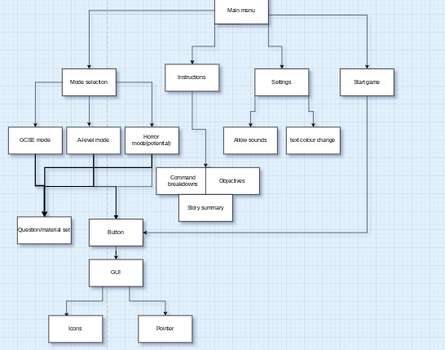

Main Game:

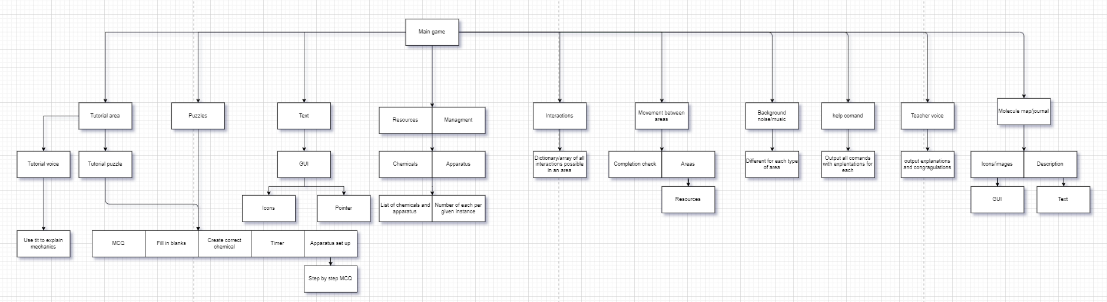

Ending:

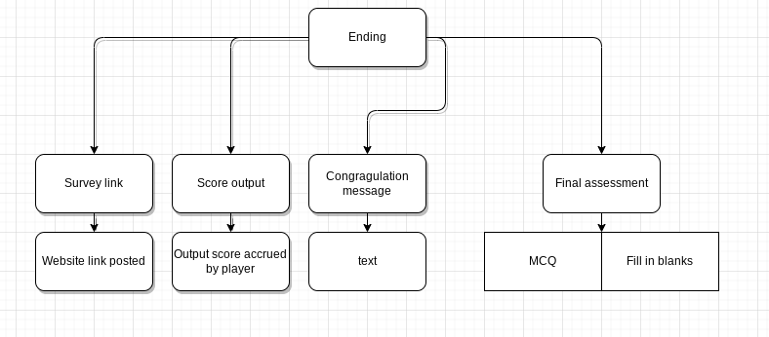

## Justification of the process

A problem like this should be broken down through use of a hierarchy chart because of a few reasons which I will mention.

One of these reasons is that it allows for the main problem to be dealt with as many small problems rather than one massive problem which has many moving parts. The fact that the breakdown causes the creation of the small problems allows for more manageable problems which will increase the speed of programming and allow for simpler programming as well.

Another of the reasons as to why the problem should be broken down is in order to find where reusable components may be used. This will help the overall program to be more robust as the small reusable parts will be used more often and so all the small errors within the reusable parts will be removed thus creating an overall robust program.

Another reason to use this sort of breakdown is because if the code was made procedurally then it would take a lot of time to find the error within the code due to the number of lines that the code takes. This would make it less suitable than breaking down the problem due to the time taken.

## Detailed breakdown

For the main menu I first broke it down into the different main components of a main menu, those being: Mode selection, Instructions, settings and finally the start game button.

For the mode selection I further broke it down into the three game modes that I plan on making, those being: GCSE, A-level and horror. These all have shared modules, those being the buttons and question sets. The button was then broken down into a GUI and that was broken down into icons and pointers. These two things are what make up most graphical user interfaces. The question sets also account for the difficulty of the game mode as they will ask for different things from the player such as in gcse the qualitative ions test doesn't have ammonium as one of the tests whilst A-level does.

For the instructions I broke it down into three separate modules, those being the command list and breakdowns, Objectives and story summary. These were not broken down any further as they are very simple text with an if statement for the player to choose which one to view at a given time.

For the settings I broke it down into two things: allow sounds and change colour These will be used to allow the player to choose what colour their text will be and whether they want to use the background sounds which should allow for a better user experience.

The start game only is a button which will transition into the main game and so what was said about the button applies here as well.

For the main game I broke that down into the core mechanics of the game, those being: The tutorial area, Puzzles, text, Resources/ resource management, Interactions, Movement between areas, background noise/music, help command, teacher voice and the molecule map/ journal.

For the tutorial area I broke it down into tutorial voice and tutorial puzzles. The tutorial voice will be used to explain the mechanics to the new players but will first ask if a tutorial is needed as returning players will not want to go through the tutorial again each time they play. The tutorial puzzles were then broken down into the puzzle types found there which are shared with the puzzles module.

For the puzzles I broke that down into the type of puzzle and elements of the puzzles which are; Multiple choice questions(MCQ), Fill in the blanks, create correct chemicals, timer and apparatus set up. The apparatus was then broken down into step by step MCQ. The timer will be present for certain questions in order to pressure the player and allow them to answer questions under pressure. These types of puzzles will be in every area and will assess the players on what they have learnt which will help the player better understand the topics.

For the text I broke that down into a graphical user interface which was then broken down into pointers and icons like wass used with the buttons previously. The text will be important as that will be the main way that the game will be able to communicate to the player about the topics. This means that the text must not be hard to read and is pleasant for the user.

For the resources/ resource management I broke that down into: Chemicals and apparatus which was further broken down into a list of them and a number of items per given instance. The number will dictate the amount of each item the player can have at a given time within the area before they have to wait a certain amount of time to have their stock replenished. The list will dictate what apparatus and chemicals can be used in a given area as some chemicals have no use in other areas such as silver nitrate not being needed for the energy topic.

For the interactions I further broke it down into a dictionary or array of possible interactions per given area. This is because only a select few chemicals will react in a meaningful way per area and those that are meaningful will be more easily used as the dictionary will allow for said interactions to be reached easily.

For the background music I simply broke it down that there will be different music per each area.This is done to give a clearer distinction between topics which seem very similar but shouldn't be confused such as benzene and alkenes or rates and energy. The music itself will also better immerse the listener and player and so the player will have a greater enjoyment if the sounds that they hear differ instead of having them all sound the same.

For the help command I simply broke it down into an output which almost repeats what the instructions command breakdown does as well where it says what commands there are and explains how said commands can be used. This will be important in case the player doesn't remember what they are able to do within the game and would otherwise give up as they don’t remember all the commands and mechanics introduced to them.

For the teacher's voice I broke it into simple outputs that explain the topic well and also give congratulations when a player completes a number of puzzles. This should be helpful in both teaching new players or helping old players to revise what they had learnt as this should be an approachable way for information to be delivered. The congratulation messages should also motivate the players to keep playing and to also help boost their confidence within the topics present.

For the molecule map I further broke that down into Icons and description which were further broken down into the graphical user interface and text respectively. The idea of the icon is to show how the molecule may appear to be seen almost as in real life. The description will include the person who discovered it, the uses of the molecule, the hazards and dangers of the molecule and how the molecule was synthesised by the player. This should hopefully lead the player to try and look up more interesting compounds and do personal research on them. This will also teach more on the individual molecules they will work with which should help them remember the uses of said molecules within exams.

For the Ending section I broke it down into the main parts of the ending, those being: The survey link, the score output, the congratulation message and the final assessment.

The survey link was then broken down into just the link to the form which will lead the player to a website with the form such as google forms which will then ask for the satisfaction rating from the player and other rating questions for feedback. This would allow for updates to the game based on player experience. This would be better than just doing the ratings on the program as I would not be able to easily see these different ratings and requests compared to using something like google forms.

The congratulation message will be done only through text as it is a very simple message for the player and so wouldn’t need to have too much code behind it other than using the already made graphical user interface.

The final assessment was broken down into fill in the blanks and multiple choice questions. The reason for the existence of the final assessment is to test the player on everything that they have been taught about within all topics. This will include randomising questions that will be asked with all the topics having the same maximum number of questions that can be asked.

## Algorithms

Common data structures which will be used:

| Data structure | Explanation | Justification |
| --- | --- | --- |
| Dictionaries | It will be used for stuff such as the interactions, question sets and resources with areas | It is better to use a dictionary for the question sets and interactions than an array as they can easily return information that is needed such as the interactions than with an array that would have to look through every term first. |
| Arrays/Lists | It will store questions for a question set which will be used for the areas | It is better to use an array/list for this than a dictionary as there will be many questions to a single question set which means that it will be able to get questions by type and have them be linearly done which the dictionary may struggle to do. |

Key variables

| Variable | Explanation |
| --- | --- |
| Score | This will keep track of how well the player is doing within the game. |
| Current music | This will indicate what the current sound file will have to play for the area and hence will play it |
| Help commands | It will be a list of all commands available for a single area. |
| Total progress | The sum of all progress done within the game divided by the number of areas which will be shown to the player during gameplay. |

Key algorithms:

**Help command function:**

def help():

print(helpcommands)

**MCQ question answering:**

def answering(question,answer):

x=0

While x<3:

playerin=input()

If playerin!=answer:

print(“incorrect try again”)

x+=1

Else:

print(“congrats”)

x=10

**The area class attributes:**

class Area():

Def __init__(self,name,chemical list,apparatus,next areas, question set,teacher):

self.name=name

self.chemicallist=chemicallist

self.apparatus=apparatus

self.nextareas=nextareas

self.questionset=questionset

self.teacher=teacher

self.progress=0

**Timer function(time needs to be imported)**

Def timer(time):

While time:

time.sleep(1)

time-=1

print(“time is up”)

Return false

**Teacher class:**

class teacher():

Def __init__(self,lines):

self.lines=lines(lines will be a dictionary which contains situations and what the teacher will say as a response)

**Moving between areas method/function:**

Def move(current area):

If currentarea.progress==100:

x=currentarea.nextareas

n=0

For i in x:

print(n,x[i].name)

n+=1

c=input(“input the number of the next area you want to visit”)

currentarea=x[c]

else:

print(“there is more to do and learn”)

**Sorting list of chemicals alphabetically:**

def insertion_sort(list):

for item in list:

for index in range(len(list)):

nextitem=list[index]

i=index-1

while i>=0 and list[i]>nextitem:

list[i+1]=list[i]

i=i-1

list[i+1]=nextitem

return list

**Fill in the blanks:**

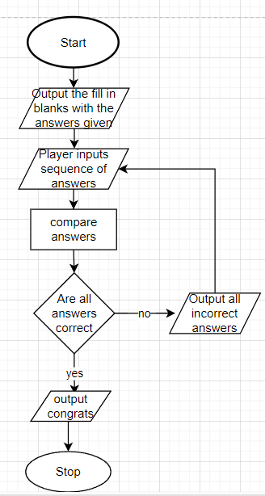

**Create correct chemical:**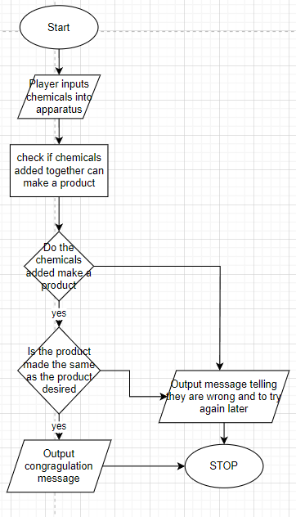

**Molecule map/journal:**

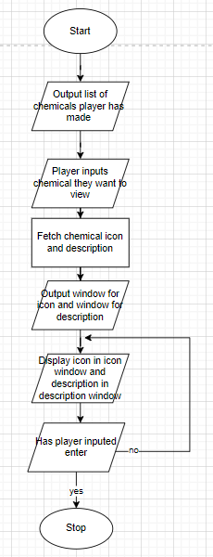

**Validating key variables:**

Score can never be less than 0, score must be an integer.

Current music must be a string/file

Help commands must be a list. Must have all possible commands for a given area.

## User interface

The user interface will be a simple graphical user interface which will be used for outputting text, images and for playing sounds within the game.

**The user interface:**

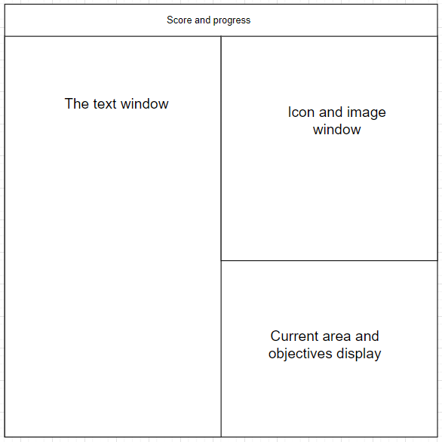

The user interface will display the score/ progress of the player, current text, images and the current area in separate windows organised as shown above.

The text window will display the current text that will be teaching or assessing the player which will include the puzzles and teacher’s voice. This is the core of the game as it is the only method as to how the player will be taught new concepts and also will be how the player is assessed for the most part. This means that for better player experience they will be able to change certain settings for the text such as colour and potentially size.

The score and progress display will be there to show the player how well they are doing within the game and to also show how much of the game they have completed.

The image display window will be there to show off certain images such as for the molecule map/journal. It will also be present for certain multiple choice questions. The main functionality is to express icons for the player to use in order to visualise key topics.

The current area and objectives display is there in order to keep the player on track and to also remind them of what area they are currently in as to help them remember what they are currently doing if they are to forget.

## Justification of how the algorithms form a complete solution

These algorithms form a complete solution by working together and building the different aspects of the solution which together form the complete solution.

One of these would be the sorting algorithm that is used. An insertion sort algorithm is used for sorting the chemicals together and also apparatus because it is a decently fast method of sorting a list. It also takes up a lot less space compared to other sorting algorithms. The reason why insertion sort was used over merge or quicksort was because the list of chemical that the players will have access to at a given time will be quite small meaning that the speed of merge sort is not a factor to be considered for the algorithm and because of its larger storage capacity taking compared to insertion sort, it makes it so that merge sort would be the lesser option in this situation

The choice to make areas and the teacher classes was due to the fact that there will be many different areas and each area will need to have different lines told by the teacher's voice. The use of classes will allow for an easier time coding each separate area and by extension will allow for a greater speed in coding. This is better than splitting each area into separate files because they will be able to all be accessed and worked on much easier and would take up a lot less memory to store.

For the use of while loops for the multiple choice questions algorithm this is used as while loops allow for a piece of code to run until a condition is met with the condition being that x is less than 3. A while loop was used instead of a for loop because the multiple choice questions only need to be looped until the player gets the question right. However with for loops, they run for a predetermined amount of times which means that even if the condition is met that means that the player still needs to repeat the question even though they had answered it correctly which a wj=hile loop allows the prevention of this.

The graphical user interface will be used to tie in every other aspect of the game in order for the player to actually utilise the main function of the project which is to learn and revise chemistry topics.

## Testing methodology

There are two types of testing that occur for a program in development. Iterative testing and Post development testing.

In iterative testing the code is ran during development to check if it works in that instance. This means that the code is constantly tested for bugs and errors which can cause the program to fail.

In post development testing the programmer runs through the program in its entirety to do a final sweep for errors and bugs within the code. This happens after the program has been fully developed.

The reason Iterative testing is needed is to check for errors whilst programming and so those errors can be resolved faster and for the final developed product to have little to no errors within the code.

The reason post development testing is needed is to test how every individual part of the program works together and to also catch errors that had not been found during iterative testing. This is done to properly ready the program so that it is capable of achieving what is needed of it.

## Iterative test data

| Test ID | Description | Test data | Expected results |
| --- | --- | --- | --- |

**Test for MCQ**

| 1 | Check the limit works | First Incorrect answer  Second Incorrect answer  Third Incorrect answer | The multiple choice function should stop after the third incorrect answer |
| --- | --- | --- | --- |
| 2 | Check that when correct answer is given that program stops | First correct | Should end the function and move on to other thing |

**Movement**

| 1 | Will check to see if both progress checker and the movement functions work together | Move(current area)  Choose unavailable area | Message telling player they can't progress until they have completed section |
| --- | --- | --- | --- |

## Post development test data

| Test ID | Description | Test data | Expected results |
| --- | --- | --- | --- |

**General checks**

| 1 | Check that the save function works for multiple accounts | Make first save  Make second save  Log onto first save | The first save is stored and has not been affected |
| --- | --- | --- | --- |
| 2 | Check that the saving and account work | Make a save file with.  Name:  Password: | Should produce an error message for the player to input a name and password |
| 3 | Check validation of save | Make save file with  Name:Jerry  Password:Jerry  Try to make other file with same name and password | Produce error message to not have the same name or password as another user |

## Test checklist

| What is being checked | Working as intended? |
| --- | --- |
| Text is correctly formatted depending on window size |  |
| Buttons open what they are meant to open such as settings opening settings menu |  |
| The teacher voice outputs the dialogue correctly |  |
| Correct icon is shown for certain questions |  |
| Score is correctly calculated |  |
| Molecule map/journal stores and outputs correct data |  |
| Progress meter is calculated correctly and shows the correct progress number. |  |
| Cursor interacts with buttons correctly |  |
| Link to the survey works correctly |  |

# Development

## Section 1: The main menu

### Iteration 1:

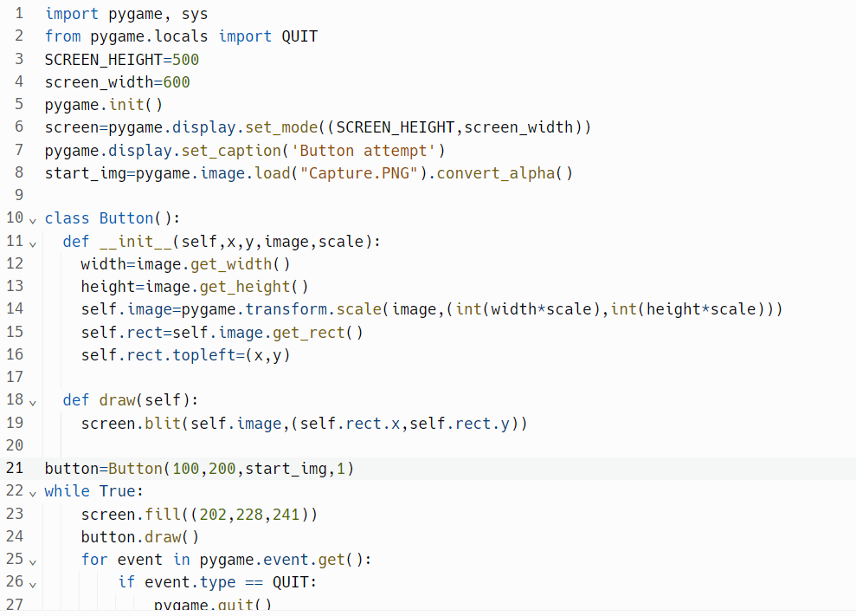

The code shown above is used to initialise a window in which the main menu will be displayed for the player to interact with and move between the different menus and it also initialises the image for the start button which will be used to begin the game.

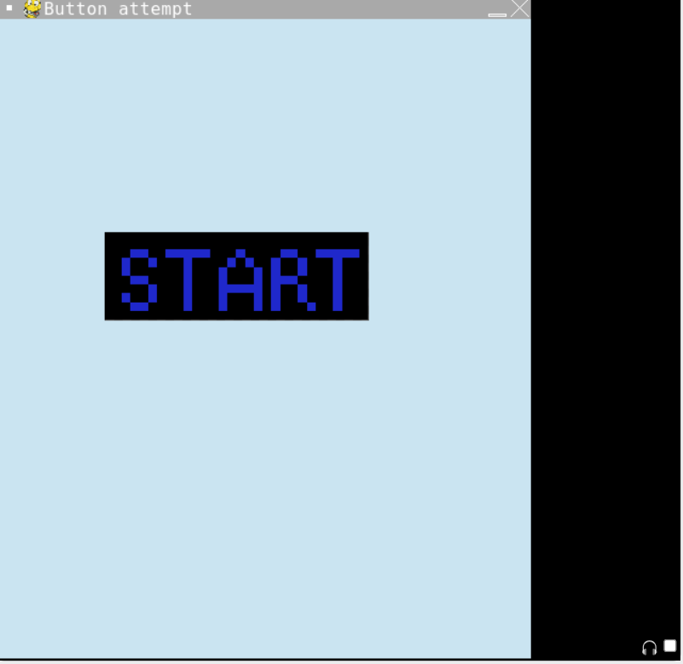

The issues as of now is that there are no other buttons for the other parts of the menu such as the mode selection button, the settings menu and the instruction menu. Another problem is that the buttons do not lead anywhere further as in if the start button were to be working it will not take the player into the main game and subsequently this will affect every other menu option as those specific menus have not been created. The main issue with this is that the button is not interactable in any way, shape or form.

The way that the issue of not being able to interact with the button was solved by looking if the mouse was within the confines of the button and then detecting if the left mouse button was clicked whilst within the confines.

### Iteration 2:

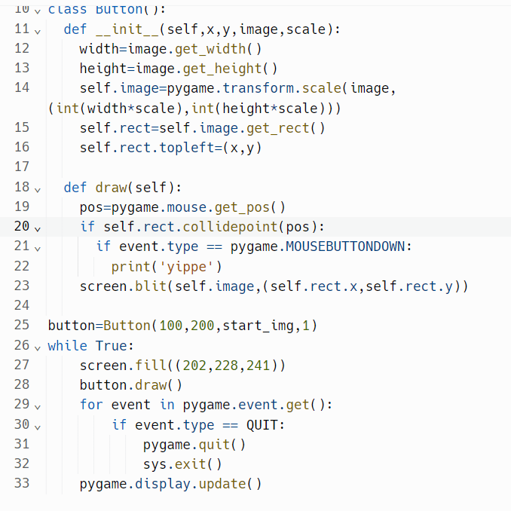

The new code shows how the button is now able to have some interactions with the mouse. This can be seen within lines 20 and 21 where it first will look if the mouse is within the rect of the button and the second line looks at whether the left mouse button has been pressed meaning that an interaction should occur. This works as intended seen with the results of the test shown below.

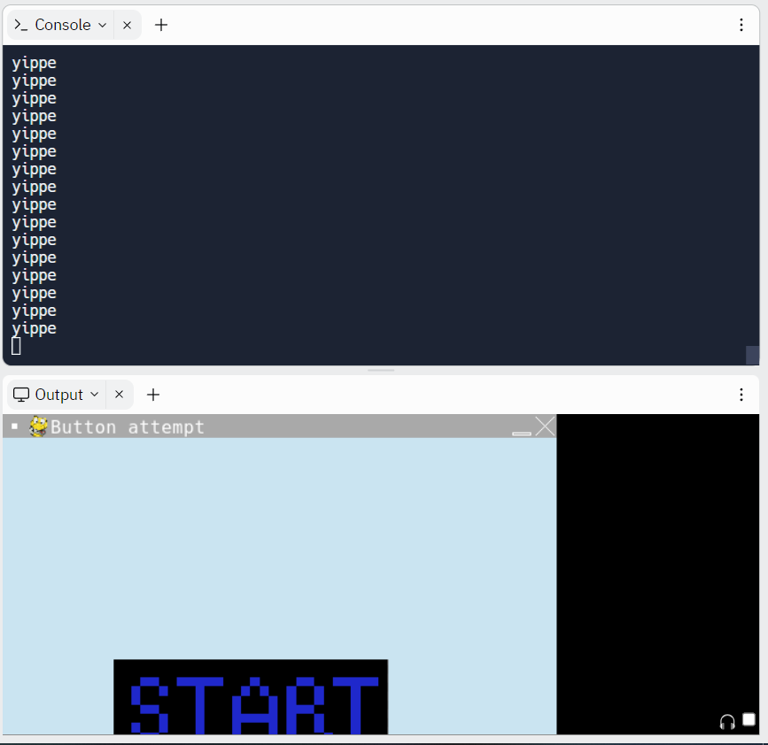

It is shown that the code is working correctly as the proof of whether the code would work or not is shown if yippe was outputted which is shown in the screenshot.

In terms of errors there are none other than some listed previously however a larger issue that has come to light is the fact that the start button will not be adjusted to the width and height of the window in which the game is played in. This is a problem because when the other buttons will be added they will have to change size in accordance with the size of the window alongside their placement within the window.

This has been fixed by making the scale of the photo of the buttons equal to the size of one of the sides divided by six hundred. This solves the problem.

### Iteration 3:

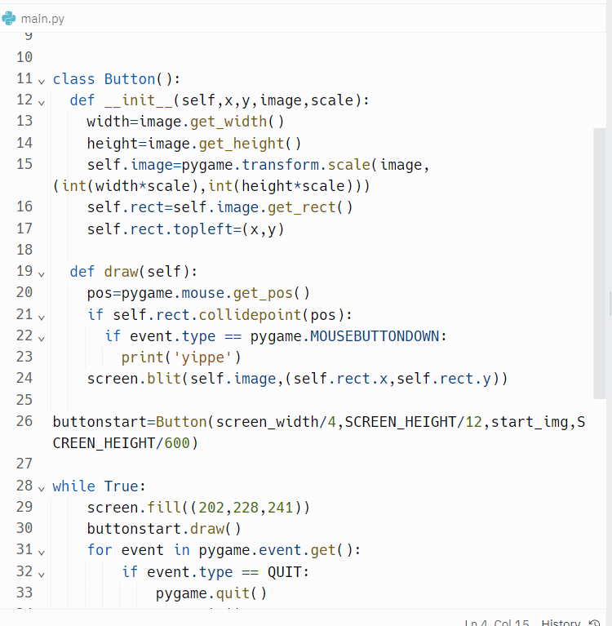

The code now scales the button correctly and also places the button in a spot in accordance to the height of the screen.

At 600*600px: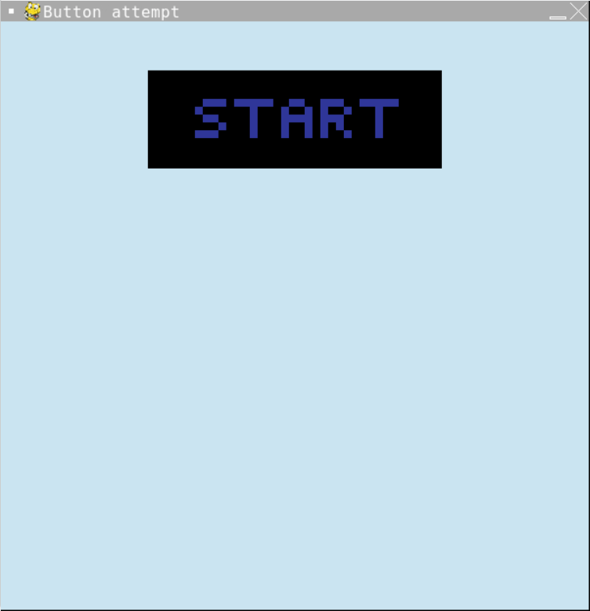

At 300*300px: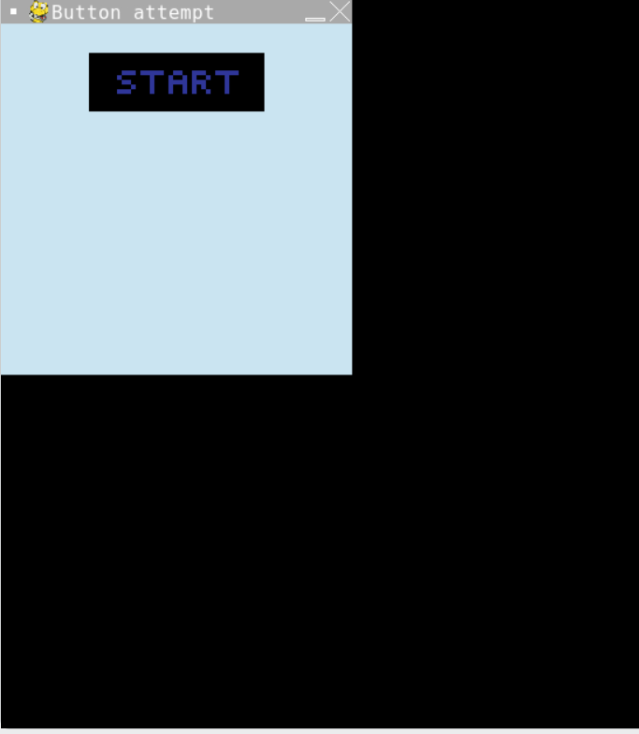

Issues that remain with the GUI is the lack of other buttons and the lack of functionality of the other buttons.

### Iteration 4:

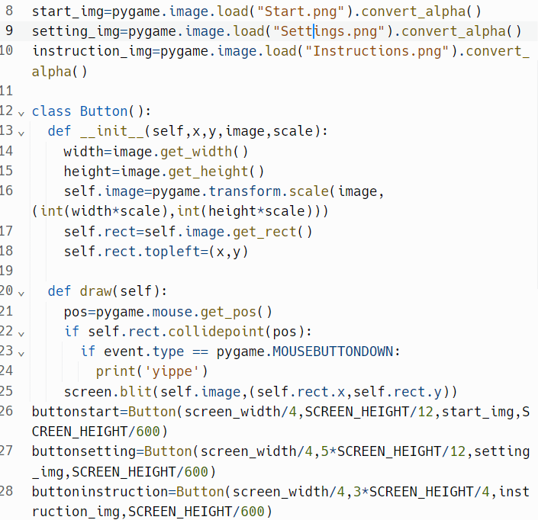

The code now supports the three buttons and works with interactions for the three different buttons as shown below.

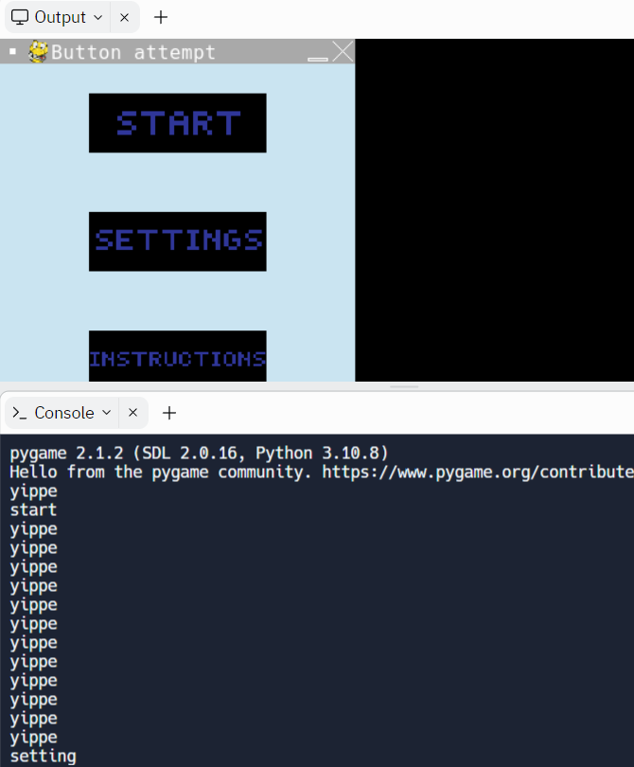

Some issues as of now is that none of the buttons do as intended which is moving to different screens such as instructions button not leading to the instructions of the game, settings not leading to the settings of the game and the start button not leading to the mode selection menu.

The first thing to do is to make the different screens for the separate buttons so that they may function as intended.

### Iteration 5:

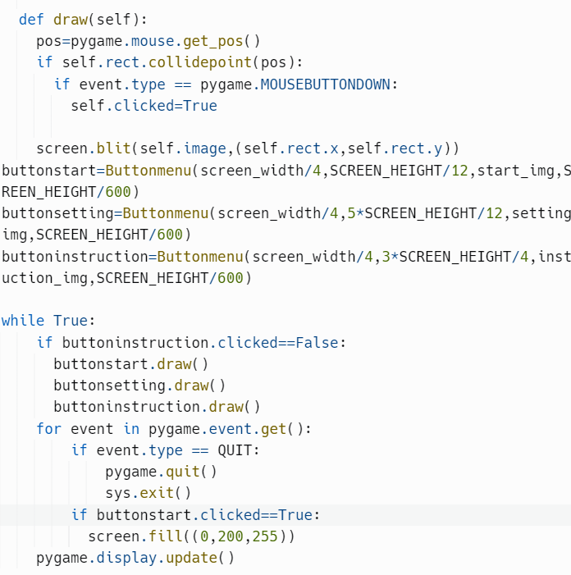

The code is there to make it so that when the start button is pressed, the display is cleared from any and all buttons.

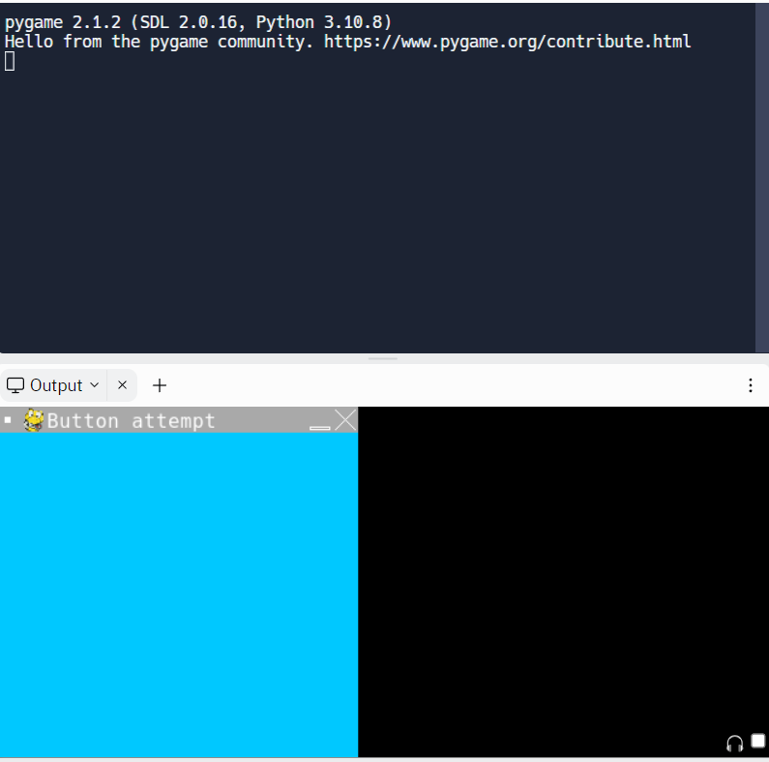

An error that is occurring is that after pressing the start button the screen slightly flickers instead of completely being erased. However the screen does erase itself only after the instruction button is pressed as well.

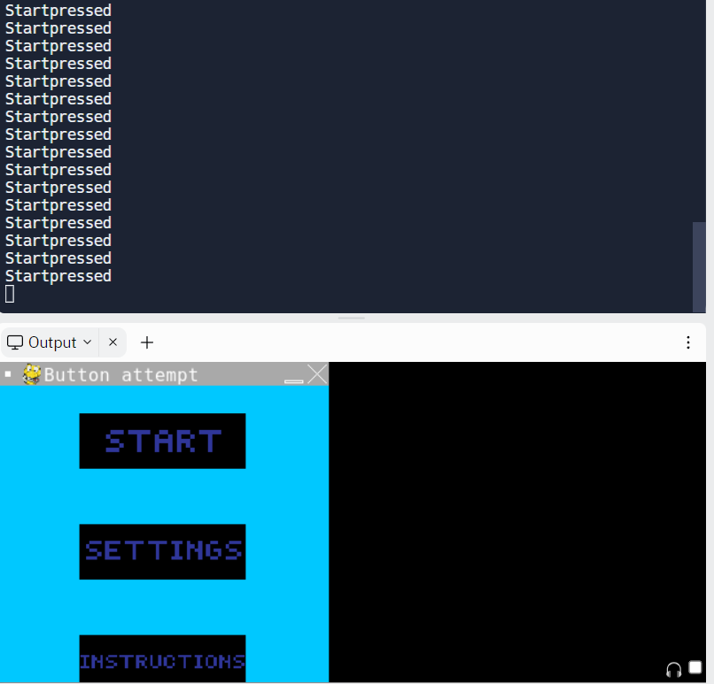

The way this can be solved is by using game states which are boolean variables which will make it so that when a certain button is pressed it will cause its attached boolean to be true and so it will allow the screen to instead have a different display for each button.

### Iteration 6:

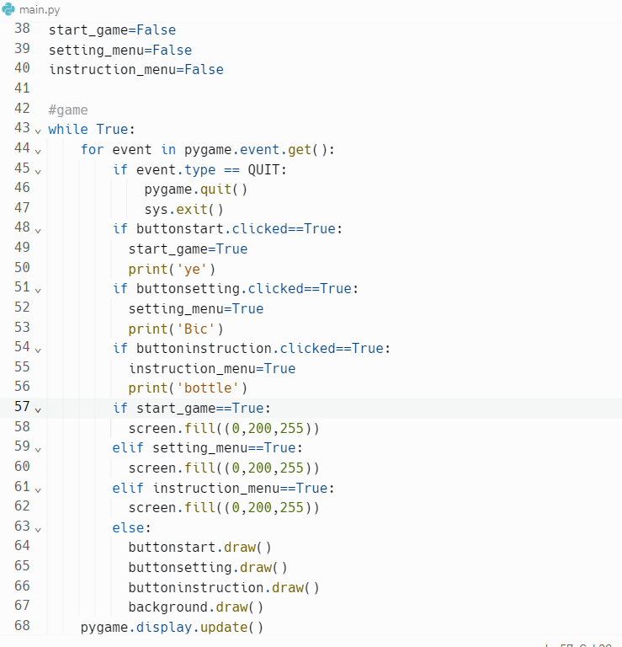

This code uses game states to switch between the different menus. It is used as it simplifies the menu creating process and allows for added menus if needed.

Testing for start button:

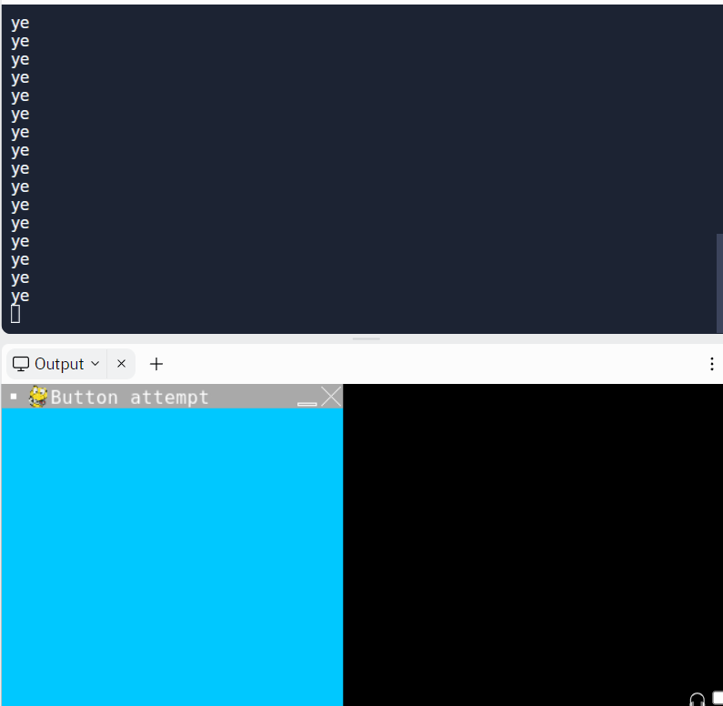

Testing for settings button:

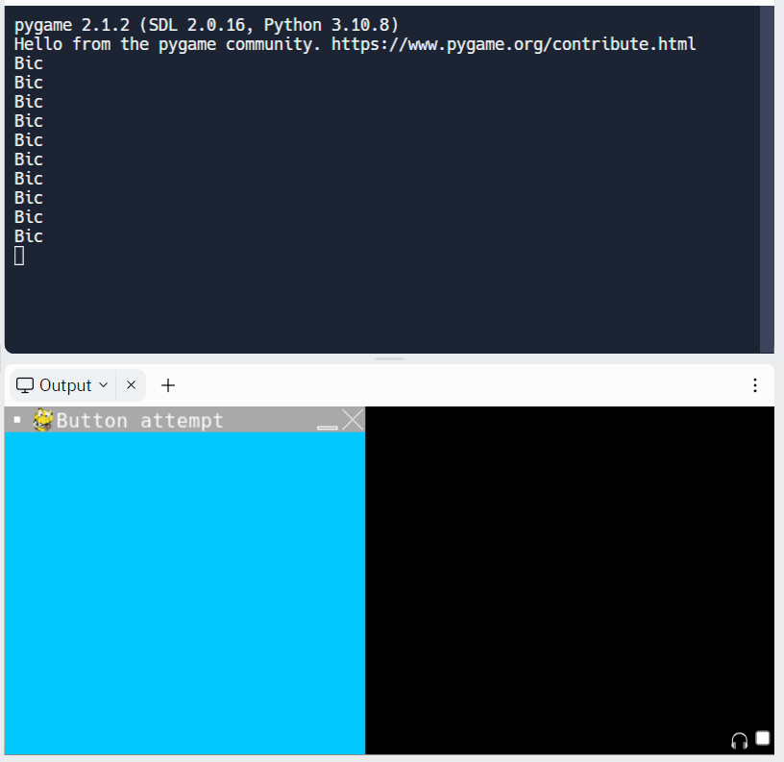

Testing for instructions button:

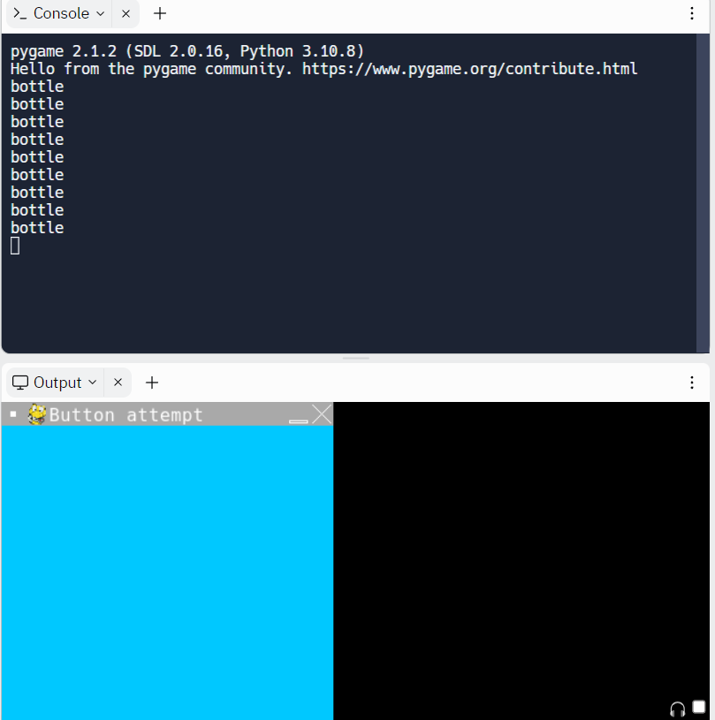

The issue as of now is that the buttons do not lead onto anything else. This is fixed by making the separate menus which will be started with the Instructions menu as that is the simplest to code and create.

### Section review:

**What I have done:**

I have made the basis for the main menu which will lead to the rest of the menu functions including the instructions to the game, settings and the game selection options.

As this is the first section there are no changes currently done to the game.

## Section 2: The instruction menu

### Iteration 1:

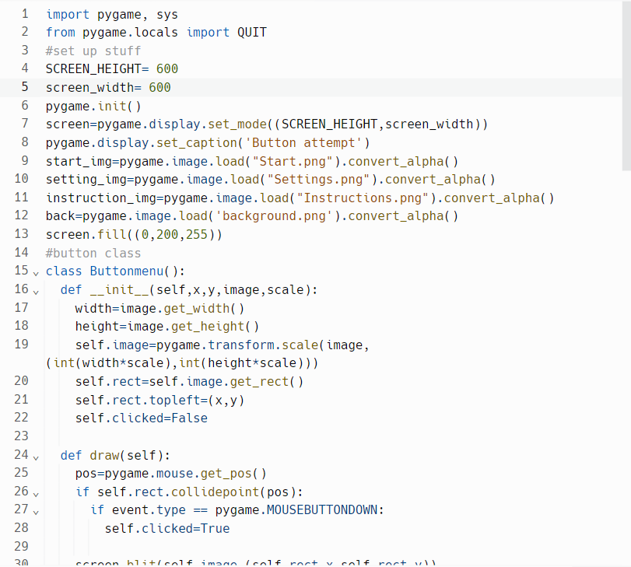

The code will output some text on the blank screen created after pressing the instructions button. This will output to the player all instructions in the game.

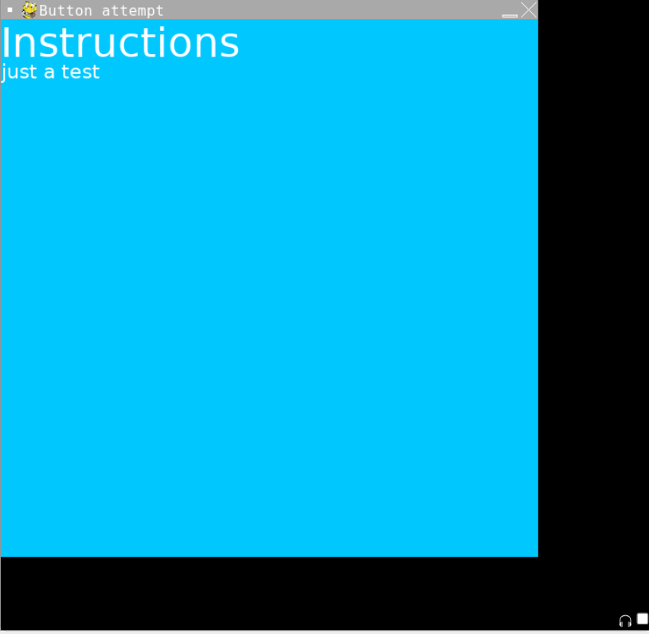

An error that occurs is that when a single line of text goes past the screen width then the text will not wrap around the screen. This poses a problem as it will make the text look a lot weirder and makes it so that the text function has to be called multiple times otherwise. This is solved by rendering each word separately and moving to a new line when one of the words surpasses the width of the screen.

### Iteration 2:

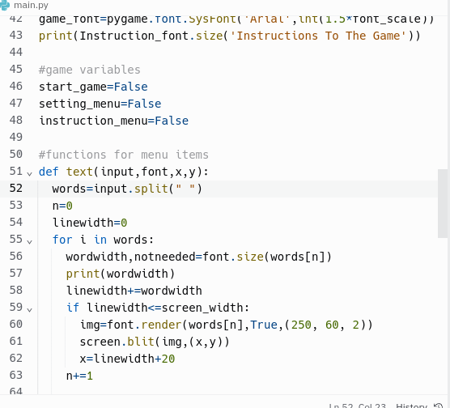

The code now will iteratively build up the line which will allow for wrapping of the text.

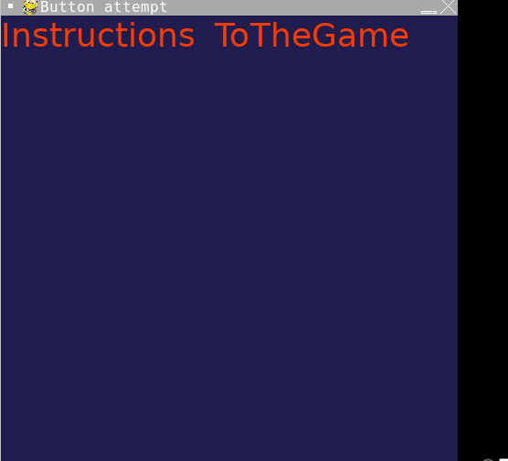

An error that is currently being experienced is that after the first word the gap between it and the other words is much larger than it is supposed to be. This can be fixed by adding a space between the words using the same thing that adds the words on to one another.

### Iteration 3:

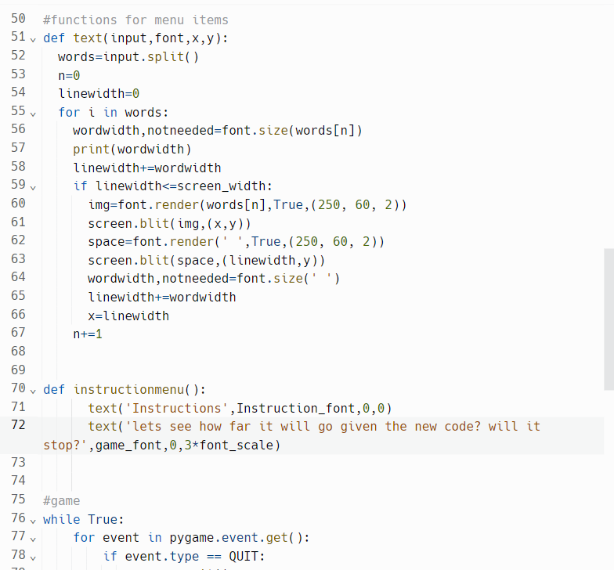

The code splits up the sentence put into the procedure into all the words that make up that sentence. It then outputs each of the words that has been added to the procedure one at a time whilst outputting a space in between each of the words.

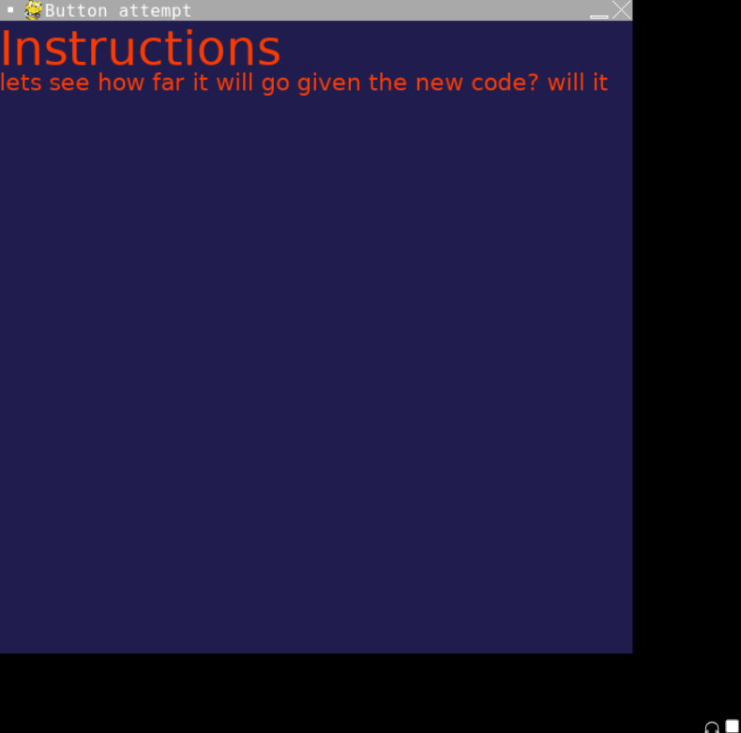

Currently the issue for the text part is that it will not wrap around the screen as it is intended which means that the instructions cannot be inputted so that it appears as a single sentence. This can be solved by making it so that the next word is outputted in the line below the current sentence.

### Iteration 4:

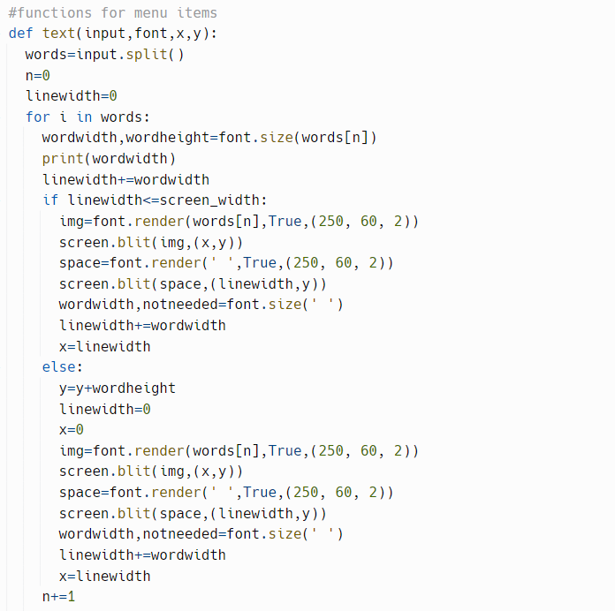

The code now switches to a new line when all available width is taken by the sentence.

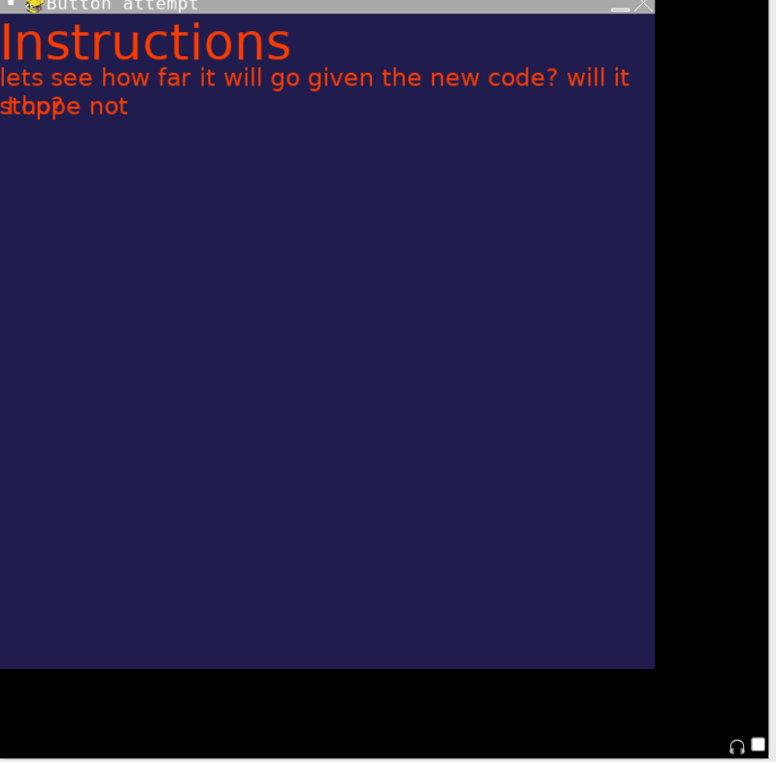

The error that is occurring is that after moving to the new line the words after the word that has been added will initially overlay that word. This is fixed by making the new x value equal to the value of the width of the word being printed on the other line and adding on a space.

### Iteration 5:

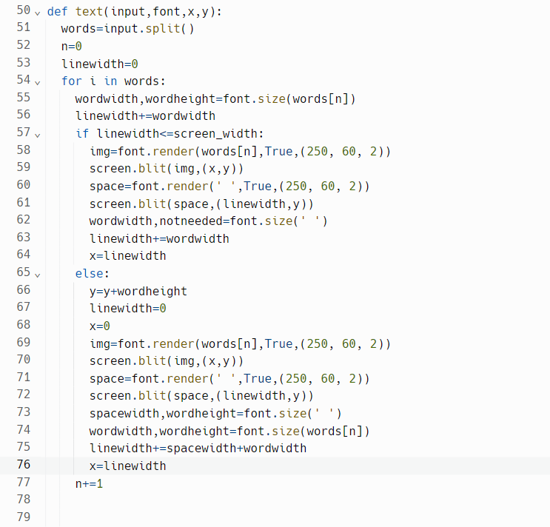

The code will now properly output sentences and allow them to seemingly wrap around the screen and make it seem as if the sentence does not cut off. It also allows for the text to stay the same even if the size of the window changes.

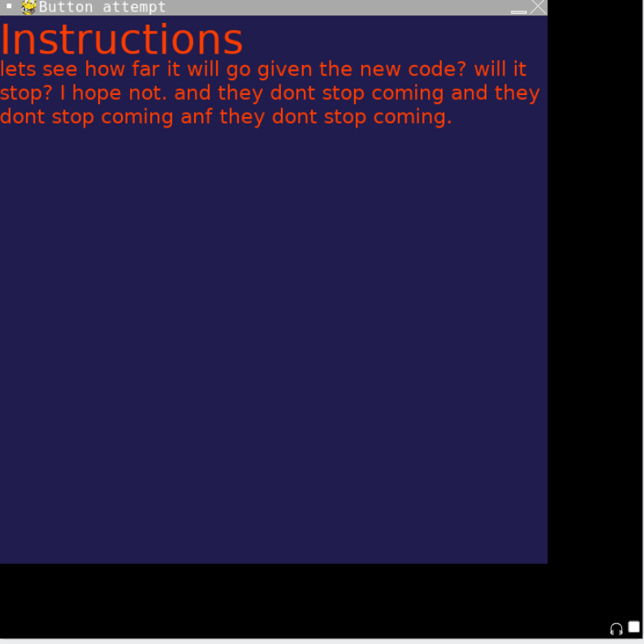

The issues that persist with the menus is that the instructions do not contain the commands and other needed things alongside a back button. The other buttons do not display what they need to display as well. The first issue is easily solved by creating the commands that will be used in the game and to also remove the testing text.

### Iteration 6:

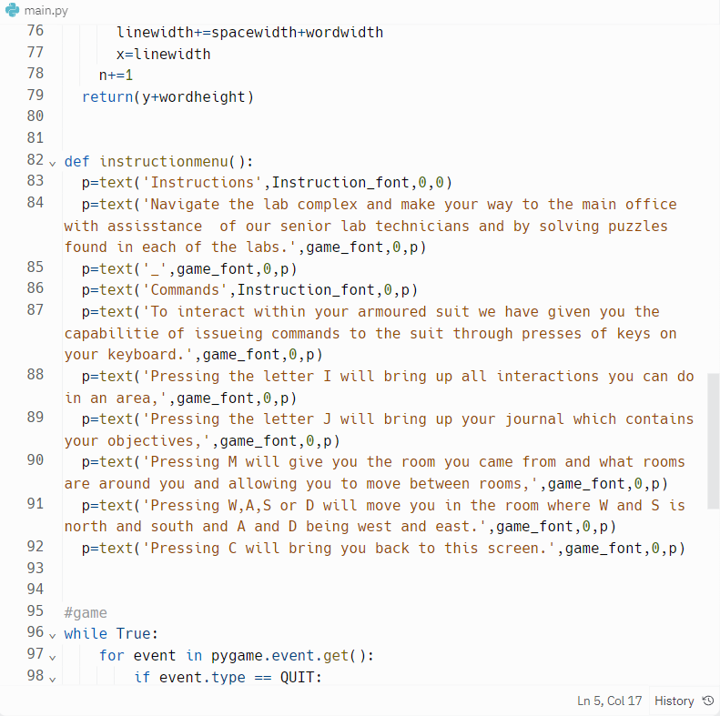

The code now outputs all commands and the main objective of the game.

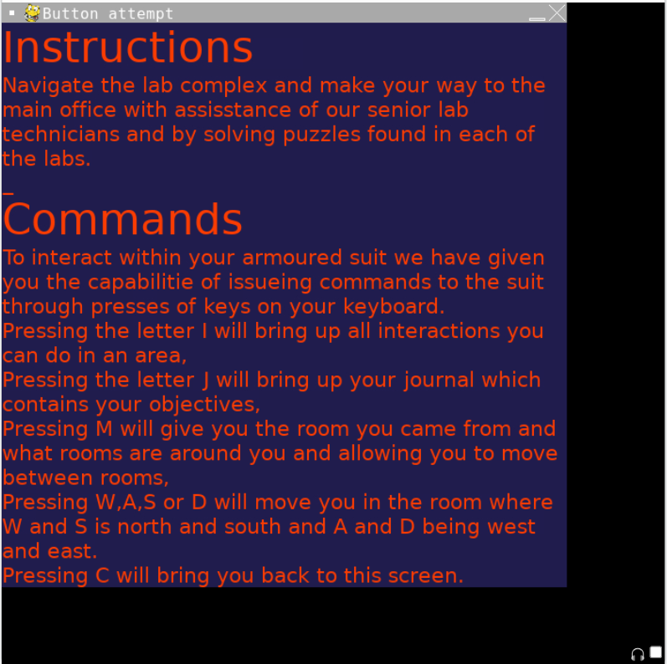

The issues as of now is that the player is stuck in this screen and has to exit the game fully to get back to the main menu and that the rest of the buttons have no functionality.

### Iteration 7:

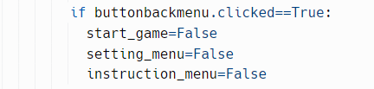

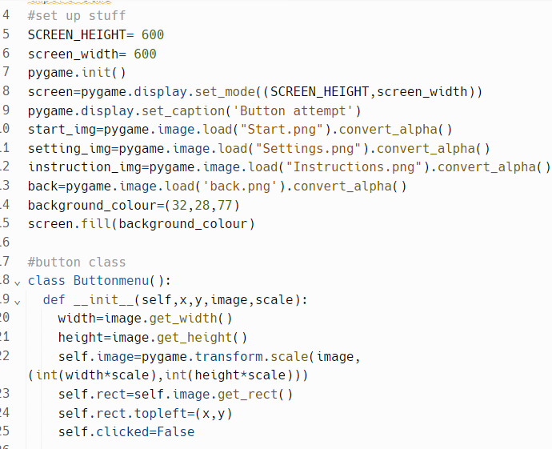

The code now outputs a back button which will take the player to the main menu after being pressed.

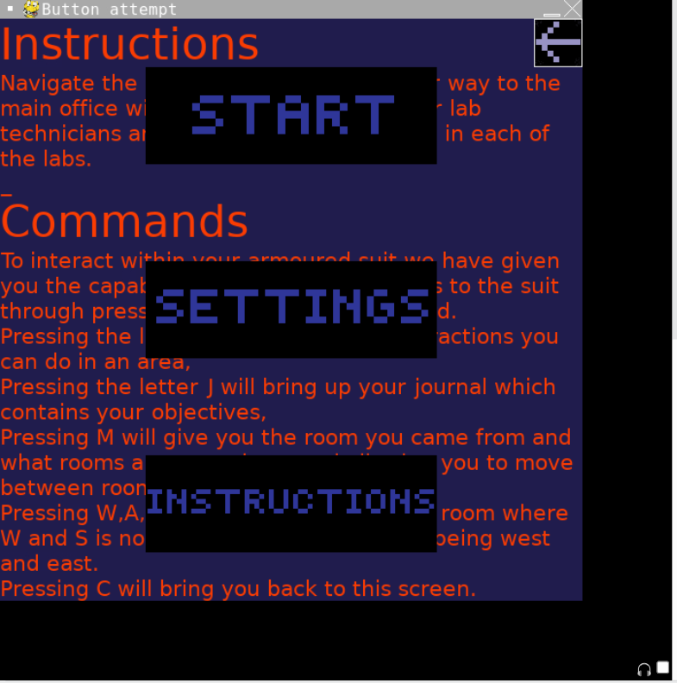

Errors with the button is that the screen still displayed the instructions menu and the buttons afterwards did not work. This could be solved by clearing the screen beforehand and also resetting the button's clicked status.

### Iteration 8:

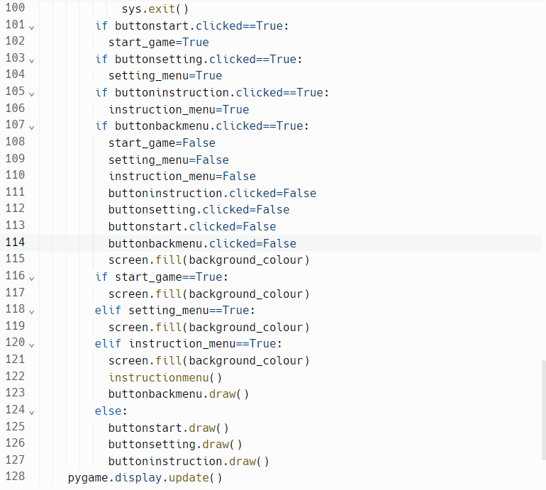

The back button now works as intended, sending the player back to the main menu and then allowing the player to choose a different option or to go back to the instructions menu repeatedly.

Shown in order of main menu, instructions, main menu, start game:

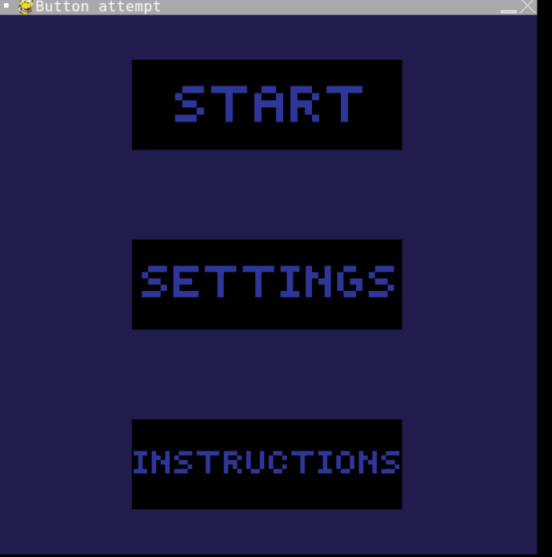

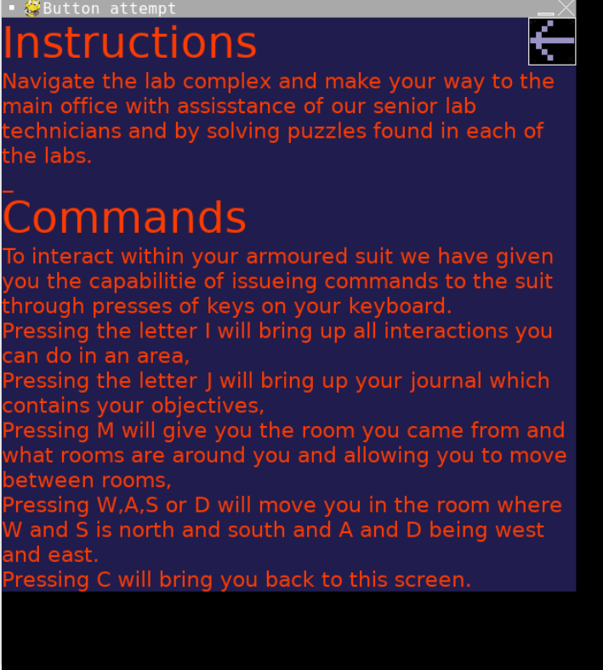



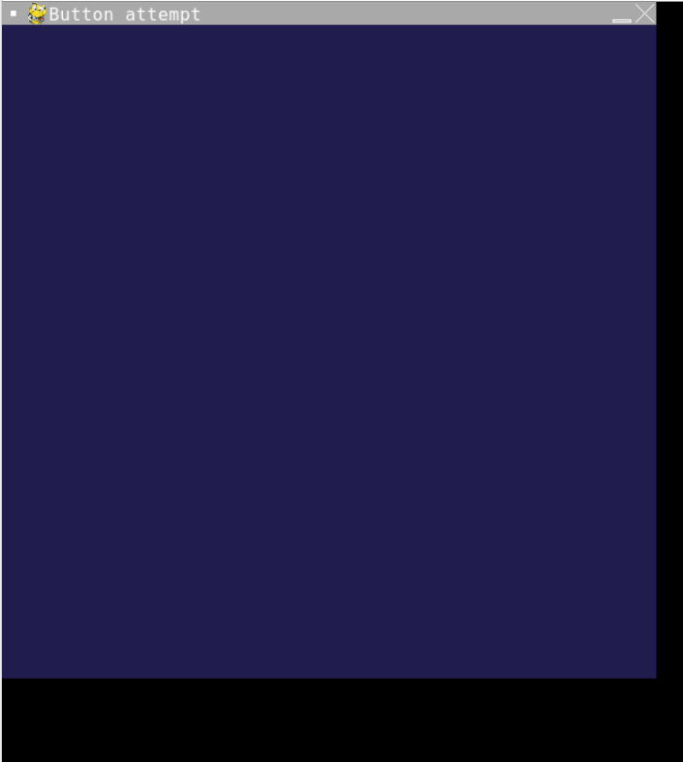

Issues as of now are the start menu and settings menu not having anything there nor anything interactable. This is solved by adding the stuff and adding the functionality to the necessary stuff.

### Section review:

**What I have done:**

I have made a function that makes text wrap around the screen similarly to google docs or microsoft word. Using this new function I made a list of commands and instructions the player will have. I also added a back button for the menu allowing the player to return to the main menu screen and move between other parts of the main menu.

**Things I have changed:**

I have made the background a different colour.

## Section 3: Settings Menu

### Iteration 1:

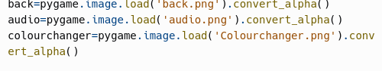

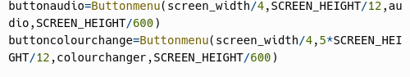

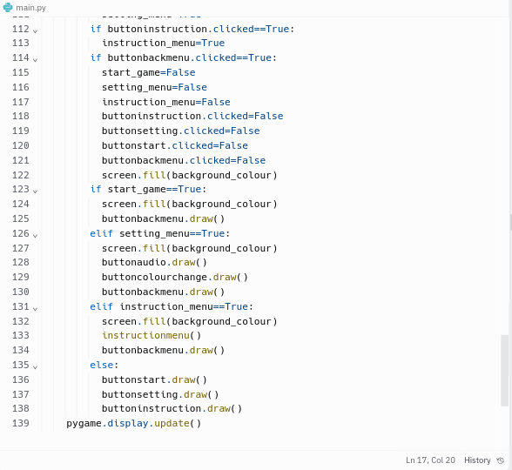

The code now supports buttons for the setting menu and it produces the back button in all other menus with its full functionality.

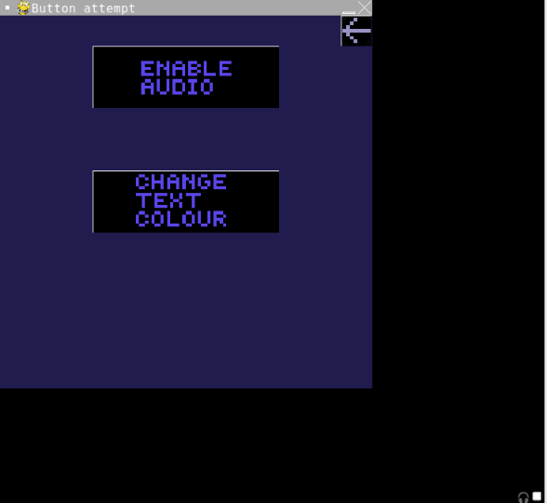

The only issues as of now is that the buttons within the settings menu have no functionality and there is no sound to enable or disable. This is fixed by having the buttons to enable or disable switch when one has been pressed.

### Iteration 2:

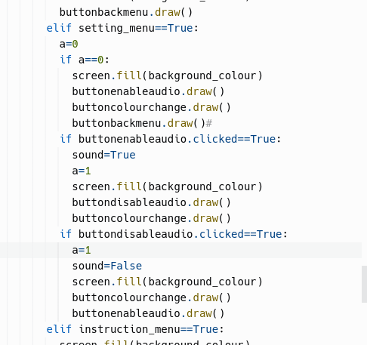

The code now supports a disable audio button and erases the background and tries to output the new button.

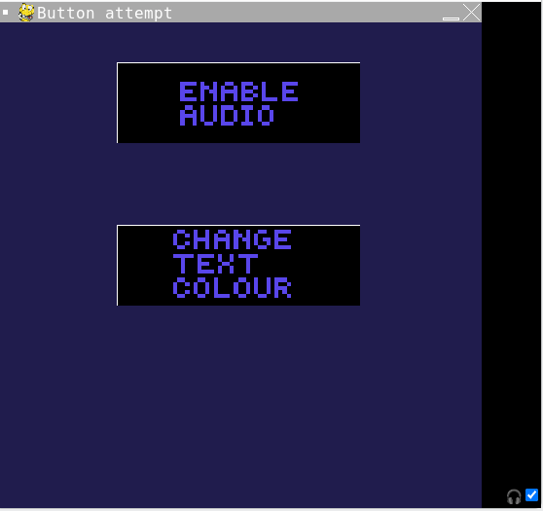

The error that is occurring is that when the enable audio button is pressed the background does disappear alongside the back button but it does not switch the buttons.

### Iteration 3:

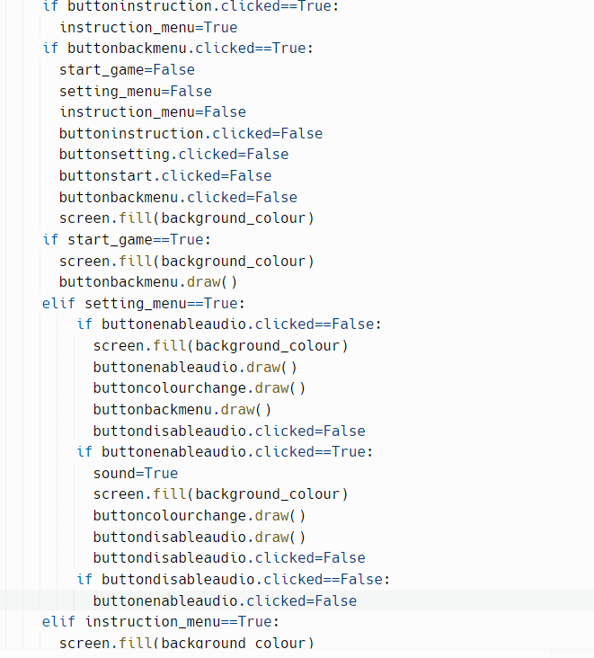

The code now manages to switch the two buttons when the enable audio button is pressed.

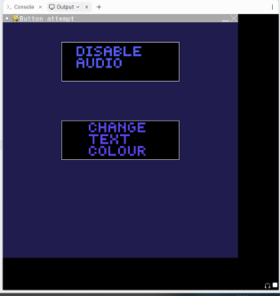

The error as of now is that if the disable button is pressed it does not change the screen permanently to the disable audio button. This can be fixed by first moving where the disable audio button is to be where the instructions button was previously in order to stop the two buttons being clicked right after one another leading to the first error.

### Iteration 4:

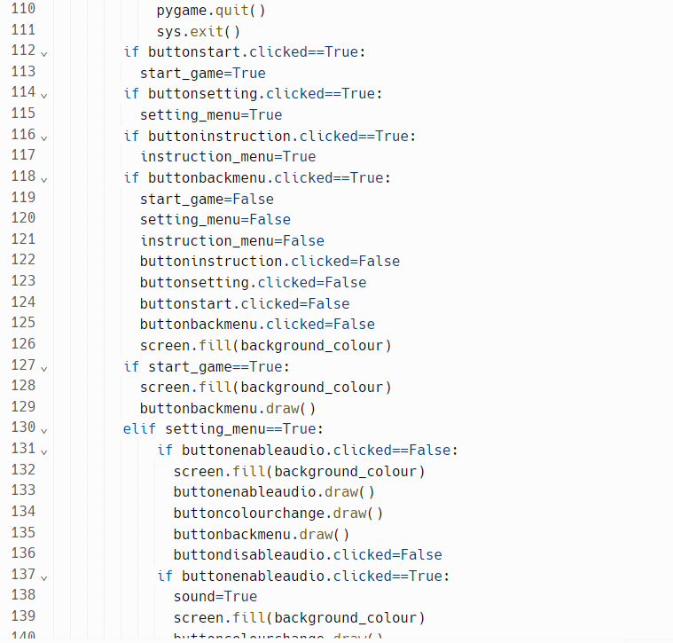

The code now properly displays the buttons when needed. It also displays the back button leading to the menu.

Before pressing:

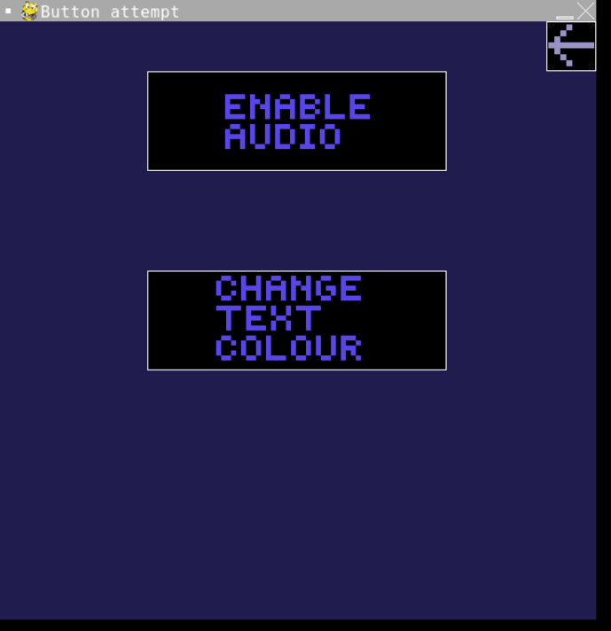

After pressing:

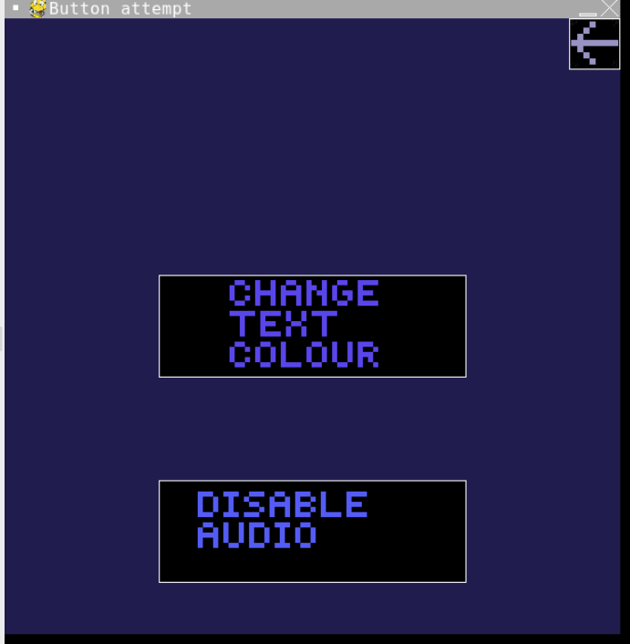

The only issues now is that there is no audio to even play and the change text colour button does not work. This is solved by adding audio and adding functionality to the change text colour button.

### Section review:

I have added functionality to the enable and disable audio buttons.

Nothing has changed in regards to the rest of the menu.

## Section 4: colour changing menu

### Iteration 1:

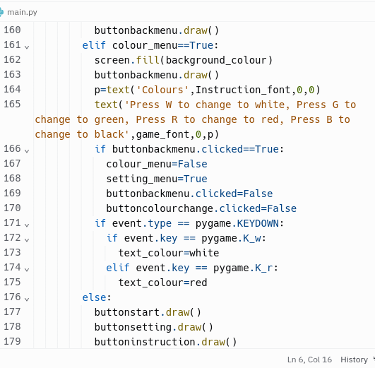

The code gives the player the instructions to change the text colour to white, red, green or black through the use of key presses. It also changes the text colour to that chosen.

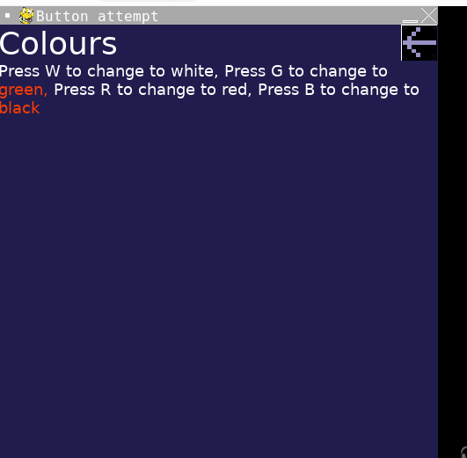

An error that is occurring is that the rest of the keys do not work and the words that are wrapped around keep the original red and do not change. This is fixed by amending the code within the text function to include the variable text_colour. Also adding the rest of the keys solves the second issue.

### Iteration 2:

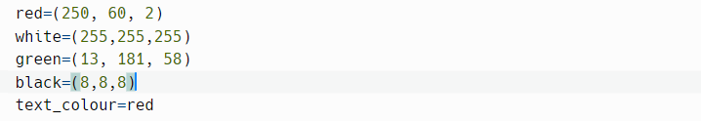

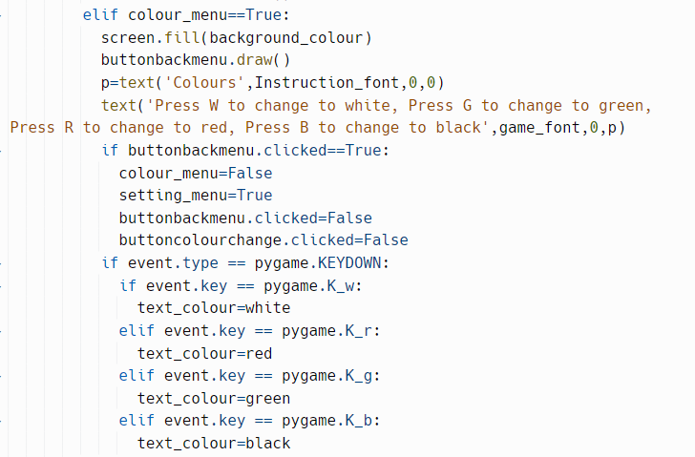

The code now outputs the instructions to change the colour of the text along with changing the colour of the text in all places it is used in like the instructions menu.

[Completion of the main menu](https://drive.google.com/file/d/1AR87d5Ua2nAyrFN0acXrJWAA_gizJwnJ/view)

### Section review:

I have completed the full functionality of the settings menu.

Aside from additions to the settings menu and adding the sound variable no other changes have occurred to the rest of the game.

## Section 5: Start game menu

### Iteration 1:

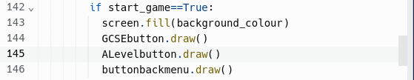

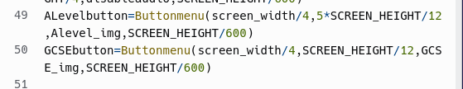

The code now displays the two buttons used to navigate between the two modes.

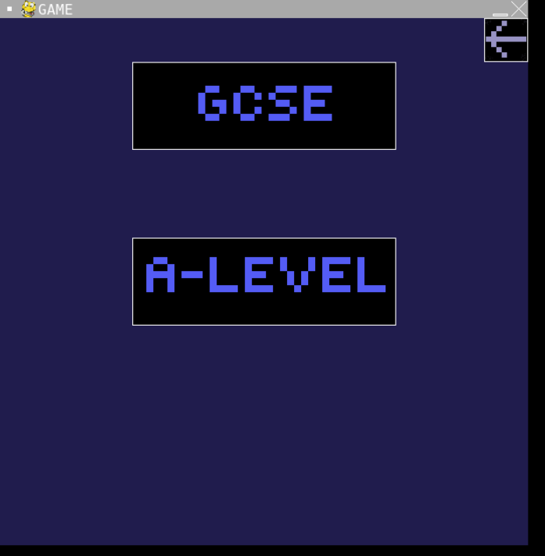

The issues as of now is that they do not lead to the two game modes. One way this can be solved is by making variables for the two different game modes and so when these game modes are true the screen is erased.

### Iteration 2:

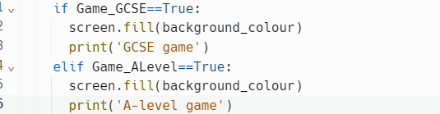



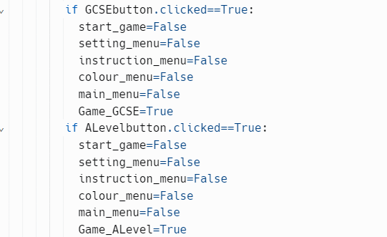

The code erases the screen when either the A-level button or the GCSE button is pressed and then outputs something to the console.

GCSE button testing:

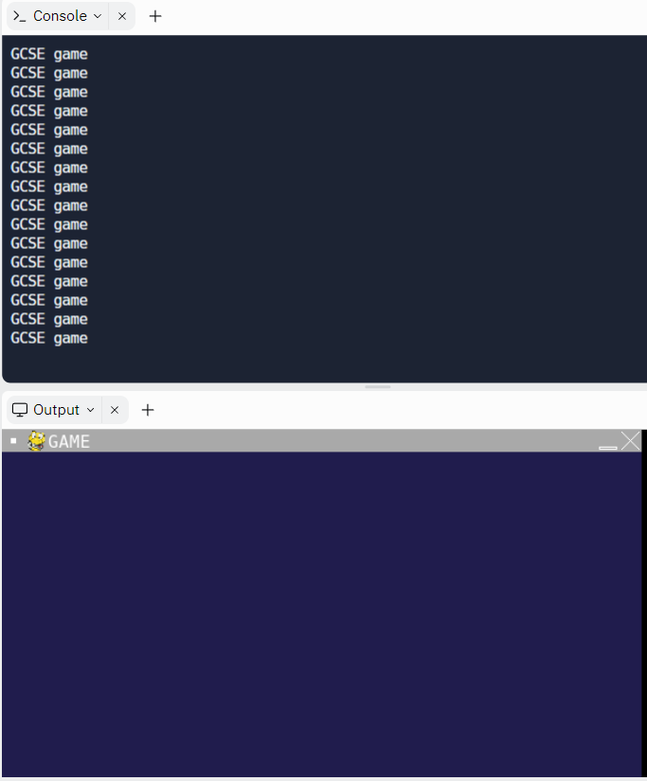

A-Level button testing:

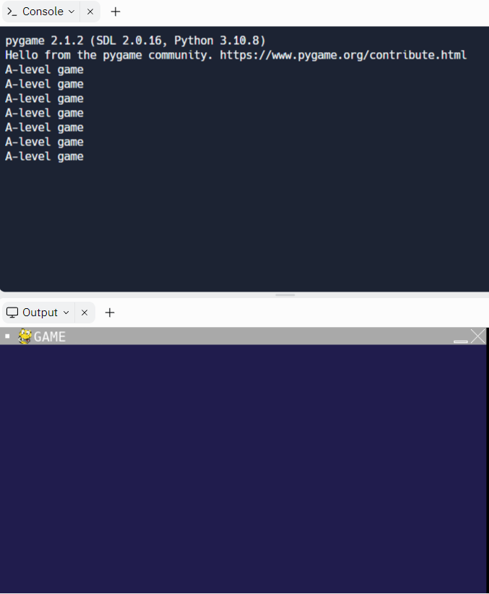

The two game modes are set with only having to load a save file being left to add to the start game menu screen though that will be done once the save function is implemented. This concludes this section of the code.

### Section review:

I have added the ability to access the two different game modes of the game.

Other than additions of some variables no other changes have been made to the rest of the game

## Section 6: Actual game audio

### Iteration 1:

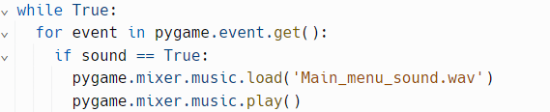

When sound is true the audio for the main menu will play. This is needed to put the player into the game in a sense.

[Testing for the audio](http://drive.google.com/file/d/1Jt91LYYFdGJZV5afiiyDi4C514RwJcey/view)

The issue with the audio is that due to the while loop the audio also loops as seen in the testing video. One potential solution to the problem is to make a variable which restricts when the sound can play along with having the loop timer for the function be -1 playing the song for an unlimited duration.

### Iteration 2:

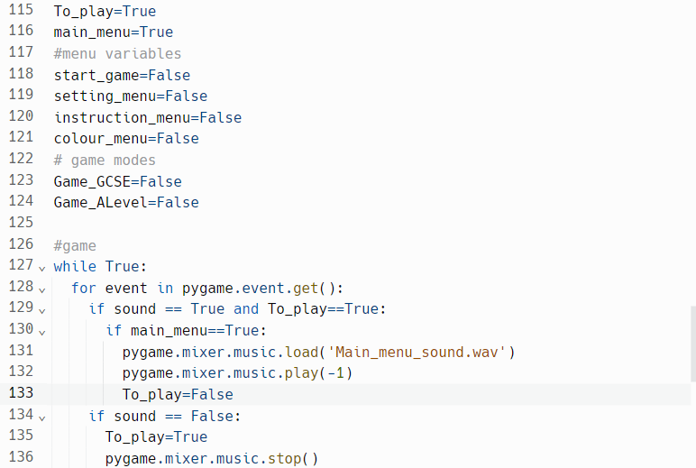

The code now properly plays the audio when the enable audio button is pressed and stops when the disable audio button is pressed whilst allowing the user to change it whenever they want.

[Audio iteration 2 test](https://drive.google.com/file/d/1WGk3133wXPKxCDIc6834dOwi8E_B70nd/view)

The audio of the game now works as intended and now can include more sounds for the different areas of the game.

### Section review:

I have added audio to the game so that it properly works without any unnecessary looping.

Apart from the changes listed above and some minor variable changes occurring with the enable and disable audio buttons nothing else has changed.

## Section 7: Introductory text

### Iteration 1:

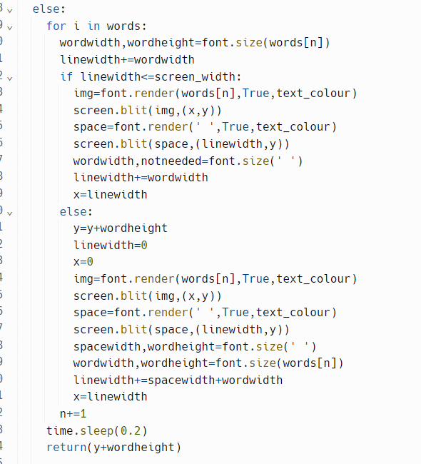

The code attempts to create a scrolling effect to the text in order to simulate as if a person is writing to the player. Why this is used instead of no scrolling text is because it animates the text and so keeps the player drawed in and more entertained than if a block of text just appeared.

[Intro text test 1](https://drive.google.com/file/d/1vRkyiT_hYBRYWzC79G_cCKwfm8KvUzgT/view)

An error as of now is that all that happens is a delay when the text is being set up and then just outputting the screen the same way as if the text was done like with the instructions and commands menu.

### Iteration 2:

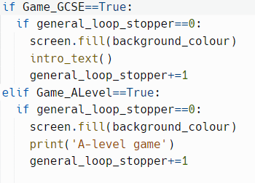

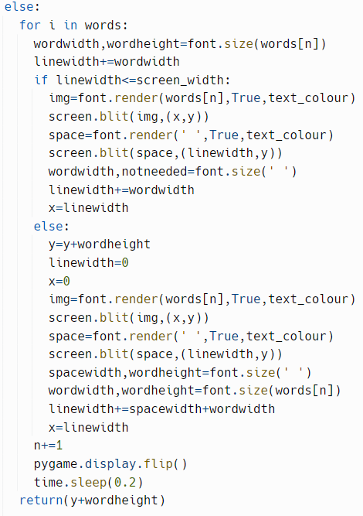

The code now properly outputs one word after the other while showing that process.

[Intro text test 2](https://drive.google.com/file/d/1F6kBiHk9xugVAcWc_YMk2dHwe-RIfWwA/view)

The only error left to correct is that it outputs words and not characters which is not what scrolling text looks like.

This can be fixed so that when the words are being checked for length on the screen if it is all good and then splits the current word into characters which then get outputted one after the other.

### Iteration 3:

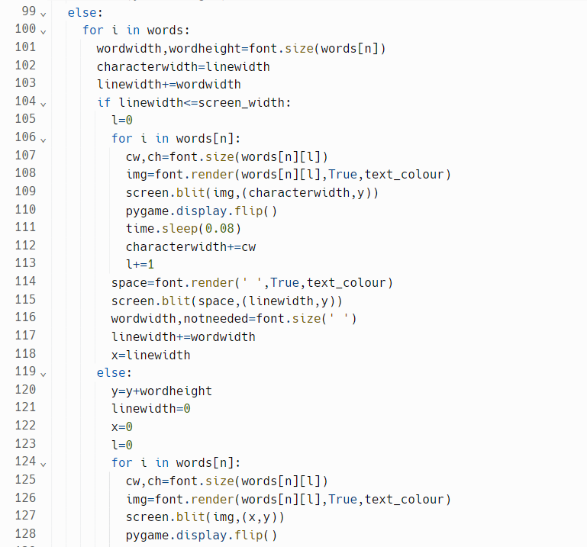

The code now does the scrolling animation as intended.

[Intro text test 3](https://drive.google.com/file/d/1h2HOuZPn1ay8r30RspXHyCihxj50BTwi/view)

The introductory text is outputted as is needed but now all that is left is to finish the introductory text and then allow the player to enter the game.

### Iteration 4:

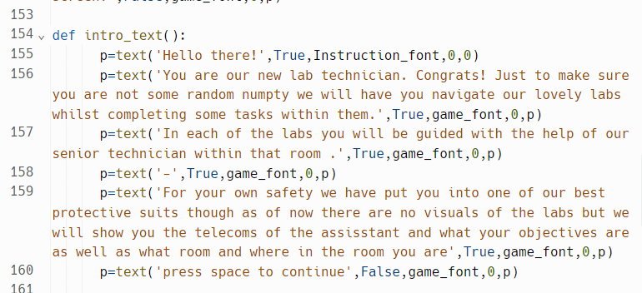

The code now outputs the introductory text and allows the user to leave the screen once done reading.

[Intro text 4](https://drive.google.com/file/d/1Rn3MZmVXSPAbk5bsh_ZTfCjdvdLkl9Qf/view)

The code now works as intended without fault.

### Section review:

I have successfully implemented the introductory text and with that the ability to have a typewriter effect on text though there are improvements that can be made which will be done when the rest of the game is finished.

In terms of changes that have been made to the rest of the code aside from a few small changes to certain variables no substantial changes have occurred to the rest of the game.

## Section 8: The game screen

### Iteration 1:





The code both sets up the progress screen which will output the progress the player has made. This is needed so that the player is in track of the progress they have made within the game as a whole.

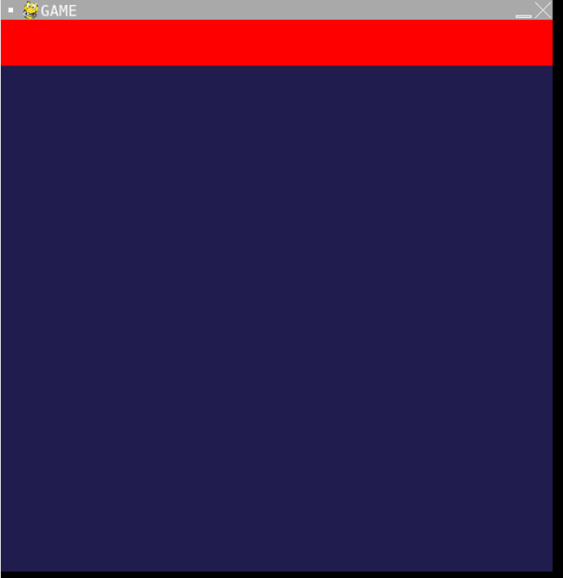

The issue as of now is that the rest of the sections have not been added and there are also no borders between the sections either. The solution to this is making the different sections and then making a function to draw borders on all the items.

### Iteration 2:

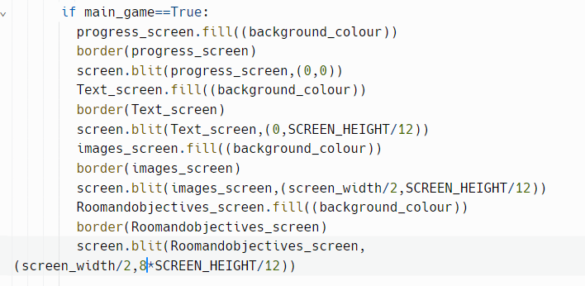

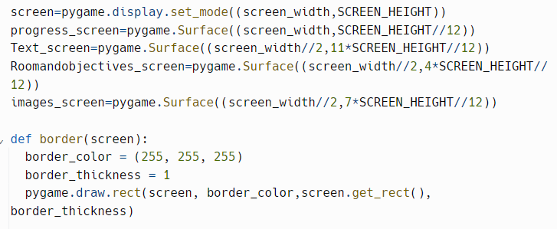

The code now outputs all the different screens and draws borders around them to distinguish between all the different sections.

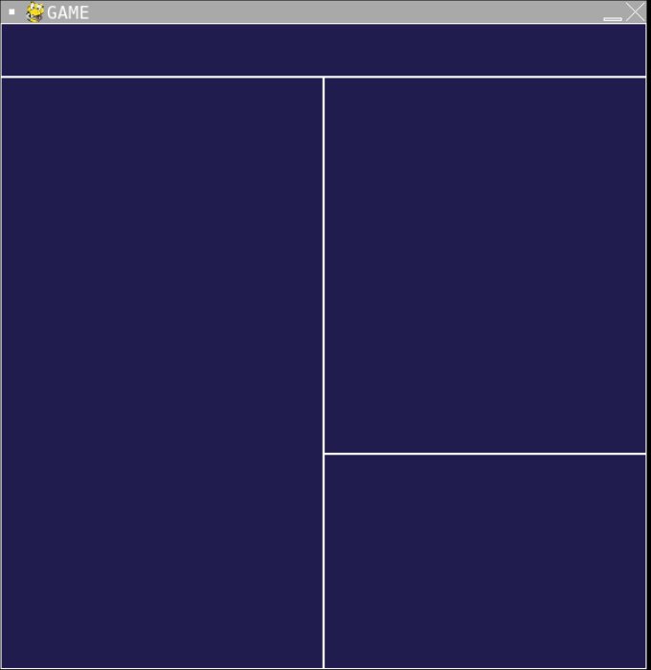

An error is that when trying to output to the text screen nothing occurs. This could be fixed by first making the colour of each of the sections be established before the loop.

### Iteration 3:

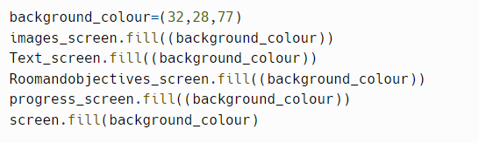

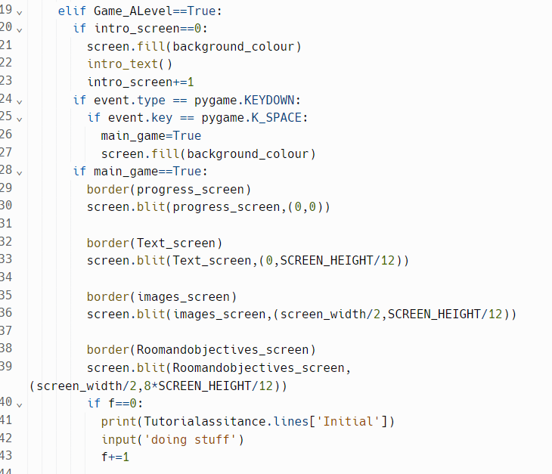

The code will now output to the screen that was mentioned.

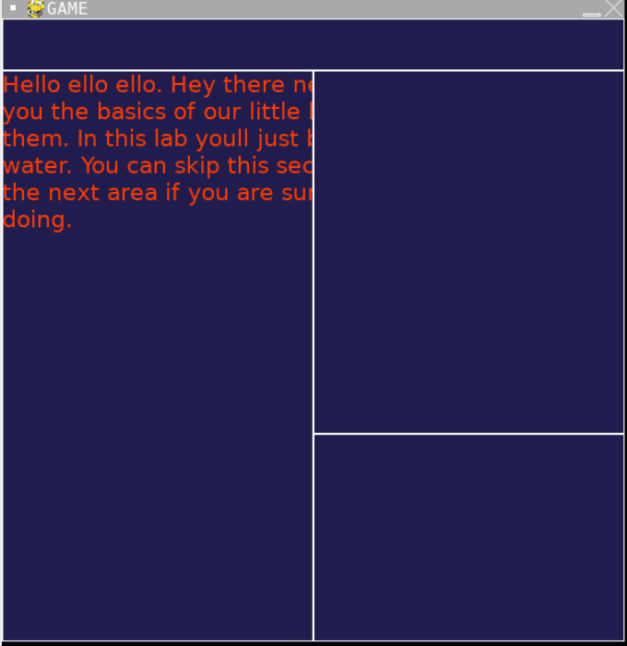

The issue as of now is that the text does not wrap around the text screen. This is fixed by changing a variable in the text function.

### Iteration 4:



The code now properly wraps the text around the text screen as intended so that the player can actually see the text.

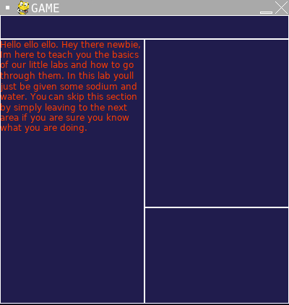

The full functions of the game screen now work as intended.

### Section review:

I have successfully added the game screen to the game.

Outside of changes shown in the screenshots I have not done significant changes elsewhere.

## Section 9: Teachers

### Iteration 1:

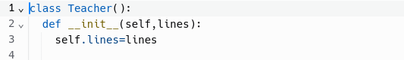

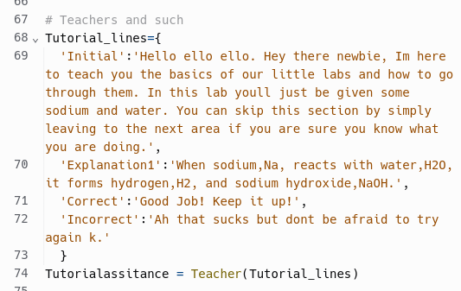

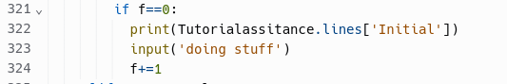

The code both makes a new class called teacher and sets up the class with a dictionary called lines. Then an instance of the class is generated for the tutorial area.

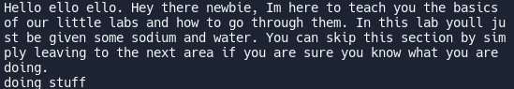

The code is able to output the required line when needed however this is not on one of the screens and only one of the teachers has been made. One way to fix the issue is to make the rest of the teachers alongside all the lines they would have.

### Iteration 2:

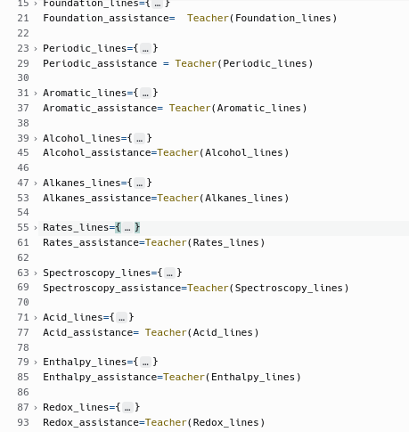

The code now contains the basis for all the A-level teachers with them all having an initial piece of dialogue, a first explanation and a thing that is said if the player got a question correct or incorrect.

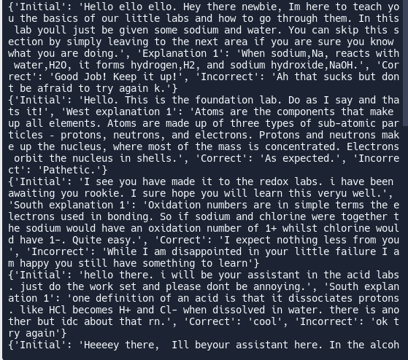

The testing shows that all the lines can be outputted like a dictionary allowing for them to be displayed to the player. Whilst the lines are not yet fully finished the main frame for them to work has been implemented and so they will be finished once other parts of the main game have been completed.

### Section review:

I have successfully added the teachers to the code.

Outside of changes shown nothing has been added or changed.

## Section 10: The area class

### Iteration 1:

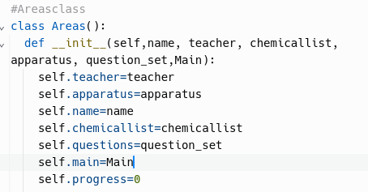

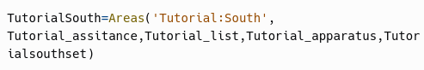

The class for the area has been made to have all of the attributes.

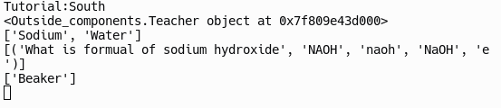

This shows the class is able to initialise properly.What is left to code is the are movement through areas and interactions whilst also outputting the necessary information to the text screen.

### Iteration 2:

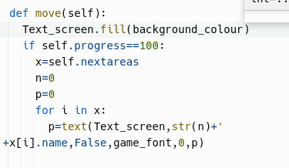

The code attempts to output the needed information to move to a different room.

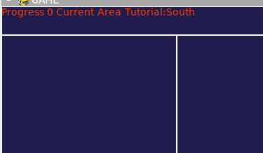

As seen it only removes the previous text until the w key is not pressed where the previous text returns immediately. One way this could be fixed is by adding a boolean variable.

### Iteration 3:



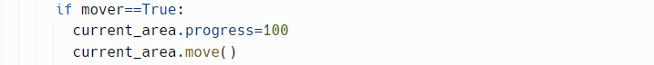

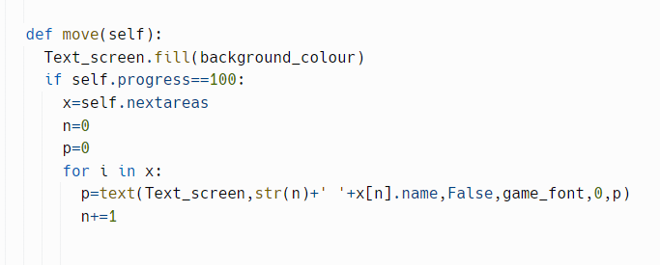

The code now properly outputs what is in the next areas list.

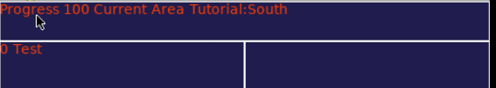

The issue now is that the current area is not ever changed. This can be fixed by both looking at the player input and then changing the room to whatever is chosen.

### Iteration 4:

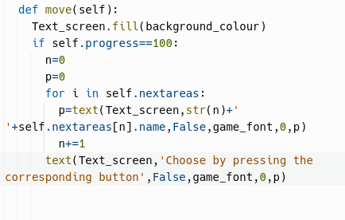

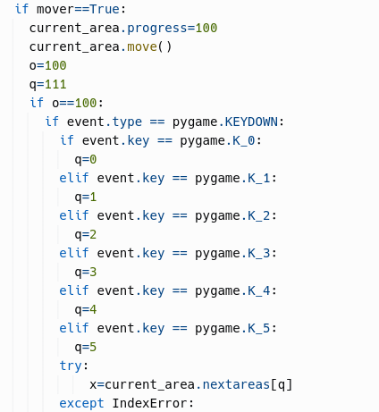

The code now is able to do a move to a different area.

before:

after:

The only issue that occurs now with this is that if there are no next areas to go to then there is no way to exit. This also stands for the moving part as well as if the player accidentally pressed w then they have to move. This could be fixed by adding a way out.

### Iteration 5:

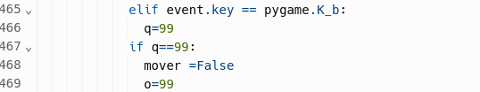

The code now works as intended.

<https://drive.google.com/file/d/1po7delkUPC8hqCseF49rnKqyRWLE6wkn/view>

The area class and movement now work as needed.

### Section review:

I have successfully completed the area class and move method.

I have also added the MCQ puzzle type as a function and I have also added temporary apparatus and chemical lists.

## Section 11:The MCQ puzzle

### Iteration 1:

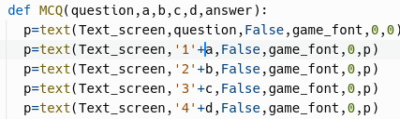



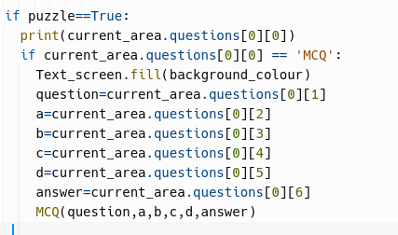

The code for the multiple choice question now outputs all of the options.

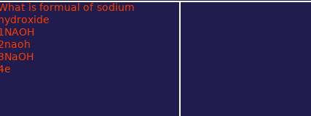

The issue as of now is that there is no ability to even attempt to answer the question.

### Iteration 2:

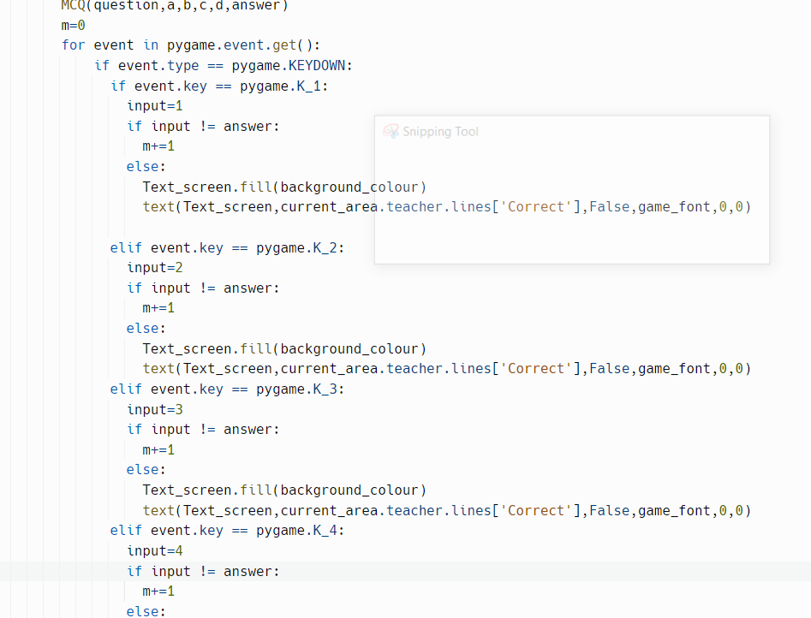

The code attempts to now get an input from the player.

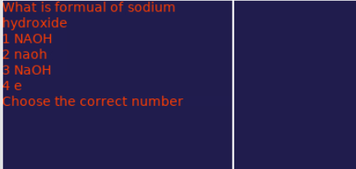

The error that is occurring is that there is no response to the input given by the player. This can be fixed by adding in a variable that looks if the buttons have been pressed and from there looking at what the input is.

### Iteration 4:

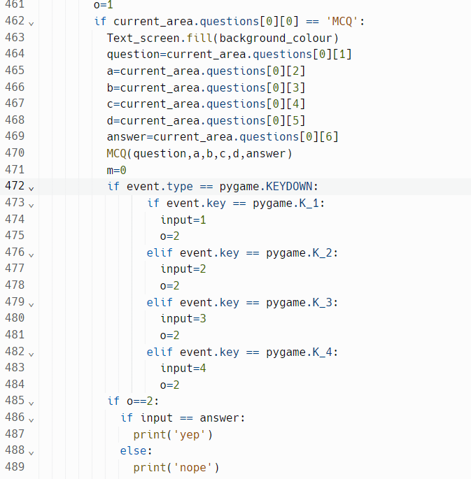

The code now accepts the inputs and outputs a yep or a nope depending on if the correct answer was inputted.

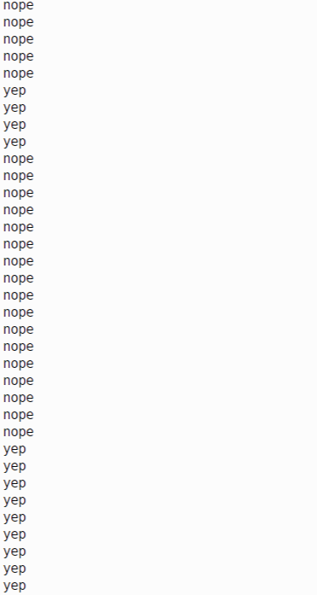

Both of the inputs work as needed. All that remains is having there be a way to try three different times before the player can no longer try again and having the correct text being outputted depending on if the player got the question correct or not.

### Iteration 5:

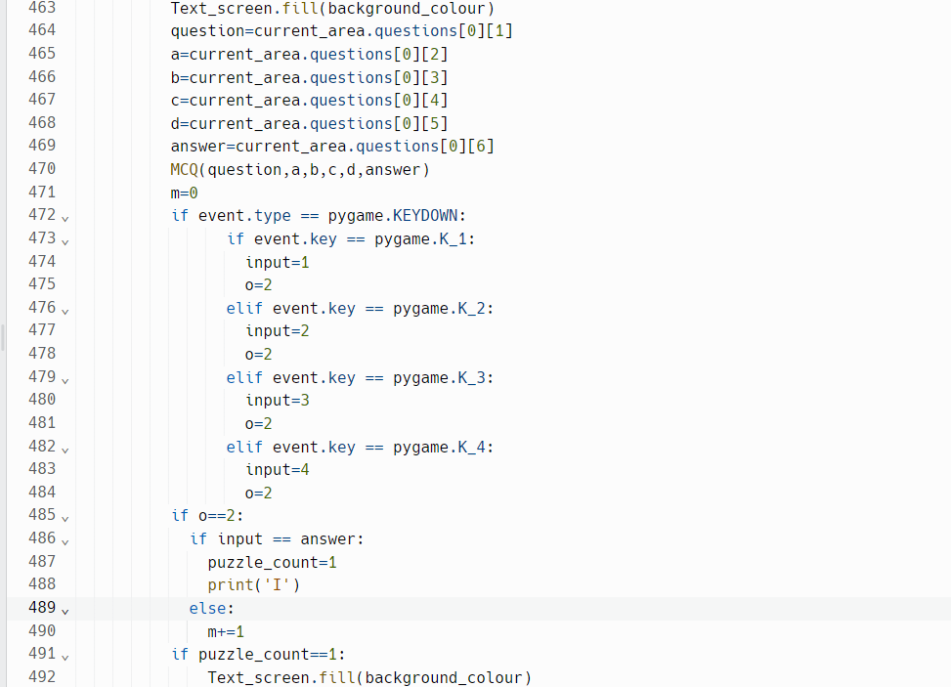

The code now outputs if the player has gotten the question correct.

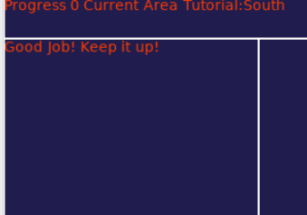

The only issue that remains is the three go part and outputting if the player got it wrong.

### Iteration 6:

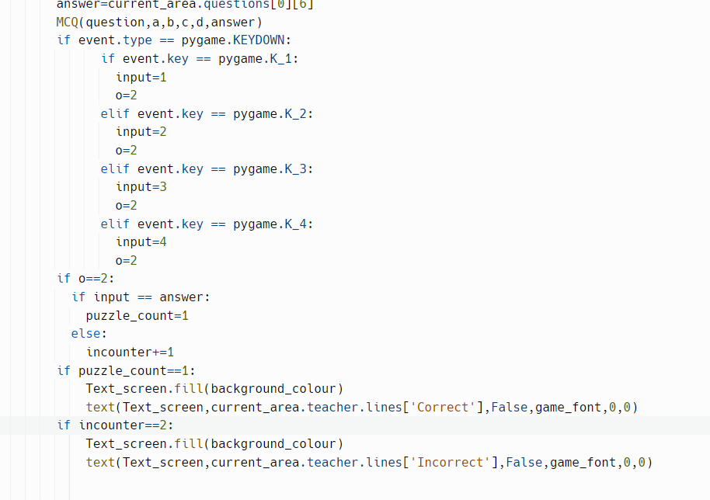

The code now gives the player three tries until it is shown that they have failed the MCQ.

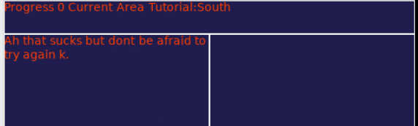

The only issue now is that the player needs to leave the screen and that is not yet possible. This is fixed by adding a way to go back from that screen using a button.

### Iteration 7:

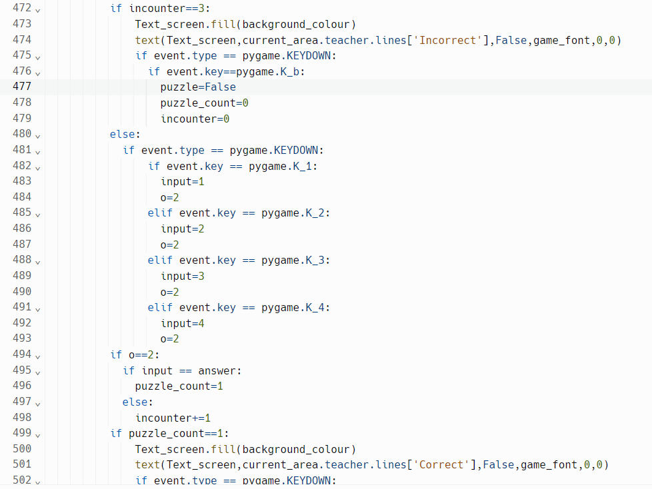

The MCQ now works as it is intended to work.

[MCQ Test](https://drive.google.com/file/d/1lbrfPG6vl8JtNXw8iGwtUpC9PYozHf5U/view)

The MCQ now works as intended

### Section review:

I have successfully added the MCQ puzzle to the game.

No other major changes have occurred.

## Section 11: Practical puzzle

### Iteration 1:

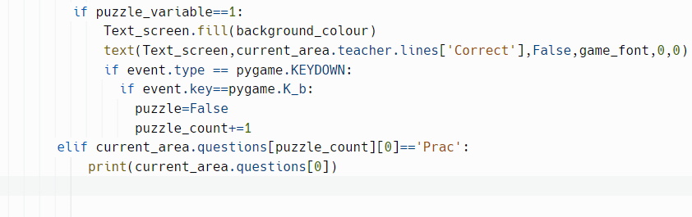

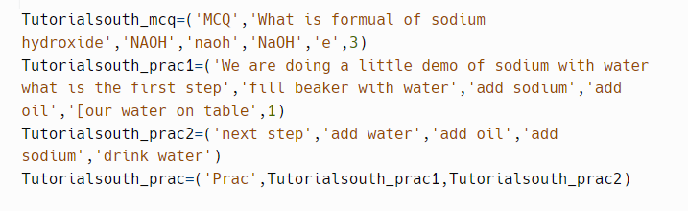

The code now outputs to the console to check if the logic of switching to a different puzzle which in this case is the practical question.

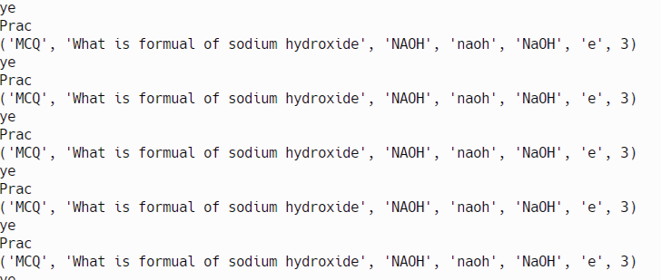

The code is now ready to have the practical puzzle made.

### Iteration 2:

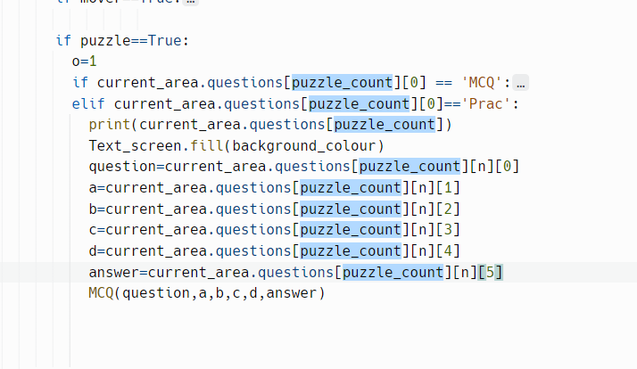

The code now outputs the first step’s MCQ.

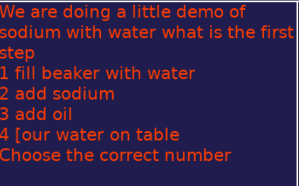

The issue that remains is to have the rest of the MCQ to work and for the different steps to be played one after the other.

### Iteration 3:

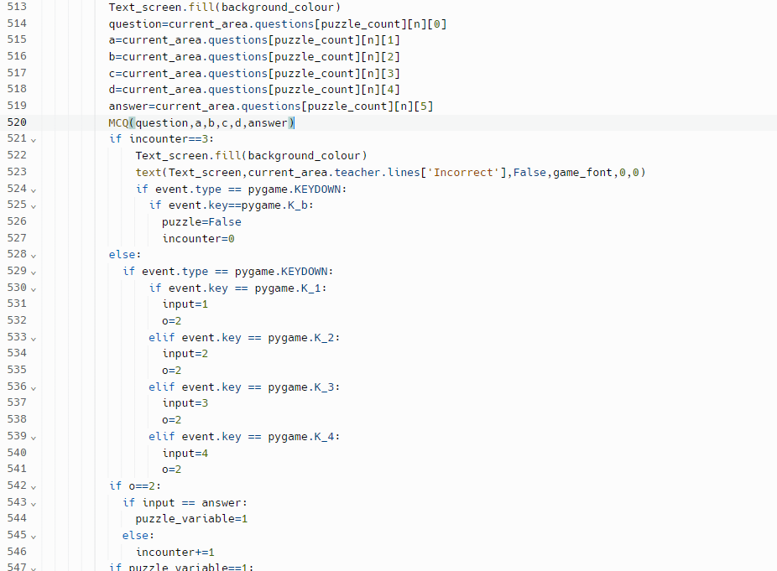

The code now allows inputs from the player in order to do the multi step MCQ.

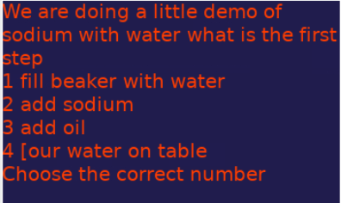

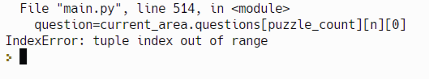

The error as seen in the second image is that when the answer given is correct and n is incremented by 1 the tuple index is now out of range. This can be fixed by making it so that the variable used to increment n is 1 to then make it 0 so as to not increment n again.

### Iteration 4:

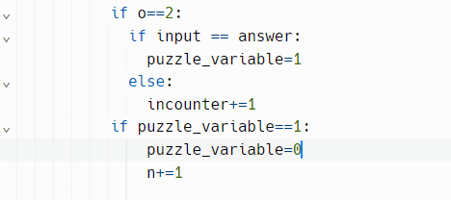

The code now moves to the next step.

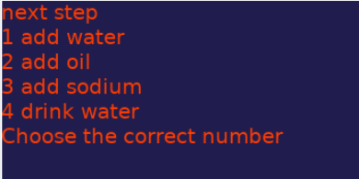

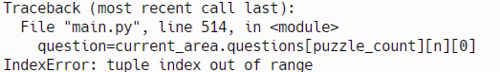

The errors that are now present is that when the full practical is complete n is still incremented and the practical part does not change. This can be fixed by adding a check within the puzzle variable to see if n is greater or equal to the length of the main practical tuple.

### Iteration 5:

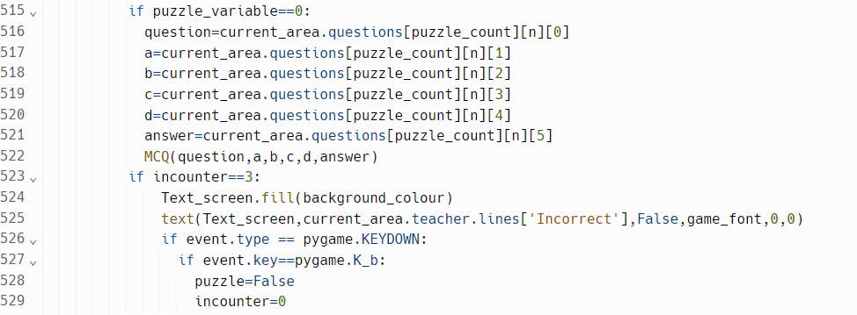

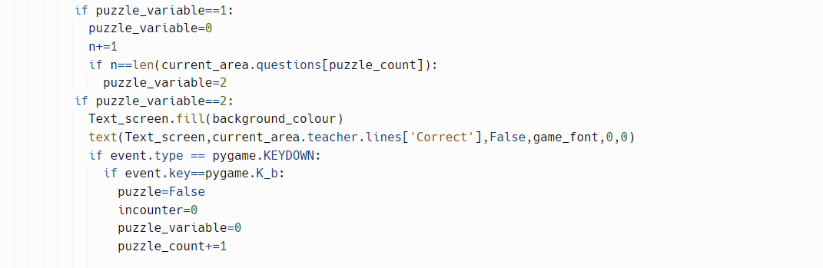

The practical puzzle is now implemented fully.

1st step:

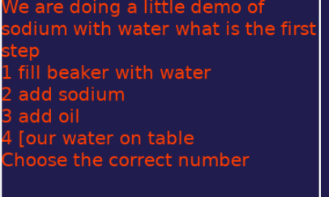

Step 2:

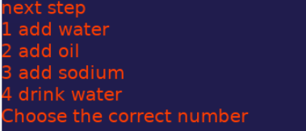

Step 3:

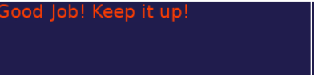

The practical puzzle is now complete and functioning as needed.

### Section review:

I have successfully added the practical puzzle to the game.

Many other changes have also occurred such as changing the puzzle_count variable from a variable that just is used for checking to being what is used to output the correct puzzle meaning another variable was made called puzzle_variable which checks for different game states.

## Section 12: Fill in the blanks puzzle

### Iteration 1:



The code is now prepared to accept the fill in the blanks question.

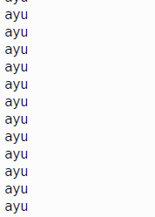

As seen in the code when the third question is done and it reaches the fill in the blanks question it prints out ayu. What is left is to implement the puzzle.

### Iteration 2:

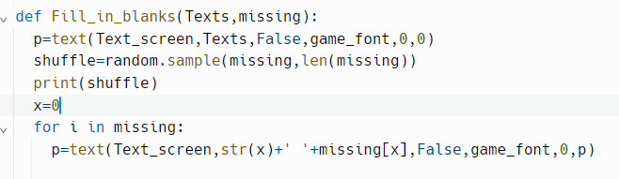

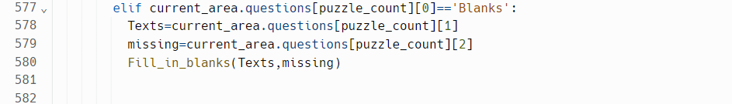

The code now outputs the text and what is going to fill in the blanks.

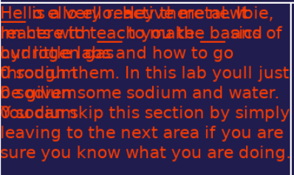

The issue that is happening is that the previous text is not being removed first leading to what is seen in the image. This can be fixed by first having the background be filled and then outputting the text as normal.

### Iteration 3:

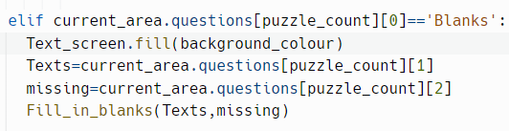

The text now shows properly.

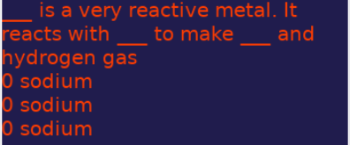

The issue now is that only the first item of the list is shown repeated thrice. This can be fixed by solving the issue in the Fill in the blanks procedure. This can be solved by adding an x+=1 in the loop.

### Iteration 4:

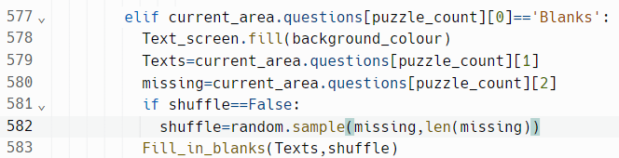

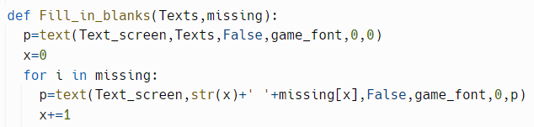

The text is now outputting correctly and also randomly.

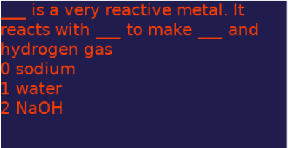

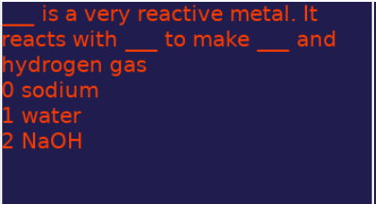

The only issue that remains to be solved is to allow the player to actually solve the puzzle. This is done by looking for key presses associated with each number shown.

### Iteration 5:

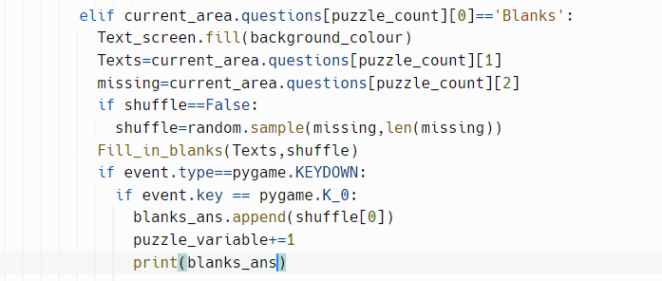

The code accepts the input of the 0 key and prints the answer of the player.

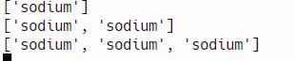

Right now the only issues are that the other keys need to work and validation has to be added in case the player tries to use a key that does not work like 4. This is done by adding validation and the rest of the keys.

### Iteration 6:

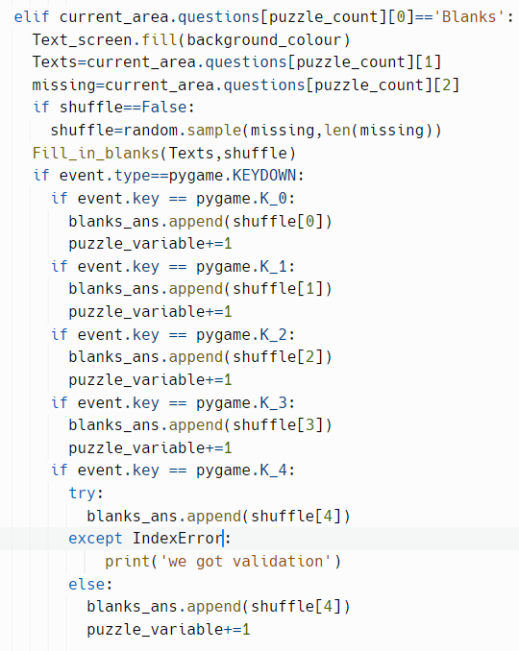

The code now validates past the 4 key.

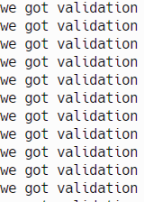

The only thing remaining is the rest of the keys and checking the answer to the missing list.

### Iteration 7:

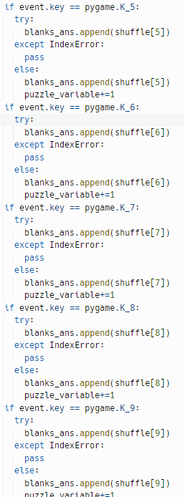.

All the key inputs work as intended now.



All that remains to add is checking the answer.

### Iteration 8:

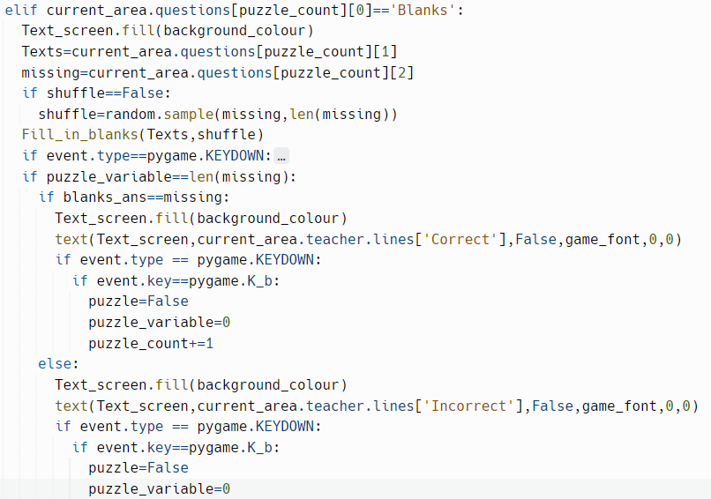

The code now fully works as intended.

Correct: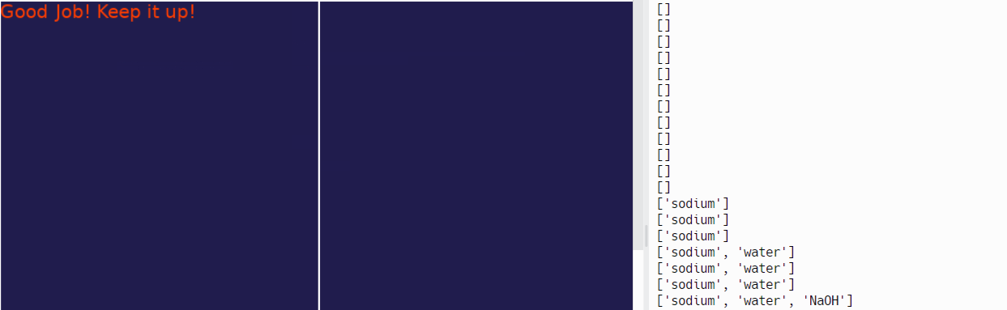

Incorrect:

There are no errors in need of fixing.

### Section review:

I have successfully implemented the fill in the blanks puzzle.

There have been no other changes other than added variables specific to the fill in the blanks puzzle.

## Section 13: Create the correct element puzzle

### Iteration 1:

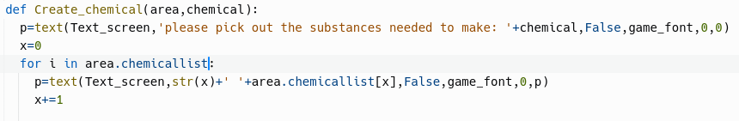

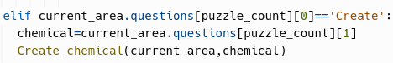

The code now outputs the list of chemicals within the area.

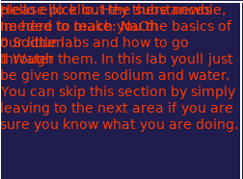

The issue is that the lines overlap one another which is a problem as the player cannot read the instructions then. This can be fixed by removing the previous text by filling in the screen.

### Iteration 2:

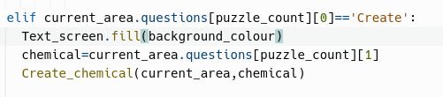

The code now shows the list without any overlapping text.

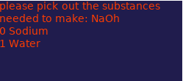

The issue now is to add in a way to answer the question.

### Iteration 3:

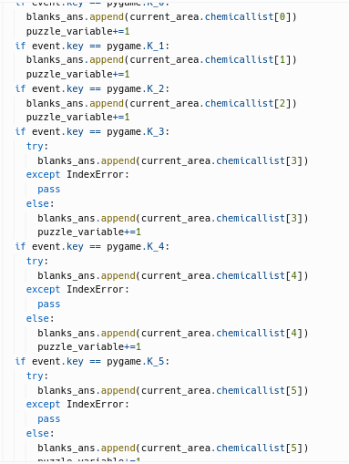

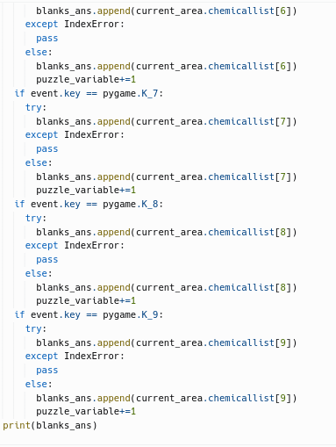

The code now accepts the player’s inputs and outputs them to the console.

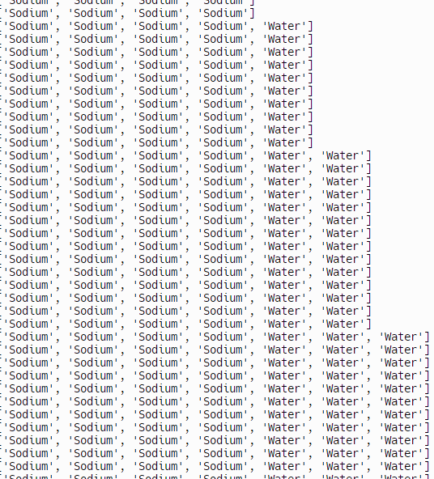

The issue that remains is checking that the answer is correct. This is done by combining all elements of the list into one string.

### Iteration 4:

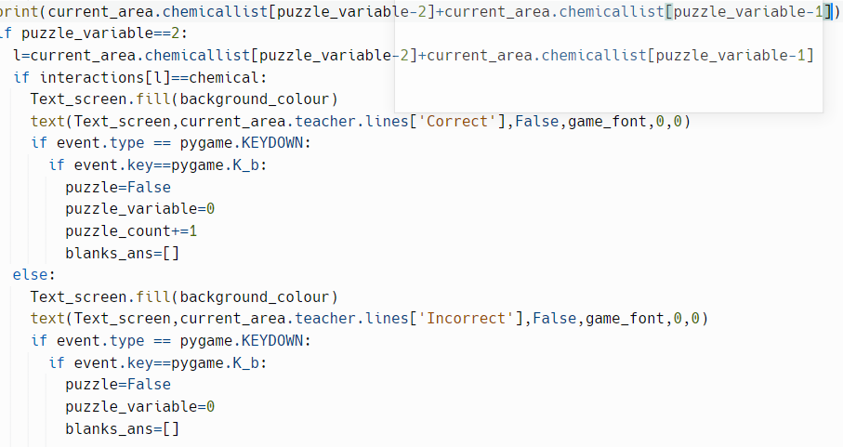

The code now checks if the player inputs the correct order of chemicals.

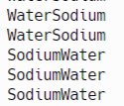

The issue is that the answer from the player switches for some reason. This can be fixed by changing the current area to blanks_ans.

### Iteration 5:

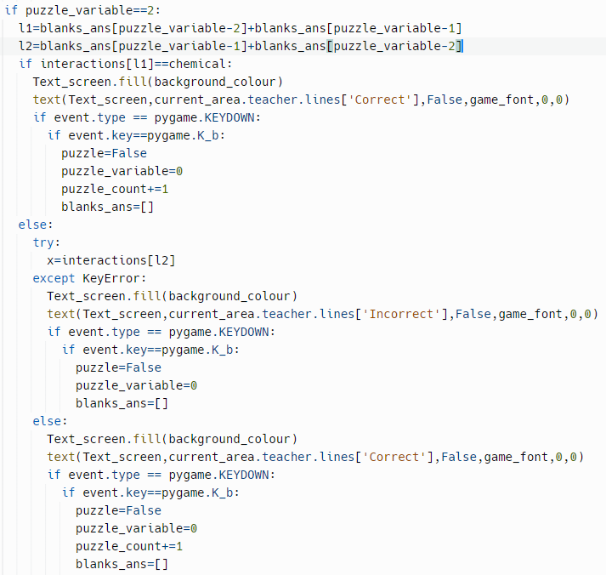

The code now allows correct answers to be processed.

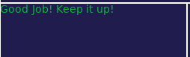

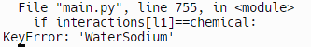

When inputted in one way the second screen is shown but if inputted the other way a key error is given. This can be fixed by first putting a try else thing.

### Iteration 6:

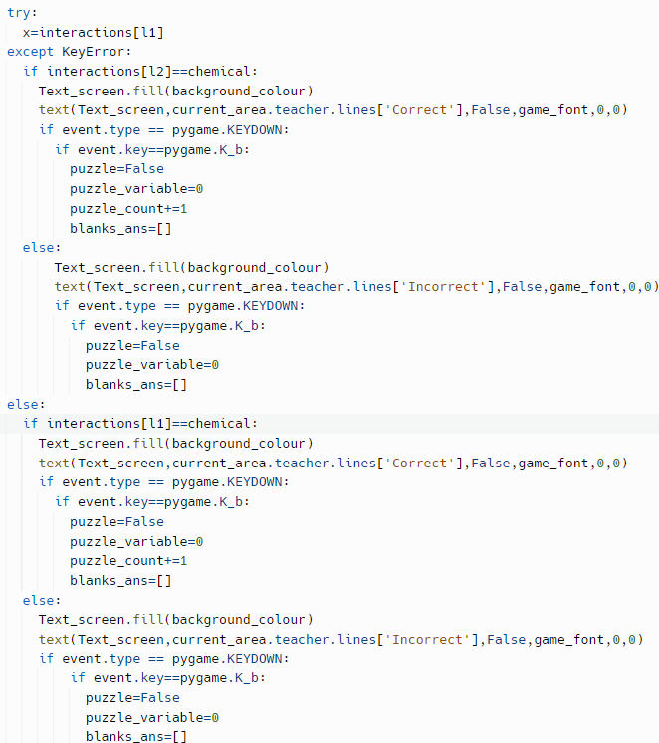

The code now works as is intended.



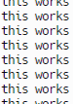

The create chemical puzzle works as intended.

### Section review:

I have successfully added the create chemical puzzle and added the beginning of the interactions dictionary.

Other than that no other changes have been made.

## Section 14: Timer

### Iteration 1:



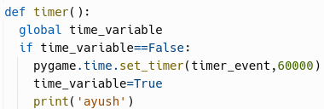

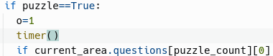

The code should now try to set a timer for 1 minute.

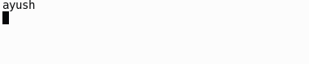

The code outputs ayush as intended. The only thing remaining is to add a way to check if the player has failed the timer.

### Iteration 2:

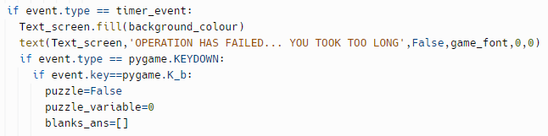

The code now checks if the 60 seconds have passed and outputs the text.

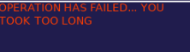

The issue with the code is that the screen shown is only temporarily there which is an issue as the player can just wait it out to get the correct answer. It can be fixed by adding an extra variable to force only that screen to show.

### Iteration 3:

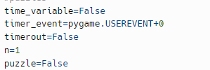

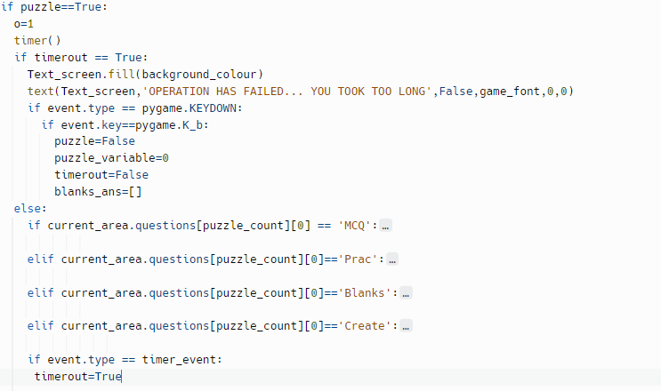

The code now works as intended.

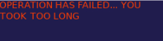

There are no more issues with the code.

### Section review:

I have successfully implemented a timer into the game. There have also been no changes to anything else in the meantime.

## Section 15: The help command

### Iteration 1:

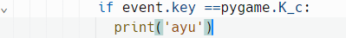

The code outputs ayu when the c key is pressed.

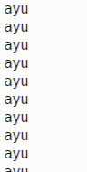

The issue as of now is the lack of functionality that the key has which is fixed by adding that functionality to it.

### Iteration 2:

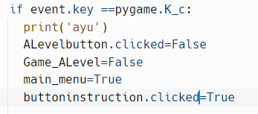

The code should now turn off the A Level section of the game.

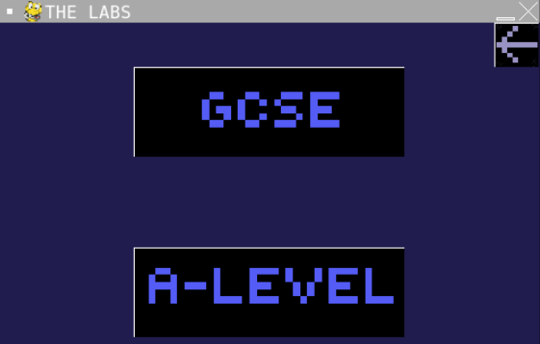

When c is pressed it returns the player to this screen. This is not ideal as the player should be returned to the instruction menu. This may be fixed by changing a different variable affecting this.

### Iteration 3:

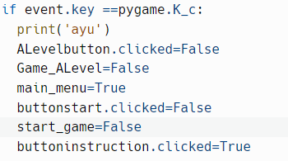

The code now successfully returns the player to the instruction menu.

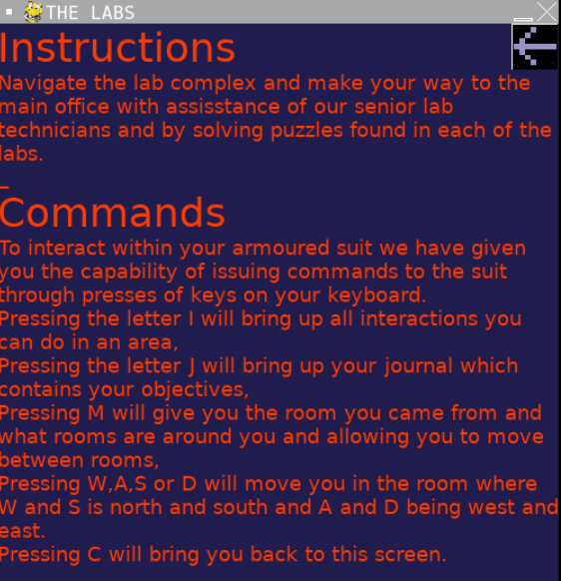

The code returns the player to the instruction menu but when the back button is pressed the player is returned to the main menu but not the main game. A way this may be fixed is adding a previous variable which could store variables and change them to be true or false depending on the situations.

### Iteration 4:

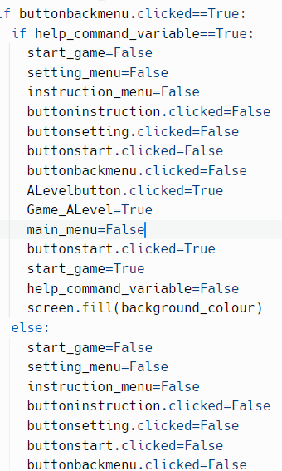

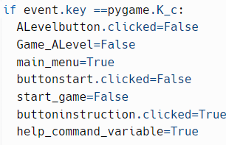

The help command now works as intended.

[Help command test](https://drive.google.com/file/d/1UBG2ILX4OsbM-ZGfUU9T5THfO2uWkHC6/view)

There are no more issues to solve.

### Section review:

I have successfully added the help command. No other changes have been made to the rest of the programme.

## Section 16: Molecule map/Journal

### Iteration 1:

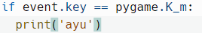

The code prepares the molecule map to be used.

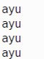

The issues that remain is to have the actual information for each thing and then output them.

### Iteration 2:

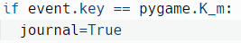

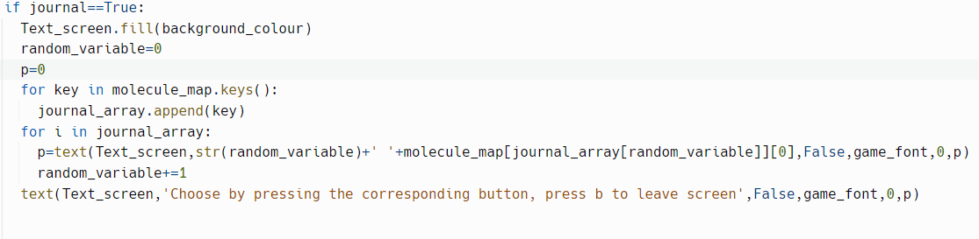

The code should output the description for all items in the dictionary.

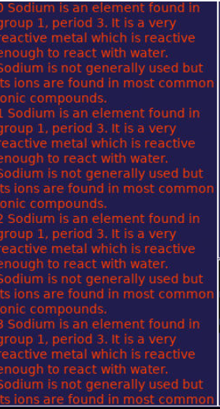

The issues are that multiple of the description is printed and that the player cannot choose anything. This can be fixed by moving the output into a procedure and then adding a variable that outputs the name of the object.

### Iteration 3:

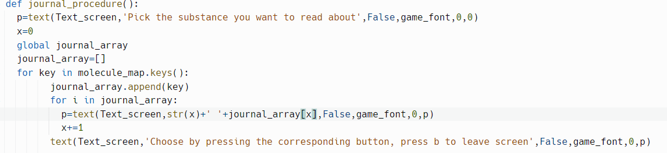

The code now outputs all necessary information.

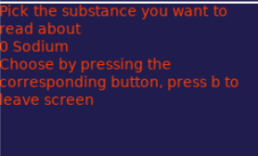

The issue now is to add functionality to the keys.

### Iteration 4:

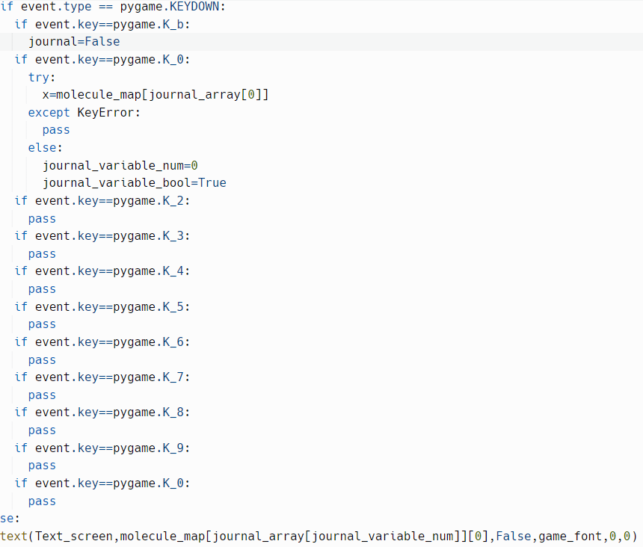

The code now outputs the sodium description when the 0 key is pressed.

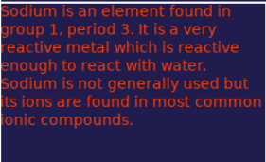

The only issues remaining are to add the image to the image screen. This can be done by drawing it to the image screen.

### Iteration 5:



The code now outputs the image associated with the chemical.

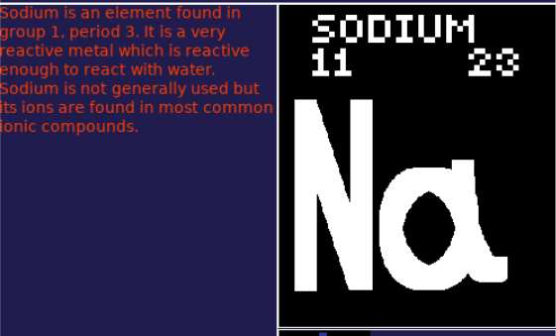

The only issue as of now is that if there are more than 9 substances the player would not be able to look at them all given the maximum number of items on the screen at a time is 10. This may be fixed by adding a way to move to another list.

### Iteration 6:

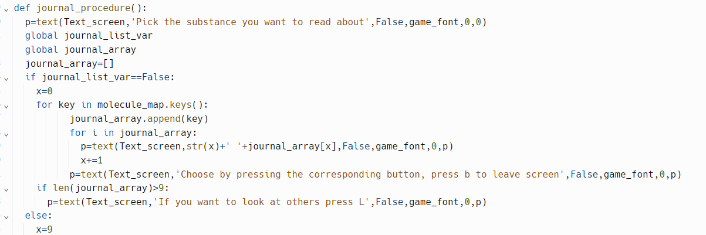

The code now works as intended.



The only issue remaining is to allow the player to go back to the main screen.

### Iteration 7:

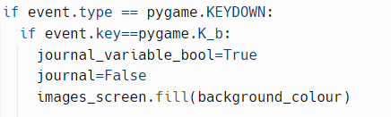

The code now works as intended.

[Molecule map journal test](https://drive.google.com/file/d/1juEbx7a_68G2RkQ_kwJ8zVSM8gCrK8Rq/view)

All that remains is to allow the player to move between sets of 10 elements.

### Iteration 8:

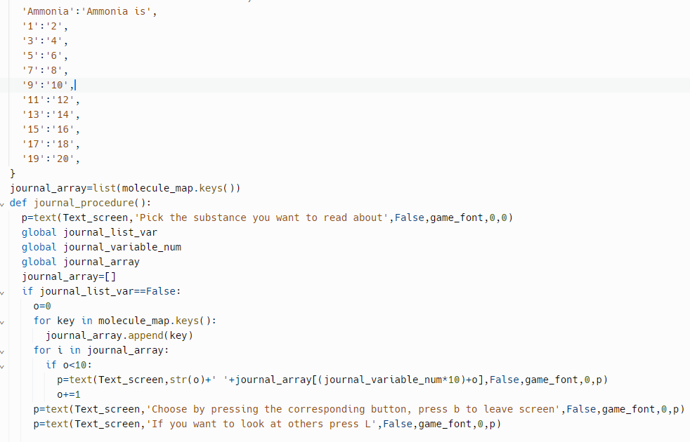

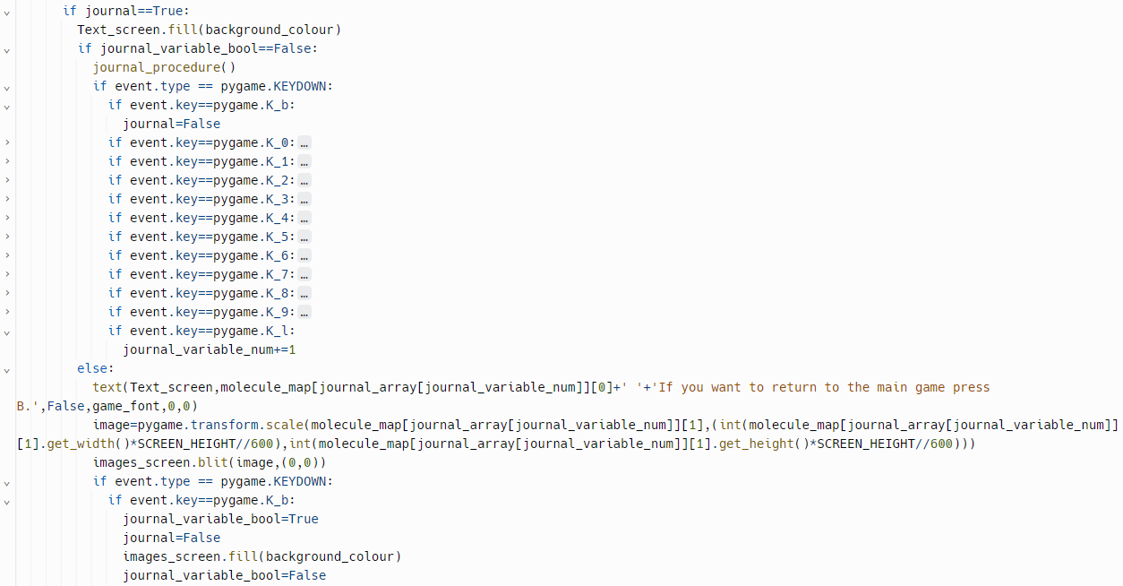

The code now allows movement to the next 10 elements.

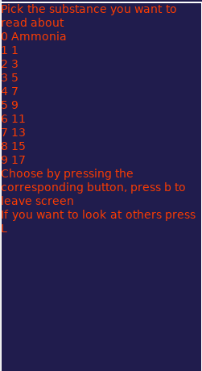

The issue is that an error occurs without the numbers shown.

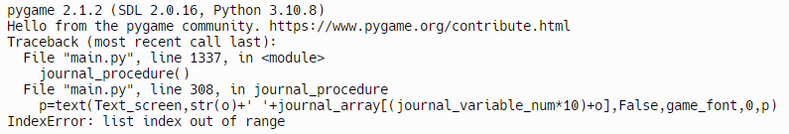

This could be fixed by adding a limit to how far the loop can go.

### Iteration 9:

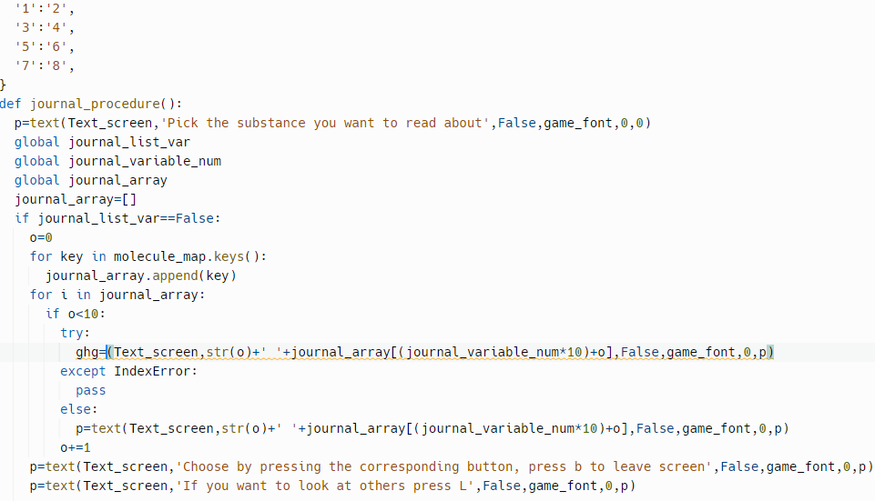

The code now allows for movement forward.

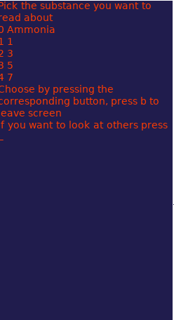

The only issues that remain are adding the rest of the elements and allowing for movement backwards.

### Iteration 10:

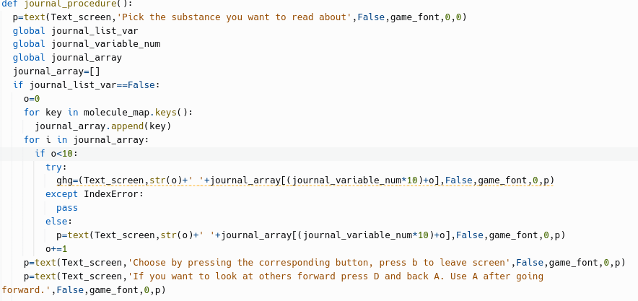

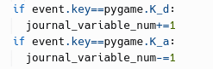

The code now allows for movement back and forth.

[Journal testing](https://drive.google.com/file/d/1CRJJxsHjJ4Lj29r4NGSlI8g7FqhfYzte/view?usp=drive_open)

The Journal now works as is intended.

### Section review:

I have successfully implemented a version of the molecule map/ journal. There have been no other changes other than ones shown.

## Section 17: Save feature

### Iteration 1:

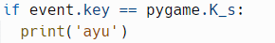

The code outputs ayu when s is pressed.

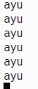

The issues as of now is that there is no saving of any variable and there is no file to save to.

### Iteration 2:



The code now stores the current area’s name and the current area's progress.

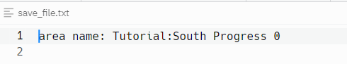

The issue that remains is to add all the remaining variables that need to be stored.

### Iteration 3:

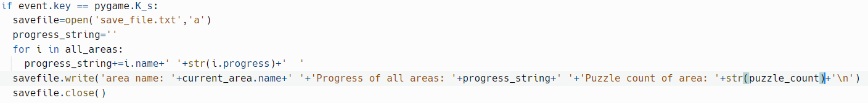

The code for saving to a file now works as fully intended.



The only issue that remains is that the last time saved is not shown.

### Iteration 4:

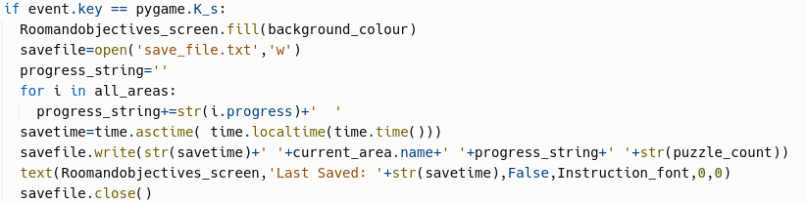

The code now outputs the last time the game was saved.

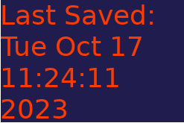

The only issue is that if the program closes the last time the game was saved is not shown.



This can be fixed by having a function check if the save file has a time bit and if so to display it.

### Iteration 5:

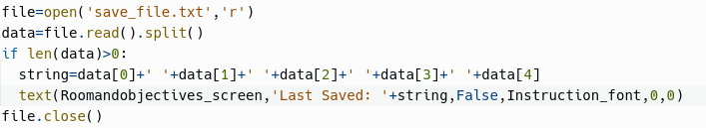

The code now works as intended.

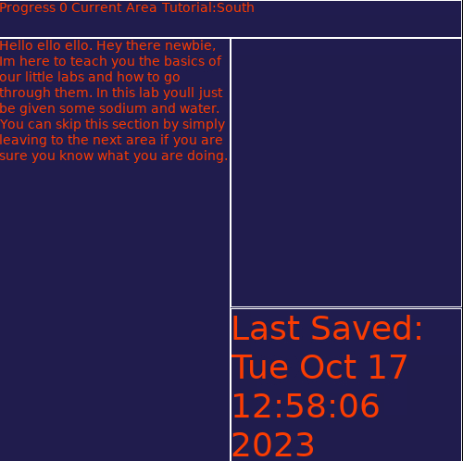

### Section review:

I have added a method for the player to save the game. In terms of other changes I have removed the potential save button as too many complications arose from using it.

## Section 18: Load feature

### Iteration 1:

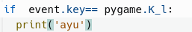

The code now outputs something if the l key is pressed.

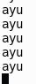

The issue with the code is the lack of functionality.

### Iteration 2:

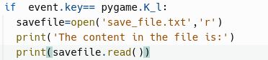

The code outputs the current data in the file.

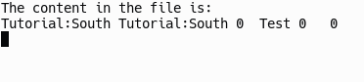

The code now needs to change the variables that have been stored in the file.

### Iteration 3:

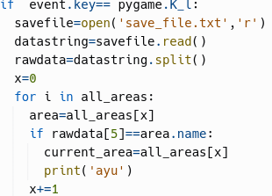

The code outputs ayu if the current area changes to what the previous current area was.

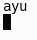

The only issue is to make all the areas have the correct progress.

### Iteration 4:

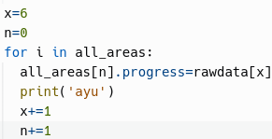

The code outputs ayu when the progress of all areas is set.

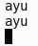

The issue now is that the puzzle count is not changed.

### Iteration 5:

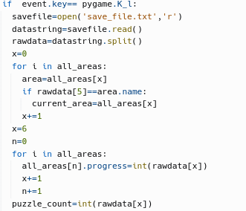

The code now works as intended.

[Loading test](https://drive.google.com/file/d/1TGMVW72_hxqFRceZ0kNq8O6sq6uu7r-F/view)

### Section review:

I have added the loading feature to the game. No other changes have been made to the program aside from changing the saving function so that it overwrites the whole file rather than appending to the file.

## Section 19: Settings menu from main game

### Iteration 1:

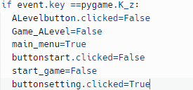

The game will bring the player to the settings menu once the player presses the z key.

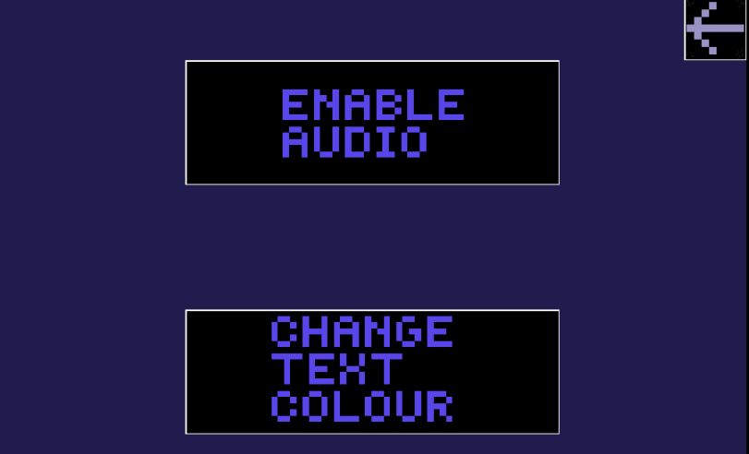

The issue as of now is that when the player presses the back button it sends the player to the main menu instead of the main game. This can be fixed by using a variable to see if the player has entered the menu by using the menu button or the Z key from the main game.

### Iteration 2:

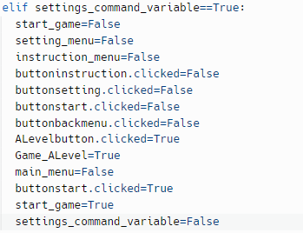

The code now works as intended.

[Settings key test](https://drive.google.com/file/d/1uudfr646vkbGvBuI344lv9WWNLy9OfcF/view)

### Section review:

I have added the ability for the player to go to the settings and change them whilst they are within the game. Aside from changes shown no other major changes have been made.

## Section 20: The GCSE side of things

### Iteration 1:

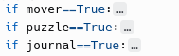

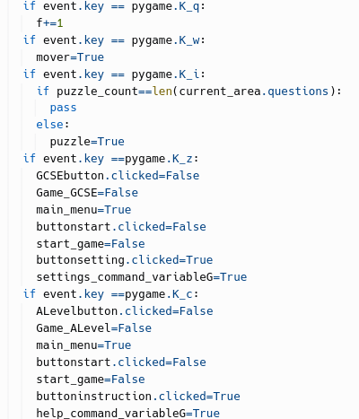

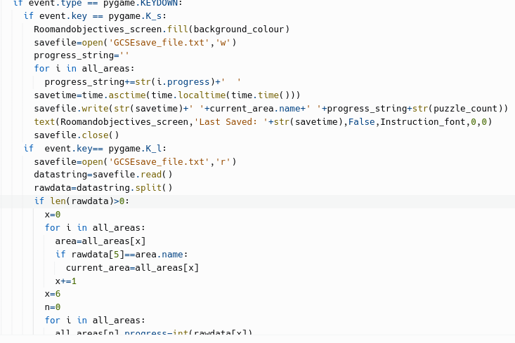

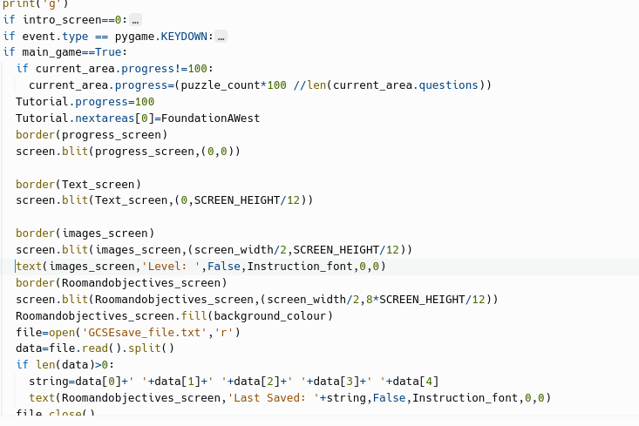

The code above includes all changes done to the A Level side of things in order for it to work with the GCSE side of things. This means having to add extra variables such as settings_command_variableG to go back to the correct game mode. Aside from that all the code in the GCSE mode is equivalent to that of the A level mode given they have the exact same mechanics as one another.

[GCSE Recording Test](https://drive.google.com/file/d/1xkJpvqT_qzByJXH45vK_uLAy2h-6ulF_/view?t=8s)

The code works as intended and without any major issues.

### Section review:

I have added the base needed to make the GCSE side of the game.

Aside from changes shown all the A level content has been added to the game alongside the whole molecule map having all of its elements made and put into place.

## Section 21: The score

### Iteration 1:



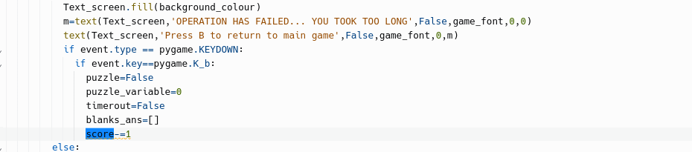

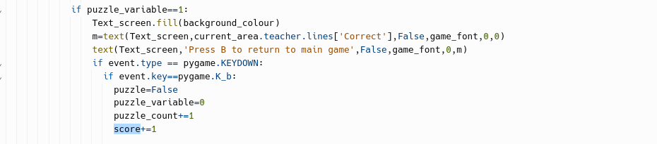

The shown snippets of code increment or reduce the score when the player answers questions correctly or incorrectly. It then outputs this score near the progress screen.

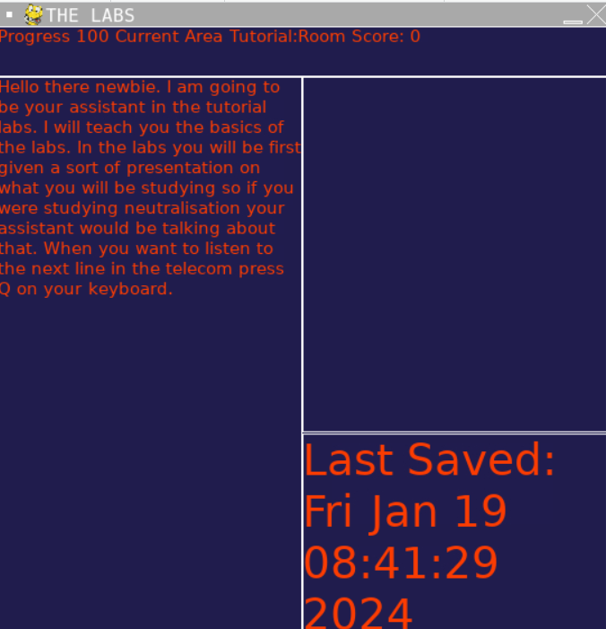

And after doing 2 questions correctly:

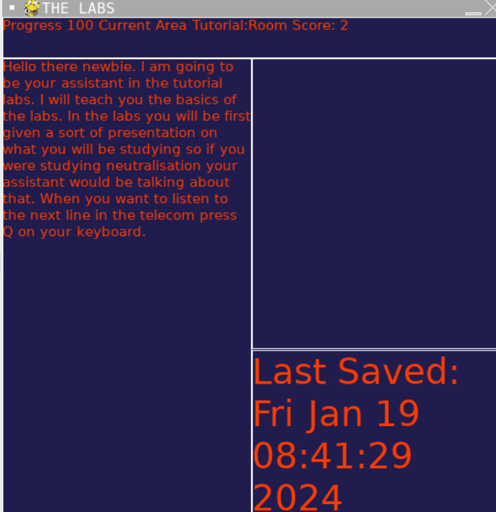

Then doing one incorrectly:

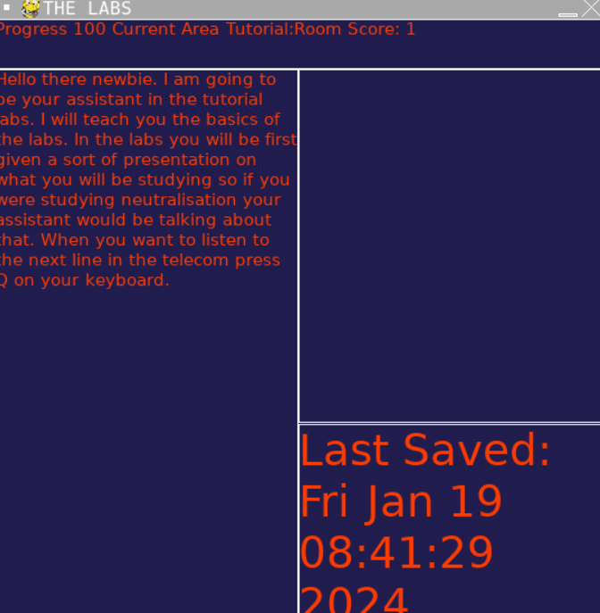

The system works as needed now.

### Section review:

I have successfully added a score system which is able to be saved and is outputted to the player to see how well they are doing.

No other major changes have been made.

## Section 22: The Survey

### Iteration 1:

The survey link is [here](https://forms.gle/1PDpNDN9pgjqZBwp8).

The survey is simply a few questions which will gage user satisfaction and see if the project abides by the success criteria.

A snippet of the survey:

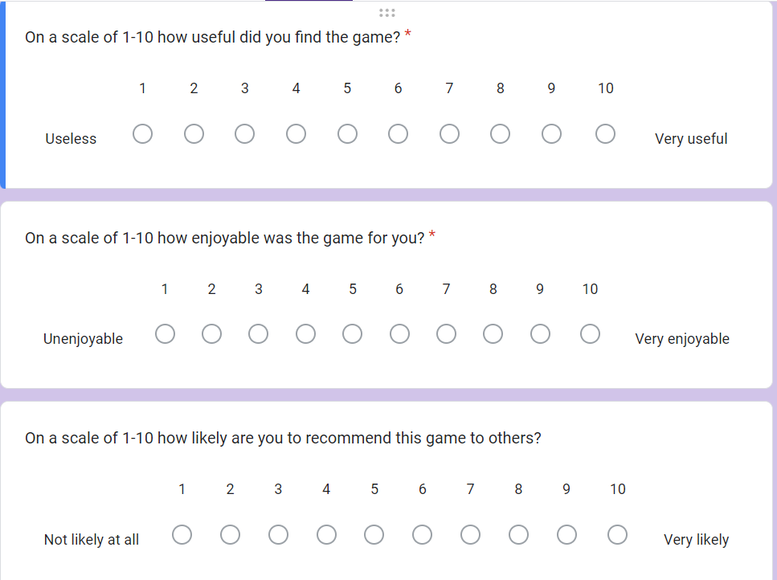

The survey is ready to be implemented with the only thing remaining is to copy the link to the player’s clipboard which will happen in The final screen.

### Section review:

I have made the survey for the players to fill out once they have completed the game.

## Section 23: The final assessment

### Iteration 1:

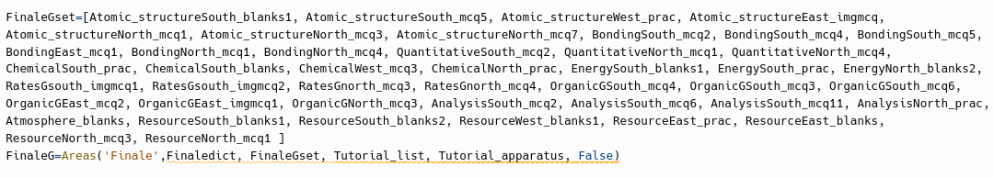



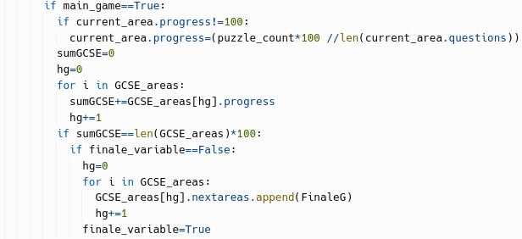

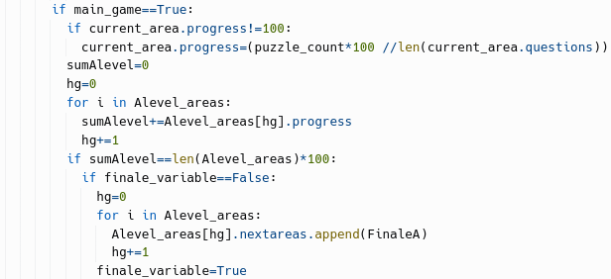

The code shows the final rooms which hold the final assessment of the a level and gcse specification. The latter code shows how the final rooms are added to every room so that the player doesn't have to backtrack if they want to relook at certain topics and then head to the final room.

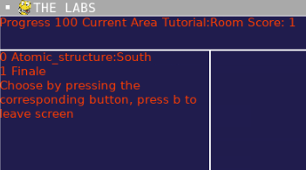

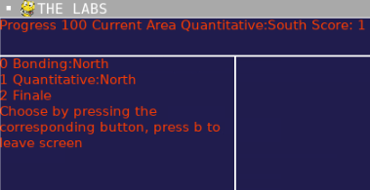

The two images show 2 different rooms which have the finale room added to each one in the gcse areas.

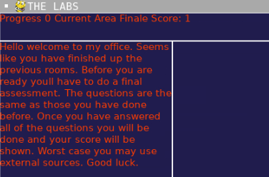

This is an image of the finale room.

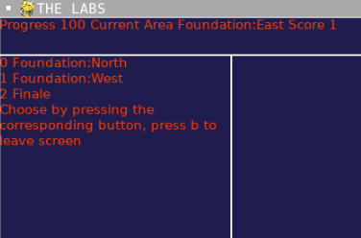

This is the same type of picture as before but with the a level rooms instead of the gcse rooms.

[This is a video showing that the questions work in both the a level and gcse finale](https://drive.google.com/file/d/1pEsWoyB8vTg6YGNfoM2GBf4D1ug1Wnt2/view)

The final assessment works as is intended.

### Section review:

I have successfully added the final assessments of the GCSE and a level sections. No other major changes have been made.

## Section 24: The final screen

### Iteration 1:

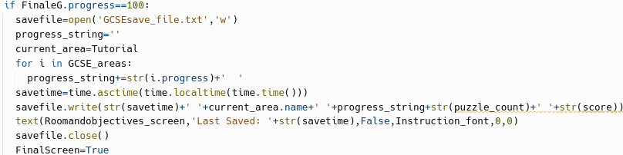

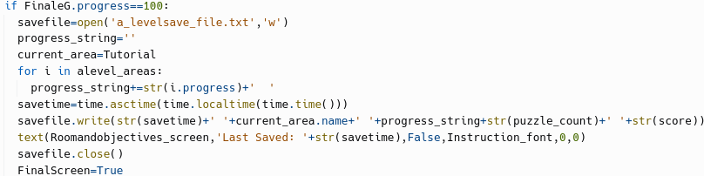

The code will make it so that when the final assessment is done that the player has their game saved with the current area as tutorial allowing the player to return to the game and replay whilst being able to skip what they are confident in.

[Here is a video showing](https://drive.google.com/file/d/1ZAmgkzDMj_R0SYKUvekP-zT40Taik-9t/view?t=2) this.

What remains to do is to code the final screen to appear, the congratulation message to be sent and the link to the survey to be copied to the player’s clipboard.

### Iteration 2:

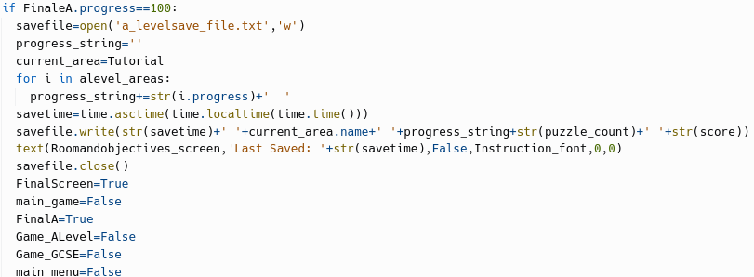

The code shows the a level portion of when the finale begins and is used to remove any and all other states in the game that may be at play. The same code minus the variables is present in the gcse section.

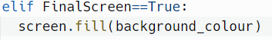

This code allows for the final screen to be added.

[Here is the testing to show.](https://drive.google.com/file/d/1-fCD4XY1RSAcU7XIzMlCvaygWk9NWdb5/view)

All that remains is outputting the congratulations message, adding the copy to clipboard feature and outputting the score.

### Iteration 3:

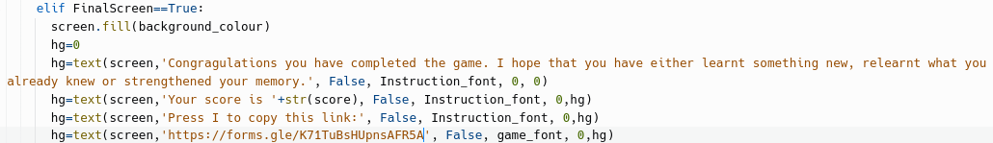

The code now outputs a final screen telling the player their score, to press the I button to copy the link, a message congratulating the player and the link itself in case the player wants to write it down themselves.

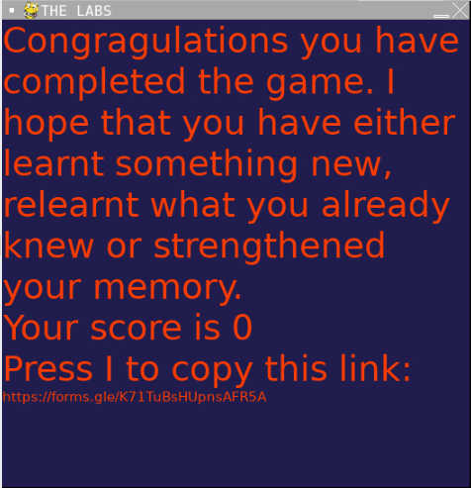

The code works as intended other than the lack of functioning copying to the clipboard. This can be solved by actually adding it.

### Iteration 4:

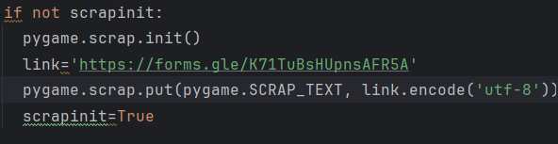

The code now allows for the link to be copied to the clipboard.

[Here is a video showing it working](https://drive.google.com/file/d/1vvFIeFjEs3_ykLFYmNGe4cAZFftb-LLD/view)

### Section review:

I have successfully added the final screen to the game. I have also added more music for the final screen and main game.

## Section 25: The text skip functionality

### Iteration 1:

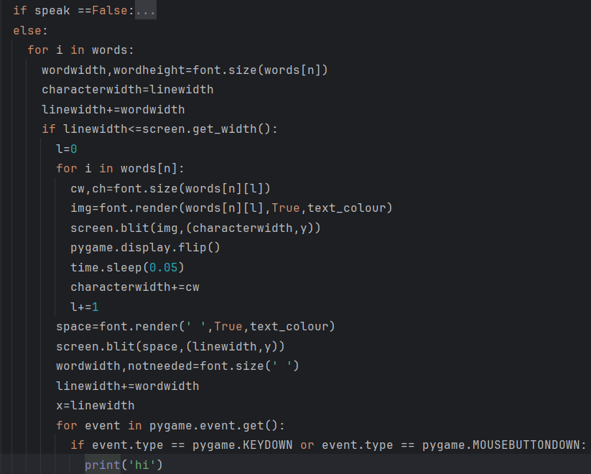

The code will now print the string hi when a key or mouse button is pressed. This is done so that a skipping addition can be added to the function.

[Here it is in action](https://drive.google.com/file/d/1V3q-fpqMgBLNkNBvu77L8eViWeUj0QNw/view)

Now the needed functionality will be added to the function trying to use a recursive technique.

### Iteration 2:

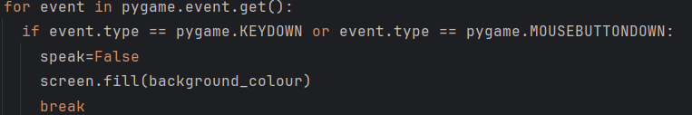

The code now tries to break from the loop whilst removing the whole background.

[Here is the testing](https://drive.google.com/file/d/19TZCfdS2ZaKdeBpAreU8NIN-bElT0bRd/view)

The current problem is that the loop still is occurring and outputting more letters to the screen. This can be solved by using a global variable which will be used for clusters of text calls.

### Iteration 3:

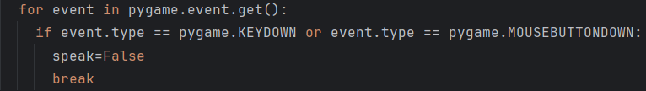

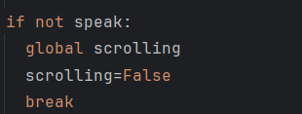

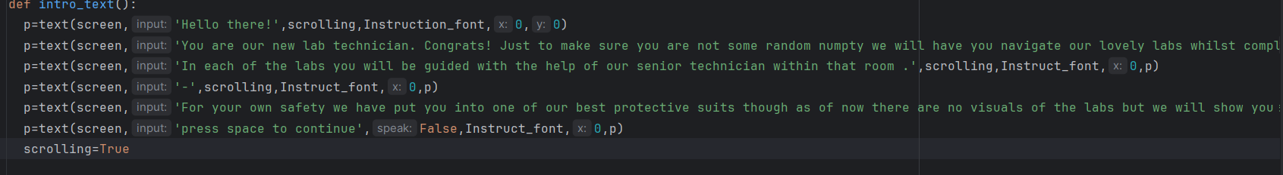

The code now allows for the text in the intro to be skipped.

[This is shown here](https://drive.google.com/file/d/1vKwi9n4ug47lvp3at2PXRaIxNQutqDX4/view)

The only issue is that when a skip happens the string that was being outputted is cut. This can be fixed by rerendering the text using a recursive technique whilst also modifying the speed at which the effect lasts.

### Iteration 4:

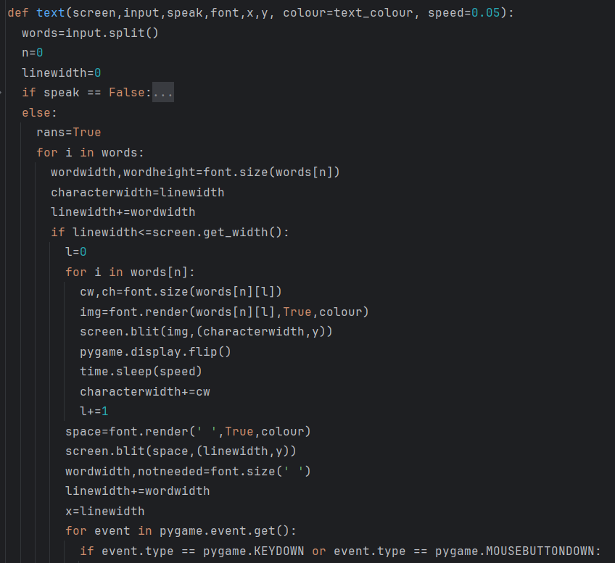

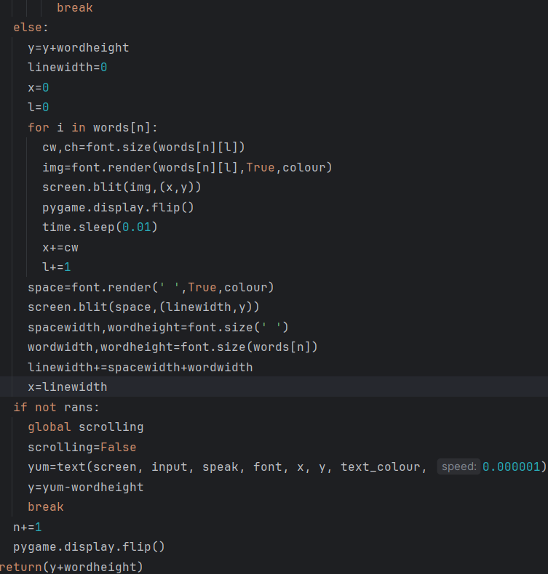

The code now works as is intended.

### Section review:

I have added a way for the player to skip the intro cutscene.

# Evaluation

## [Post development testing & robustness video](https://drive.google.com/file/d/1wAPuxORKdk3kLFxh4ykcdZ7rHySlNhSY/view)

There is no audio unfortunately as the software used to film.

## Success criteria

| Criteria | Explanation | Justification |
| --- | --- | --- |
| Majority of players must enjoy the game. | It means that most players who will play the game will have some enjoyment out of it and be satisfied with the game. | The reason this is needed for success is because if players do not enjoy the game then they will not try and use it for revision which is the entire point of it. |
| Players recommend the game to others | It will show that the players have enjoyed the game and also have used it effectively. | This shows the success of the game because it means that more people will be playing the game making it more seen within the game market allowing even more people to learn and revise. |
| Replaying | It is when the players play the game multiple times whether that be in different modes or the same mode again. | This shows the game is useful for revision as players are seen playing the game multiple times for the use of learning and revision. |

## Usability features

The program’s interface is quite easy to learn as initially you only see buttons so using a mouse is seen as the only way of interacting and from there the player only needs to remember 6 buttons and only 2 if the player wants to only do all the interactions.

The program’s interface is not the most memorable but due to its inherent simplicity the player should be able to return to the game and manage to play it without issue.

In terms of error handling, the program struggles a bit as there is only the tutorial room to explain the mechanics and the instructions menu to also explain them. Also whenever a player gets an answer incorrect they will not be told why they were incorrect.

The program is quite customizable as the only thing that properly matters is the font colour and that can be customised to a high degree.

## Limitations

The limitations of the program is a lack of feedback from the program if the player gets something wrong which is an issue given this is meant to teach the player. Also all the learning is very brief for only exam practice meaning those who want to just learn are unable to have the best experience.

Some things that I would have liked to have added but were unable to: a typewriter effect for the main game including changing the colour changer to just a text settings menu which additionally included a text speed regulator, A visual way to construct necessary apparatus that may be used, A functionally better timer with a visual indicator for how much time left.

A few features that have been left out due to their presence clashing with the intended flow of the game are: The timer affecting how long it takes to complete create tasks, setting up apparatus, having to manage resources and having different sets of apparatus for each area.

The two paragraphs before this detail limitations of the program in relation to what I set out to make in the analysis.

## Maintenance issues

The program itself is very robust as most of the algorithms have dedicated input handling and do not allow any incorrect data to be run through the program.

# Full Code

## Outside components.py

import pygame

class Teacher():

def __init__(self,lines):

self.lines=lines

# Teachers

Tutorial_lines={

'Initial':'Hello there newbie. I am going to be your assistant in the tutorial labs. I will teach you the basics of the labs. In the labs you will be first given a sort of presentation on what you will be studying so if you were studying neutralisation your assistant would be talking about that. When you want to listen to the next line in the telecom press Q on your keyboard.',

'Explanation 1':'Good now for the rest. Pressing I will give you a puzzle which is there to test your knowledge of what you have just learnt. Pressing W allows you to move between areas. Pressing Z will bring up the settings menu. Press S to save your current progress and press L to load said progress.',

'Explanation 2':'Pressing M brings you to the molecule journal which is like an encyclopaedia for all the substances you will deal with in the labs. So now if you want to look through all these commands again press C. So now I will just run through the explanations for you to complete the area if this is your first time.',

'Explanation 3':'Sodium is a reactive metal and reacts with water making NaOH, sodium hydroxide. That is all you need to know for this area',

'Correct':'Good Job! Keep it up!',

'Incorrect':'Ah that sucks but dont be afraid to try again k.'

}

Tutorial_assitance = Teacher(Tutorial_lines)

#A level

Foundation_lines_west={

'Initial':"Hello. This is the foundation lab. Do as I say and thats it!",

'Explanation 1':'Atoms are the components that make up all elements. Atoms are made up of three types of subatomic particles – protons, neutrons, and electrons. Protons and neutrons make up the nucleus, where most of the mass of the atom is concentrated. Electrons orbit the nucleus in shells. Protons are positively charged whilst electrons are negatively charged and neutrons are neutral in charge.',

'Explanation 2':'The relative masses of protons and neutrons are both 1 whilst electrons are 1/1836. The relative charges of both protons and electrons is 1.16x10^-19 with positive and negative being the sign respectively. Atomic number is the number of protons in an atom and is what identifies elements as they each have their respective number of protons.',

'Explanation 3':'Isotopes are atoms with the same number of protons but a different number of neutrons causing a change in its mass. The mass number is the number of protons added with the number of neutrons. Isotopes of an element have the same reactions as reactions are driven by electrons and not neutrons.',

'Explanation 4':'Ions are charged atoms caused by a gain or loss of electrons. Cations are positive and are from a loss of electrons and anions are negative caused by a gain of electrons.',

'Correct':'As expected.',

'Incorrect':'Pathetic.'

}

Foundation_assistance_west=Teacher(Foundation_lines_west)

Foundation_lines_east={

'Initial':'The mass of atoms is incredibly hard to find normally so what is done is that the atoms are compared to a Carbon-12 isotope which has 12 mass units,u. This makes is so that RELATIVE ISOTOPIC MASS is the mass of an isotope relative to 1/12th the mass of an atom of Carbon-12.',

'Explanation 1':'Relative atomic mass is the weighted mean mass of an element relative to 1/12th of the mass of a Carbon-12 atom. Weighted mean takes into account the percentage abundance of each isotope and the relative isotopic mass of said isotopes.',

'Explanation 2':'Relative atomic mass can be determined with a mass spectrometer which works by: placing the sample in the mass spec, it is vaporised and ionised, ions are accelerated and because heavier ions move slower than lighter ions they are separated, ions are detected on the mass spec as a charge to mass ratio.Then you can calculate by dividing the sum of the product of the mass and abundance of each isotope by the sum of abundances.',

'Explanation 3, ':'One mole is the amount of a substance that contains 6.02x10^23 atoms. That number is also known as Avogadros constant. The mass of 1 mol of an element is its RAM in grams. Empirical Formula is the simplest whole number ratio of atoms of each element in a compound. Relative molecular mass compares the mass of a molecule to 1/12 the mass of an atom of Carbon-12. Relative formula mass(MR) compares the mass of a formula unit to 1/12 the mass of an atom of Carbon-12.',

'Explanation 4':'Some formulas to remember: 1dm^3=1000cm^3, n=cV with c being concentration, n being moles and V being volume, n=m/M m being mass in grams and M being relative molecular mass, 1mol of gas is 24dm^3 of volume, pV=nRT with p being pressure in pascals, V being volume, n being moles, T is temperature in kelvin and R is the gas constant.',

'Correct':'As expected.',

'Incorrect':'Pathetic.'

}

Foundation_assistance_east=Teacher(Foundation_lines_east)

Foundation_lines_north={

'Initial':'Electrons are sorted into shells with the first able to hold 2, the second 8, the third 18 and the fourth holding 32. Shells are regarded as energy levels and are split into atomic orbitals which are regions around a nucleus that can hold up to 2 electrons with opposite spins. There are different types of orbitals being s,p,d and f with each type having a different shape.',

'Explanation 1':'Each shell contains 1 s-orbital, each shell from n=2 contains 3 p-orbitals and from n=3 each shell contains 5 d-orbitals. From n=4 each shell contains 7 f-orbitals. To draw an s-orbital you draw a circle and the three axis lines. For p-orbitals you have to draw three separate orbitals along each axis shaped like a dumbell.',

'Explanation 2':'Sub shells that make up shells have different energy levels. s is smallest whilst f is highest and are filled in such order. In an orbital both electrons must have opposite spin to one another and they fill in each orbital before pairing. Electron configuration is written as 1s22s22p6 and so on until all the electrons in an atom have been written. Also the 4s orbital is filled before the 3d orbitals are. Ions of d block elements begin from losing electrons from the 4s orbital.',

'Explanation 3':'Ionic bonding is the electrostatic attraction between positive and negative ions. Dot and cross diagrams show the movement of electrons from the cation to the anion using dots and crosses to show electrons. The structure of ionic compounds is called giant ionic lattices as each ion attracts oppositely charged ions in all directions. These strong electrostatic attractions cause the properties that ionic compounds have those being: high melting and boiling points and the ability dissolve in polar liquids.',

'Explanation 4':'When solid, ionic compounds are not conductive as there are no mobile charge carriers but when dissolved or melted in liquids they are conductive. Covalent bonds are the strong electrostatic attraction between a shared pair of electrons and the nuclei of the bonded atoms. It is the overlap of two orbitals making it localised between two atoms and these can be expressed in dot and cross diagrams which shows the sharing of the electrons.',

'Explanation 5':'A dative covalent bond is a covalent bond where the shared pair of electrons is supplied by one of the bonding atoms only usually from a lone pair of electrons. Average bond enthalpy is a measurement of covalent bond strength. Electron pairs repel one another causing different angles to form between them making different shapes.',

'Explanation 6':'Bonding pair repulsion is weaker than lone pair repulsion. The different shapes and their bond angles: tetrahedral;109.5, trigonal planar;120, square planar;90, linear;180, octahedral;90, pyramidal;107, non-linear;104.5. Electronegativity is the measure of an atoms ability to attract the electrons in the shared pair and this increases as you go across across a period as nuclear charge increases and electron shielding remains the same.',

'Explanation 7':'In non-polar bonds the bonded electron pair is shared equally between the atoms and converse for polar bonds. Polar molecules are molecules that are polar due to dipoles in the molecule not cancelling each other out. Molecules have forces between them and fall into three different categories: Induced dipole-dipole interactions/London forces, permanent dipole-dipole interactions, hydrogen bonding.',

'Explanation 8':'London forces are weak intermolecular forces that occur due to movement of electrons producing changing dipoles in a molecule and making instantaneous dipoles which induce dipoles on neighbouring molecules attracting one another. The more electrons a molecule has the larger the induced dipole and so the stronger the london forces and so stronger intermolecular forces arise.',

'Explanation 9':'Permanent dipole-dipole interactions act between permanent dipoles in different polar molecules. Simple molecular substances are made up of simple molecules and have low melting and boiling points and are non conductive. Hydrogen bonds is a bond between a lone pair of electrons on an electronegative atom and a hydrogen atom. These bonds are the strongest and produce the anomalous properties of water: ice is less dense than water and makes it have relatively high melting and boiling points.',

'Correct':'As expected.',

'Incorrect':'Pathetic.'

}

Foundation_assistance_north=Teacher(Foundation_lines_north)

Periodic_lines_west={

'Initial':'Hello there! It is my great pleasure to welcome you to our lovely periodic table study lab. I hope you enjoy your stay.',

'Explanation 1':'Across each period there is a repeating trend in properties of elements. This is called periodicity. The properties include: electron configuration, ionisation energy, structure, melting points. Ionisation energy is the measure of how easily an atom loses electrons to form positive ions. Factors that affect it: atomic radius(distance between nucleus and outer electrons), Nuclear charge(number of protons meaning if there are more protons then their is greater attraction between the nucleus and outer electron), electron shielding( if it is higher then their is reduced attraction leading to lower energy).',

'Explanation 2':'The formula for first ionisation energy of sodium is: Na(g) -> Na+(g)+e- and successive would have the previous ion and removing an electron. the element must be gaseous. Successive ionisation energies provide evidence for different energy levels as when there are spikes in ionisation energy between ionisation numbers it means that the next electron is removed from a lower energy level. This can tell how many electrons are in the outer shell. The trend when going down a period is an increase in ionisation energy other than with the element in group three as an electron is added to a p-orbital. Ionisation also goes down as you go down groups as electron shielding increases and the effect of nuclear charge increasing is lesser than this.',

'Explanation 3':'Another fall happens at the element in group 6 as a paired electron is present in the highest energy level causing more repulsion meaning the ionisation energy is lower. Metallic bonding is bonding found in metals where each atom donates its outer shell electron to a shared pool of electrons which are delocalised in the structure leaving cations which are in fixed positions. This gives the properties of metals: strong metallic bonds, high electrical conductivity and high melting and boiling points.',

'Explanation 4':'Giant covalent lattices are networks of strong covalent bonds. This means that they have high melting and boiling points, low solubility and low conductivity although there are exceptions notably graphene.',

'Correct':'Nice keep it up',

'Incorrect':'Ahh. Try again when your ready.'

}

Periodic_assistance_west = Teacher(Periodic_lines_west)

Periodic_lines_east={

'Initial':'Redox reactions are reactions in which one element is oxidised(loses electrons) and another is reduced(gains electrons). To remember this use the acronym OILRIG(Oxidation is loss, reduction is gain). In group 2 as you go down the group the reactivity increases. In water, group 2 hydroxides are only slightly soluble and this increases as you go down the group with Beryllium hydroxide not dissolving in water at all.',

'Explanation 1':'Some common uses of group 2 metals include: agriculture where it is used to increase the pH of soil and in certain medicines to treat acid indigestion as they form strong bases.',

'Explanation 2':'Halogens or group 7 are the most reactive nonmetal group. As you go down the group the boiling and melting point increases as the number of electrons increases creating stronger London forces. They can also undergo displacement reactions with the less reactive halogen being displaced. As you go down the group the reactivity of the halogen decreases. Furthermore, the reducing power of the halide ions increases as you go down the group',

'Explanation 3':'Disproportionation is a redox reaction where the same element is oxidised and reduced such as with chlorine and water where chlorine has a +1 charge in HClO and a -1 charge in HCl. This reaction is used to remove bacteria from water. This is risky as the chlorine may react with hydrocarbons in the water making chlorinated hydrocarbons which can cause cancer.',

'Explanation 4':'You can test to see what types of ions are in a solution. To test for carbonates you would add nitric acid(HNO3) to the solution, if bubbles are seen then the solution has carbonate ions. To test for sulfates you would add barium nitrate and if a white precipitate is formed then the solution has sulfate ions. To test Halides you would add silver nitrate and if a white precipitate is formed then chloride ions are present, if cream bromide ions and if yellow iodide ions. To test all options the sequence and chemicals shown must be followed as some false positives may be seen like silver carbonate and sulfate that are insoluble in water.',

'Explanation 5':'For ammonium ions you lightly heat aqueous ammonium and hydroxide ions to form ammonia gas. This can then be detected by using a damp pH indicator paper and turns it blue.',

'Correct':'Nice keep it up',

'Incorrect':'Ahh. Try again when your ready.'

}

Periodic_assistance_east=Teacher(Periodic_lines_east)

Alkanes_lines_east={

'Initial':'Welcome to the alkane lab. I will be your assistant.',

'Explanation 1': 'Organic chemistry is the chemistry of carbon. Hydrocarbons Are compounds containing carbon and hydrogen only. Alkanes are saturated(only single bonds) hydrocarbons. They are named by counting how many carbons are in the longest continuous chain then adding -ane. So an alkane with 1 carbon is called methane, 2 is ethane and so on. The first four are: meth-,eth-,prop-,but-. The rest come from the greek prefix e.g. hexa, penta.',

'Explanation 2':'Some more key terms: Aliphatic(Carbon not joined in rings.), alicyclic(Carbon joined in a ring with or without branches), Aromatic(Some or all carbons are within a benzene ring), Homologous series(A family of compounds with similar chemical properties), Functional groups(A part of an organic molecule that is largely responsible for the molecules chemical properties).',

'Explanation 3':'Naming organic molecules can seem stressful but it follows a strict set of rules: Identify the longest unbranched chain of carbon atoms which will determine the stem, Identify any functional groups and alkyl side chains and then select the appropriate prefix or suffix, add a number representing the positions of the alkyls or functional groups on the chain.',

'Explanation 4':'Functional group and prefix and suffix of compounds: Alkene(C=C) (none) (-ene), Alcohol (-OH) (hydroxy-) (-ol), Haloalkane(-Cl -Br -I) (chloro- bromo- iodo-) (), Aldehyde (-CHO) () (-al), Ketone (-C(CO)C-) (oxo-) (-one), Carboxylic acid(-COOH) () (-oic acid), Ester(-COOC-) () (-oate), Acyl chloride(-COCl) () (-oyl chloride), Amine(-NH2) (amino-) (-amine), Nitrile(-CN) () (-nitrile)',

'Explanation 5':'Some ways of representing the formula of organic compounds other than molecular and empirical are: Displayed formula(Shows all relative positions of all atoms of the molecule), Structural formula(It shows using the smallest detail necessary e.g. Butane-CH3CH2CH2CH3), Skeletal formula(It is like displayed but with the removal of all carbon and hydrogen labels and bonds to hydrogens leaving a carbon skeleton with functional groups attached. A line represents a single bond, an intersection is a carbon atom, the end of a line represents a CH3 group.). Any prefix rules also apply to suffixes.',

'Explanation 6':'Isomerism is when different compounds have the same molecular formula. Structural Isomers are compounds with the same molecular formula but different structural formula. Stereoisomers have the same structural formula but different arrangements in space these isomers will be talked about in different rooms.',

'Explanation 7':'There are multiple types of reactions that occur but many have similar types of mechanisms but first we must talk about bond fission. There are two types: Homolytic fission( when the covalent bond breaks each atom has a single unpaired electron making a radical), Heterolytic fission(When a covalent bond breaks one of the atoms gets both of the electrons in the bond making a positive and negative ion). In mechanisms curly arrows show the movement of electrons and begin on either a bond or pair of electrons and end on atoms or bonds.',

'Explanation 8':'The types of mechanisms: Addition(2 reactants join together to make a single product), Substitution(An atom or group is replaced by a different atom or group), Elimination(The removal of a small molecule from a large one making 2 products). On a different note, ALkanes are composed of Sigma Bonds which is an overlap of two orbitals each containing one electron. Alkanes are usually filled with tetrahedral shapes where the sigma bonds allow for free rotation though they are mostly drawn as zigzags they can look a myriad of different ways. the general formula of Alkanes is CnH2n+2',

'Explanation 9':'As chain length increases in alkanes so too does boiling point because there is a greater surface area of contact london forces between molecules is greater. The effect of branching is the opposite to this as there is less surface area of contact. Alkanes also have 2 noteworthy reactions, combustion which you should already know and Halogenation',

'Explanation 10':'Halogenation is the addition of halogens to a molecule. Free radical substitution is used for halogenation of alkanes and involves three steps. Initiation is the step where the radicals are made by using UV radiation to break the bond in the halogen through homolytic fission creating radicals e.g. Cl2 ->2Cl*. Propagation is the steps where the reaction propagates. The first step is the molecule reacting with the halogen radical making a radical molecule alongside the hydrogen halide, the second is the radical molecule with the non radical halogen molecule making the product alongside another halogen radical. Termination is the step where all the radicals collide together. so you would have the halogen molecule, the desired molecule and then the two beginning alkanes added together e.g. 2*CH3->C2H6.',

'Explanation 11':'Limitations of this include further substitution and substitution at different positions on the carbon chain which is means the resulting mixture has many impurities that are hard to get rid of.',

'Correct':'Correct',

'Incorrect':'Incorrect'

}

Alkanes_assistance_east=Teacher(Alkanes_lines_east)

Alkanes_lines_west={

'Initial':'Alkenes are unsaturated hydrocarbons with a general formula of CnH2n. They have at least one C=C bond. The double bond is formed by the production of a pi-bond which is an overlapping of the p-orbitals of the 2 carbon atoms. It also locks the 2 carbons in position causing the stereoisomers talked about previously. Pi-bond electron density is concentrated above and below the line connecting the two atoms. The shape around a double bond changes from tetrahedral to trigonal planar. Alkenes are named by adding the -ene prefix and if it is found in a chain where it can have multiple positions you add a number indicating the start position e.g. but-2-ene.',

'Explanation 1':'Back to stereoisomerism. If a molecule has a C=C double bond and different groups attached to each carbon atom of the double bond. If both the priority groups are on the same side then it is a Z isomer and if not then it is an E isomer. Cis-trans isomers are special case E/Z isomers where the difference is that one of the groups attached on each carbon must be the same. Cis is Z and trans is E. To figure out the priority group on each side: look at the atoms right next to the carbon in the double bond and look at their atomic number the higher the atomic number the higher the priority, If the first atoms have the same priority look at the next ones until you find a point of difference and again the same thing as before.',

'Explanation 2':'Alkenes are more reactive than alkanes due to the pi bond in alkenes. Pi bond electrons are more exposed than sigma bonds and so it more easily breaks. A common reaction type Alkenes have is addition reactions: Hydrogenation(adding hydrogen) with a nickel catalyst, Halogenation with the halogen molecule or hydrogen halide producing a dihaloalkane or haloalkane respectively, Hydration using steam and H3PO4(phosphoric acid)',

'Explanation 3':'A majority of the reactions are electrophilic addition reactions. The double bond is a region of high electron density meaning it attracts electrophiles(atom or group of atoms that are attracted to negative things and accept electron pairs) which includes cations and partially positive atoms. The mechanism: a curly arrow starts from the double bond and goes to a partially positive charge, a curly arrow from the bond to the partially negative atom. This leaves a carbon with a positive charge and the other has the partially positive atom, the negative ion remaining then has a curly arrow drawn from it to the positive carbon.',

'Explanation 4':'An important factor to consider where the negative atom is placed is which carbocation is more stable where it goes from least to most stable: Primary(Bonded carbon only has one carbon attached), Secondary(Bonded carbon has 2 carbons attached), Tertiary(Bonded carbon has 3 carbons attached). Alkenes also can make polymers through addition polymerisation. They are made with a monomer unit given in the form: n(number of unit) unit -> -[repeat unit without double bond]-n. Environmental concerns about polymers are that they take an incredibly long time to decompose.',

'Explanation 5':'The ways to reduce this: recycling(Conserves finite fossil fuel and reduces waste in landfills, the plastics must be sorted), PVC Recycling(PVC is hazardous to recycle due to the high chlorine content. Solvents are used to dissolve the PVC and is then recovered by precipitation),Burning(The waste polymer can be burned to reclaim the energy they have stored), Feedstock Recycling(Using chemical and thermal processes to reclaim the monomer and such from waste polymers). Some polymers are biodegradable meaning microorganisms break them down into H2O,CO2 and biological compounds.',

'Correct':'Correct',

'Incorrect':'Incorrect'

}

Alkanes_assistance_west=Teacher(Alkanes_lines_west)

Alkanes_lines_north={

'Initial':'Haloalkanes are organic molecules that contain a halogen. Halogen atoms are more electronegative than carbon atoms. This means in the carbon-halogen bonds the carbon is partially positive. They then attract nucleophiles(opposite of electrophile) which react with the haloalkane replacing the halogen. Most mechanisms involve a curly arrow from the nucleophile to the partially positive Carbon and then an arrow from the bond to the halogen. C-F bonds are the strongest whilst C-I bonds are the weakest. This makes Iodoalkanes the most reactive.',

'Explanation 1':'To test the differences in reactivity of the haloalkanes you: add a few drops each of the different haloalkanes to separate test tubes containing 1cm3 of ethanol. Then you stand the test tubes in 60 degrees celsius water alongside a test tube containing 0.1moldm-3 solution of AgNO3. Add a few drops of the AgNO3 and observe which changes the fastest and slowest. The test tube containing the Iodoalkane will produce a yellow precipitate first with Bromoalkane next and Chloroalkane last.',

'Explanation 2':'Organohalogen compounds have many uses including: pesticides, general solvent, refrigerants, fire retardants and making polymers. In the Ozone layer Ozone absorbs harmful UV radiation. This sets up this type of general reaction O2+O⇌O3. CFCs(Chloro-fluorocarbons) catalyse this causing the rate of ozone depletion to increase depleting the ozone layer. This is another radical substitution reaction. The same is said for NO',

'Explanation 3':'General reactions of haloalkanes: Haloalkane+NaOH(aq)refluxed -> alcohol, Haloalkane+NH3(dissolved in ethanol)->Amine, Haloalkane+NaCN->Nitrile',

'Correct':'Correct',

'Incorrect':'Incorrect'

}

Alkanes_assistance_north=Teacher(Alkanes_lines_north)

Alcohol_lines_south={

'Initial':'Heey there, Ill beyour assistant here. In the alcohol lab! Lets get startedd.',

'Explanation 1': 'Alcohols are basically any molecule that has ann -OH group attached to it. To name em you gotta add an -ol to the end and then add the carbon number in front like heptan-2-ol. Alcohols have lower boiling points than alkanes cause alkanes only have london forces but alcohols have both london forces and hydrgoen bonding.',

'Explanation 2':'Alcohols also are more soluble in water causee it can make hydrogen bonds to waterr molecules and as chain length increases the influencee of the -OH is less so solubility goes down. The different typess of alcohols are primary, secondary, tertiary and the samee logic is with the haloalkanes here. ye',

'Explanation 3':'Reactions of alcohols include combustionn, oxidation, dehydration and substitutiion. Oxidation of alcohol uses potassium dichromate(K2Cr2O7) acidified with dilute sulfuric acid which goes from orange to green when the alcohol is oxidised. There aree 3 reactions needed to be learnt for this: primary alcohol refluxed or distilled and secondary alcohol refluxxed. An aldehyde is made from a primary distilled, a carboxylic acid is produced from primary refluxed, a ketone is made from secondary refluxxed. No reaction takes place for tertiaryy alcoholss. For dehydration, adding phosphoric acid(H3PO4) produces an alkene where the -OH is broken and H2O.',

'Explanation 4': 'The ssubsitution reaction needs NaX (X being a halogen) and sulfuric acid. This creates a haloalkane. It is done this way as it is hard to deal with HX so it is produced in situ(in place) with the reaction NaX(s) + H2SO4(aq) -> NaHSO4(aq) + HBr(aq)..',

'Correct':'Urrah!',

'Incorrect':'Try... try again. Ight?'

}

Alcohol_assistance_south=Teacher(Alcohol_lines_south)

Alcohol_lines_north={

'Initial':'In organicc chemistry many reactions allow for the changing of functional groups which we need to do sometimes. Ill lay it all out in writing: Alkanes->Haloalkanes(UV, Halogen); Haloalkanes->Nitriles(NaCN), Alcohols(NaOH(aq)), Amines(NH3/ethanol); Alcohol->Haloalkane(NaX(X=Halogen)/H2SO4), ALdehyde(Primary alcohol/ K2Cr2O7/ H2SO4/ Distilled), Carboxylic acid(Primary alcohol/ K2Cr2O7/ H2SO4/ Refluxed), Ketone(Secondary alcohol/ K2Cr2O7/ H2SO4/ Distilled), Ester(Carboxylic acid/H2SO4), Alkene(H2SO4); Carboxylic acid-> Ester(Alcohol/H2SO4), Acyl chloride(SOCl2). The rest will continue...',

'Explanation 1':'Acyl Chloride->Primary amide(NH3), Secondary amide(primary amine), Ester(alcohol), Carboxylic acid(H2O); Ester-> Sodium salt+alcohol(NaOH(aq)), Carboxylic acid(dilute acid); Aldehyde/ketone -> hydroxynitrile(NaCN/H+), alcohol(NaBH4/H2O); Alkene-> Haloalkane(HX(X=Halogen)), Alcohol(H2O(g)/H3PO4); Nitrile-> Carboxylic acid(H2O/HCl), Amine(H2/Ni). If you want to see a clearerr scheme go to the journal.',

'Correct':'Urrah!',

'Incorrect':'Try... try again. Ight?'

}

Alcohol_assistance_north=Teacher(Alcohol_lines_north)

Aromatic_lines_south={

'Initial':'Hallo! Welcome to the aromatic lab! Dont sniff the air, you may just die. Ill be the main man to take you through this lovely lab and teach you bout benzene and other fun things.',

'Explanation 1':'Benzene has the chemical formula C6H6. Aromatic chemistry comes from benzene rings as the stuff smells hence aromatic. Onto structure. So scientists took a long time tryin to figure out how benzene looks like and this guy kekule comes along and proposes that benzene has alternating single and double bonds, that was very wrong.',

'Explanation 2':'There is quite a bit of evidence to disprove this: the lack of reactivity as it doesnt decolourise bromine under normal conditions, the lengths of the carbon-carbon bonds are all the same which isnt the case as C-C and C=C bonds have different lengths, the enthalpy change of hydrogenation is far less than expected as cyclohexene has an enthalpy of -120kjmol-1 and the model predicts a -360jmol-1 enthalpy but it is only -208kjmol-1. This led to the delocalised model being made.',

'Explanation 3':'Benzene is a cyclic planar hexagonal hydrocarbon where each carbon uses 3 of its electrons in carbon-carbon bonds, each carbon has p-orbitals perpendicular to the plane which overlap in both directions, creating a system of pi-bonds which is delocalised.',

'Explanation 4':'When naming benzene molecules if the benzene is the parent group then you just add the prefixes of the group, else if an alkyl group with a functional group or a chain with more than 7 carbons is attached then the prefix phenyl is used. If there is more than one group on the ring then the ring becomes numbered right starting from the priority group.',

'Explanation 5':'Benzene can undergo electrophilic substitution reactions with cations. The general mechanism is; a curly arrow from the ring to the cation, then you have the cation and hydrogen on the same carbon with the ring becoming a horseshoe and having a positive charge, the hydrogen-carbon bond has an arrow from it to the centre of the ring, this produces the product and a proton. The reactions: Nitration(HNO3+H2SO4, below 50 celsius no further substitution and above you have further substitution. Produces water), Halogenation(Halogens normally dont react so a halogen carrier is used e.g. FeBr3, AlCl3. Produces HX), Alkylation(Haloalkane and halogen carrier used, produces HX)',

'Correct':'Lets go! I knew you had it in ya',

'Incorrect':'You know as they say it is what it is. When you are ready, go again.'

}

Aromatic_assistance_south = Teacher(Aromatic_lines_south)

Aromatic_lines_north={

'Initial':'Now phenols right, they are benzenes with an -OH group attached to it. They act as weak acids and are less soluble in water due to the non-polar benzene ring and dissociates into phenoxide ions and a proton. They are more acidic than alcohols but less so than carboxylic acids. Ethanol doesnt react with NaOH or Na2CO3. Phenols and carboxylic acids react with strong bases but only carboxylic acids react with weak bases.',

'Explanation 1':'Phenol reacts with NaOH making sodium phenoxide and H2O. It is also able to react with halogens and HNO3 at room temperature without the need of a catalyst. This increased reactivity compared to benzene caused by a lone pair of electrons from the oxygen p-orbital being donated to the pi-system increasing electron density attracting electrophiles more.',

'Explanation 2':'Some groups attached to the benzene ring may activate or deactivate the ring meaning it will increase or decrease reactivity of the molecule. This leads us to directing groups. Many different groups can be added to the ring and cause any further substituted groups to be added to the 2 and 4 carbons or the 3 carbons. 2 and 4 directing groups, also known as ortho and para directing:NH2, NHR, OH, OR, R, C6H6, Halogen. They all are activating except for the halogens.',

'Explanation 3':'3 directing, also known as meta directing, groups include: RCOR, COOR, SO3H, CHO, COOH, CN, NO2, NR3+. They all are deactivating. A way to remember which are 2,4 directing and 3 directing is whether electrons are donated into the ring, usually from a lone pair of electrons. It is important to know these effects for multi-stage synthesis involving our lovely benzene.',

'Explanation 4':'Ye we got a reaction scheme: Benzene->halogen benzene(halogen carrier/Halogen), ketone benzene(Acyl chloride/Halogen carrier), alkyl benzene(haloalkane/halogen carrier), nitrobenzene(HNO3/H2SO4); ketone benzene-> phenyl alcohol(NaBH4/H2O); nitrobenzene-> aminobenzene(HCl/Sn)',

'Correct':'Lets go! I knew you had it in ya',

'Incorrect':'You know as they say it is what it is. When you are ready, go again.'

}

Aromatic_assistance_north=Teacher(Aromatic_lines_north)

Rates_lines_south={

'Initial':'HELLO! Welcome to rates and equilibrium lab! I hope you like maths cause thats the main course!',

'Explanation 1':'First thing first! The rate of a reaction is measured by the change in concentration divided by the time taken (rate=(ΔC)/t)! This rate of reaction is fastest at the very beginning of the reaction. To increase rate of reaction: Increase pressure, Increase temperature, Increase surface area and use a catalyst too. This involves collision theory where for a reaction to take place particles have to collide with the correct orientation and they have to have sufficient energy to overcome activation energy. An increase of concentration increases ROR(Rate Of Reaction) as there is a higher number of molecules in a given volume meaning there is a much higher number of collisions meaning more successful collisions. Ditto for pressure.',

'Explanation 2':'To monitor how a reaction progresses you can look at concentration of reactant decrease or that of product forming. [] denotes concentration of. With the release of gas monitor the change in mass of solution, amount of gas produced both in interval periods using a balance or a gas syringe respectively. A catalyst is a substance that changes ROR without permanent change to itself. They are not used up in the reaction, may react with a reactant to form an intermediate or provide a surface for the reaction to take place. It is regenerated at the end of a reaction. It increases ROR by providing an alternative pathway of lower activation energy.',

'Explanation 3':' 2 types: Homogeneous(same physical state as reactants, forms intermediates) and Heterogeneous(different physical state of reactants, Reactants absorb onto the catalyst, react and then leave the surface by desorption). Catalysts are important as they reduce energy needed for a reaction lowering the need for fossil fuel burning. This means less global warming! The boltzmann distribution is a spread of the energy of different molecules in a substance. The graph is in your journal. Ea is the activation energy for a reaction. The area under the curve is the total number of molecules, There is also no maximum energy so the graph doesnt touch the x axis. If temperature increases: the peak is lower and shifted to the right and more molecules have more than the activation energy. With a catalyst a line further up the peak is drawn labelled Ec.',

'Explanation 4':'Reversible reactions are reactions that take place in a forward and reverse direction e.g. N2+3H2⇌2NH3. In an equilibrium system: the rate of forward and backward are equal, [Products] and [Reactants] dont change. For it to remain in equilibrium it must be happening in a closed system. The position of equilibrium indicates the extent of the reaction. Le chateliers principle states when a system is in equilibrium is subject to external change the system adjusts itself to minimise the effect of that change.',

'Explanation 5':'Effect of concentration:Increasing [Reactants] shifts EQP(equilibrium point) right and with decrease in [Products]. The converse shifts equilibrium left. Effect of temperature: If forward reaction is exothermic then increasing temp shifts the EQP left and decreasing shifts EQP to right and the converse is true if forward reaction is endothermic. The effect of Pressure: Increasing shifts EQP to side with less moles of gas and converse for decreasing. Catalysts have no effect on the EQP.',

'Correct':'Nice nice, maths is mathing lets go lets go',

'Incorrect':'looks like the maths aint mathing but soon it will.'

}

Rates_assistance_south=Teacher(Rates_lines_south)

Rates_lines_east={

'Initial':'Now onto Orders. Changing concentration changes ROR meaning rate is directly proportional to [Reactant]^n. The power,n, is the order of reaction for that reactant. The common ones are Zero([Reactant] has no effect on rate), First(Rate is directly proportional to [reactant]), Second(rate is directly proportional to [reactant]^2).',

'Explanation 1':'The rate equation gives the mathematical relationship between [Reactants] and the rate. Rate=k[A]^m[B]^n where k is rate constant, A is reactant A, m is order of reactant A, B is reactant B and n is order of reactant B. Overall order is the sum of orders: overall order =m+n+... The units of k can be worked out by making k be the subject and then resolving the rest of the equation into units, then cancel common units and there are your units for k.',

'Explanation 2':'You can get orders of a reaction experimentally by: doing an initial experiment with certain concentrations measuring the initial rate, repeat with one of the concentrations changed, do the same for the other reactants. Compare experiments with each other figuring out the order by the factor of change between the [reactant] and initial rate. You can get concentration-time graphs by use of continuous monitoring. Ive already talked about monitoring by gas collection and mass loss so what are the others? Using a colorimeter: the wavelength of light passing through a solution is controlled using a filter as the amount of light absorbed by the solution is measured by the colorimeter.',

'Explanation 3':'From a concentration-time graph you can get the order, Zero(Straight line with negative gradient equal to k), First(Produces a downward curve with decreasing gradient over time, The time taken for [reactant] to halve is constant and is called half life.), Second(Same as first but steeper and tailing of more slowly.). 2 ways of determining k from a first order C-t graph: Using rate(Draw tangent, gradient of tangent is rate, calculate k from rate and [A]), Half-life(use k=(ln2)/half-life)',

'Explanation 4':'Rate-concentration graphs are plotted using measurements of rate at different concentrations and look different for different orders: Zero(horizontal line rate=k), First(Straight line through origin, k=gradient), Second(Upward curve with increasing gradient, to find k a second graph of rate-concentration^2 needs to be plotted where k=gradient). The initial rate is the instantaneous rate at the start of a reaction usually seen with a tangent at t=0. A clock reaction is the best way as you just measure t before visual change, initial rate is proportional to 1/t. This is an approximate but is more accurate than normal reactions.',

'Explanation 5':'Reaction equations only give the full balanced reactants and products however it is usually unlikely the reaction can only happen in one step so most reactions occur in multiple steps called a reaction mechanism. The slowest step is called the rate determining step. The rate equation only includes anything before and included in the rate determining step, the orders match the number of species in the rate determining step. You will get it once youve completed the questions.',

'Explanation 6':'Increasing temperature increases k. This is seen with the Arrhenius equation: k=Ae^-Ea/RT with k being rate constant, A is the pre-exponential factor(frequency factor), Ea is activation energy, R is gas constant and T is temperature. We cant really use it to solve for anything so we have to apply some logarithms giving us: ln(k)=-Ea/RT +ln(A) giving us a y=mx+c graph. We then plot 1/T to get a downward graph with gradient -Ea/RT and intercept ln(A). In exams you will be asked to draw and collect data from the graphs but due to technological limits we cant do the same.',

'Correct':'Nice nice, maths is mathing lets go lets go',

'Incorrect':'looks like the maths aint mathing but soon it will.'

}

Rates_assistance_east=Teacher(Rates_lines_south)

Rates_lines_north={

'Initial':'Now back to equilibrium. we skipped over an important thing that is Kc(equilibrium constant). Kc=([C]^c[D]^d)/([A]^a[B]^b) where a and b are the reactants and C and D are products with a b c d being the number in front of each of the chemical species. An example for N2+O2⇌2NO would be Kc=([NO]^2)/([N2][O2]). The value of Kc tells you where the equilibrium point lies precisely. If Kc=1 then EQP is in the middle, Kc>1 means EQP is towards products, Kc<1 means EQP is towards reactants. You first need to know what the equilibrium concentrations are. You can calculate this by using I.C.E. Find Initial moles, find the Change in the moles, Write the equilibrium moles. From the equilibrium moles you can calculate the equilibrium concentration.',

'Explanation 1':'Units of Kc are determined by substituting the units for the concentration and then cancel common units. Kc also doesnt account for anything non gaseous. Kp(equilibrium constant in partial pressures) is a different way of looking at where the EQP lies instead of using concentration it uses pressure. Mole fractions are needed and are calculated by number of moles of the species/total moles. Partial pressure(p(A)) is calculated by mole fraction x total pressure. A Kp expression would look like: Kp=(p(NO)^2)/((p(N2)p(O2)). Calculating units is the same as Kc and units are that of pressure.',

'Explanation 2':'You will need to do an explanation of what happens to Kc and Kp when concentration, pressure or temperature changes. For temperature: State what the forward and backward reaction type is, write the Kp/Kc formula, if temperature increases/decreases the system is no longer in equilibrium, to restore equilibrium EQP needs to shift (left/right, depends on what the reaction type is) to decrease/increase the temperature of the system favouring the (forward if endothermic, reverse if exothermic)/(converse), Kp/Kc increases/decreases as more of the numerator/denominator will be made.',

'Explanation 3':'For Pressure: state the reaction, state the Kp expression, if pressure increases/decreases system is no longer in equilibrium, to restore equilibrium EQP needs to shift to (side with less/more moles of gas) to decrease/increase pressure, amount of numerator/denominator decreases and amount of denominator/numerator increases, new equilibrium established with same Kp.',

'Explanation 4':'For concentration: state reaction, state the Kc expression, if [A] increases/decreases then system is no longer in equilibrium, to restore the EQP shifts to (opposite side of A), concentrations must change by having [A] to decrease/increase meaning [reactants of other side] must increase/decrease. New equilibrium is established with the same Kc value.',

'Correct':'Nice nice, maths is mathing lets go lets go',

'Incorrect':'looks like the maths aint mathing but soon it will.'

}

Rates_assistance_north=Teacher(Rates_lines_north)

Acid_lines_south={

'Initial':'hello there. I will be your assistant in the acid labs. just do the work set or not idc.',

'Explanation 1':'a strong acid is an acid that fully dissociates when dissolved whilst a weak one only partially dissociates. an alkali is a base that releases OH- ions when dissolved in water. In neutralisation reactions H+ ions react with a base displacing the metal or ammonium ions from the base. general thingy for alkali is alkali+acid->water+salt. examples are stuff like HCl+NaOH->NaCl+H2O. with carbonates you get CO2 gas as well.',

'Explanation 2':'titration is a technique used to find the concentration of a solution, identifying unknown chemicals and seeing purity of a substance. we do it by putting 25cm3 of the known or unknown solution into a conical flask along with some indicator like methyl orange(red with acidic, yellow when basic) or phenolphthalein(colourless when acidic, purple when basic), then you add your other solution into a burette, you then add from the burette to the conical flask whilst stirring the flask until the endpoint(When the indicator changes slightly), you repeat until you have at least 3 concordant(within 0.1cm3 of each other) results, get a mean and calculate.',

'Explanation 3':'to make up a standard solution you have to: measure out a mass to get the concentration you want, dissolve it in less distilled water than you need for the volumetric flask, add it to the volumetric flask using a funnel, wash the beaker with distilled water and wash the funnel back into the volumetric flask, finish making up the solution to the line, slowly invert the solution to mix it up.',

'Explanation 4':'uncertainty calcs are real important to do. when adding or subtracting quantities you add the uncertainty, when multiplying or dividing you add the percentage uncertainties. percentage uncertainties are calculated by equation: percentage uncertainty= uncertainty/value.',

'Explanation 5':'an addition to titration are titration curves. these are curves produced by measuring pH during a titration with pH on the y and volume of thing added on the x, there are 4 of these: weak acid+weak base, strong acid+weak base, weak acid+strong base, strong acid+strong base. most curves have a vertical section which is found at the equivalence point(nH+=nOH-) which is at x where moles of acid and base are equal. ranges: strongacid-base(3-11), strongacid-weakbase(3-7), weakacid-strongbase(5-12), weak-weak(none). it is important to choose an indicator which falls into this range as those questions will be asked.',

'Correct':'cool',

'Incorrect':'ok try again'

}

Acid_assistance_south= Teacher(Acid_lines_south)

Acid_lines_west={

'Initial':'new definition: a bronsted-lowry acid is a proton donor, a bronsted-lowry base is a proton acceptor. Conjugate acid-base pairs are pairs of chemical species that can be interchanged by addition or removal of a proton eg HCl and Cl-. new defs: monobasic acid(releases 1 proton), dibasic acid(releases 2 protons), tribasic acid(releases 3 protons)',

'Explanation 1':'the pH scale is a negative logarithmic scale. this means a low [H+] has a high value of pH and opposite for high [H+]. the equation is: pH=-log([H+]) with log being to the base of 10. this means [H+]=10^-pH. for strong acids [H+]eq=[HA]initial so pH of strong acid can be worked out by its concentration.',

'Explanation 2':'the general dissociation equation of an acid: HA ⇌ H+ + A- can set up an equilibrium equation: Ka(dissociation constant)=([H+][A-])/[HA]. Ka changes with temperature and usually is pretty small. this is not good cus you have very small values so we apply another negative logarithm to get pKa. its the same as pH but in place of [H+] you have Ka. the stronger the acid the higher the Ka and lower the pKa value and the weaker the opposite is true.',

'Explanation 3':'calculating the pH of weak acids is much harder as [H+] does not equal [HA]. what we have to do is use that Ka expression and make some assumptions giving us: [H+]^2=Ka[HA]. to determine Ka you make a standard solution and measure the pH. the approximations we use: dissociation of water is negligible and [H+]~[A-] and if pH>6 then dissociation of water is significant, [HA]>>[H+] and only holds for acids with small Ka.',

'Explanation 4':'Kw(ionic product of water) is the Ka of water. we use it to find the pH of strong bases. strong bases fully dissociate into OH- ions and cations. this means that the [OH-] is equal to the [base] if it is monobasic. there are 2 methods to find pH from this: [H+]=kw/[OH-], 14-pOH=pH. pH of weak acids can be solved using a similar method to that of weak acids. ',

'Correct':'cool',

'Incorrect':'ok try again'

}

Acid_assistance_west=Teacher(Acid_lines_west)

Acid_lines_north={

'Initial':'buffer solution is a solution which minimises change in pH on addition of small amounts of an acid or base. you prepare em by adding a weak acid and its conjugate salt or by adding an alkali to large amounts of a weak acid. this is to make a reserve of things that can remove a base or acid.',

'Explanation 1':'here is how you word how it works. for H+: [H+] increases, H+ ions react with conjugate base, EQP shifts left removing most of the H+ ions, H+ + A- -> HA. for OH-: [OH-] increases, small [H+] reacts with OH-, H+ + OH- -> H2O, HA dissociates shifting equilibrium right to restore the H+ ions.',

'Explanation 2':'to calculate pH of buffer solution do [H+]=Ka[HA]/[A-]. blood itself has a buffer system where it needs to be between 7.35 and 7.45 pH with the most important part being the buffer of carbonic acid(H2CO3) and hydrogencarbonate(HCO3-).',

'Correct':'cool',

'Incorrect':'ok try again'

}

Acid_assistance_north=Teacher(Acid_lines_north)

Organic2_lines_south={

'Initial':'Hey. Welcome to the second organic lab. its carbonyls and amines here.',

'Explanation 1':'A carbonyl group is C=O. it makes 2 types of chemicals called aldehydes(C=O is on the end of a chain) and ketones(C=O found in the not on the end of a chain). Aldehydes can be oxidised into carboxylic acids. C=O bonds are polar with a partial positive charge on the carbon and a partial negative charge on the oxygen. This allows for nucleophilic addition. Carbonyls react with NaBH4 reducing them to alcohols. They also react with HCN creating hydroxynitriles. The mechanisms: arrow from negative ion goes to carbon attached to oxygen, arrow from double bond goes to oxygen, arrow from negative oxygen goes to H2O or H+.',

'Explanation 2':'You can identify whether a compound has a carbonyl group using 2,4-DNP. It is usually dissolved in methanol and sulfuric acid. If a yellow/orange precipitate forms then a carbonyl group is present. If you recrystallize the precipitate and measure the boiling point and compare that value to a database you can identify what the compound is. Tollens reagent is used to differentiate between aldehydes and ketones. You make it using AgNO3, NaOH and dilute NH3. If an aldehyde is added a silver mirror is formed otherwise nothing occurs.',

'Explanation 3':'Carboxylic acids contain a carboxyl group consisting of a carbonyl and hydroxyl group. This means that they are able to form hydrogen bonds with water. This means carboxylic acids with up to 4 carbons are soluble with water but as number of carbons increases solubility decreases as the non-polar carbon chain has a greater effect on the overall polarity.',

'Explanation 4':'The reactions of carboxylic acids have already been stated but one of its derivatives they missed was acid anhydrides formed by the removal of water from 2 carboxylic acids. Its ester is formed by addition of alcohol forming an ester and carboxylic acid.',

'Correct':'Nicely done',

'Incorrect':'Unfortunate but we can improve'

}

Organic2_assistance_south=Teacher(Organic2_lines_south)

Organic2_lines_north={

'Initial':'Now we enter the amines. Amines are organic molecules derived from NH3 where one or more hydrogen atoms in the NH3 have been replaced by a carbon chain/ring. There are three types: primary(1 alkyl group attached to nitrogen), secondary(2 alkyl groups attached), tertiary(3 alkyl groups attached).',

'Explanation 1':'Naming amines: if on the end add suffix -amine, if on any other use prefix amino- with a number in front indicating position, in secondary or tertiary amines containing same alkyl group prefixes di- or tri- used to indicate number of alkyl groups attached with suffix -amine, when 2 or more groups are attached to a nitrogen atom the compound is named N-(substituted derivative of larger group).',

'Explanation 2':'Amines act as bases as the lone pair can accept a proton forming a dative covalent bond. As they are bases they form salts where the naming instead of amine you have ammonium and then attach the original ion name e.g. chloride, bromide etc. To make primary amines you react NH3 with a haloalkane dissolved in ethanol and then using NaOH. for secondary and tertiary amines you have to allow the primary amine formed to further react. For aromatic amines you have to use Nitrobenzene reacted with concentrated HCl and a tin catalyst with excess NaOH.',

'Explanation 3':'Amino acids are organic compounds containing an amine and carboxyl group. The human body has 20 common amino acids called alpha-amino acids. The general form:RCH(NH2)COOH. The amine group reacts with acids to make salts as is the same with the carboxyl group and alkalis, they also react with alcohols to create esters.',

'Explanation 4':'Amides are the products of reactions of acyl chlorides and ammonia or amines. The types of amines carry over here with the same rule. A new type of stereoisomerism is optical isomerism. It is found with molecules that contain chiral centres(a carbon with 4 different atom/groups of atoms). It causes the molecule to exist in 2 non-superimposable mirror image structures aka enantiomers. Think of them as hands. All but one of the alpha-amino acids have enantiomers. To draw them first do a 3d line diagram, add a mirror line then copy from one side to the other.',

'Explanation 5':'You already learnt a small bit on addition polymers but now we got some condensation polymers. The main 2 of these are polyesters and polyamides. When making polyesters the monomers are joined by ester linkages in a long chain. They can be made from one monomer containing both a carboxylic acid and alcohol group, or from 2 monomers one containing 2 carboxyls and the other 2 hydroxyl groups. Polyamides are the same but instead of ester linkages they have amide linkages.',

'Correct':'Nicely done',

'Incorrect':'Unfortunate but we can improve'

}

Organic2_assistance_north=Teacher(Organic2_lines_north)

Spectroscopy_lines={

'Initial':"Salutations, fellow intellectual! Welcome to the spectroscopy labs!",

'Explanation 1':'Mass spectrometry is a nifty technique allowing us to measure the mass of organic molecules and isotopes. It does this by first vaporising the sample then ionising it. The spiffy machine then measures the mass-to-charge ratio of the ion giving us the handy molecular mass of the ion. Since youve learnt the fascinating RAM calculations we will now talk about what to do for organic molecules. The process is simple. Find the peak at the highest point on the x-axis. You usually have an M+1 peak due to carbon-13.',

'Explanation 2':'Now we have a new spiffy technique! IR spectroscopy. It blasts organic compounds with a varying wavelength IR beam, This is because certain bonds can absorb the IR. The spiffy device then measures the transmittance(What goes through) against the wavenumber. We can use this graph to see what exactly is in our organic molecule. You are definitely not expected to remember any peaks as you will be given them.',

'Explanation 3':'Now we have NMR, a fancy technique utilising the magnetic properties of atoms to look at different environments of certain elements in an organic molecule. TMS is used as a reference point. 13C NMR looks at the different carbon environments and 1H at hydrogen. The number of peaks states the number of environments and where they are on the spectra tells you what is present. To figure out the environments you have to look at what the thing is bonded to and what that thing is bonded to.',

'Explanation 4':'Chromatography is a spiffy technique used to separate components from a mixture of substances. All forms have a: Stationary phase(does not move and is normally a liquid or solid supported on a solid) and Mobile phase(moves as a gas or liquid). TLC(Thin layer chromatography) is a technique that indicates the number of components in a mixture. The adsorbent is the stationary phase with different components having different affinities for the adsorbent. Separation occurs due to differences in affinities. It is done by: drawing a line 1cm from the base using pencil, use a capillary tube to add the samples to the base line, prepare the C tank by adding a small amount of solvent and a watch glass, place TLC inside, allow solvent to rise to 1cm before top, if visible spots circle with pencil.',

'Explanation 5':'TLCs are analysed with a little thing called retention factor, calculated by: Rf=distance moved by component/distance moved by solvent front. Another nifty type of chromatography is gas chromatography. The stationary phase is a high boiling liquid adsorbed onto an inert solid and the mobile phase is an inert gas carrier. A small amount of the volatile mixture is injected into the machine where the mobile carrier gas carries the components through the capillary column containing the stationary phase. The more soluble the slower that component moves. This makes a nice graph for us: retention times tell us what is in the mixture, peak integrations tell us the concentration.',

'Explanation 6':' To find peak integration: prepare standard solutions of compound being investigated, obtain gas chromatograms, plot calibration curve of peak area against concentration, obtain a GC of the compound in the mixture, use the curve to measure the concentration of the compound.',

'Correct':"Well done! Your scientific prowess shines through!",

'Incorrect':"Ah, almost there. Remember, scientific exploration is fraught with occasional missteps. Give it another go, and we'll fine-tune your expertise!"

}

Spectroscopy_assistance=Teacher(Spectroscopy_lines)

Enthalpy_lines_south={

'Initial':'yo yo yo. Welcome to the enthalpy labs. Ill be the one to help you! Just a heads up! We gone be real close to maths here.',

'Explanation 1':'Enthalpy(H) is the measure of heat energy in a chemical system. Enthalpy change(ΔH) of a reaction is the H(products)-H(reactants). This can be negative or positive. It follows this thing called the law of conservation of energy(energy cannot be made or destroyed). When a reaction occurs with a change in enthalpy heat energy is transferred between it and the surroundings. Exothermic reactions have negative ΔH and release energy with endothermic being the opposite. You also got H graphs. They show ΔH and Ea(activation energy) of a reaction. Ea is the minimum energy required for a reaction to occur. The ΔH of a reaction can change depending on the conditions which is why we use standard conditions:100kPa, 298K(25C), 1moldm-3, standard state(physical state of reactants under standard conditions).',

'Explanation 2':'Let me throw some definitions out: Standard enthalpy change of reaction(enthalpy change of a reaction in the molar quantities shown in the equation under standard conditions), Standard enthalpy change of formation(The enthalpy change that takes place when one mole of a compound is formed from its elements under standard conditions.), Standard enthalpy change of combustion(The enthalpy change when 1 mole of a substance fully reacts with oxygen under standard conditions.), Standard enthalpy change of neutralisation(the enthalpy change of a reaction forming 1 mole of H2O under standard conditions).',

'Explanation 3':'kelvin is just celsius plus 273. To calculate energy change you can use the equation q=mcΔT with q being heat energy, m being mass of surroundings, c being the specific heat capacity(energy required to raise the temperature of 1g of a substance by 1K)of the surroundings and ΔT being change in temperature being calculated as Tfinal-Tinitial. For determining enthalpy change of combustion: use measuring cylinder to measure 150cm3 of water, pour in beaker, measure initial temp, add liquid fuel to spirit burner, measure mass, place burner under beaker and light it, let it go for 3 minutes then extinguish the fire and measure the temp, reweigh spirit burner. For this you will also need q/n=ΔH.',

'Explanation 4':'For reaction and neutralisation the same is done but without the fire and instead you have continuous monitoring of the temperature. Average bond enthalpy is the energy needed to break 1 mole of a specific type of bond in a gaseous molecule. Energy is always needed to break bonds meaning they are endothermic with a positive ΔH value. The limitations is that the actual bond enthalpy is different in different environments. the average is the mean of all the actual bond enthalpies. For endothermic reactions the energy absorbed when breaking bonds is more than the energy released when making bonds with the opposite for exothermic. To calculate ΔH from this do: sum of bond enthalpies in reactants- sum of bond enthalpies in products.',

'Explanation 5':'New thing Hess law. It states that if a reaction has 2 routes with the same start and end conditions then the ΔH of the reactions are the same. This can extend to any number of enthalpy changes. You will see the examples of this in the questions.',

'Correct':'Ye science!',

'Incorrect':'You cant keep letting it get away with this! Try again, you got this!'

}

Enthalpy_assistance_south=Teacher(Enthalpy_lines_south)

Enthalpy_lines_west={

'Initial':'We got some mo definitions: First electron affinity(ΔH when 1 electron is added to each atom in 1 mole of gaseous atoms to form 1mole of gaseous -1 ions), Standard enthalpy change of atomisation(ΔH when 1 mole of gaseous atoms is formed from its element under standard conditions), Lattice enthalpy(ΔH when 1 mole of an ionic compound is formed from its gaseous ions under standard conditions). Lattice enthalpy is the measure of how strong an ionic bond is in a giant ionic lattice. it cant be measured directly so we use this thing called the Born-Haber cycle.',

'Explanation 1':'The way we will do it is simple: Remember the acronym FAIL(enthalpy of formation=enthalpy of atomisation+enthalpy of ionisation+lattice enthalpy). So to draw you have: the ionic compound at the bottom with its elements above it and an arrow going down which is formation, you draw an arrow up with atomising one of the elements and repeat until all the elements have been atomised, then you draw an arrow up for ionisation energy for the positive ion and repeat until you reach the positive charge needed, then you draw an arrow down for first electron affinity and if a higher negative charge is needed you repeat but draw up, once you have the gaseous ions needed you draw an arrow down to the ionic compound with the term lattice enthalpy. This is the fool proof way to do those questions where if you need to find a specific value you just draw and calculate using FAIl, but dont actually.',

'Explanation 2':'More definitions: Standard enthalpy change of solution(ΔH that happens when 1 mol of solute dissolves in solvent), Standard enthalpy change of hydration(Enthalpy change when dissolving gaseous ions in water to form 1 mole of aqueous ions). The dissolving process involves: the ionic lattice breaking up, water molecules then surround the ion. The cycle is similar with the ionic compound at the bottom with an arrow up to the aqueous ions, then at the very top you draw the gaseous ions with an arrow to the ionic labelled Lattice enthalpy, arrows for hydration then go down to the aqueous ions labelled hydration.',

'Explanation 3':'Factors that affect Lattice Enthalpy: Ionic size; ionic radius increases, attraction between ions decreases, lattice energy is less negative, melting point decreases. Ionic charge; ionic charge increases, attraction between ions increases, Lattice enthalpy becomes more negative, melting point increases. Factors affecting hydration are the same as Lattice enthalpy. Some extras: charge density is higher meaning the ions can get closer to each other or the water molecule, positive ions are attracted to the negative oxygen in the water molecule and negative ions are attracted to the positive hydrogens in water.',

'Correct':'Ye science!',

'Incorrect':'You cant keep letting it get away with this! Try again, you got this!'

}

Enthalpy_assistance_west=Teacher(Enthalpy_lines_west)

Enthalpy_lines_north={

'Initial':'Fun stuff coming. We have entropy(S). Entropy is the measure of the dispersal of energy in a system which also represents disorder so the higher the entropy the higher the disorder. The units are: JK-1mol-1. In general solids have the lowest entropy and gases have the highest entropy. At 0K entropy would also be 0 but above 0K all particles have positive entropy. If a system changes to become more random there is a change in entropy(ΔS) that is positive with the opposite true for a system becoming less random. As you can guess changing state has a ΔS as with systems.',

'Explanation 1':'Melting and boiling increase randomness and so ΔS is positive. So reactions that produce gas increase entropy. You can also predict the sign of ΔS where reactants and products have different moles of gas where more moles in products means positive and less is negative. Standard entropy is the entropy of 1 mole of a substance under standard conditions.Calculating entropy change is easy you just do sum of standard entropies of products-sum of standard entropies of reactants.',

'Explanation 2':'The term feasibility is used to say whether a reaction can occur and is energetically feasible. The overall change in energy is called free energy change(ΔG) and is made up of ΔH and entropy change at the temperature(TΔS). This is described in Gibbs equation: ΔG=ΔH-TΔS where T is in kelvin. For a reaction to be feasible ΔG<0. Also remember entropy is tiny compared to ΔH so you have to convert to kJ from J. If ΔG>0 then a reaction cannot take place. It is limited though as some reactions have negative ΔG but dont occur. This can be explained by high activation energy as when a catalyst is added the reaction occurs. This means it doesnt take into account kinetics or ROR.',

'Correct':'Ye science!',

'Incorrect':'You cant keep letting it get away with this! Try again, you got this!'

}

Enthalpy_assistance_north=Teacher(Enthalpy_lines_north)

Redox_lines_south={

'Initial':'I see you have made it to the redox labs. I have been awaiting you rookie. I sure hope you will learn this very well.',

'Explanation 1':'Oxidation numbers are in simple terms the electrons used in bonding. So if sodium and chlorine were together the sodium would have an oxidation number of 1+ whilst chlorine would have 1-. Quite easy. Reduction is a gain of electrons or decrease in oxidation number while oxidation is a loss of electrons or increase in oxidation number. Remember OILRIG. Redox reactions involve the gain of electrons for a chemical species and a loss of electrons. Half equations are used to show the separate oxidation and reduction reactions that occur in a redox reaction. E.g. a half equation of HCl(aq)+NaOH(s): H+(aq)+NaOH(s)->H2O(l)+Na+',

'Explanation 2':'In redox reactions there is always an oxidising agent(I will use [O]) and reducing agent(I will use [R]) where the [O] takes electrons and [R] adds electrons. You can use half equations to form redox equations: have the reduction and oxidation equations, balance the electrons, add and cancel electrons alongside species on both sides. You can do the same with oxidation numbers: Summarise information given to you, assign oxidation numbers to those that change, balance only those that have changed oxidation number, balance remaining atoms.',

'Explanation 3':'A new type of titration are redox titrations which are very similar to the titrations you have seen before. You will study 2 different ones: potassium manganate(VII) (KMnO4) under acidic conditions, sodium thiosulfate (Na2S2O3) for determination of iodine. The procedure for the KMnO4: A standard solution of KMnO4 is added to the burette, using a pipette add a measured volume of solution being added alongside an excess of dilute sulfuric acid, the solution is self indicating, end point is first permanent pink, repeat till concordant results are achieved. When reading the meniscus read the top. This titration is used for any [R]. The rest is normal titration calculations. You can use a variety of other [O] with the correct modifications.',

'Explanation 4':'Iodine/thiosulfate titrations involve thiosulfate ions being oxidised and I2 being reduced which may seem kind of limiting if we could only do stuff with the iodine but we add a step to use it for [O]. The procedure: add a standard solution of Na2S2O3 to the burette, prepare a solution of the [O], add it to a conical flask with a pipette alongside excess KI which reacts with [O] to make I2 making the solution turn a yellow-brown colour, do the titration as normal until you reach a pale straw colour, add starch for the endpoint which is when the blue-black just disappears. Using the stuff you can do the necessary calcs in an exam',

'Correct':'I expect nothing less from you',

'Incorrect':'While I am disappointed in your little failure I am happy you still have something to learn'

}

Redox_assistance_south=Teacher(Redox_lines_south)

Redox_lines_north={

'Initial':'Now onto electrode potentials. We will be looking at a type of electrochemical cell called a voltaic cell which converts chemical energy into electrical energy by process of moving electrons produced by reactions. A half-cell contains the chemical species present in a redox half equation. A voltaic cell is made when 2 different half-cells are added together. The chemicals have to be kept apart else the electrons would flow uncontrollably and heat energy would be produced instead of electrical. Metal/metal ion cells are the simplest half-cell and consist of a metal rod dipped into a solution of its aqueous ion. Its represented with a vertical line for the phase boundary between the solution and metal.',

'Explanation 1':'At the phase boundary where the metal is in contact with its ions you have an equilibrium. Conventionally, forward is reduction and reverse is oxidation. Alone there is no net transfer but when 2 are connected the direction of electron flow depends on the relative tendency of each electrode to release electrons. Ion/ion half cells contain ions of different oxidation states, this type of half cell has no metal to transport electrons so an inert electrode made of platinum is used.',

'Explanation 2':'You can tell which electrode has the higher tendency to lose or gain electrons by which is more reactive. The more reactive metal electrode will lose electrons and be negative and converse for the less reactive. Standard electrode potential is the tendency to be reduced and gain electrons. The standard chosen is a half-cell containing H2 and solution with H+ that is under standard conditions. The standard electrode potential is the emf of a half-cell connected to the standard H2 cell. The sign of standard electrode potential shows the sign of the half-cell connected to the H2 cell and shows the relative tendency to gain electrons when compared to the H2 cell. ',

'Explanation 3':'To measure a standard electrode potential the half cell is connected to a standard H2 electrode. The electrodes are connected by a wire allowing electrons to flow, the solutions by a salt bridge allowing ions to flow and typically contains a concentrated solution of an electrolyte that does not react with either solution. The more negative the standard electrode potential the greater the tendency to lose electrons and be oxidised and the lower the tendency to gain electrons and reduce. Converse for more positive values. Metals tend to have negative standard electrode potential whilst non-metals tend to have positive values instead. In general the more negative the standard electrode potential the more reactive the metal and the more positive the more reactive the non-metal.',

'Explanation 4':'Cells can be assembled using any half-cells with the emf being the cell potential(Ecell). The procedure to measure: prepare 2 half-cells(for Metal/metal ion you have to have concentration of 1moldm-3, ion/ion need inert cathode, gaseous ones need to be at 100kPa, all of them need temp of 288K), connect the cathodes with a wire, prepare salt bridge using KNO3, record standard electrode potential from voltmeter. Ecell=standard electrode potential of positive - negative.',

'Explanation 5':'You can predict feasibility of a redox reaction using standard electrode potentials. The most negative system has the greatest tendency to be oxidised and lose electrons and vice versa for positive ones. In general if the electrode potential of a reaction is positive it is seen as feasible. Limitations: Reaction rate(It gives no indication of ROR), Concentration(the value of electrode potential changes if concentration is not 1moldm-3). If any other conditions are not the same as standard conditions then electrode potential will be different.',

'Explanation 6':'The key requirement for batteries is for two electrodes to have different electrode potentials. There are 3 types of cells: Primary(Non-rechargeable and are designed to be used once, electrical energy is produced by reduction and oxidation at the electrodes but are incapable of being reversed. Used for low-current, long storage devices), Secondary(Rechargeable. The cell reaction can be reversed during recharging. The chemicals in the cell are then regenerated), Fuel(Uses energy from the reaction of a fuel with oxygen to create a voltage. Fuel and oxygen flow into the cell and products flow out, and can operate continuously provided the fuel and oxygen are supplied. They dont need to be recharged)',

'Incorrect':'While I am disappointed in your little failure I am happy you still have something to learn'

}

Redox_assistance_north=Teacher(Redox_lines_north)

Transition_lines_south={

'Initial':'Hello there. Welcome to the transition metals lab. Here we will be looking at the purest of transition metals and how they behave.',

'Explanation 1':'The d-block elements are found in between group 2 and 13 and are called such as they have their highest energy electrons in the d subshell. They are used for various reasons like titanium in joint replacement and planes, silver in coins and iron in construction. Transition elements are d-block elements that form more than one ion with a partially filled d subshell. They form compounds where the transition metal has different oxidation states, are coloured and both the elements and the compounds can act as catalysts. The number of oxidation states increases to manganese and then decreases: Ti(2,3,4,5), V(2,3,4,5), Cr(2,3,4,5,6), Mn(2,3,4,5,6,7), Fe(2,3,4,5,6), Co(2,3,4,5), Ni(2,3,4), Cu(1,2,3). A species containing a transition element in its highest oxidation state is often a strong [O].',

'Explanation 2':'The transition metals are useful catalysts and are used in industry such as: iron in Haber process, Contact process to make SO3 uses Vanadium, Hydrogenation of vegetable fats using Nickel, decomposition of H2O2 using MnO2. They are all heterogeneous catalysts but some reactions call for homogeneous catalysts.',

'Correct':'Youre goddamn right',

'Incorrect':'You had to do something different! Did I teach you nothing?!'

}

Transition_assistance_south= Teacher(Transition_lines_south)

Transition_lines_west={

'Initial':'D-block elements are able to form complex ions like [Cu(H2O)6]2+. They are formed when one or more molecules or negative ions bond to a central metal ion. These molecules or ions are known as ligands(molecules or ions that donate a pair of electrons to a centre metal ion forming dative covalent bonds). The coordinate number indicates the number of coordinate bonds attached to the central metal ion. To represent: square brackets are used to group it all up, overall charge is shown outside, ligand is inside round brackets with the number of ligands being shown outside those brackets.',

'Explanation 1':'Monodentate ligands(able to donate 1 pair of electrons to a central metal ion), Bidentate ligands(able to donate 2 pairs of electrons). Most common bidentate ligands: 1,2-diaminoethane(en), ethandioate ion(oxalate)',

'Explanation 2':'The shapes of these are important where 6 coordinate ions have an octahedral shape whereas 4 coordinate ions can have a square planar or tetrahedral shape. They can show both cis-trans and optical isomerism. This depends on the type and number of ligands with some 4 coordinate and 6 coordinate containing 2 monodentate ligands showing cis-trans and some 6 coordinate containing mono and bidentate ligands showing cis-trans and optical isomerism. The simplest is square planar cis-trans where in the cis-isomer the 2 identical groups are on the same side and conversely for trans you can also say the bond angle between the identical ligands is 90(cis) or 180(trans). The same applies to 6 coordinates. You will have to draw the 3d structure. The same follows for bidentate whilst optical is the same as before.',

'Correct':'Youre goddamn right',

'Incorrect':'You had to do something different! Did I teach you nothing?!'

}

Transition_assistance_west= Teacher(Transition_lines_west)

Transition_lines_east={

'Initial':'Ligand substitution reactions are those where one ligand is replaced by a different one. Reactions of aqueous copper(II) ions: First we start with [Cu(H2O)6]2+, With excess aqueous ammonia it goes from light to dark blue as 4 ammonia ligands replace 4 H2O ligands, [Cu(H2O)6]2+ + 4NH3 -> [Cu(NH3)4(H2O)2]2+ + 4H2O, when carrying out the qualitative analysis add dropwise to see a pale blue precipitate and then the dark blue; With chloride ions concentrated HCl is used turning the blue to a yellow solution as 6 H2O is replaced with 4 Cl-, if water is added to the yellow a pale blue is made, an intermediate green is formed from the blue and yellow mixing, [Cu(H2O)6]2+ + 4Cl- ⇌ [CuCl4]2- + 6H2O, the change in coordinate number means a change in colour and as the Cl- ions are larger so less fit.',

'Explanation 1':'For chromium(III) ions: Initially in water you have [Cr(H2O)6]3+ for KCr(SO4)2 which is pale purple or [Cr(H2O)5SO4]+ which is green; With ammonia when added dropwise initially a grey-green precipitate is formed of Cr(OH)3 then it dissolves to form [Cr(NH3)6]3+ which is purple, Violet [Cr(H2O)6]3+ + 6NH3 -> Purple [Cr(NH3)6]3+ + 6H2O.',

'Explanation 2':'Ligand substitution occurs even in our blood. In red blood cells haemoglobin is the iron containing protein which is 4 protein chains held together by weak intermolecular forces. Each protein chain has a haem molecule where the O2 binds to the Fe2+ core creating oxyhaemoglobin which releases oxygen to the body cells and CO2 bonds to the same haemoglobin and is released from the body. CO can also be bonded forming carboxyhaemoglobin which replaces oxyhaemoglobin as the CO bonds more strongly and so a majority of the haemoglobin no longer carries oxygen which can lead to death if too much CO is breathed in.',

'Explanation 3':'Precipitation reactions occur when 2 aqueous solutions containing ions react together and produce an insoluble ionic solid called a precipitate. Transition metal ions react with aqueous NaOH and NH3 to form precipitates, some will dissolve in excess NaOH or NH3 to form complex ions. Reactions: Cu2+(makes blue precipitate and is insoluble in excess NaOH), Fe2+(green precipitate that is insoluble in excess NaOH but turns brown at its surface on standing in air), Fe3+(Orange brown precipitate, insoluble in excess NaOH), Mn2+(light brown precipitate). With the excess NH3 a first stage precipitate is formed such as Cu(OH)2 which is blue and Cr(OH)3 which is green, Fe3+, Fe2+ and Mn2+ react in the same way as NaOH.',

'Correct':'Youre goddamn right',

'Incorrect':'You had to do something different! Did I teach you nothing?!'

}

Transition_assistance_east= Teacher(Transition_lines_east)

Transition_lines_north={

'Initial':'The redox reaction of Fe2+ and MnO4- causes the purple solution to become colourless. Reaction: MnO4- + 8H+ + 5Fe2+ -> Mn2+ + 5Fe£+ + 4H2O. Fe2+ is oxidised. 2Fe3+ + 2I- -> 2Fe2+ + I2, Fe3+ is reduced. You can use electrode potentials to explain redox reactions. For reaction of fe2+ and MnO4-: electrode potential of MnO4- is more positive than Fe2+/Fe3+ so Fe2+ is oxidised and MnO4-is reduced. This is the standard way of doing it.',

'Explanation 1':'Aqueous dichromate(Cr2O72-) has an orange colour and Cr3+ has a green colour. Acidified dichromate can be reduced to Cr3+ by adding zinc: Cr2O72- + 14H+ + 3Zn -> 2Cr3+ + 7H2O + 3Zn2+. Cr3+ can be further reduced to Cr2+ ,which is pale blue, with an excess of Zn: Zn+ 2Cr3+ -> Zn2+ + 2Cr2+. Cu2+ reacts with I- to make brown I2 and white CuI as Cu2+ is reduced to Cu+. When Cu2O reacts with H2SO4 the Cu disproportionates as Cu is reduced and oxidised. ',

'Correct':'Youre goddamn right',

'Incorrect':'You had to do something different! Did I teach you nothing?!'

}

Transition_assistance_north=Teacher(Transition_lines_north)

#GCSE

Atomic_structure_lines_south={

'Initial':'Hey there! Here we got some good ol basics of atoms and the like. Also some history ye. Let have fun.',

'Explanation 1':'So atoms are made up of neutrons, electrons and protons. Atoms are tiny itty bitty things with most being about 0.2 nanometres in diameter. The nucleus of an atom is in the middle of the atom and contains only neutrons and protons and so contains most of the mass of the atom. It is important to remember that the number of protons is equal to the number of electrons. Atomic number tells us the number of protons an element has per atom and the mass number tells you the number of protons plus number of neutrons. Elements consist of atoms with the same atomic number and each have a symbol like carbon is C.',

'Explanation 2':'Isotopes are different forms of the same element which have the same number of protons but different numbers of neutrons. This means we need a relative atomic mass which is the average mass of an element taking into account the different masses and abundances of the isotopes. It is calculated by: Sum of(isotope abundances x isotope mass numbers)/sum of abundances.',

'Explanation 3':'Two different atoms join together to form compounds. Compounds are substances formed from 2 or more elements and are held together by chemical bonds. Making bonds involves the atoms giving, taking or sharing electrons with the nuclei not being affected. Usually a metal and nonmetal compound consists of ions where the metal loses electrons and the nonmetal takes those electrons. With 2 nonmetals you have a sharing of electrons creating what is known as a covalent bond.',

'Explanation 4':'Formulas show us what atoms are in a compound and it is basically element symbols together and show the proportions of each atom. Chemical changes are shown with chemical equations. A word equation is using the names of the compounds or atoms in a reaction such as water + sodium -> sodium hydroxide. Symbol equations use the formula and symbols of the reactants(What is used) and products(What is made) and these have to be balanced. To balance follow the simple process: Find an element that does not balance and pencil in a number, see if it balances if not try a different one until it is sorted.',

'Incorrect':'OOF',

'Correct':'Good stuff'

}

Atomic_structure_assistance_south=Teacher(Atomic_structure_lines_south)

Atomic_structure_lines_west={

'Initial':'Mixtures are 2 or more elements or compounds mixed together and are easily separated unlike compounds and have a mixture of properties of the stuff except for chemical ones. There are a few ways of separating mixtures. These include:Filtration(Separating insoluble solids and liquids by folding filter paper into a cone and leaving it in a funnel), Evaporation(Separating a soluble solid from a solution. Done by pouring solution in evaporating dish, slowly heating the solution until dry crystals are left), Crystallisation(Separate soluble solid and solution, pour solution into evaporating dish and gently heat, once some solvent has been evaporated remove from heat and leave to cool, crystals begin to form as they are insoluble in high concentration low temp solutions, filter crystals out of solution, dry them). ',

'Explanation 1':'You can use the techniques given to separate rock salt by first grinding the mixture, then dissolve the mixture in water leaving sand behind, filter the mixture, evaporate. Distillation is a technique used to separate 2 liquids with different boiling points. It starts with the solution being heated with the liquid with the smallest boiling point evaporating first, that vapour is then cooled, condenses and is collected with the rest of the solution being left behind. The problem is that there has to be very different boiling points. The apparatus will be shown in a question.',

'Incorrect':'OOF',

'Correct':'Good stuff'

}

Atomic_structure_assistance_west=Teacher(Atomic_structure_lines_west)

Atomic_structure_lines_east={

'Initial':'The theory of the atom has changed quite a bit over time. In the 19th century John Dalton described atoms to be solid spheres with different spheres being made up of different elements, in 1897 JJ Thomson concluded that atoms werent solid spheres but had smaller negatively charged particles making the plum pudding model(PPM) being a ball of positive charge with electrons stuck in it. Then in 1909 Rutherford did the alpha particle scattering experiment where they fired positively charged alpha particles at an extremely thin sheet of gold, from the PPM they expected the particles to pass straight through as they thought the positive charge was spread out but instead of it just passing through, the alpha particles deflected a lot or even deflected backwards.',

'Explanation 1':'This evidence created the nuclear model where a small positively charged nucleus is surrounded by a cloud of negative electrons. Then Bohr came along and suggested this cloud was actually arranged as shells. Further experiments showed the nucleus could be split up into protons and after that James Chadwick proved the existence of neutrons. This all gives us the model you will be learning about.',

'Explanation 2':'Electron shells have rules to them: electrons always occupy shells, the lowest shells are always filled first those being the closest to the nucleus, only a certain number of electrons are allowed in each shell with the 1st having 2 max, 2nd has 8 max and the same for the 3rd, Atoms are happier when they have full shells, . You have to follow these rules to work out the electronic structure of elements.',

'Explanation 3':'The periodic table was also developed over time. Initially elements were just arranged in terms of relative atomic mass or chemical properties. Dimitri Mendeleev created a periodic table which had gaps for predicted elements. He mainly ordered the table in terms of atomic mass but did switch the order if the properties matched better. The gaps made it so that elements with similar properties stayed grouped up and indicated the existence of undiscovered elements and what their properties could be. He was right.',

'Explanation 4':'The modern periodic table helps us see patterns in properties of elements. There are about 100 elements and are ordered in increasing atomic numbers. Elements with similar properties form columns known as groups, The group number tells you the number of electrons in the outer shell and so the properties of the groups are similar. They also allow for predictions in reactivity. The rows are called periods and each new period represents another full shell of electrons.',

'Incorrect':'OOF',

'Correct':'Good stuff'

}

Atomic_structure_assistance_east=Teacher(Atomic_structure_lines_east)

Atomic_structure_lines_north={

'Initial':'Lets talk about metals and nonmetals. Metals are elements that can form positive ions when they react and are to the bottom and left of the table. Non-metals are right top and generally do not form positive ions. The electronic structure of atoms affect how they will react where if they have less electrons they will lose electrons as it takes less energy to remove them but atoms with many electrons in their outer shell it is easier to gain electrons instead. Metals and non-metals have different physical properties where metals have metallic bonding which causes them to have similar base properties: strong, malleable, good conductors of heat and electricity, high boiling and melting points. Non metals have different properties depending on their structure which varies.',

'Explanation 1':'Transition metals are the clump of elements between group 2 and 3 and have some special properties including: having more than one ion, having coloured compounds and are good catalysts.',

'Explanation 2':'Group 1 metals also known as alkali metals are reactive soft metals. The metals are: lithium, sodium, potassium, rubidium, caesium and francium. They all have a low density as well with the first three being less dense than water and as they only have one electron in their outer shell they are incredibly reactive. As you go down the reactivity increases as outer electron is further from the nucleus and electron shielding increases so less energy is needed to remove the electron, lower melting and boiling points and higher relative atomic mass. This means they usually only form ionic compounds. They react with water, chlorine and oxygen readily. You will see these in questions.',

'Explanation 3':'Group 7 elements also known as halogens are non metals with coloured vapours. Fluorine is a reactive poisonous yellow gas, chlorine is a reactive poisonous green gas, bromine is a poisonous red-brown volatile liquid and iodine is a dark grey solid or purple vapour. As you go down the group halogens become less reactive, have higher melting and boiling points and higher relative atomic mass. Halogens can form molecular compounds with non metals and ionic compounds with metals. Another important thing is that more reactive halogens will displace less reactive ones. You will see equations again in questions.',

'Explanation 4':'Group 0 also known as the noble gases include helium,neon and argon. They all have complete outer shells and are monatomic unlike chlorine or other gaseous elements. They are also inert meaning they do not react. As you go down the group the boiling point increases which happens due to an increase in the number of electrons in each atom making greater intermolecular forces which need more energy to be overcome. You may be asked to estimate the value of the boiling point of a noble gas given values of different ones so you have to know the pattern.',

'Incorrect':'OOF',

'Correct':'Good stuff'

}

Atomic_structure_assistance_north=Teacher(Atomic_structure_lines_north)

Bonding_lines_south={

'Initial':'Welcome, welcome. I am glad to be here with you in the bonding labs. It will be simple but crucial for your success in chemistry.',

'Explanation 1':'Ions show up in most places for us. They are made by the transfer of electrons(gain or loss) and are charged particles meaning they could be one atom or a group. The number of electrons transferred is the same as the charge on the ion. When a metal and non metal react together the metal loses electrons and forms a positively charged ion. The nonmetal gains electrons and forms a negatively charged ion. The oppositely charged ions are strongly attracted to one another by electrostatic forces. The attraction is called an ionic bond. Groups 1,2,6 and 7 are most likely to form ions as they dont need to gain or lose many electrons to have full outer shells. Dot and cross diagrams show arrangement of electrons in atoms or ions. You can see examples in the journal.',

'Explanation 2':'An ionic compound is a compound that contains ionic bonds and has a regular lattice structure called giant ionic lattices. Ionic compounds have similar properties: high melting and boiling points due to strong ionic bonds that take a lot of energy to overcome, when solid they are non conductive as the ions are unable to move, when liquid or dissolved they conduct electricity as the ions are free to move and carry charge. To find empirical formula(The smallest whole number ratio of each element in the compound e.g NaCL, Na2O).',

'Explanation 3':'Covalent bonds occur between 2 non metals bonded together as they share a pair of electrons. The positive nucleus of the atoms are attracted to the shared pair of electrons by electrostatic forces making the bond strong. Atoms only share electrons from their outer shell and each single bond provides an extra shared electron for each atom. Generally each atom makes enough bonds to fill up its outer shell.',

'Explanation 4':'There are different ways of drawing covalent bonds: dot and cross(electrons drawn overlapping are shared, useful for showing what electrons come from which atom but do not show relative sizes of atoms or how they are arranged in space.), displayed(Shows single covalent bonds as single lines between atoms and are good to show how atoms are connected in big structures but dont show 3d structure of the molecule or which atoms electrons come from), 3d model(Shows the atoms, bonds and their arrangement in space next to each other but quickly get confusing for larger molecules and do not show where electrons come from). Molecular formula can be obtained by just counting how many of each atom there is in the diagram.',

'Explanation 5':'Properties of simple molecular substances: Atoms within molecules are held strongly together but between molecules the forces of attraction are weak. So to melt or boil you only need to break the weak intermolecular forces so the melting and boiling points are low on average and so most molecular substances are liquids or gases at room temperature, as the molecules get bigger so too does the strength of the intermolecular forces so more energy is needed to break and melting and boiling point increases, they also do not conduct electricity as they are not charged so there are no free electrons or ions.',

'Explanation 6':'There are three states of matter: solid, liquid and gas. Materials come in these forms. What state a material is at a temperature depends on the forces between particles which depends on: the material, temperature and pressure. Solids:strong forces keep particles close together in fixed positions giving a lattice. Liquids: weak force between particles meaning random arrangement and free to move but they stick to one another, constant random motion which gets faster the hotter the liquid. Gases: Very weak force, random arrangement and free to move and are far apart, move in straight lines, do not keep a definite shape or volume, constant motion.',

'Explanation 7':'Physical changes change the arrangement or energy of particles. When solid is heated particles gain energy causing more vibration which weakens forces, at melting point particles have enough energy to break from their position making liquids. As liquids are heated the particles move faster, weakening and breaking the bonds meaning it boils. As it cools the reverse of all that has been said occurs with condensation and freezing. State symbols tell you the state of a substance in an equation. (s) is solid, (l) is liquid, (g) is gas, (aq) is aqueous or dissolved in water.',

'Correct':'Keep it going',

'Incorrect':'Its just a minor setback. Try again'

}

Bonding_assistance_south=Teacher(Bonding_lines_south)

Bonding_lines_east={

'Initial':'Metallic bonding involves delocalised electrons and metals consisting of giant metallic structures. The electrons in the outer shell of the metal atoms are delocalised and are free to move and so there is a strong electrostatic attraction between metal ions and the shared electrons. These forces hold the atoms together in a regular structure. This gives the properties of: high melting and boiling points due to the strong forces, good conductors of heat and electricity as the electrons can carry charge and heat through the structure, malleability as they are arranged in layers that can slide over one another and making it so that alloys are harder than pure metals as there is a mix of sizes of atoms making it harder for layers to slide.',

'Explanation 1':'Giant covalent structures are macromolecules. All the atoms are bonded to one another with the strong covalent bonds and so they have very high melting and boiling points as a lot of energy is needed to break the covalent bonds between atoms. They dont contain charged particles so they cant conduct electricity though there are exceptions like graphite. Main examples include: diamond, graphite and silicon dioxide.',

'Correct':'Keep it going',

'Incorrect':'Its just a minor setback. Try again'

}

Bonding_assistance_east=Teacher(Bonding_lines_east)

Bonding_lines_north={

'Initial':'Allotropes are different structural forms of the same element in the same physical state. Carbon has many allotropes with lots of unique properties. Diamond has a giant covalent structure, is made up of carbon atoms that each form 4 covalent bonds. This makes diamond very hard, have a high melting point and makes it non conductive to electricity. Graphite consists of sheets of hexagons. Each carbon only forms 3 bonds creating the sheets. layers have no covalent bonds and are held together weakly and are free to move over one another making graphite soft and slippery, good for a lubricant and makes it have a high melting point. Graphite is also able to conduct electricity due to it having a delocalised electron per atom.',

'Explanation 1':'Graphene is one layer of graphite. This means the sheet is only one atom thick making it essentially 2D. The network of covalent bonds makes it strong but makes it very light so it is added to composite materials to add strength without adding much weight and like graphite it can conduct electricity.',

'Explanation 2':'Fullerenes are molecules of carbon shaped like hollow balls or closed tubes. They are mainly hexagons, pentagons and heptagons. They can be used to cage other molecules for something like drug delivery. They also have a huge surface area meaning they could act as industrial catalysts. They could also be used as lubricants. With nanotubes they are tiny carbon cylinders. The ratio between the length and diameter is very high and they can conduct heat and electricity. They have high tensile strength and is used in electronics or to strengthen materials without adding much weight.',

'Explanation 3':'Nanoparticles are very small particles that have a diameter between 1-100nm where 1nm=1x10^-9m. They have a large surface area(sa) to volume(v) ratio(r) savr=sa/v. As particles decrease in size the size of their sa increases in relation to their volume. As nanoparticles have a high savr they are better suited for different tasks such as catalysts. They are used in: nanomedicine(fullerenes in relation to drug delivery), electric circuits, silver nanoparticles are antibacterial and used in socks and other such stuff where less bacteria is needed and cosmetics. However the effects on health are not fully understood yet so new products have to be properly tested, worry is about that the long term impacts are not yet known but nanoparticles have been used extensively already.',

'Correct':'Keep it going',

'Incorrect':'Its just a minor setback. Try again'

}

Bonding_assistance_north=Teacher(Bonding_lines_north)

Quantitative_lines_south={

'Initial':'Hello there. We will be doing the maths here.',

'Explanation 1':'Relative formula mass(Mr) which is the sum of the relative atomic masses. To find the percentage mass of an element in a compound by doing ((relative atomic mass x number of atoms)/Mr) x 100. The mole is the name given to an amount of a substance. 1 mole is equal to 6.02x10^23(Avogadros constant) particles. Avogadros constant is used as the sum of the mass of those particles is equal to the Mr of that substance in grams. Formula: number of moles=(mass)/(relative molecular mass). Mass is conserved in a chemical reaction and if it seems to change a gas is most likely to be involved. If mass increases a gas was used as a reactant and if a decrease then gas was produced.',

'Explanation 2':'In chemical equations the numbers in front of chemicals represent moles. In 2Na + H2SO4 -> Na2SO4 +H2 2 moles of Na react with 1 mole of H2SO4 to make 1 mole of Na2SO4 and H2. You can balance equations if you have the reacting masses by: changing all masses to moles, dividing by smallest moles. Reactions stop when one reactant is used up and that reactant is labelled the limiting reactant. The amount of product is based on the limiting reactant so if you have moles of limiting reactant you can deduce moles of product and then mass. One mole of a gas occupies 24dm3 of volume at 20 celcius so the formula: Volume of gas = mass/Mr',

'Correct':'Correct',

'Incorrect' :'Incorrect'

}

Quantitative_assistance_south=Teacher(Quantitative_lines_south)

Quantitative_lines_north={

'Initial':'Solutions are just mixtures where a solute(what is dissolved), is dissolved in a solvent(what dissolves). Concentration is a measure of how many particles are in a given volume. Formula: concentration(C) = mass of solute(m) / (volume of solvent(V)) or using number of moles(n) instead of m. Using m gives grams per unit volume and n is moles per unit volume. Usually dm3 is the volume which is equal to 1 litre. cm3 is equal to ml. to convert between m3, dm3 and cm3 you have to x1000 going down the chain or divide 1000 going up the chain. Converting between mol/dm3 and g/dm3 use n=m/M the mole equation.',

'Explanation 1':'Atom economy is the percentage of reactants forming useful products. You can calculate using atom economy= 100 x (Mr of desired product)/(Mr of reactants). High atom economy is better for profits and the environment as you have less waste and less resources used. Percentage yield compares actual and theoretical yield. Formula: percentage yield = 100 x(mass/moles made)/(Theoretical mass/ moles). No reaction has 100% yield. This happens because: Not all reactants react to make a product as the reaction may be reversible, reactants may react with surroundings, You may lose products when separating from reaction mixture.',

'Correct':'Correct',

'Incorrect' :'Incorrect'

}

Quantitative_assistance_north=Teacher(Quantitative_lines_north)

Chemical_lines_south={

'Initial':'In chemistry we have many different types of reactions. Here we will be looking at the more common acids, metal and redox reactions.',

'Explanation 1':'Acids and bases are an integral part of chemistry and show up in most places. The pH scale goes from 0 to 14 and is what measures how acidic or basic a solution is. The lower the pH the more acidic the solution is and the higher the pH the more basic. Neutral for us is a pH of 7. You can measure pH of a solution using: indicator(A dye that changes colour depending on the pH and is useful for estimating pH), ph metre(measures numerical value of pH). Acids(substances that form H+ ions in water making a solution with pH<7) and bases(substances that react with acid to form a salt) neutralise each other. Alkalis are bases that dissolve in water and form a solution with pH>7. They also release OH- ions in water. Here you get the general formula: acid + base -> salt + water.',

'Explanation 2':'Titrations are what we use to find concentrations of unknown concentrations. Here are the steps you need to follow: Using a pipette and pipette filler add either the acid or alkali into a conical flask alongside 2-3 drops of indicator, use a funnel to fill a burette with the other solution making sure you do it below eye level in case of acid spills, record initial volume on the burette, add solution from burette to the conical flask whilst continuously swirling until a colour change occurs, record final volume on burette, that is your trial, repeat but when you get near the end point add from burette dropwise, get three results and take a mean. For the titration you have to use an indicator like phenolphthalein(colourless in acid, pink in alkali.).',

'Explanation 3':'In water acids produce protons(H+). Strong acids fully dissociate in water meaning all particles release H+ giving us an equation HCl -> H+ + Cl-. Weak acids only partially dissociate in water meaning not all particles release H+ ions giving an equation of CH3COOH ⇌ H+ + CH3COO-. pH is a measure of the concentration of H+ and a decrease of 1 in pH means the concentration of H+ increased by a factor of 10. Strong acids are not the same as concentrated acids as strength only tells you how many acid particles dissociate.',

'Explanation 4':'Here are reactions you have to learn and their general formula: Metal + Acid -> Salt + Hydrogen gas, Metal hydroxide + Acid -> Salt + Water, Metal Oxide + Acid -> Salt + water, Metal carbonate + Acid -> Salt + Water + Carbon dioxide.',

'Correct':'Good job',

'Incorrect':'eee that sucks. Try again when you ready again'

}

Chemical_assistance_south=Teacher(Chemical_lines_south)

Chemical_lines_west={

'Initial':'The Reactivity series lists in order the reactivity of the metals: Potassium, Sodium, Lithium, Calcium, Magnesium, Aluminum, (Carbon), Zinc, Iron, (Hydrogen), Copper, Silver, Gold. The reactivity tells us how easily a metal loses electrons. Carbon and Hydrogen are there to show how the metals will react with them so metals less reactive than carbon can be extracted from their ores by reduction and metals more reactive than hydrogen will react with acids.',

'Explanation 1':'All metals above magnesium react with water. The reactions the metals have with acids tell a lot about their reactivity where the higher the reactivity the faster the reaction occurs. To get pure metals you have to separate them from their oxides or ores. As said before the metals less reactive than carbon can be extracted with carbon as they are reduced(loss of oxygen). Metals more reactive have to be extracted using electrolysis.',

'Explanation 2':'Oxidation and reduction doesnt just mean a gain or loss of oxygen but can also be in terms of electrons. Use OILRIG(Oxidation is loss, reduction is gain). Redox reactions are reactions where both oxidation and reduction occurs such as in acid reactions. To construct an ionic equation first write out all of the ions and non ionic substances on both sides, then cancel what appears on both sides. Half equations show the gain or loss of electrons for a single species.',

'Correct':'Good job',

'Incorrect':'eee that sucks. Try again when you ready again'

}

Chemical_assistance_west=Teacher(Chemical_lines_west)

Chemical_lines_north={

'Initial':'Electrolysis means splitting up with electricity. During electrolysis, a current is passed through an electrolyte(liquid or solution that can conduct electricity) which is usually a molten or dissolved ionic compound. The ions move to the electrodes and react and the compound decomposes. Remember PANIC(Positive anode, negative cathode) where the cathode attracts positive ions and the anode negative ions. The positive ions gain electrons and negative lose electrons forming uncharged elements.',

'Explanation 1':'Electrolysis of molten ionic solids forms the elements. the electrodes have to be inert so they do not react. If we take an example of NaCl at the cathode we have this half equation: Na+ + e- -> Na where the metal is reduced and at the anode we have: 2Cl- -> 2e- + Cl2 where the non-metal is oxidised.',

'Explanation 2':'As stated with the reactivity series some metals have to be electrolysed to be separated from their ore. It is a very expensive process and takes a lot of energy. The main example used is aluminium from bauxite which contains Al2O3. Since Al2O3 has a high melting point cryolite is mixed to reduce the melting point and since the ions are free to move electricity is conducted. The positive Al3+ ions are attracted to the cathode creating Al atoms which sink to the bottom of the tank. O2- ions go to the anode. ',

'Explanation 3':'It may be easier to discharge ions from an aqueous solution. In those solutions there will also be H+ and OH- ions. Which ion is discharged depends on the relative reactivity. Cathode: If the metal is more reactive than hydrogen then hydrogen gas will be produced. Anode: If OH- and halide ions are present then the halogen is produced otherwise you have water and oxygen being produced.',

'Correct':'Good job',

'Incorrect':'eee that sucks. Try again when you ready again'

}

Chemical_assistance_north=Teacher(Chemical_lines_north)

Energy_lines_south={

'Initial':'Hi. Welcome to the energy labs. We got graphs. And also fuel cells.',

'Explanation 1':'An exothermic reaction is one which transfers energy to the surroundings usually by heating and is shown in a rise in temperature. Examples include: combustion, neutralisation and oxidation. An endothermic reaction is one that takes in energy from the surroundings and is shown with a decrease in temperature. Examples include: Citric acid and sodium hydrogencarbonate, Thermal decomposition and photosynthesis. Those reactions are used in sports injury packs to become instant coolers.',

'Explanation 2':'Energy transfer can be measured by initial temperature of reagents, mixing them in a polystyrene cup and measuring the temperature at the end. The main issue is that heat will be lost to the surroundings. This can be counteracted by adding insulation and adding a lid to the cup. You can also use this to test different variables of a reaction. Here is one testing effect of acid concentration: put 25cm3 of 0.25mioldm-3 of HCl and NaOH to separate beakers, add the beakers to a water bath of 25 degrees until both solutions are at 25 degrees. Add the HCl and NaOH to a polystyrene cup, record temperatures every 30 seconds until the highest temperature has been recorded, repeat using 0.5moldm-3 and 1moldm-3.',

'Explanation 3':'During chemical reactions bonds are broken and new ones are formed. Energy must always be supplied to break bonds and so is endothermic, energy is then released when bonds are formed and so is exothermic. In exothermic reactions the energy released when bonds are formed is greater than is supplied when bonds are broken and vice versa for endothermic reactions. Reaction profiles show the are diagrams that show the relative energies of the reactants and products of a reaction and how energy progresses during a reaction the difference in height is the energy change. More will be explained in questions. You will have to work out energy change by doing: sum of bond energy for reactants - sum of bond energy for products. Again it will be explained more in questions.',

'Correct':'Very nice. Very good.',

'Incorrect':'Not very nice. Not very good'

}

Energy_assistance_south=Teacher(Energy_lines_south)

energy_lines_north={

'Initial':'Chemical reactions in a cell produce electricity and that is what most batteries are made of. An electrochemical cell is made up of 2 different electrodes in contact with an electrolyte. The 2 electrodes must be able to conduct electricity, the electrolyte is a liquid that contains ions that react with the electrodes, the chemical reaction produces a charge difference between the electrodes ands so if they are connected by a wire a current between the electrodes forms.',

'Explanation 1':'The voltage of a cell depends on: the electrolyte and the difference in reactivity of the electrodes. Batteries are formed when 2 or more cells are connected in series. In non-rechargeable batteries the reactants are used up over time and once one of the reactants is fully used up no more electricity can be produced. In some rechargeable cells the current causes the reaction to reverse.',

'Explanation 2':'Fuel cells are electrical cells that are supplied with fuel and oxygen and use energy from that reaction to produce electrical energy efficiently. When fuel enters the cell it is oxidised creating a potential difference. There are many types with the most common being Hydrogen fuel cells which produce only water as a byproduct. These fuel cells can be used in cars and provide a more sustainable source of energy to cars. Their advantages to normal and electric cars include: no pollutants, no toxic metals being made, no need to charge, less expensive to make than fuel cells, need to be refuelled less often.',

'Explanation 3':'Hydrogen fuel cells involve a redox reaction and are constructed with an acid electrolyte (Usually phosphoric acid) and electrodes are porous carbon with a catalyst. Hydrogen goes to the anode compartment and oxygen to the cathode, at anode hydrogen is oxidised to H+ and H+ in the electrolyte to move to the cathode. At the cathode oxygen is reduced and reacts with the H+. The electrons flow through an external circuit creating a current.',

'Correct':'Very nice. Very good.',

'Incorrect':'Not very nice. Not very good'

}

Energy_assistance_north=Teacher(energy_lines_north)

RatesG_lines_south={

'Initial':'Hi welcome to the rates labs. We got a few fun stuff coming and some good ol math.',

'Explanation 1':'The rate of a chemical reaction is how fast the reactants are changed into products. You need to understand the graphs associated with rate of reaction. To find the speed of a reaction by recording the amount of reactant used over time. The steeper the line the faster the rate. Quickest reactions have the steepest lines. You will see questions with graphs. Reaction rates are explained by collision theory(particles have to collide with enough energy to react). Rate depends on collision frequency and energy transferred in a collision. Rate depends on: Temperature(particles move faster and have more energy), Concentration(More particles in a given volume means more collisions), Surface area(If surface area increases then there is more area to work on so more collisions), Catalyst(Decreases activation energy and is not used up)',

'Explanation 2':'Rate of reaction = Amount of reactant used or product formed/ Time is a formula you have to use. 1st way: You can record visual change in a reaction if initial is transparent and final is opaque, You can measure how long it takes for a mark to disappear on the other side, If just colour measure time taken for colour to appear or disappear. It uses only a stopwatch. Another is measuring change in mass if one of the reactants or products is a gas and you take measurements in intervals of time. This method allows for graphs to be made and is the most accurate. It uses a stopwatch and balance. A final way is measuring volume of gas produced. Follows a same procedure a the previous but without a balance and instead a gas syringe.',

'Explanation 3':'Examples of the previous: Magnesium and HCl and seeing how concentration affects rate, Sodium thiosulfate and HCl to make a yellow precipitate and you put a cross underneath the conical flask and see how concentration affects rate. To find mean rate of reaction you take the overall change in y and divide by overall change in x. To find rate at a point draw a tangent to the curve and find the gradient of the tangent.',

'Incorrect':'Unfortunate but as they say you must fail before you can succeed',

'Correct':'Very good keep that train a rolling'

}

RatesG_assistance_south=Teacher(RatesG_lines_south)

RatesG_lines_north={

'Initial':'Reversible reactions are reactions in which the products can make the reactants. An example reaction is A + B ⇌ C + D. As reactants react the concentration falls meaning it happens slower and since concentration of products increases the rate of the reverse reaction increases. At a point the rate of forward and reverse reaction is equal. This is called equilibrium. The position of equilibrium can be to the left or right as the concentration of the products and reactants do not need to be equal to one another for the rate to be equal. If concentration of products is greater then the equilibrium is to the right and if opposite equilibrium is to the left.',

'Explanation 1':'In reversible reactions one of the reactions is exothermic and the other is endothermic. Reversible reactions try to counteract change to the system. This is called Le Chateliers principle. If temperature is increased the reaction will move to the endothermic direction so you get more products from the endothermic reaction. Vice versa if decreasing temperature. Changing pressure impacts only gases and if pressure increases then the reaction where less moles of gas is produced happens more and vice versa for decreasing. If you increase concentration of reactants then more products are made to counteract this change but decreasing has the opposite effect. If you increase products more reactants is made and opposite if decreasing.',

'Incorrect':'Unfortunate but as they say you must fail before you can succeed',

'Correct':'Very good keep that train a rolling'

}

RatesG_assistance_north=Teacher(RatesG_lines_north)

OrganicG_lines_south={

'Initial':'Welcome to the organic labs also known as the lab of carbon. See carbon at higher levels has so many reactions with itself and its compounds that we have a whole section dedicated to it.',

'Explanation 1':'Hydrocarbons are compounds containing only carbon and hydrogen. Alkanes are the simplest hydrocarbon and consist only of single bonds. The general formula is: C(n)H(2n+2). They are a homologous series( A group of organic compounds that react the same) and are saturated meaning each carbon forms four bonds. The first four are methane(CH4), ethane(CH3CH3), propane(CH3CH2CH3) and butane(CH3CH2CH2CH3). What you saw there was structural formula and is a written form of showing the structure of an organic molecule. To see displayed formula look in your journal though you will see some a level stuff. Hydrocarbon properties change as the length of the carbon chain changes: The shorter the chain the more runny(less viscous), the more volatile(lower boiling point it has) and the more flammable.',

'Explanation 2':'One reaction that we need to learn for alkanes is combustion. It is a fancy way of saying burning. Complete combustion is when the hydrocarbon fully reacts with oxygen so usually you need plenty of it otherwise you have incomplete combustion. Complete produces only water and carbon dioxide but incomplete produces carbon and carbon monoxide as well as having a smoky yellow flame. Complete combustion releases a lot of energy and is what is used in cars and planes for the sake of efficiency of fuel.',

'Explanation 3':'Crude oil is a fossil fuel and is formed from the remains of plants and animals that died millions of years ago. It is a mixture of lots of different hydrocarbons which is separated using fractional distillation. How it works: oil is heated up until most of it is gas, the gases enter the fractioning column, In the column a temperature gradient forms(hot at bottom cool at top), the longer hydrocarbons condense lower than shorter ones due to boiling point difference, the separate parts condense and are drained, the different fractions have different chain lengths. Crude oil is used widely as: fuel for modern transport, in the petrochemical industry as feedstock( starting ingredients).',

'Explanation 4':'Short chain hydrocarbons are a good fuel and long chain hydrocarbons are not as useful. What we do is take the long chains and break them to form shorter chain hydrocarbons that are more useful. This process is called cracking. There are 2 ways of cracking but both start by vaporising(turning into a gas) the long hydrocarbon. Catalytic: the vapour is passed over hot powdered aluminium oxide catalyst and are split apart on the surface of the catalyst. Steam: mix the vapour with steam and heat to a high temperature.',

'Incorrect':'Thats ruff but you will get it.',

'Correct':'Looks like youve got the hang of that. Good job.'

}

OrganicG_assistance_south=Teacher(OrganicG_lines_south)

OrganicG_lines_east={

'Initial':'Alkenes are unsaturated hydrocarbons as they have a double carbon carbon bond. The C=C bond means that alkenes have 2 less hydrogens compared to alkanes. The double bond can open up to make a single bond allowing the 2 carbons to bond. This makes them reactive especially compared to alkanes. The first four names are: ethene(CH2CH2), propene( CH3CHCH2), butene( CH3CH2CHCH2) and pentene( CH3CH2CH2CHCH2). The general formula is C(n)H(2n). Alkenes also combust like alkanes. ',

'Explanation 1':'A common reaction alkenes have is addition reactions which are reactions where something is added onto the alkene: RCHCH2 + XY -> RCHYCXH2 where R is a carbon chain. Hydrogenation is adding hydrogen and needs a catalyst to happen, Halogenation is adding halogens to alkenes e.g. ethane + bromine -> dibromoethane as both bromines attach to the ethene. This means alkenes turn bromine water colourless so you can differentiate between alkanes and alkenes if orange bromine water turns colourless. Steam reacts with alkenes and forms alcohols.',

'Explanation 2':'A more interesting thing is polymers which is a long chain of repeating units(monomers). They are formed when lots of small monomers join together in a process called polymerisation and usually need high pressure and a catalyst. Plastics are made up of polymers. Addition polymers are made from unsaturated monomers and those monomers usually have a double covalent bond. polymers have the prefix of poly in front of the monomer name. In the questions you will see the repeating units of the polymer and monomer.',

'Incorrect':'Thats ruff but you will get it.',

'Correct':'Looks like youve got the hang of that. Good job.'

}

OrganicG_assistance_east=Teacher(OrganicG_lines_east)

OrganicG_lines_north={

'Initial':'Now lets talk about alcohols. They have the -OH functional group and end in -ol. They have the general formula of C(n)H(2n+1)OH. The first four names are the same as the alkanes but replace the -e with -ol. The first four have similar properties such as flammability, solubility, reacting with sodium and being oxidised to form carboxylic acids. Alcohols are used as solvents and fuels. Ethanol can be made in fermentation. It uses yeast to convert sugars into ethanol and carbon dioxide. Fermentation occurs fastest at temperatures around 37 degrees celsius in a slightly acidic solution under anaerobic conditions( no oxygen). In different conditions the enzyme could be denatured( destroyed) or work slower.',

'Explanation 1':'Carboxylic acids are compounds that have the -COOH functional group. Their names are the same as alkanes but replacing the -ane with -anoic acid. Carboxylic acids react like other acids. The salts formed end in the number of carbon name( meth, eth, prop) and -anoate so ethanoic acid would form an ethanoate. Carboxylic acids can dissolve in water releasing H+ ions but they are weak acids. Esters have the functional group -COO- and are formed from an alcohol and carboxylic acid alongside an acid catalyst like H2SO4. Water is a byproduct. The only one you need to care about is ethyl ethanoate made from ethanoic acid and ethanol. ',

'Explanation 2':'A different type of polymer is called condensation polymers and involves monomers which contain different functional groups. The monomers react together and bonds form between them making a chain. For each bond a small molecule like water is lost. The simplest of these polymers contain 2 different types of monomer each with 2 of the same functional groups. You can also use one monomer with 2 different functional groups.',

'Explanation 3':'Polymers are found in nature. An amino acid is an organic molecule containing an amino group(-NH2) and carboxyl group (-COOH). Proteins are polymers of amino acids and happen as the amino group can react with the carboxyl group. As you know proteins are basically the building blocks of the human body. DNA is another organic polymer and is made from 2 polymer chains of monomers called nucleotides, the nucleotides each contain a small molecule known as a base with 4 types: A ,C, G, T. The bases on the different chains pair up with each other and form cross links keeping the nucleotides together. The order of bases acts as a code for an organisms genes. Simple sugars can also form polymers.',

'Incorrect':'Thats ruff but you will get it.',

'Correct':'Looks like youve got the hang of that. Good job.'

}

OrganicG_assistance_north=Teacher(OrganicG_lines_north)

Analysis_lines_south={

'Initial':'Welcome to the analysis labs. We will learn some neat ways to see what ions are present in solutions and identifying gases. In the North part we look at purity and chromatography.',

'Explanation 1':'Here are the tests to identify gases if the gas is in a test tube: if damp litmus paper turns white you have chlorine, if you add a glowing splint which then reignites oxygen is present, if limewater turns cloudy when the gas is bubbled through it CO2 is present, if a burning splint causes a squeaky pop to occur hydrogen is present.',

'Explanation 2':'Here are the tests to identify anions: carbonates contain CO3 2- ions and will produce CO2 when a dilute acid is added, sulfates contain SO4 2- ions and will make a white precipitate after HCL and barium chloride is added, For halides you add nitric acid then silver nitrate causing a precipitate to form and the colour depends on the halide. Chloride (Cl-) is white, bromide (Br-) is cream and iodide (I-) is yellow.',

'Explanation 3':'Flame tests are one way to see what cations are present in a solution. They are done by cleaning a nichrome/platinum wire with emory paper and then sticking it in blue bunsen flames, the wire is clean and then dip the wire into the solution then put it through the fire. The colour produced is for a specific metal: Lithium (Crimson), Potassium (Lilac), Sodium (Yellow), Copper(II) (Green), Calcium (Orange red).',

'Explanation 4':'Some metals will form a coloured precipitate with NaOH: Calcium; Ca2+ makes white, Copper(II) Cu2+ makes blue, Iron(II) Fe2+ makes green, Iron(III) Fe3+ makes brown, Aluminium Al3+ makes white which dissolves in excess NaOH solution making a colourless solution, Magnesium Mg2+ makes white',

'Explanation 5':'Flame emission spectroscopy is a way to see what metal ions are in a solution. It works by doing the normal flame test and uses a spectroscope to measure the different wavelengths produced by the flame. All you have to do is use already known line spectra of certain ions to identify the spectra of a mixture of ions. You will be unable to see the spectra due to the limitations of your suit.',

'Correct':'Good job. You are paving a path of success',

'Incorrect':'Unfortunate but as they say it is what it is.'

}

Analysis_assistance_south=Teacher(Analysis_lines_south)

Analysis_lines_north={

'Initial':'Let us talk about purity. In chemistry, a pure substance is one that contains only one compound or element. They melt or boil at certain temperatures. You can use this information to see how pure a substance you have is. Impurities cause melting points to go down and boiling points to increase.',

'Explanation 1':'A formulation is a mixture with exact amounts of components. They are important in the pharmaceutical industry and other more menial things.',

'Explanation 2':'Lets look at chromatography now shall we. Chromatography occurs in 2 phases: a mobile( molecules can move as liquid or gas) and stationary phase( Where molecules can not move, usually solid). You will have to know how to do paper chromatography: draw a line in pencil near the bottom of a sheet of filter paper as pencil is insoluble, add a spot of ink to the line and place the sheet in a beaker of solvent, make sure the ink isnt touching the solvent, place a lid on top od the container, solvent moves up the paper with each dye moving at a different rate, when solvent has reached the top take the paper out of the beaker.',

'Explanation 3':'Each chemical will have an Rf value which can be calculated from the chromatogram. An Rf value is the ratio between the distance the substance moved and the distance the solvent moved so Rf= distance travelled by substance/ distance travelled by solvent. Rf values are dependant on the solvent used.',

'Correct':'Good job. You are paving a path of success',

'Incorrect':'Unfortunate but as they say it is what it is.'

}

Analysis_assistance_north=Teacher(Analysis_lines_north)

Atmosphere_lines={

'Initial':'welcome to the atmosphere lab. we are just looking at the chemistry of the atmosphere. thats it.',

'Explanation 1':'you need to know how the atmosphere evolved so here is the short: early in earths life so the first billion years earth had lot of erupting volcanoes which gave off nitrogen, water vapour, methane and ammonia but no oxygen; water vapour then condensed forming oceans which dissolved a lot of CO2 which reacted some to make sediments on the seabed and then some marine animals evolved to have shells made of the carbonates and green plants plus algae evolved to absorb carbon and make oxygen; some of the carbon then got trapped in fossil fuels and rocks. that is the evolution of the atmosphere in a condensed manner. the main gases in the atmosphere are nitrogen(78%), oxygen(21%)and carbon dioxide(>1%).',

'Explanation 2':'lets talk a bit about climate change and greenhouse gases(GHGs). examples of GHGs include: CO2, methane and water vapour and they act like an insulating layer keeping earth warm enough for life. how this works: short wavelength radiation from the sun enters the atmosphere and isnt absorbed, GHGs then absorb the long wavelength radiation reflected off the earth, they re-radiate back to earth, the long wavelength is thermal radiation. we humans affect GHG levels through: deforestation, burning fossil fuels, agriculture and creating waste. increasing CO2 is linked to climate change which is where the average temperature of earth increases and could have dangerous consequences such as polar caps melting, rising sea levels, changing rainfall patterns, severity and frequency of storms.',

'Explanation 3':'carbon footprints are a measure of CO2 and other GHGs released over the full life cycle of something. measuring the total carbon footprint of something is basically impossible due to the number of factors to consider. rough calculations are still possible to be done. here are ways to reducing carbon footprints: renewable or nuclear energy, using efficient processes, taxes to companies based on GHG emission, government cap on emissions, CO2 capturing tech. it is still difficult to make reductions as the technology is not advanced enough, lots of countries need to use fossil fuels due to their economy and international agreements are hard to make.',

'Explanation 4':'combustion of fossil fuels releases gases and particles where, as we learnt, hydrocarbons can have incomplete combustion which produces particulates which can cause some problems: if inhaled they could get stuck in the lungs and cause global dimming. carbon monoxide is also dangerous as it will bind to the haemoglobin instead of oxygen so you die. Sulfur dioxide is released from fossil fuels that contain sulfur impurities, nitrogen oxides form from the heat of burning and when they mix with water in clouds they form sulfuric and nitric acid making acid rain. also they are bad for breathing.',

'Correct':'that works',

'Incorrect':'that dont work'

}

Atmosphere_assistance=Teacher(Atmosphere_lines)

Resource_lines_south={

'Initial':'Hi. We are in the resource lab. It is a miscellaneous place due to the differing topics but I am sure we will learn some fun stuff.',

'Explanation 1':'We will begin with talking about materials and their properties. Ceramics are non-metal solids with high melting points that are not made from carbon based compounds. Some ceramics are made from clay which is soft when dug up and wet so it can be moulded into different shapes but when fired at high temperatures it hardens to form clay ceramics. Clay is ideal for pottery and making bricks. Another ceramic is glass which is generally transparent and can be moulded when hot and brittle when thin. We use 2 types: soda lime glass( heating a mixture of limestone, sand and sodium carbonate until melted), borosilicate glass( heat sand and boron trioxide). Borosilicate glass has a higher melting point than sand lime glass.',

'Explanation 2':'Composites are made of one material embedded in another. The embedded material is known as reinforcement and is surrounded by a matrix acting as a binder. The properties are dependent on the materials that compose it. Examples: fibreglass( consists of fibres of glass embedded in matrix of polymer. It has a low density but is strong and is used for things like skis), Carbon fibre( polymer matrix and long chains of carbon atoms(carbon fibres) or carbon nanotubes), Concrete( made from a material made up from fragments like sand and embedded in cement making it strong), Wood( cellulose fibres held by a polymer matrix)',

'Explanation 3':'Polymers can have very different properties by how they are made and what makes up the polymer. The how is the catalyst and the conditions used. Examples of the how: Low density polyethene is made from ethene at moderate temperature and high pressure and is flexible, High density polyethene made from ethene but at low temperature, pressure and a catalyst and is more rigid. The type of Monomers affects the properties as the bonds between polymer chains are different. Thermosetting polymers contain monomers that can form cross links with other chains and so they do not soften when heated and are strong, hard and rigid. Thermosoftening polymers contain individual polymer chains entwined together with weak forces between the chains and can be melted.',

'Explanation 4':'Alloys are made by adding another element to a metal disrupting the structure making them harder. Steels are alloys of iron and have small amounts of carbon and here are some examples: low carbon( has 0.1-0.3% carbon, is easily shaped and is used for car bodies), high carbon( 0.22-2.5% carbon is very hard and inflexible and is used for cutting tools and bridges), Stainless(chromium is added as well is corrosion resistant and is used in cutlery and containers for corrosive substances). Other alloys: bronze( copper and tin used to make statues and medals), brass( copper and zinc used in situation where low friction is needed), aluminium alloys( low density but strong)',

'Explanation 5':'Corrosion is where metals react with substances in their environment and are gradually destroyed. Iron corrodes easily and is called rusting for iron and its alloys specifically. In order to rust iron needs contact with oxygen and water which are present in air. we get an equation: Fe + O2 + H2O -> hydrated Fe2O3. It only happens on the surface of a material and it flakes off leaving more material to corrosion. Aluminium also corrodes but does not flake meaning you get an oxide layer protecting the rest of the metal. To show oxygen and water are needed for rust you can have 3 boiling tubes one with water, no air one with air no water and one with both. The one with both rusts. There are 2 ways to prevent rusting: coating which could be painting, electroplating or greasing; sacrificial where a more reactive metal is added with the iron. Galvanising is sacrificial using zinc.',

'Correct':'Nice. Let us continue.',

'Incorrect':'Unfortunate. Try again.'

}

Resource_assistance_south=Teacher(Resource_lines_south)

Resource_lines_west={

'Initial':'Lets talk about sustainability. Natural resources are those that form without human input with some being able to be replaced by synthetic( man made) products or improved by man made processes. Renewable resources reform at a similar rate or faster than we use them and finite/ non-renewable is the opposite. They include: fossil fuels, minerals and metals. Extracting finite resources have social, economic and environmental effects.',

'Explanation 1':'Sustainable development is an approach to development taking into account the needs of present and future generations. Along with using finite resources, extracting them can be unsustainable due to the amount of energy used and waste produced. If people reduce how much they use finite resources then theyll last longer. Chemists can develop and adapt processes that use lower amounts of finite resources and reduce damage to the environment. Copper is a finite resource and is limited and to improve sustainability a way is to extract copper poor ores. Some ways of doing this: Bioleaching( Bacteria are used to convert copper compounds in the ore into soluble copper compounds), Phytomining( Grow plants in soil that contains copper, the plants cannot use the copper so it builds up in the leaves. The plants are harvested and then you get those compounds)',

'Explanation 2':'As we have discussed, extracting metals takes a lot of energy but recycling them takes far less and conserves the finite amount of metals we have. Usually metals are recycled by melting then recasting them. Glass can also be recycled as bottles can often be reused without reshaping but other forms cannot so they are recycled by first separating by colour then chemical composition. The glass is then crushed and melted to be reshaped.',

'Explanation 3':'Life cycle assessments (LCAs) look at every stage of a products life to assess the impact it would have on the environment. Here is what is considered: Getting raw materials (Extracting raw materials needed for a product can damage the local environment and need to be processed to extract the needed material which takes a lot of energy), Manufacturing and packaging ( Manufacturing can also take a huge amount of energy and cause pollution. Waste products and how they are dispossed also have to be considered), Using the product(Effects on the environment and how long the product is used), Product disposal(How the product is disposed like in landfills and transporting the product).',

'Explanation 4':'You can use LCAs to compare items though they do have issues: it is hard to give a value to the effects of pollutants, LCAs are not objective and have biases.',

'Correct':'Nice. Let us continue.',

'Incorrect':'Unfortunate. Try again.'

}

Resource_assistance_west=Teacher(Resource_lines_west)

Resource_lines_east={

'Initial':'Lets talk a bit about potable water and water treatment. Potable water is water that is safe for humans to drink. It is not pure water as it contains dissolved substances. How it is produced depends on the location: rainwater is a type of freshwater( water which hasnt got much dissolved in it), when it rains the water can collect as surface or groundwater, water from these sources need to be treated bu filtering with a mesh then sand and gravel and finally sterilisation using chlorine gas or UV light.',

'Explanation 1':'In some dry countries seawater is treated by desalination as they do not have enough ground and surface water. It is usually treated with distillation or use of membranes like reverse osmosis where the membrane allows only water molecules to pass. Both processes use lots of energy. You can test and distil water in the lab and here is the practical: test the pH of the water using a pH metre, if pH above 8.5 add acid and less than 6.5 add alkali, test for NaCl doing flame and anion tests. Distilling you use distillation apparatus then retest the water.',

'Explanation 2':'Humans produce a lot of wastewater such as through baths, washing up and toilet activities and similarly lots of wastewater is produced including slurry from animal farms. Sewage has to be treated to remove any organic matter and microbes before it can be returned to natural sources. Industrial processes also produce a lot of waste water and can also contain harmful chemicals so extra stages of treatment are needed.',

'Explanation 3':'Here are the stages of sewage treatment: screening (Removing large bits of material and grit), sedimentation( The sewage is allowed to stand in a settlement tank where heavier solids sink to produce sludge while lighter effluent is on top), aerobic digestion ( Effluent removed and treated with biological aerobic digestion where air is pumped through water to encourage aerobic bacteria to break down the organic matter.), anaerobic digestion( The sludge is put in a tank where anaerobic digestion occurs breaking down organic matter releasing methane and the remaining waste can be used as fertiliser). If wastewater has toxic substances then extra stuff happens like adding chemicals, UV radiation or membranes.',

'Correct':'Nice. Let us continue.',

'Incorrect':'Unfortunate. Try again.'

}

Resource_assistance_east=Teacher(Resource_lines_east)

Resources_lines_north={

'Initial':'Final thing. The Haber process. It is an important industrial process that makes ammonia(NH3) which is needed for fertilisers. The reaction: N2 + 3H2 ⇌ 2NH3. It is suited for an industrial scale as nitrogen is obtained from air and hydrogen from methane with steam. The reactants are passed over an iron catalyst at high temperatures(450 celsius) and high pressures(200 atmospheres). As the reaction is reversible some NH3 produced converts back into nitrogen and hydrogen meaning dynamic equilibrium forms. The ammonia is formed as a gas but is condensed and removed with the unused nitrogen and hydrogen being recycled.',

'Explanations 1':'As the reaction is reversible a compromise must be made due to le chateliers principle and position of equilibrium you get a trade off between increasing rate and maximising yield. The forward reaction is exothermic meaning increasing temperature lowers yield but increases rate. The 450 celsius is a compromise as even though there is less yield you get more in a shorter time frame. The pressure needs to be high as of le chatelier but having too high is expensive and dangerous to maintain so 200 atmosphere is the compromise there. The catalyst just increases rate of reaction.',

'Explanation 2':'NPK fertilisers provide plants with elements needed for them to grow. In the past farmers used manure but formulated fertilisers are better as they are more available, easier to use and have just enough of each nutrient. The three main elements in fertilisers are nitrogen, phosphorus and potassium. Fertilisers replace missing elements in the soil or provide more of them to increase crop yield as crops grow bigger and faster. NPK fertilisers are formulations containing salts of the 3 elements.',

'Explanation 3':'Ammonia is used to produce nitrogen compounds like nitric acid when combined with oxygen and water or salts when reacted with acids. With nitric acid NH3 makes ammonium nitrate. Ammonium nitrate is made differently in the lab and in industry. In industry the reaction is made in giant vats, high concentration making a very exothermic reaction and the heat produced evaporates water making a super concentrated product. In the lab it is done by titration and crystallisation, reactants are at much lower concentration than industry and so less heat is produced meaning it is safer for the person. Crystallisation is not used in industry as it is slow.',

'Explanation 4':'Phosphate and Potassium are sourced from mined compounds. Potassium chloride and sulphate are mined and used for potassium. Phosphate rock is mined for phosphates and is reacted with acids to make phosphoric acid.',

'Correct':'Nice. Let us continue.',

'Incorrect':'Unfortunate. Try again.'

}

Resource_assistance_north=Teacher(Resources_lines_north)

Finaled={

'Initial':'Press Q',

'Explanation 1':'Hello welcome to my office. Seems like you have finished up the previous rooms. Before you are ready youll have to do a final assessment. The questions are the same as those you have done before. Once you have answered all of the questions you will be done and your score will be shown. Worst case you may use external sources. Good luck.',

'Correct':'Good. Continue',

'Incorrect':'Try again'

}

Finaledict=Teacher(Finaled)

#chemical list

Tutorial_list=['Sodium','Water']

Alkane_list=['Cl2', 'AgNO3', 'Ethene', 'UV', 'NaOH(aq)', 'CH4','CH3CHClCH3', 'NaCN']

AlcoholSouth_list=['CH3CH2OH','H3PO4','HBr', 'CH3CHOHCH3', 'K2Cr2O7/H2SO4']

AlcoholNorth_list1=['CH2ClCH3','NaCN','NH3','CH2OHCH3','NaX', 'K2Cr2O7/ H2SO4', 'H2SO4', 'CH3COOH','SOCl2','Alcohol/H2SO4']

AlcoholNorth_list2=['CH3COH', 'NaCN/H+', 'NaBH4/H2O', 'CH3COOCH3','NaOH(aq)','Acid','CH3COCl','NH3','Primary amine']

AromaticSouth_list=['C6H6','HNO3/H2SO4','Br2/FeBr3','CH3Cl/AlCl3']

OrganicG_list= ['Ethene', 'H2', 'Cl2', 'Steam']

Resource_list=['Ammonia','HNO3', 'Sodium Phosphate']

#apparatus

Tutorial_apparatus=['Beaker']

#GCSE

#interactions between chemicals

interactions={

'SodiumWater':'NaOH',

'Cl2UV':'Cl*',

'CH4Cl2':'CH3Cl',

'EtheneCl2':'1,2-dichloroethane',

'EtheneH2':'Ethane',

'EtheneSteam':'Ethanol',

'CH3CHClCH3NaCN':'CH3CH(CN)CH3',

'CH3CHClCH3NaOH(aq)':'CH3CHOHCH3',

'CH3CH2OHH3PO4':'CH2CH2',

'CH3CH2OHK2Cr2O7/H2SO4':'CH3COOH',

'CH3CHOHCH3K2Cr2O7/H2SO4':'CH3COCH3',

'CH3CH2OHHBr':'CH3CH2Br',

'CH2ClCH3NaCN':'CH2(CN)CH3',

'CH2ClCH3NH3':'CH2(NH2)CH3',

'CH2OHCH3NaX':'CH2XCH3',

'CH2OHCH3K2Cr2O7/ H2SO4':'CH3COOH',

'CH3COOHSOCl2':'CH3COCl',

'CH3COOHAlcohol/H2SO4':'CH3COO-group',

'CH3COHNaCN/H+':'CH3CH(CN)OH',

'CH3COHNaBH4/H2O':'CH3CH2OH',

'CH3COOCH3NaOH(aq)':'CH3COONa+CH3OH',

'CH3COOCH3Acid':'CH3COOH',

'CH3COClNH3':'CH3CONH2',

'CH3COClPrimary amine':'CH3CONR',

'C6H6HNO3/H2SO4':'C6H5NO2',

'C6H6Br2/FeBr3':'C6H5Br',

'C6H6CH3Cl/AlCl3':'C6H5CH3',

'AmmoniaHNO3':'Ammonium nitrate',

'Sodium PhosphateHNO3':'Phosphoric acid'

}

sound=False

To_play=True

main_menu=True

main_game=False

#game variables

start_game=False

setting_menu=False

instruction_menu=False

colour_menu=False

general_lines=['Initial', 'Explanation 1', 'Explanation 2', 'Explanation 3', 'Explanation 4', 'Explanation 5', 'Explanation 6', 'Explanation 7', 'Explanation 8','Explanation 9', 'Explanation 10', 'Explanation 11'

'Explanation 12', 'Explanation 13', 'Explanation 14', 'Explanation 15', 'Explanation 16', 'Explanation 17', 'Explanation 18', 'Explanation 19', 'explanation 20']

settings_command_variableA=False

settings_command_variableG=False

help_command_variableA=False

help_command_variableG=False

# Areas stuff

current_area=None

#skipping thing maybe

scrolling = True

skipper=False

mover=False

# game modes

Game_GCSE=False

Game_ALevel=False

journal=False

journal_variable_bool=False

journal_variable_num=0

journal_list_var=0

intro_screen=0

f=0

#puzzles

time_variable=False

timer_event=pygame.USEREVENT+0

timerout=False

n=1

puzzle=False

puzzle_count=0

puzzle_variable=0

shuffle=False

blanks_ans=[]

incounter=0

score=0

finale_variable=False

finalmusic=False

FinalScreen=False

FinalG=False

FinalA=False

speakervariable=True

## Main.py

import pygame, sys

import pygame.scrap

from pygame.locals import QUIT

import time

import random

from Outside_components import *

pygame.init()

pygame.mixer.init()

scrapinit=True

#set up stuff, remember to change in outside comps as well

displaysize=pygame.display.Info()

if displaysize.current_w>displaysize.current_h:

SCREEN_HEIGHT= displaysize.current_h//1.1

screen_width= displaysize.current_h//1.1

else:

SCREEN_HEIGHT= displaysize.current_w//1.1

screen_width= displaysize.current_w//1.1

o=100

q=111

screen=pygame.display.set_mode((screen_width,SCREEN_HEIGHT))

progress_screen=pygame.Surface((screen_width,SCREEN_HEIGHT//12))

Text_screen=pygame.Surface((screen_width//2,11*SCREEN_HEIGHT//12))

Roomandobjectives_screen=pygame.Surface((screen_width//2,4*SCREEN_HEIGHT//12))

images_screen=pygame.Surface((screen_width//2,7*SCREEN_HEIGHT//12))

def border(screen):

border_color = (255, 255, 255)

border_thickness = 1

pygame.draw.rect(screen, border_color,screen.get_rect(), border_thickness)

pygame.display.set_caption('THE LABS')

#button images

start_img=pygame.image.load("images/Start.png").convert_alpha()

setting_img=pygame.image.load("images/Settings.png").convert_alpha()

instruction_img=pygame.image.load("images/Instructions.png").convert_alpha()

back=pygame.image.load('images/back.png').convert_alpha()

enableaudio=pygame.image.load('images/enableaudio.png').convert_alpha()

disableaudio=pygame.image.load('images/disableaudio.png').convert_alpha()

colourchanger=pygame.image.load('images/Colourchanger.png').convert_alpha()

GCSE_img=pygame.image.load('images/GCSEbutton.png').convert_alpha()

Alevel_img=pygame.image.load('images/ALevelbutton.png').convert_alpha()

background_colour=(32,28,77)

images_screen.fill((background_colour))

Text_screen.fill((background_colour))

Roomandobjectives_screen.fill((background_colour))

progress_screen.fill((background_colour))

screen.fill(background_colour)

#button class

class Buttonmenu():

def __init__(self,x,y,image,scale,screentype):

width=image.get_width()

height=image.get_height()

self.image=pygame.transform.scale(image,(int(width*scale),int(height*scale)))

self.rect=self.image.get_rect()

self.rect.topleft=(x,y)

self.clicked=False

self.screen=screentype

def draw(self):

pos=pygame.mouse.get_pos()

if self.rect.collidepoint(pos):

if event.type == pygame.MOUSEBUTTONDOWN:

self.clicked=True

self.screen.blit(self.image,(self.rect.x,self.rect.y))

#button instances

buttonstart=Buttonmenu(screen_width/4,SCREEN_HEIGHT/12,start_img,SCREEN_HEIGHT/600,screen)

buttonsetting=Buttonmenu(screen_width/4,5*SCREEN_HEIGHT/12,setting_img,SCREEN_HEIGHT/600,screen)

buttoninstruction=Buttonmenu(screen_width/4,3*SCREEN_HEIGHT/4,instruction_img,SCREEN_HEIGHT/600,screen)

buttonbackmenu=Buttonmenu(11*screen_width/12,0,back,SCREEN_HEIGHT/600,screen)

buttonenableaudio=Buttonmenu(screen_width/4,SCREEN_HEIGHT/12,enableaudio,SCREEN_HEIGHT/600,screen)

buttoncolourchange=Buttonmenu(screen_width/4,5*SCREEN_HEIGHT/12,colourchanger,SCREEN_HEIGHT/600,screen)

buttondisableaudio=Buttonmenu(screen_width/4,3*SCREEN_HEIGHT/4,disableaudio,SCREEN_HEIGHT/600,screen)

ALevelbutton=Buttonmenu(screen_width/4,5*SCREEN_HEIGHT/12,Alevel_img,SCREEN_HEIGHT/600,screen)

GCSEbutton=Buttonmenu(screen_width/4,SCREEN_HEIGHT/12,GCSE_img,SCREEN_HEIGHT/600,screen)

#fonts

font_scale=int(SCREEN_HEIGHT/40)

Instruction_font=pygame.font.SysFont('Arial',3*font_scale)

Instruct_font=pygame.font.SysFont('Arial',int(1.5*font_scale))

game_font=pygame.font.SysFont('Arial',int(1.2*font_scale))

#menu items

#colours

red=(250, 60, 2)

white=(255,255,255)

green=(13, 181, 58)

black=(15, 9, 1)

yellow=(236, 252, 3)

purple=(179, 66, 175)

text_colour=red

def text(screen,input,speak,font,x,y,speed=0.05):

words=input.split()

n=0

linewidth=0

if speak == False:

for i in words:

wordwidth,wordheight=font.size(words[n])

linewidth+=wordwidth

if linewidth<=screen.get_width():

img=font.render(words[n],True,text_colour)

screen.blit(img,(x,y))

space=font.render(' ',True,text_colour)

screen.blit(space,(linewidth,y))

wordwidth,notneeded=font.size(' ')

linewidth+=wordwidth

x=linewidth

else:

y=y+wordheight

linewidth=0

x=0

img=font.render(words[n],True,text_colour)

screen.blit(img,(x,y))

space=font.render(' ',True,text_colour)

screen.blit(space,(linewidth,y))

spacewidth,wordheight=font.size(' ')

wordwidth,wordheight=font.size(words[n])

linewidth+=spacewidth+wordwidth

x=linewidth

n+=1

return(y+wordheight)

else:

rans=True

for i in words:

wordwidth,wordheight=font.size(words[n])

characterwidth=linewidth

linewidth+=wordwidth

if linewidth<=screen.get_width():

l=0

for i in words[n]:

cw,ch=font.size(words[n][l])

img=font.render(words[n][l],True,text_colour)

screen.blit(img,(characterwidth,y))

pygame.display.flip()

time.sleep(speed)

characterwidth+=cw

l+=1

space=font.render(' ',True,text_colour)

screen.blit(space,(linewidth,y))

wordwidth,notneeded=font.size(' ')

linewidth+=wordwidth

x=linewidth

for event in pygame.event.get():

if event.type == pygame.KEYDOWN or event.type == pygame.MOUSEBUTTONDOWN:

rans=False

break

else:

y=y+wordheight

linewidth=0

x=0

l=0

for i in words[n]:

cw,ch=font.size(words[n][l])

img=font.render(words[n][l],True,text_colour)

screen.blit(img,(x,y))

pygame.display.flip()

time.sleep(0.01)

x+=cw

l+=1

space=font.render(' ',True,text_colour)

screen.blit(space,(linewidth,y))

spacewidth,wordheight=font.size(' ')

wordwidth,wordheight=font.size(words[n])

linewidth+=spacewidth+wordwidth

x=linewidth

if not rans:

global scrolling

scrolling=False

yum=text(screen, input, speak, font, x, y,0.000001)

y=yum-wordheight

break

n+=1

pygame.display.flip()

return(y+wordheight)

def instructionmenu():

p=text(screen,'Instructions',False,Instruction_font,0,0)

p=text(screen,'Navigate the lab complex and make your way to the main office with assisstance of our senior lab technicians and by solving puzzles found in each of the labs.', False, Instruct_font, 0,p)

p=text(screen,'-',False,Instruct_font,0,p)

p=text(screen,'Commands',False,Instruction_font,0,p)

p=text(screen,'To interact within your armoured suit we have given you the capability of issuing commands to the suit through presses of keys on your keyboard.',False,Instruct_font,0,p)

p=text(screen,'Pressing the letter I will bring up all interactions you can do in an area,',False,Instruct_font,0,p)

p=text(screen,'Pressing the letter M will bring up your journal which contains information of compounds and other things you have and will learn,',False,Instruct_font,0,p)

p=text(screen,'Pressing Z will give you the Settings menu to toggle or change some settings,',False,Instruct_font,0,p)

p=text(screen,'Pressing W will move you to a different area,',False,Instruct_font,0,p)

p=text(screen,'Pressing Q will let you see what your assistant has said', False, Instruct_font, 0, p)

p=text(screen,'Pressing C will bring you back to this screen.',False,Instruct_font,0,p)

def intro_text():

global scrolling

p=text(screen,'Hello there!',scrolling,Instruction_font,0,0)

p=text(screen,'You are our new lab technician. Congrats! Just to make sure you are not some random numpty we will have you navigate our lovely labs whilst completing some tasks within them.',scrolling,Instruct_font,0,p)

p=text(screen,'In each of the labs you will be guided with the help of our senior technician within that room .',scrolling,Instruct_font,0,p)

p=text(screen,'-',scrolling,Instruct_font,0,p)

p=text(screen,'For your own safety we have put you into one of our best protective suits though as of now there are no visuals of the labs but we will show you the telecoms of the assisstant and what your objectives are as well as what room and where in the room you are',scrolling,Instruct_font,0,p)

p=text(screen,'press space to continue',False,Instruct_font,0,p)

scrolling=True

#Areasclass

class Areas():

def __init__(self,name, teacher, chemicallist, apparatus, question_set,Main):

self.teacher=teacher

self.apparatus=apparatus

self.name=name

self.chemicallist=chemicallist

self.questions=question_set

self.main=Main

self.progress=0

self.nextareas=[]

def move(self):

Text_screen.fill(background_colour)

if self.progress==100:

n=0

p=0

for i in self.nextareas:

p=text(Text_screen,str(n)+' '+self.nextareas[n].name,False,game_font,0,p)

n+=1

text(Text_screen,'Choose by pressing the corresponding button, press b to leave screen',False,game_font,0,p)

else:

return False

#puzzles

def MCQ(question,a,b,c,d,answer):

p=text(Text_screen,question,False,game_font,0,0)

p=text(Text_screen,'1'+' '+ a,False,game_font,0,p)

p=text(Text_screen,'2'+' '+b,False,game_font,0,p)

p=text(Text_screen,'3'+' '+c,False,game_font,0,p)

p=text(Text_screen,'4'+' '+d,False,game_font,0,p)

text(Text_screen,'Choose the correct number',False,game_font,0,p)

def Fill_in_blanks(Texts,missing):

p=text(Text_screen,Texts,False,game_font,0,0)

x=0

for i in missing:

p=text(Text_screen,str(x)+' '+missing[x],False,game_font,0,p)

x+=1

p=text(Text_screen,'Choose the correct number in a sequence',False,game_font,0,p)

return p

def Create_chemical(list,chemical):

p=text(Text_screen,'please pick out the substances needed to make: '+chemical,False,game_font,0,0)

x=0

for i in list:

p=text(Text_screen,str(x)+' '+list[x],False,game_font,0,p)

x+=1

text(Text_screen,'Choose the correct number in a sequence',False,game_font,0,p)

def timer():

global time_variable

if time_variable==False:

pygame.time.set_timer(timer_event,60000)

time_variable=True

#molecule map dictionary

molecule_map={

'Sodium':['Sodium is an element found in group 1, period 3. It is a very reactive metal which is reactive enough to react with water. Sodium is not generally used but its ions are found in most common ionic compounds.',pygame.image.load("images/Sodium_image.png").convert_alpha()],

'Hydrogen':['Hydrogen is a gas and is the lightest element. It doesnt have many uses but it is used in fuel cells, making ammonia and the glass industry. It is also in almost all organic molecules.', pygame.image.load("images/Hydrogen_img.png").convert_alpha()],

'Water':['Water(H2O) is a compound that as we all know is imperative for life. It is one of the most commonly used solvents in general. It is also the basis for 0 celcius being freezing and 100 celsius being boiling. Ice is actually less dense than water which is caused by its hydrogen bonds.',pygame.image.load("images/Water_img.png").convert_alpha()],

'Sodium Hydroxide':['Sodium Hydroxide(NaOH) is one of the most commonly used strong bases in schools and in general. It is an ionic compound composed of a Sodium and Hydroxide ion. It is quite dangerous as it can cause skin and eye irritation on contact which can mean a loss of eyes. Remember your goggles.',pygame.image.load("images/Sodium_Hydroxide_img.png").convert_alpha()],

'Carbon':['Carbon is called the king of elements given we have a whole sector of chemistry dedicated to the molecules it forms and is a part of. It has many forms where it can look like black dust or diamond. It is able to make four bonds and that happens through a process of hybridisation which we wont be covering.', pygame.image.load("images/Carbon_img.png").convert_alpha()],

'The General Synthesis Pathways':['This is the reaction pathway to interchange between groups without the molecules needed for those changes. Those are in the Alcohols North lab.', pygame.image.load("images/Pathways_img.png").convert_alpha()],

'Chlorine':['Chlorine is a yellow-green poisonous gas found in group 7 which exists usually as ionic compounds most commonly in table salt as NaCl. It is usually used to kill bacteria in water.', pygame.image.load("images/Chlorine_img.png").convert_alpha()],

'Bromine':['Bromine is a deep-red toxic liquid which releases brown toxic fumes. Bromine is used in a plethora of areas such as agriculture, fire retardants and dyes.',pygame.image.load("images/Bromine_img.png").convert_alpha()],

'Iodine':['Iodine is a black shiny crystal that sublimes into a purple vapour. It has many uses like staining cells to be seen under a microscope or as an industrial dye.',pygame.image.load("images/Iodine_img.png").convert_alpha()],

'Lithium':['Lithium is a very reactive metal like sodium. It is the least reactive of the alkali metals but still is able to violently react with water. Its main application is in rechargeable batteries.',pygame.image.load("images/Lithium_img.png").convert_alpha()],

'Potassium':['Potassium is an incredibly reactive metal more so than Sodium. Its compounds are used in many different areas of the world like glass making, fertilisers, detergent and pharmaceutical endeavours.',pygame.image.load("images/Pottasium_img.png").convert_alpha()],

'Sodium Chloride':['Sodium Chloride is table salt that we use to season our food. Usually it is used to harvest chlorine through electrolysis.', pygame.image.load("images/Sodium_Chloride_img.png").convert_alpha()],

'Ammonia':['Ammonia is colourless gas which has an incredibly pungent smell. Its main use is as a fertiliser and in explosives. An uncommon use of its salts is to help wake up unconscious people in the form of smelling salts',pygame.image.load("images/Ammonia_img.png").convert_alpha()],

'Hydrochloric Acid':['Hydrochloric Acid is the most commonly used lab acid for titrations and other such needs. It is a strong acid that, when not dissolved, is a gas making it hard to work with when not dissolved.',pygame.image.load("images/Hydrochloric_Acid_img.png").convert_alpha()],

'Sulfuric acid':['Sulfuric is another of the common acids used in labs with it being used primarily as an acid catalyst. It is preferred over HCl as it is a liquid at room temperature rather than a gas. It is a strong dibasic acid.', pygame.image.load("images/Sulfuric_acid_img.png").convert_alpha()],

'Phosphoric acid':['Phosphoric acid is a solid acid which allows uses that other acids dont have like being a heterogeneous catalyst for the hydrolysis of alkenes. It is a strong tribasic acid', pygame.image.load("images/Phosphoric_Acid_img.png").convert_alpha()],

'Beryllium':['Beryllium is the 1st of the group 2 metals. It is a soft, silvery white metal. It is used in alloys with copper and nickel to make gyroscopes, springs and non-sparking tools. Other alloys are used in aviation for weapons and the aircraft itself. It is a very toxic element which funnily enough is the main element in emeralds. Its hydroxide is insoluble in water.', pygame.image.load("images/Beryllium_img.png").convert_alpha()],

'Magnesium':['Magnesium is a reactive silvery metal which when on fire produces a blinding blind light.It is used in areas that benefit from having a light metal being used like car seats. Its high reactivity also means it is widely used in flares and fireworks. It is also what is within chlorophyll.', pygame.image.load('images/Magnesium_img.png').convert_alpha()],

'Calcium':['Calcium is silvery, soft metal which is quite reactive, being able to react with water. It is used as a reducing agent and is found in limestone(Calcium carbonate). Limestone is used to produce quicklime(Calcium oxide) which then reacts with water to make up an ingredient in the cement we use. Calcium phosphate is what bones are made up of.', pygame.image.load("images/Calcium_img.png").convert_alpha()],

'Strontium':['Strontium is a silvery metal which is so reactive it burns in air. Its main uses are to give a deep red colour in fireworks due to its salts and producing ferrite magnets.', pygame.image.load("images/Strontium_img.png").convert_alpha() ],

'Barium':['Barium is a soft, silvery metal which has not got many common uses. Its main ones are in drilling fluids and paint in glassmaking. Barium nitrate also gives fireworks a green colour though it is also heavily toxic to humans upon consumption. Barium sulfate however is insoluble in water and so is used as a qualitative test.', pygame.image.load("images/Barium_img.png").convert_alpha()],

'Nitrogen':['Nitrogen is a gas which is important as it is used for fertilisers, explosives, nitric acid, nylon and dyes. It also makes a very unreactive atmosphere which is needed for quite a few reactions namely grignard reactions. It is produced through the Haber process which produces ammonia which from there the Nitrogen can be used.', pygame.image.load("images/Nitrogen_img.png").convert_alpha()],

'Oxygen':['Oxygen is a colourless gas that is incredibly reactive where there is a whole type of reaction which describes the reaction of a substance with oxygen.', pygame.image.load("images/Oxygen_img.png").convert_alpha()],

'Phosphorus':['Phosphorus comes in a white and red form. White phosphorus is a poisonous waxy solid which causes burns in contact with skin. It glows in the dark and can spontaneously combust in air. The red is an amorphous non-toxic solid. White is used in flares whilst red is used on the side of match boxes. Phosphorus in general is used in fertilisers.' , pygame.image.load("images/Phosphorus_img.png").convert_alpha()],

'Sulfur':['Sulfur comes in multiple forms but the most common are a yellow crystal or powder. It is used in rubber production, fungicides and in black gunpowder. Its main use is in Sulfuric acid which has its own page here.', pygame.image.load("images/Sulfur_img.png").convert_alpha()],

'Silicon':['Silicone is a solid which has a blue-grey metallic sheen when ultrapure. It is used for many purposes including: Alloys used in transformer plates, polymers, its oil is used in lubricants and the element is used for semiconductors. Large numbers of rocks have silicate minerals. Silicon dioxide is what glass is made of.', pygame.image.load("images/Silicon_img.png").convert_alpha()],

'Aluminium':['Aluminium is a soft metal which is very light. Aluminium by itself is used extensively in the world due to its light weight such as in cans. Its alloys are used in larger things like cars and aviation as aluminium on its own is not the strongest.', pygame.image.load("images/Aluminium_img.png").convert_alpha()],

'Scandium':['Scandium is a silver metal that burns in air and can react with water. It is mainly used in research but scandium-aluminium alloys have been used in Russian fighter jets and bikes. Scandium iodide is used to a highly efficient light source resembling sunlight by being added to mercury vapour lamps.', pygame.image.load("images/Scandium_img.png").convert_alpha()],

'Titanium':['Titanium is a metal that is as strong as steel but being much less dense. This allows it to be used where light weight material is needed such as with hip and bone replacements, bikes and aviation. Titanium is also very resistant to corrosion meaning it is used in desalination plants and other things that are in constant contact with seawater. The largest use is as a pigment with titanium oxide as it is white.', pygame.image.load("images/Titanium_img.png").convert_alpha()],

'Vanadium':['Vanadium is a silvery metal which is resistant to corrosion. It is mainly used as a steel additive where vanadium-steel alloys are very tough and are used in armour plates, axles, tools and crankshafts. When 1% of vanadium and a little chromium is added it makes steel shock resistant and vibration resistant. Other vanadium alloys are used in nuclear power plants as vanadium doesnt absorb neutrons well. Vanadium oxide is used for pigments, as a catalyst and in producing superconducting magnets.', pygame.image.load("images/Vanadium_img.png").convert_alpha()],

'Chromium':['Chromium is a hard silvery metal which has a blue tinge. It is usually used in steel to harden it making stainless steel and to produce other alloys. It is also used to tan leather though alternatives are being looked at due to the effluents toxicity with its other compounds being important catalysts and pigments given it can produce a range of colours.', pygame.image.load("images/Chromium_img.png").convert_alpha()],

'Manganese':['Manganese is a hard, brittle, silver metal and due to these properties is used in alloys. Steel usually contains about 1% manganese to increase its strength and resistance to wear. Manganese(IV) oxide is used as a catalyst, rubber additive and to decolourise glass with iron impurities whilst Manganese(II) oxide is a powerful oxidising agent.', pygame.image.load("images/Manganese_img.png").convert_alpha()],

'Iron':['Iron is a shiny grey metal that rusts in damp air. Although it rusts easily Iron is one of the most used metals of the modern day due mostly in part to the alloys it makes, namely steel. There are many different types of steel which are made with varying amounts of carbon and different elements like stainless steel which has chromium. A different use of Iron is in the Haber process as a catalyst. It is also used to make permanent magnets.', pygame.image.load("images/Iron_img.png").convert_alpha()],

'Cobalt':['Cobalt is a silvery-blue metal and like iron can be magnetised to make permanent magnets and is alloyed with nickel and aluminium to make powerful magnets. Other cobalt alloys are used in jet and gas turbines. It is also used in electroplating as it is hard, resistant to corrosion and looks pretty. It salts are also used due to their blue colour.', pygame.image.load("images/Cobalt_img.png").convert_alpha()],

'Nickel':['Nickel is a silvery metal that is resistant to corrosion and so is used to plate other metals and is used in making stainless steel. Nichrome is an alloy of nickel, chromium and small amounts of silicon, manganese and iron. Copper-nickel alloys are used in desalination plants whilst nickel steel is used in seafaring. Nickel is also used as a catalyst for hydrogenation.', pygame.image.load("images/Nickel_img.png").convert_alpha()],

'Copper':['It is a ductile reddish-gold metal. It is one of the first metals humans worked with and was mixed with a small amount of tin to make bronze. Many coins also use a copper alloy and in the past copper itself was used for the lowest denomination coins. Nowadays the majority of copper is used in electrical wiring as it conducts well and can be turned into wires very easily. Its compounds are used for varying uses such as copper sulfate being an algicide and Fehlings solution.', pygame.image.load("images/Copper_img.png").convert_alpha()],

'Zinc':['Zinc is silvery metal with a blue tinge that tarnishes in air. Its main use is in the galvanisation of other metals to prevent rusting. Large quantities of zinc are used in die-casting which is a type of casting needed to mass produce cars and other such things. It is also used in many different alloys such as brass. Its oxide is used in a variety of sectors including: paints, rubber, inks, soap, batteries and electrical equipment.', pygame.image.load("images/Zinc_img.png").convert_alpha()],

'Silver':['Silver is a soft shiny metal. Its biggest use was as a currency in the past. Sterling silver is 92% silver with the rest being other metals. It has other uses such as making mirrors, dental alloys, electrical contacts and batteries. It also has antibacterial properties and so silver nanoparticles are used in socks to prevent athletes foot.', pygame.image.load("images/Silver_img.png").convert_alpha()],

'Platinum':['Platinum is a shiny silver metal which is as resistant to corrosion as gold. It is used in jewellery though it is mainly used as a catalyst in general such as in cars, fuel cells and other chemical needs. It also has a use in cancer treatment where platinum based molecules are able to target cancer cells.',pygame.image.load("images/Platinum_img.png").convert_alpha()],

'Gold':['Gold is a soft, bright yellow metal which is extremely unreactive. It is used primarily in jewellery, coins and electronics. Some more interesting applications are in treating arthritis and as a catalyst.', pygame.image.load("images/Gold_img.png").convert_alpha()],

'Silver Nitrate':['Silver Nitrate is an inorganic compound with formula AgNO3. For us we only care about its use in the qualitative analysis of Halide ions. It is prepared using Silver and nitric acid.', pygame.image.load("images/Silver_Nitrate_img.png").convert_alpha()],

'Ethene':['Ethene is an alkene which is a gas at room temperature. It has many uses including, making poly(ethene), making ethanol by hydrolysis and being a hormone used by plants. A more niche use of ethene is as an anaesthetic with 85% ethene and 15% oxygen.', pygame.image.load("images/Ethene_img.png").convert_alpha()],

'Methane':['Methane is a colourless gas which we mainly use as fuel for domestic fires such as in ovens or stove tops. It is the smallest hydrocarbon.', pygame.image.load("images/Methane_img.png").convert_alpha()],

'2-chloropropane':['2-chloropropane is a haloalkane which is a gas at room temperature and has a sweet odour. It has very few uses with the only talking point being used as a solvent.', pygame.image.load("images/2-chloropropane_img.png").convert_alpha()],

'Sodium Cyanide':['Sodium cyanide is a white solid which is incredibly toxic. As cyanide has high metal affinity any salts it makes with them creates extremely toxic salts. NaCN is used in quite a few places such as making nitriles and hydroxynitriles, in the mining of gold and in wildly illegal cyanide fishing.', pygame.image.load("images/Sodium_cyanide_img.png").convert_alpha()],

'Ethanol':['Ethanol also known as alcohol by the majority of people. Mainly people would use it to get drunk in many spirits and beverages similar to that though it is used for other things such as anaesthetic, antiseptic and solvent. A more interesting use is as an alternative fuel for cars.', pygame.image.load("images/Ethanol_img.png").convert_alpha()],

'Hydrobromic acid':['Hydrobromic acid or hydrogen bromide is a strong acid like HCl. Its mainly used to make inorganic bromides and bromoalkanes. In its non dissolved form it is a gas', pygame.image.load("images/Hydrobromic_acid_img.png").convert_alpha()],

'Propan-2-ol':['Propan-2-ol is an alcohol and is the simplest secondary alcohol. Its uses include: Being a solvent used for cleaning as it evaporates quickly, a sanitizer and cleaner and in cars as a fuel additive.', pygame.image.load("images/Propan-2-ol_img.png").convert_alpha()],

'Potassium dichromate':['Potassium dichromate is a bright, red-orange crystal which is acutely toxic to humans. The main use we have for it in the labs is as a powerful oxidising agent and as a qualitative test to see if a mixture has primary or secondary alcohols.', pygame.image.load("images/Potassium_dichromate_img.png").convert_alpha()],

'1-chloroethane':['1-chloroethane is a haloalkane which is a flammable gas. It has not many uses but in the past it was used to make TEL which is an anti knock additive for gasoline. Nowadays it is used as a topical anaesthetic and as a recreational drug.', pygame.image.load("images/1-chloroethane_img.png").convert_alpha()],

'Sodium halides':['Sodium makes many salts and now we will talk about the salts it makes with halides. Sodium chloride is just table salt. Sodium bromide is another salt and is used mainly as a source of bromide ions but also is used as a disinfectant. Sodium iodide is another salt and is mainly used as a supplement for iodine deficiency.', pygame.image.load("images/Sodium_halides_img.png").convert_alpha()],

'Ethanoic acid':['Ethanoic acid also known as acetic acid is the main component of vinegar. It is a weak acid and is able to dissolve polar and nonpolar compounds as well. It is used in ester production, as a solvent, cancer screening and in food as vinegar.',pygame.image.load("images/Ethanoic_acid_img.png").convert_alpha()],

'Thionyl chloride':['Thionyl chloride is a colourless liquid that has an acrid smell. It is mainly used as a chlorinating agent and sometimes as a solvent. It is also listed in the chemical weapons convention as it may be used to make many weapons.', pygame.image.load("images/Thionyl_chloride_img.png").convert_alpha()],

'Ethanal':['Ethanal is a liquid or gas normally due to its boiling point being close to room temperature. In the past it was used for developing acetic acid though that use has been decreasing over time. China is one of the bigger consumers of Ethanal.', pygame.image.load("images/Ethanal_img.png").convert_alpha()],

'Sodium borohydride':['Sodium Borohydride is a crystalline solid and is usually used in its aqueous form. It is a very powerful reducing agent and has uses in paper making and reducing ketones and aldehydes into alcohols.', pygame.image.load("images/Sodium_borohydride_img.png").convert_alpha()],

'Methyl methanoate':['Methyl methanoate is the simplest ester. It is a colourless liquid and smells like a cleaning product. It has a high tendency to become gas and so has found uses in quick drying and as a replacement for CFCs and other chemicals that harm the ozone layer.', pygame.image.load("images/Methyl_methanoate_img.png").convert_alpha()],

'Ethanoyl chloride':['Ethanoyl chloride is a colourless, corrosive, volatile liquid. its main uses are in organic synthesis where it is used to make amides, esters and adding ketones to benzenes.', pygame.image.load("images/Ethanoyl_chloride_img.png").convert_alpha],

'Benzene':['Benzene is a flammable liquid with a sweet scent. It has a large use in industry though it is barely used in consumer products due to its toxicity. It is usually found in petroleum. Our main use for it is making aromatic compounds.', pygame.image.load("images/Benzene_img.png").convert_alpha()],

'Halogen carriers':['Halogen carriers are a type of catalyst used in the halogenation of benzene and other unreactive molecules like it. The main ones we use are AlCl3, FeCl3, AlBr3 and FeBr3. In the image M is the metal and X is the halogen.', pygame.image.load("images/Halogen_carriers_img.png").convert_alpha()],

'Chloromethane':['Chloromethane is a flammable, sweet smelling gas. It was formerly used as a refrigerant until it was proven that CFCs cause the ozone layer to be damaged.', pygame.image.load("images/Chloromethane_img.png").convert_alpha()],

'1,2-dichloroethane':['1,2-dichloroethane is a colourless, chloroform smelling liquid. It is mainly used in making Vinyl chloride monomers which are a precursor to PVC. It was also used as a degreaser and paint remover though it was banned for that due to its toxicity.', pygame.image.load("images/1,2-dichloroethane_img.png").convert_alpha],

'Isopropyl cyanide':['Isopropyl cyanide is a liquid and was found in many meteorites. It is very toxic where it is toxic on contact on skin or fatal if inhaled or swallowed. It was found in many cosmic gas clouds as well. It is used as a solvent.', pygame.image.load("images/Isopropyl_cyanide_img.png").convert_alpha()],

'Propanone':['Propanone also known as acetone is a flammable, volatile liquid. It has many uses like being a solvent, cleaning, cooling bath and for cleaning nails.', pygame.image.load("images/Propanone_img.png").convert_alpha()],

'1-bromoethane':['1-bromoethane is a volatile liquid with an ether odour. It has its main use in alkylation of certain compounds. It is seen as dangerous and so exposure to them need to be limited.', pygame.image.load("images/1-bromoethane_img.png").convert_alpha],

'Propionitrile':['Propionitrile is a colourless, water-soluble liquid. It is not too remarkable and is only really used as a solvent.', pygame.image.load("images/Propionitrile_img.png").convert_alpha()],

'Ethylamine':['Ethylamine is a primary amine which condenses just below room temperature and has a strong ammonia smell. It is generally used in organic synthesis.', pygame.image.load("images/Ethylamine_img.png").convert_alpha()],

'2-Hydroxypropanenitrile':['2-Hydroxypropanenitrile is a colourless liquid which when degraded looks yellow. it is used in making esters with lactic acid.', pygame.image.load("images/2-Hydroxypropanenitrile_img.png").convert_alpha()],

'Sodium ethanoate':['Sodium ethanoate is the sodium salt of ethanoic acid. It has a variety of uses including: used as a carbon source for growing bacteria, used to clean up H2SO4, as flavouring and to make buffer solutions.', pygame.image.load("images/Sodium_ethanoate_img.png").convert_alpha()],

'Methanol':['Methanol is the simplest alcohol and so is a volatile, flammable liquid. It is used in the production of formaldehyde and acetic acid and as a gasoline additive though it has other uses as well.', pygame.image.load("images/Methanol_img.png").convert_alpha()],

'Ethanamide':['Ethanamide is a solid at room temperature and has used primarily as a plasticizer and an industrial solvent', pygame.image.load("images/Ethanamide_img.png").convert_alpha()],

'Nitrobenzene':['Nitrobenzene is a yellow oil which does not mix with water. It also smells a bit like almonds. It has an interesting use as a chemical used to mask unpleasant odours, It is also used in organic synthesis', pygame.image.load("images/Nitrobenzene_img.png").convert_alpha()],

'Bromobenzene':['Bromobenzene is usually a colourless liquid though old samples are yellow. It is used in organic synthesis to add phenyls to other molecules.', pygame.image.load("images/Bromobenzene_img.png").convert_alpha()],

'Toluene' :['Toluene or methylbenzene is a colourless liquid that smells like paint thinner. Its main uses are as a precursor to benzene, a solvent and as an additive for gasoline. A more niche application is in the making of trinitrotoluene also known as TNT.', pygame.image.load("images/Toluene_img.png").convert_alpha()]

}

def journal_procedure():

p=text(Text_screen,'Pick the substance you want to read about',False,game_font,0,0)

global journal_list_var

global journal_variable_num

global journal_array

journal_array=[]

o=0

for key in molecule_map.keys():

journal_array.append(key)

for i in journal_array:

if o<10:

try:

ghg=(Text_screen,str(o)+' '+journal_array[(journal_list_var*10)+o],False,game_font,0,p)

except IndexError:

pass

else:

p=text(Text_screen,str(o)+' '+journal_array[(journal_list_var*10)+o],False,game_font,0,p)

o+=1

p=text(Text_screen,'Choose by pressing the corresponding button, press b to leave screen',False,game_font,0,p)

p=text(Text_screen,'If you want to look at others forward press D and back A. Use A after going forward.',False,game_font,0,p)

#area setup

Tutorial_mcq=('MCQ','What is formual of sodium hydroxide','NAOH','naoh','NaOH','e',3)

Tutorial_create1=('Create','NaOH')

Tutorial_prac1=('We are doing a little demo of sodium with water what is the first step','fill beaker with water','add sodium','add oil','pour water on table',1)

Tutorial_prac2=('next step','add water','add oil','add sodium','drink water',3)

Tutorial_prac=('Prac',Tutorial_prac1,Tutorial_prac2)

Tutorial_blanks=('Blanks','___ is a very reactive metal. It reacts with ___ to make ___ and hydrogen gas',['sodium','water','NaOH'])

Tutorialset=[Tutorial_mcq,Tutorial_prac,Tutorial_blanks,Tutorial_create1]

Tutorial=Areas('Tutorial:Room', Tutorial_assitance, Tutorial_list, Tutorial_apparatus, Tutorialset,False)

#A-level

FoundationAWest_mcq1=('MCQ','What is the relative charge of a proton.' ,'1','+1','-1','0',2)

FoundationAWest_mcq2=('MCQ','What is the relative charge of a neutron.' ,'0','+1','-1','1',1)

FoundationAWest_mcq3=('MCQ','what is the atomic number?','The mass of an element', 'The atomic radius of an element', 'The number of neutrons in an element','The number of protons of an element',4)

FoundationAWest_blanks1=('Blanks','___ are atoms with the same number of ___ but a different number of ___.',['Isotopes','Protons','Neutrons'])

FoundationAWest_mcq4=('MCQ','Do isotopes of the same element different reactions?','Yes','No','_','_', 2)

FoundationAWest_blanks2=('Blanks','___ are charged atoms caused by ___ or loss of ___. ___ are positive and ___ are negative.', ['Ions', 'Gain', 'Electrons', 'Cations', 'Anions'])

FoundationAWestset=[FoundationAWest_mcq1, FoundationAWest_mcq2, FoundationAWest_mcq3, FoundationAWest_blanks1, FoundationAWest_mcq4, FoundationAWest_blanks2]

FoundationAWest=Areas('Foundation:West', Foundation_assistance_west,Tutorial_list,Tutorial_apparatus,FoundationAWestset,False)

FoundationAEast_mcq1=('MCQ','What is relative isotopic mass?', 'The weighted mean of all atoms of an element', 'Mass of an isotope compared to 1/12 the mass of a carbon 12 atom', 'Mass of an isotope compared to 1/13 of a carbon 13 atom', 'The mass of an isotope',2)

FoundationAEast_mcq2=('MCQ','What is relative atomic mass?', 'The weighted mean mass of an element relative to 1/12th of the mass of a Carbon-12 atom','Total mass of the elements atoms','The relative isotopic mass of the heavist isotope of that element.','The percentage abundance of the largest isotope.',1)

FoundationAEast_blanks1=('Blanks','___ can be determined using a ___ which works by placing the sample into the machine which is then ___ and ___. The machine then detect ions as a ___ ratio.',['Relative Atomic Mass','Mass Spectrometer','Vaporised','Ionised','mass-to-charge'])

FoundationAEast_blanks2=('Blanks','___ is the simplest whole number ___ of atoms of each ___ in a compound.',['Empirical Formula','Ratio','Element'])

FoundationAEastset= [FoundationAEast_mcq1, FoundationAEast_mcq2, FoundationAEast_blanks1, FoundationAEast_blanks2]

FoundationAEast=Areas('Foundation:East' , Foundation_assistance_east, Tutorial_list, Tutorial_apparatus,FoundationAEastset,False)

FoundationANorth_mcq1=('MCQ','How many electrons can be fit into an orbital at most?','1','2','3','6',2)

FoundationANorth_mcq2=('MCQ','What is the shape of a p orbital','Sphere','Clover','Dumbbell','Cylinder',3)

FoundationANorth_mcq3=('MCQ','How many p-orbitals are in an atom with an energy level of 3','1','3','6','18',3)

FoundationANorth_mcq4=('MCQ', 'Which orbital has the second lowest energy level?','s','p','d','f',2)

FoundationANorth_blanks1=('Blanks','___ is the electrostatic attraction between postive and ___ ___',['Ionic Bonding','Negative','Ions'])

FoundationANorth_blanks2=('Blanks','The structures caused by ionic bonds is called ___. Each ___ attracts oppositley charged ___ in all directions. These strong ___ attractions cause properties of ___ including ___ and the ability to dissolve in polar liquids.',['Giant Ionic lattices','Ion','Ion','Electrostatic','Ionic Compounds', 'High melting and Boiling points'])

FoundationANorth_mcq5=('MCQ','When can ionic compounds not conduct electricity?','When molten', 'When solid',' When dissolved','_',2)

FoundationANorth_mcq6=('MCQ','What is the bond angle of pyramidal?', '90','104.5','107','107.5',3)

FoundationANorth_mcq7=('MCQ','Which is the strongest?','Hydrogen bonding','Permanent dipole-dipole interactions','London Forces','Ionic bonds',4)

FoundationANorthset=[FoundationANorth_mcq1, FoundationANorth_mcq2, FoundationANorth_mcq3, FoundationANorth_mcq4, FoundationANorth_blanks1,FoundationANorth_blanks2,FoundationANorth_mcq5,FoundationANorth_mcq6,FoundationANorth_mcq7]

FoundationANorth=Areas('Foundation:North', Foundation_assistance_north, Tutorial_list, Tutorial_apparatus,FoundationANorthset,False)

PeriodicWest_mcq1=('MCQ','What is not a factor that affects ionisation energy?','Atomic radius','Nuclear charge','Electron shielding','Atomic mass',4)

PeriodicWest_mcq2=('MCQ', 'What is the formula for the second ionisation energy of Es?','Es->Es+ + e-', 'Es(g)->Es2+(g) + 2e-','Es+ -> Es2+ + e-','Es+(g) -> Es2+(g)+e-',4)

PeriodicWest_mcq3=('MCQ','Why is there a fall in ionisation energy from magnesium to aliminium?','Less electron shielding','An electron is added to a higher energy level', 'A paired electron has been made','Nuclear charge increases',2)

PeriodicWestset=[PeriodicWest_mcq1,PeriodicWest_mcq2,PeriodicWest_mcq3]

PeriodicWest=Areas('Periodic:West', Periodic_assistance_west, Tutorial_list, Tutorial_apparatus,PeriodicWestset,False)

PeriodicEast_mcq1=('MCQ','Which of these group 2 hydroxides is insoluble in water?', 'Be(OH)2','Ca(OH)2','Mg(OH)2','Sr(OH)2',1)

PeriodicEast_mcq2=('MCQ','What is not a trend in halogens?','Reducing power of halide ions increases down the group','Reactivity decreases going down the group','Boiling point decreases as you go down the group','London forces between the halogen molecule increases',3)

PeriodicEast_blanks=('Blanks','___ is a redox reaction where the same ___ is oxidised and ___. An example is when ___ is added to water to remove ___. A downside to this is the potential for the ___ to react with ___ in the water making chlorinated hydrocarbons.',['Disproportionation', 'Element', 'Reduced', 'Chlorine', 'Bacteria', 'Chlorine','Hydrocarbons'])

PeriodicEast_prac1=('An unknown solution must be tested for ions. What is your first step?','Add HCl', 'Add HNO3', 'Add Ba(NO3)2','Add limewater',2)

PeriodicEast_prac2=('Their was no reaction with the HNO3. What do you add now?','HCl','AgNO3','Ba(NO3)2','limewater',3)

PeriodicEast_prac3=('There was no reaction to the Ba(NO3)2. What do you add now?', 'AgNO3','AgCl','H2O','NaOH',1)

Periodiceast_prac=('Prac',PeriodicEast_prac1,PeriodicEast_prac2,PeriodicEast_prac3)

PeriodicEastset=[PeriodicEast_mcq1, PeriodicEast_mcq2, PeriodicEast_blanks, Periodiceast_prac]

PeriodicEast=Areas('Periodic:East',Periodic_assistance_east, Tutorial_list, Tutorial_apparatus,PeriodicEastset,False)

AlkanesEast_mcq1=('MCQ','What is the name of an alkane with 3 carbons?', 'Methane', 'Butane','Propane','Ethane',3)

AlkanesEast_mcqimg1=('IMG MCQ','What is the name of the molecule shown?','Hexane','Propane','Methane','Heptane',1,pygame.image.load('images/Alkaneimg1.png').convert_alpha())

AlkanesEast_mcqimg2=('IMG MCQ','What is the name of the molecule shown?','Methanal','Methanone','Propanal','Butanone',1, pygame.image.load('images/Alkaneimg2.png').convert_alpha())

AlkanesEast_Blanks1=('Blanks','___ is when different compounds have the same ___ formula but different ___ formula.',['Isomerism','molecular','structural'])

AlkanesEast_mcq2=('MCQ', 'What do curly arrows represent in mechanisms?','Movement of protons','Movement of electrons','Movement of neutrons','Movement of bonds',2)

AlkanesEast_create1=('Create','Cl*')

AlkanesEast_create2=('Create','CH3Cl')

AlkanesEast_Blanks2=('Blanks','___ fission is when a ___ is broken and each bonded ___ gets one ___ each from the bond creating 2 ___.',['Homolytic fission','Bond','Atom','Electron', 'Radicals'])

AlkanesEast_Blanks3=('Blanks','___ fission is when a bond is broken and only one of the bonded ___ gets both ___ from the bond creating a positive and ___ ion.',['Heterolytic','Atoms','Electrons','Negative'])

AlkanesEast_mcq3=('MCQ','What is not a limitation of free radical substitution?', 'mixture after has many impurities','Substitution at different positions','Further substitution','Causes halogenation',4)

AlkanesEastset=[AlkanesEast_mcq1, AlkanesEast_mcqimg1, AlkanesEast_mcqimg2, AlkanesEast_Blanks1, AlkanesEast_mcq2, AlkanesEast_create1, AlkanesEast_create2, AlkanesEast_Blanks2 ,AlkanesEast_Blanks3, AlkanesEast_mcq3]

AlkanesEast=Areas('Alkane:East',Alkanes_assistance_east,Alkane_list,Tutorial_apparatus,AlkanesEastset,False)

AlkanesWest_mcq1=('MCQ','What is the general formula for an alkene?','C2H4', 'CnH2n+2', 'CnH2n','CnHn',3)

AlkanesWest_imgmcq1=('IMG MCQ','What is the name of the molecule shown?', 'Heptene', 'Pent-1-ene', 'Hex-2-ene', 'Hept-3-ene',4, pygame.image.load( 'images/Alkeneimg1.png').convert_alpha())

AlkanesWest_imgmcq2=('IMG MCQ','Is the molecule shown an E or Z isomer?', 'E', 'Z', '-','-',2,pygame.image.load( 'images/Alkeneimg2.png').convert_alpha())

AlkanesWest_blanks=('Blanks','___ are atoms or groups of atoms that are attracted to ___ and accept ___.',['Electrophiles','Negative species','electrons'])

AlkanesWest_mcq2=('MCQ','What is the most stable carbocation?','Primary','Secondary','Tertiary','Quaternary',3)

AlkanesWest_create1=('Create','1,2-dichloroethane')

AlkanesWest_imgmcq3=('IMG MCQ','What is the molecule shown?', '3,5,5-trimethylheptene','5-ethyl-3,5-dimethylhept-1-ene','heptene','5-ethyl-3,5-methylhept-1-ene',2,pygame.image.load( 'images/Alkeneimg3.png').convert_alpha())

AlkanesWestset=[AlkanesWest_mcq1,AlkanesWest_imgmcq1 ,AlkanesWest_imgmcq2, AlkanesWest_blanks, AlkanesWest_mcq2,AlkanesWest_create1 ,AlkanesWest_imgmcq3]

AlkanesWest=Areas('Alkanes:west',Alkanes_assistance_west,Alkane_list,Tutorial_apparatus,AlkanesWestset,False)

AlkanesNorth_prac1=('We are comparing the reactivity of Chlorobutane ,Iodobutane and Bromobutane. What is the first step?','Add a few drops of each haloalkane to seperate test tubes containing 1cm3 water','Add a few drops of each haloalkane to seperate test tubes containing 1cm3 ethanol','Add a few drops of each haloalkane to seperate test tubes containing 1cm3 AgNO3','-',2)

AlkanesNorth_prac2=('Now that we have added the haloalkanes what now?','Stand them in a hot water bath','Add a few drops of AgNO3 to each test tube','-','-',1)

AlkanesNorth_prac3=('Now what do we do after heating them up?','Add ehtanol','add water','add AgNO3','Add the haloalkane',3)

AlkanesNorth_prac4=('What is the first colour observed?','white','Cream','yellow','green',3)

AlkanesNorth_prac=('Prac',AlkanesNorth_prac1,AlkanesNorth_prac2,AlkanesNorth_prac3, AlkanesNorth_prac4)

AlkanesNorth_mcq1=('MCQ','What is the propogation step for CFCs catalysing Ozone decay?', 'CCl2F2 -> CCl*F2+Cl*','CCl2F2 -> CF2+Cl2','CCl2F2 -> CClF2 + Cl*','CCl2F2 -> CClF2+Cl*',1)

AlkanesNorth_mcq2=('MCQ','What is one of the propogation reactions of chlorine with ozone?','Cl* +O3 -> O2 +ClO', 'Cl* +O3 -> ClO2 +O*','Cl* +O3 -> ClO3','-',1)

AlkanesNorth_create1=('Create','CH3CH(CN)CH3')

AlkanesNorth_create2=('Create','CH3CHOHCH3')

ALkanesNorthset=[AlkanesNorth_prac, AlkanesNorth_mcq1, AlkanesNorth_mcq2, AlkanesNorth_create1, AlkanesNorth_create2]

AlkanesNorth=Areas('Alkane:North',Alkanes_assistance_north,Alkane_list,Tutorial_apparatus,ALkanesNorthset,False)

AlcoholSouth_imgmcq1=('IMG MCQ','Name the molecule shown.','Butanol','Butan-2-ol','Butan-1-ol','Butan-3-ol',2, pygame.image.load( 'images/Alcohols1.png').convert_alpha())

AlcoholSouth_mcq1=('MCQ','What is a reason for the lower boiling point of alcohols compared to Alkanes?','Stronger London forces','permanent dipole', 'Hydrogen bonding', 'weaker london forces',3)

AlcoholSouth_mcq2=('MCQ', 'What is not a factor of the solubility of alcohols','Hydrogen bonding','Chain length','Number of hydroxy groups','Type of alcohol',4)

AlcoholSouth_mcq3=('MCQ','What will the colour change be if 2-methylpropan-2-ol is reacted to K2Cr2O7 and refluxed?','None','Green to yellow','Orange to green','Green to orange',1)

AlcoholSouth_create1=('Create','CH3COOH')

AlcoholSouth_create2=('Create','CH3COCH3')

AlcoholSouth_create3=('Create','CH2CH2')

AlcoholSouth_create4=('Create','CH3CH2Br')

AlcoholSouthset=[AlcoholSouth_imgmcq1, AlcoholSouth_mcq1, AlcoholSouth_mcq2, AlcoholSouth_mcq3, AlcoholSouth_create1, AlcoholSouth_create2, AlcoholSouth_create3, AlcoholSouth_create4]

AlcoholSouth=Areas('Alcohol:South',Alcohol_assistance_south,AlcoholSouth_list,Tutorial_apparatus,AlcoholSouthset,False)

AlcoholNorth1_create1=('Create','CH2(CN)CH3')

AlcoholNorth1_create2=('Create','CH2(NH2)CH3')

AlcoholNorth1_create3=('Create','CH2XCH3')

AlcoholNorth1_create4=('Create','CH3COOH')

AlcoholNorth1_create5=('Create','CH3COCl')

AlcoholNorth1_create6=('Create','CH3COO-group')

AlcoholNorth1set=[AlcoholNorth1_create1, AlcoholNorth1_create2, AlcoholNorth1_create3, AlcoholNorth1_create4, AlcoholNorth1_create5, AlcoholNorth1_create6]

AlcoholNorth1=Areas('Alcohol:North1', Alcohol_assistance_north, AlcoholNorth_list1, Tutorial_apparatus, AlcoholNorth1set, False)

AlcoholNorth2_create1=('Create','CH3CH(CN)OH')

AlcoholNorth2_create3=('Create','CH3CH2OH')

AlcoholNorth2_create4=('Create','CH3COONa+CH3OH')

AlcoholNorth2_create5=('Create','CH3COOH')

AlcoholNorth2_create6=('Create','CH3CONH2')

AlcoholNorth2_create7=('Create','CH3CONR')

AlcoholNorth2set=[AlcoholNorth2_create1, AlcoholNorth2_create3, AlcoholNorth2_create4, AlcoholNorth2_create5, AlcoholNorth2_create6, AlcoholNorth2_create7]

AlcoholNorth2=Areas('Alcohol:North2', Alcohol_assistance_north, AlcoholNorth_list2, Tutorial_apparatus, AlcoholNorth2set, False)

AromaticSouth_mcq=('MCQ','What is not a piece of evidence disproving kekule?','Bond lengths in benzene are all the same','lack of reactivity','enthalpy of hyrdogenation being lower than expected','enthalpy of hydrogenation is higher than expected',4)

AromaticSouth_imgmcq=('IMG MCQ','Which of the structures shown is the delocalised model','a','b','c','d',2, pygame.image.load( 'images/Aromatic1.png').convert_alpha())

AromaticSouth_blanks=('Blanks','___ is less reactive than the ___ model. This is because benzene has a ___ ring of electrons with low ___. The kekule model has three ___ pi-bonds each with high electron density.',['Benzene', 'Kekule', 'Delocalised', 'Electron Density', 'Localised'])

AromaticSouth_create1=('Create','C6H5NO2')

AromaticSouth_create2=('Create','C6H5Br')

AromaticSouth_create3=('Create','C6H5CH3')

AromaticSouthset=[AromaticSouth_mcq, AromaticSouth_imgmcq, AromaticSouth_blanks, AromaticSouth_create1, AromaticSouth_create2, AromaticSouth_create3]

AromaticSouth=Areas('Aromatic:South', Aromatic_assistance_south, AromaticSouth_list, Tutorial_apparatus, AromaticSouthset, False)

AromaticNorth_mcq1=('MCQ','Which of these react with Na2CO3.', 'Ethanol', 'Phenol', 'Ethanoic acid','-',3)

AromaticNorth_mcq2=('MCQ','Which of these groups deactivates the benzene ring?','-Cl','-NH2','-R','-OH',1)

AromaticNorth_mcq3=('MCQ','Which of these groups is 2-4 directing?','-NO2','-NH2','-COOH','SO3H',2)

AromaticNorth_mcq4=('MCQ','What order would I need to do this reqaction to get 1-methyl-2,4,5-trinitrobenzene?','Alkylate, Nitrate','Nitrate,Alkylate','Nitrate, Brominate','Brominate,Alkylate',1)

AromaticNorthset=[AromaticNorth_mcq1, AromaticNorth_mcq2, AromaticNorth_mcq3, AromaticNorth_mcq4]

AromaticNorth=Areas('Aromatic:North', Aromatic_assistance_north, AromaticSouth_list, Tutorial_apparatus, AromaticNorthset, False)

RatesSouth_mcq1=('MCQ','What is the equation for rate of reaction?', 'rate=concentration/time', 'rate=moles/time', 'rate=time/concentration', 'rate=time/moles',1)

RatesSouth_mcq2=('MCQ','Which does not increase rate of reaction?','Increasing pressure','Increasing temperature','Decreasing surface area','Using a catlayst',3)

RatesSouth_mcq3=('MCQ','Which is not a reason for why increasing concentration increases rate of reaction','More collisions occur','More particles in a given volume','More particles have sufficient energy','The energy of the particles increase',4)

RatesSouth_mcq4=('MCQ','Which of these is not needed for a substance to be considered a catalyst.','Is regenerated at the end of a reaction','Acts a surface for the reactants', 'Suffers no permanent change','Speeds up a reaction',2)

RatesSouth_mcq5=('MCQ','What is not a benefit of catalysts','Reduce energy needed for a reaction','Lower fossil fuel usage','Makes purer products','Decreases time taken for a reaction.',3)

RatesSouth_mcq6=('MCQ','What is effect on equilibrium point if the [Reactants] increases?','Shifts right','Shifts left','-','-',1)

RatesSouth_mcq7=('MCQ','What is effect on equilibrium point if the pressure increases in this reaction: 3H2+N2⇌2NH3?','Shifts right','Shifts left','-','-',1)

RatesSouthset=[RatesSouth_mcq1, RatesSouth_mcq2, RatesSouth_mcq3, RatesSouth_mcq4, RatesSouth_mcq5, RatesSouth_mcq6, RatesSouth_mcq7]

RatesSouth=Areas('RatesEquilibrium:South', Rates_assistance_south, Tutorial_list, Tutorial_apparatus, RatesSouthset, False)

RatesEast_mcq1=('MCQ','What does zero order mean?','Change in concentration has no affect on rate','Rate is inversly proportional to [reactant]','Rate is directly proportional to [reactant]','Rate is directly proportional to [Reactant]^2',1)

RatesEast_mcq2=('MCQ','What are the units of k for this rate equation: rate=k[H2]^3[N2]?', 'moldm-3','mol-3dm9s-1', 'mol3dm-9s-1','mol-3dm-9s-1',2)

RatesEast_prac1=('We are measuring the order of HCl what is the apparatus not needed?','Gas syringe','HCl','Magnesium','Beaker',4)

RatesEast_prac2=('Now that we have the apparatus what are the first steps?','Measure out a mass of Mg, volume of low concentration HCl, attach gas syringe.','Set up apparatus fully, measure out HCl', 'Measure out HCl, attach gas syringe.','measure mass of Mg',1)

RatesEast_prac3=('Now that we have our neccesary things what now?', 'add Mg, add bung and gas syringe.', 'add Mg, bung and gas syringe then measuring the volume produced every 5 seconds','Add Mg, measure mass lost evdery 5 seconds', '-',2)

RatesEast_prac4=('Do we repeat his for different concentrations?','yes','no','-','-',1)

RatesEast_prac=('Prac', RatesEast_prac1, RatesEast_prac2, RatesEast_prac3, RatesEast_prac4)

RatesEast_mcq3=('MCQ','If a concentration time graph is a straight negative line what is the order?','Zero','First','Second','Third',1)

RatesEast_mcq4=('MCQ','Which of these would be an appropriate rate determining step for the rate equation: rate=k[N2O] and equation: 2N2O->2N2+O2?','N2O->N2+O','2N2O->2N2+O2', 'N2O+O->N2+O2','N2O->N2+O2',1)

RatesEastset=[RatesEast_mcq1, RatesEast_mcq2,RatesEast_prac, RatesEast_mcq3, RatesEast_mcq4]

RatesEast=Areas('RatesEquilibrium:East', Rates_assistance_east, Tutorial_list, Tutorial_apparatus, RatesEastset, False)

RatesNorth_mcq1=('MCQ','What is the Kc expression for H2(g)+I2(g)⇌2HI(g)?','Kc=[HI]/([H2][I2])','Kc=([HI]^2)/([HI][I2])','Kc=([H2][I2])/[HI]','Kc=([H2][I2])/([HI]^2)',2)

RatesNorth_mcq2=('MCQ','Given you have 2moles of H2 and I2 initially and 2moles HI at equilibrium, what is the moles of H2 at equilibrium?','1','2','1.5','0.5',1)

RatesNorth_mcq3=('MCQ','What are the untis of Kc for this reaction H2(g)+I2(g)⇌2HI(g)?','moldm-3','None','mol-1dm3','mol-2dm6',2)

RatesNorth_mcq4=('MCQ','What will happen to Kc if the pressure increases for 3H2(g)+N2(g)⇌2NH3(g)?','Increase','decrease','nothing','-','3')

RatesNorth_blanks1=('Blanks','When pressure increases for 3H2(g)+N2(g)⇌2NH3(g) the system is no longer in ___, to restore equilibrium the ___ has to shift to the right to ___ pressure. Kp=___. Amount of ___ decreases and amount of numerator ___. new equilibrium is established with same Kp',['Equilibrium', 'Equilibrium point', 'Decrease','([NH3]^2)/([N2][H2]^3)','Denominator','Increases'])

RatesNorth_blanks2=('Blanks','When temperature increases for 3H2(g)+N2(g)⇌2NH3(g) H=-92kJmol-1 the system is no longer in ___. To restore equilibrium the ___ has to shift to the right to ___ temperature of the system favouring the ___ reaction, Kc=___. Amount of ___ increases and so Kc increases.',[ 'Equilibrium', 'Equilibrium point', 'Decrease','Forward','([NH3]^2)/([N2][H2]^3)' ,'Numerator'])

RatesNorthset=[RatesNorth_mcq1, RatesNorth_mcq2, RatesNorth_mcq3, RatesNorth_mcq4, RatesNorth_blanks1, RatesNorth_blanks2]

RatesNorth=Areas('ratesEquilibrium:North', Rates_assistance_north, Tutorial_list, Tutorial_apparatus, RatesNorthset, False)

AcidsSouth_mcq1=('MCQ','what is the definition of a strong acid?', 'a substance that releases protons', 'an acid that fully dissocitates in water', 'an acid that partially dissociates in water', 'a substance that releases at least one proton',2)

AcidsSouth_mcq2=('MCQ','what is the definition of a weak acid?', 'a substance that releases protons', 'an acid that fully dissocitates in water', 'an acid that partially dissociates in water', 'a substance that releases at least one proton',3)

AcidsSouth_prac1=('we are doing a titration. whats the first step?','add the unknown concentrationto the burrette','add indicator into the burrette', 'add indicator into conical flask','-',1)

AcidsSouth_prac2=('now that you have your acid in the burrette what now?','add 25cm3 known concentration alkali to conical flask','add indicator into burrette','add indicator into conical flask','-',1)

AcidsSouth_prac3=('now that you have your set up what now?','add indicator into burrette','add indicator into conical flask','add 25cm3 known concentration alkali into conical flask','start titrating.',2)

AcidsSouth_prac4=('we have skipped the titrations but you have the results: 20.4, 20.5, 20.7, 20.3. what is the average titre?','20.475','20.4','20.55','20.5',2)

AcidsSouth_prac=('Prac', AcidsSouth_prac1, AcidsSouth_prac2, AcidsSouth_prac3, AcidsSouth_prac4)

AcidsSouth_mcq3=('MCQ','why do we rinse the beaker and funnel when making a standard soultion?', 'to clean the apparatus','to make sure the solution has the correct concentration','the water will be added anyways','to make sure there is no contamination',2)

AcidsSouth_mcq4=('MCQ','which of these indicators would be used with a weak acid strong base titration?','Phenolphthalien(8.2-10)','methyl orange(3.2-4.4)','Thymol blue 1st(1.2 - 2.8)','-','1')

AcidsSouthset=[AcidsSouth_mcq1, AcidsSouth_mcq2, AcidsSouth_prac, AcidsSouth_mcq3, AcidsSouth_mcq4]

AcidsSouth=Areas('Acid:South', Acid_assistance_south, Tutorial_list, Tutorial_apparatus, AcidsSouthset, False)

AcidsWest_mcq1=('MCQ','what is the definition of a bronsted-lowry acid?','a proton releaser','a proton acceptor','a proton donor', 'a proton collector',3)

AcidsWest_mcq2=('MCQ','what is the conjugate base of H3PO4?','PO4 3-', 'HPO42-','H2PO4-','H4PO4+',3)

AcidsWest_mcq3=('MCQ','what is the pH of a solution of 0.1moldm^3 of H2SO4?','1','0.69','1.3','2',2)

AcidsWest_mcq4=('MCQ','what does a high pKa value mean?','it is a weaker weak acid','it is a stronger weak acid','it is a strong acid','it dissociates a lot of H+ in water.',1)

AcidsWest_mcq5=('MCQ','what is the pH of a solution with 0.1moldm-3 NaOH?','13','1','11','12',1)

AcidsWestset=[AcidsWest_mcq1, AcidsWest_mcq2, AcidsWest_mcq3, AcidsWest_mcq4, AcidsWest_mcq5]

AcidsWest=Areas('Acids:West', Acid_assistance_west, Tutorial_list, Tutorial_apparatus, AcidsWestset, False)

AcidsNorth_blanks1=('Blanks','a ___ is a solution that minimises change in ___ on addition of small amounts of an ___ or a base.',['Buffer solution','pH','Acid'])

AcidsNorth_blanks2=('Blanks','when ___ increases, ___ increases and reacts with the ___, ___ shifts to the left removing most of the ___ ions, ___.',['[H+]','H+','Conjugate base','Equilibrium point','H+','H+ + A- ->HA'])

AcidsNorth_mcq1=('MCQ','what is the pH range blood should be?','7.3-7.4','7.35-7.45','7.25-7.35','7.2-7.3',2)

AcidsNorthset=[AcidsNorth_blanks1, AcidsNorth_blanks2, AcidsNorth_mcq1]

AcidsNorth=Areas('Acids:North', Acid_assistance_north, Tutorial_list, Tutorial_apparatus, AcidsNorthset, False)

Organic2south_imgmcq1=('IMG MCQ','What is wrong with the diagram?','There needs to be water and not H+','No dipoles present','Curly arrow is wrong','Molecule is wrong',2,pygame.image.load('images/Organic21.png').convert_alpha())

Organic2south_mcq1=('MCQ','If tollens agent is added to an aldehyde what is the result?','Clear solution','Orange precipitate','Silver mirror','Effervescence',3)

Organic2south_mcq2=('MCQ','Which is nto a factor affecting solubility of carboxylic acids?','The hydrogen bonds','Carbon chain length','Overall polarity','number of hydrogens',4)

Organic2southset=[Organic2south_imgmcq1, Organic2south_mcq1, Organic2south_mcq2]

Organic2South=Areas('Carbonyls', Organic2_assistance_south, Tutorial_list, Tutorial_apparatus, Organic2southset, False)

Organic2North_imgmcq1=('IMG MCQ','What type of amine is shown?', 'Primary', 'Secondary','Tertiary','-',2,pygame.image.load('images/Organic22.png').convert_alpha())

Organic2North_imgmcq2=('IMG MCQ','What is the name of the molecule shown?','dimethylamine','trimethylamine','2-aminoethane','ethamine',2,pygame.image.load('images/Organic22.png').convert_alpha())

Organic2North_mcq1=('MCQ','What compounds can amino acids not form?','Acid salts','Base salts','Esters','Alcohols',4)

Organic2North_imgmcq3=('IMG MCQ','Which of these is not the same enantomier?','A','B','C','D',2,pygame.image.load('images/Organic23.png').convert_alpha())

Organic2Northset=[Organic2North_imgmcq1, Organic2North_imgmcq2, Organic2North_mcq1, Organic2North_imgmcq3]

Organic2North=Areas('Amines', Organic2_assistance_north, Tutorial_list, Tutorial_apparatus, Organic2Northset, False)

Spectroscopy_imgmcq1=('IMG MCQ','How many carbon environments are there in the molecule shown?', '7', '6', '4', '5', 4, pygame.image.load('images/Spectroscopy1.png').convert_alpha())

Spectroscopy_imgmcq2=('IMG MCQ','How many hydrogen environments?','4','13','5','10',1,pygame.image.load('images/Spectroscopy1.png').convert_alpha())

Spectroscopy_mcq1=('MCQ','How do you calculate Rf?','Rf=distance moved by solvent front/distance moved by component','Rf=distance moved by component/distance moved by solvent front','Rf=Distance moved by component/total length of tile','-',2)

Spectroscopyset=[Spectroscopy_imgmcq1, Spectroscopy_imgmcq2, Spectroscopy_mcq1]

Spectroscopy=Areas('Spectroscopy', Spectroscopy_assistance, Tutorial_list, Tutorial_apparatus, Spectroscopyset, False)

EnthalpySouth_mcq1=('MCQ','What is the incorrect value for standard conditions shown?','100kPa','25K','1moldm-3','standard states', 2)

EnthalpySouth_blanks1=('Blanks','___ is the enthalpy change of a reaction in the ___ quantities shown in the equation under ___',['Standard enthalpy change of reaction', 'Molar','Standard conditions'])

EnthalpySouth_blanks2=('Blanks','___ is the enthalpy change that takes place when 1 mole of a ___ is formed from its ___ under ___',['Standard enthalpy change of formation', 'Compound', 'Elements', 'Standard conditions'])

EnthalpySouth_blanks3=('Blanks','___ is the enthalpy change when 1 mole of a ___ reacts fully with ___ under ___',['Standard enthalpy change of combustion', 'Substance', 'Oxygen', 'Standard conditions'])

EnthalpySouth_prac1=('We are finding the enthalpy change of combustion for methanol what is the first step','Add 150cm3 of methanol to a beaker','Measure the temperature','Add 150cm3 of water to the beaker','-',3)

EnthalpySouth_prac2=('Now that we have added the water to the beaker what now?','Add methanol to burner and light it','Add methanol to burner and weigh','-','-',2)

EnthalpySouth_prac3=('So we have let it burn for 3 minutes what now?','Extinguish fire','Extinguish fire measure temperature of water', 'Extinguish fire weigh the burner','-',2)

EnthalpySouth_prac=('Prac',EnthalpySouth_prac1, EnthalpySouth_prac2, EnthalpySouth_prac3)

EnthalpySouth_imgmcq=('IMG MCQ','What is the value of the Combustion enthalpy shown?','200','691','-99','-196',4, pygame.image.load('images/Enthalpy1.png').convert_alpha())

EnthalpySouthset=[EnthalpySouth_mcq1, EnthalpySouth_blanks1, EnthalpySouth_blanks2, EnthalpySouth_blanks3,EnthalpySouth_prac, EnthalpySouth_imgmcq]

EnthalpySouth=Areas('Enthalpy:South',Enthalpy_assistance_south, Tutorial_list, Tutorial_apparatus, EnthalpySouthset, False)

EnthalpyWest_blanks1=('Blanks','___ is the enthalpy change when 1 ___ is added to each atom in 1 mole of ___ to form 1 mole of gaseous -1 ions',['First electron affinity','Electrons','Gaseous atoms'])

EnthalpyWest_blanks2=('Blanks','___ is when 1 mole of gaseous ___ is formed from its element ___',['Standard enthalpy change of atomisation','Atoms','Under standard conditions'])

EnthalpyWest_blanks3=('Blanks','___ is when 1 mole of an ___ is formed from its ___ ___',['Lattice enthalpy','Ionic compound','gaseous ions','Under standard conditions'])

EnthalpyWest_imgmcq1=('IMG MCQ','Is the born-haber cycle correct?','Yes','No','-','-',2, pygame.image.load('images/Enthalpy2.png').convert_alpha())

EnthalpyWest_mcq1=('MCQ','Which is not a factor affecting Lattice enthalpy?','Ionic charge','Ionic radius','Atomic radius','-',3)

EnthalpyWestset=[EnthalpyWest_blanks1, EnthalpyWest_blanks2, EnthalpyWest_blanks3,EnthalpyWest_imgmcq1, EnthalpyWest_mcq1]

EnthalpyWest=Areas('Enthalpy:West',Enthalpy_assistance_west, Tutorial_list, Tutorial_apparatus, EnthalpyWestset, False)

EnthalpyNorth_mcq1=('MCQ','What is entropy?', 'Disorder', 'Order', 'Dispersal of energy','Concentration of energy',3)

EnthalpyNorth_mcq2=('MCQ','What has the most entropy?','Solid' ,'Liquid', 'Gas','-',3)

EnthalpyNorth_mcq3=('MCQ','Is the sign of ΔS going to be positive or negative for: N2(g)+3H2(g)→2NH3(g)','Positive','Negative','-','-',2)

EnthalpyNorth_mcq4=('MCQ','If ΔG<0 is the reaction feasible?', 'Yes', 'No', '-','-',1)

EnthalpyNorth_mcq5=('MCQ','What is a limitation of using ΔG?','Doesnt tell us how fast a reaction occurs','Only gives a yes or no for feasibility','Doesnt account for ROR','Accounts for kinetics',3)

EnthalpyNorthset=[EnthalpyNorth_mcq1, EnthalpyNorth_mcq2, EnthalpyNorth_mcq3, EnthalpyNorth_mcq4, EnthalpyNorth_mcq5]

EnthalpyNorth=Areas('Enthalpy:North',Enthalpy_assistance_north, Tutorial_list, Tutorial_apparatus, EnthalpyNorthset, False)

RedoxSouth_mcq1=('MCQ','What is the oxidation number of S in Na2SO4?','0','6','4','8',2)

RedoxSouth_prac1=('We are doing a redox titration with KMnO4. What is the first step?','Add a standard solution of KMnO4 to the flask', 'Add a standard solution of KMnO4 to the burette', 'Using a pipette add the solution to the flask','Using a pipette add the solution to the burette',2)

RedoxSouth_prac2=('Do we add an indicator?','Yes','No','-', '-', 2)

RedoxSouth_prac3=('Now that we have the KMnO4 in the burette and we have added the solution to the flask in the interimwhat do we do now?','Do the titration with the endpoint being the first colourless','Do the titration with the endpoint being the first blue', 'Do the titration with the endpoint being the first pink','Do the titration with the endpoint being the first yellow',3)

RedoxSouth_prac_1=('Prac',RedoxSouth_prac1, RedoxSouth_prac2, RedoxSouth_prac3)

RedoxSouth_mcq2=('MCQ','What do we use as the endpoint for Iodin/thiosulfate titrations?','Starch','The Iodine','The disappearance of blue-black','Pale yellow',3)

RedoxSouthset=[RedoxSouth_mcq1, RedoxSouth_prac_1, RedoxSouth_mcq2]

RedoxSouth=Areas( 'Redox:South', Redox_assistance_south, Tutorial_list, Tutorial_apparatus, RedoxSouthset, False)

RedoxNorth_mcq1=('MCQ', 'What is a metal/metal ion cell not comprised of?','-', 'Metal rod','Vertical line','Metal ions',3)

RedoxNorth_mcq2=('MCQ','What is the equilibrium equation for a Zn/Zn2+ cell?','Zn⇌Zn2+','Zn2+ + 2e-⇌Zn','Zn⇌Zn2+ + 2e-', 'Zn2+⇌Zn',2)

RedoxNorth_mcq3=('MCQ', 'What is not part of a Ion/ion half cell?','Inert electrode','Solution containing both ions','2 solutions containing both ions each','-',3)

RedoxNorth_mcq4=('MCQ','What is used for the standard of standard electrode potential?','Hydrogen', 'Sodium', 'Potassium', 'Copper',1)

RedoxNorth_mcq5=('MCQ','What does a positive value of standard electrode potential mean?', 'Greater tendancy to lose electrons andlower tendancy to gain electrons', 'Greater tendancy to lose and gain electrons','Greater tendancy to gain electrons', 'Greater tendancy to gain electrons and lower tendancy to lose electrons',4)

RedoxNorth_mcq6=('MCQ','If the positive electrode is 0.6 and the negative electrode is -0.6 what is the Ecell?','0.0','1.2','-1.2','0.6',2)

RedoxNorth_mcq7=('MCQ','Which of the cells are rechargeable?','Primary', 'Secondary', 'Fuel','-',2)

RedoxNorth_mcq8=('MCQ','Which cell can continuously operate?','Primary', 'Secondary', 'Fuel','-',3)

RedoxNorthset=[RedoxNorth_mcq1, RedoxNorth_mcq2, RedoxNorth_mcq3, RedoxNorth_mcq4, RedoxNorth_mcq5, RedoxNorth_mcq6, RedoxNorth_mcq7, RedoxNorth_mcq8]

RedoxNorth=Areas('Redox:North', Redox_assistance_north, Tutorial_list, Tutorial_apparatus, RedoxNorthset, False)

TransitionSouth_mcq1=('MCQ','Which is not a transition element?', 'V', 'Cu', 'Sc', 'Ti', 3)

TransitionSouth_mcq2=('MCQ','Which of these is a use of transition metal catalysts?','Hydrogenation of vegetable fats', 'The Haber process', 'The Contact process', 'All of them',4)

TransitionSouthset=[TransitionSouth_mcq1, TransitionSouth_mcq2]

TransitionsSouth=Areas('Transition:South', Transition_assistance_south, Tutorial_list, Tutorial_apparatus, TransitionSouthset, False)

TransitionWest_mcq1=('MCQ','What is the ligand in [Cu(H2O)6]2+?','(H2O)6', 'Cu', 'H2O', '2+',3)

TransitionWest_mcq2=('MCQ','If a complex ion has a coordinate number of 6 what shape is it?','Octohedral','Trigonal planar', 'Square planar', 'Tetrahedral',1)

TransitionWestset=[TransitionWest_mcq1, TransitionWest_mcq2]

TransitionWest=Areas( 'Transition:West', Transition_assistance_west, Tutorial_list, Tutorial_apparatus, TransitionWestset, False)

TransitionEast_mcq1=('MCQ','What is the colour change for [Cu(H2O)6]2+ with excess NH3?','Blue to red', 'Light blue to dark blue', 'Red to yellow', 'Yellow to green',2)

TransitionEast_mcq2=('MCQ','What is used to change the blue [Cu(H2O)6]2+ solution to yellow?','H2SO4','HNO3','HCl','Ethanoic acid',3)

TransitionEast_mcq3=('MCQ', 'What is the colour of [Cr(H2O)5SO4]+', 'Blue', 'Yellow', 'Red', 'Green', 4)

TransitionEast_mcq4=('MCQ', 'What is the first colour of solution after NH3 is added to [Cr(H2O)6]3+ dropwise?','Grey-green', 'Blue-green', 'Blue-red', 'Blue-yellow', 1)

TransitionEast_mcq5=('MCQ','What is the colour if when NaOH is added to Cu2+','Red','Brown','Orange brown','Blue',4)

TransitionEast_mcq6=('MCQ','What is the ion if when NH3 is added a light brown precipitate is formed?','Fe3+', 'Fe2+', 'Mn2+', 'Cu2+',3)

TransitionEastset=[TransitionEast_mcq1, TransitionEast_mcq2, TransitionEast_mcq3, TransitionEast_mcq4, TransitionEast_mcq5, TransitionEast_mcq6]

TransitionEast=Areas( 'Transition:East', Transition_assistance_east, Tutorial_list, Tutorial_apparatus, TransitionEastset, False)

TransitionNorth_mcq1=('MCQ','What happens when Fe2+ ions are added to a solution of MnO4-?','Solution becomes colourless', 'Fe2+ is oxidised', 'MnO4- is reduced', 'All of them',4)

TransitionNorth_mcq2=('MCQ','What is used to reduce Cr3+ to Cr2+?','Excess of Zn', 'Excess of Mg', 'Excess of Fe', 'Excess of Cu',1)

TransitionNorthset=[TransitionNorth_mcq1, TransitionNorth_mcq2]

TransitionNorth=Areas( 'Transition:North', Transition_assistance_north, Tutorial_list, Tutorial_apparatus, TransitionNorthset, False)

FinaleAset=[FoundationAWest_blanks1, FoundationAWest_blanks2, FoundationAEast_mcq2, FoundationANorth_blanks2, PeriodicWest_mcq3, PeriodicEast_blanks, Periodiceast_prac, AlkanesEast_Blanks1, AlkanesEast_Blanks2, AlkanesEast_Blanks3, AlkanesWest_imgmcq2, AlkanesNorth_prac, AlcoholSouth_mcq3,AromaticSouth_mcq, AromaticSouth_blanks, AromaticNorth_mcq2, AromaticNorth_mcq4, RatesSouth_mcq7, RatesSouth_mcq3, RatesEast_prac,RatesNorth_blanks1, RatesNorth_blanks2, AcidsSouth_prac, AcidsSouth_mcq4, AcidsWest_mcq3, AcidsNorth_blanks2, Organic2south_imgmcq1, Organic2North_imgmcq3, Spectroscopy_imgmcq2, EnthalpySouth_blanks1, EnthalpySouth_blanks2, EnthalpySouth_prac, EnthalpyWest_blanks3, EnthalpyWest_blanks1, EnthalpyNorth_mcq5, RedoxSouth_prac_1, RedoxNorth_mcq5, TransitionSouth_mcq2, TransitionEast_mcq6, TransitionEast_mcq3, TransitionNorth_mcq2]

FinaleA=Areas('Finale', Finaledict, Tutorial_list, Tutorial_apparatus, FinaleAset, False)

Tutorial.nextareas.append(1)

FoundationAWest.nextareas.append(FoundationAEast)

FoundationAWest.nextareas.append(Tutorial)

FoundationAEast.nextareas.append(FoundationANorth)

FoundationAEast.nextareas.append(FoundationAWest)

FoundationANorth.nextareas.append(FoundationAEast)

FoundationANorth.nextareas.append(PeriodicWest)

FoundationANorth.nextareas.append(AlkanesEast)

PeriodicWest.nextareas.append(FoundationANorth)

PeriodicWest.nextareas.append(PeriodicEast)

PeriodicEast.nextareas.append(PeriodicWest)

AlkanesEast.nextareas.append(FoundationANorth)

AlkanesEast.nextareas.append(AlkanesWest)

AlkanesWest.nextareas.append(AlkanesEast)

AlkanesWest.nextareas.append(AlkanesNorth)

AlkanesNorth.nextareas.append(AlkanesWest)

AlkanesNorth.nextareas.append(AlkanesEast)

AlkanesNorth.nextareas.append(AlcoholSouth)

AlcoholSouth.nextareas.append(AlkanesNorth)

AlcoholSouth.nextareas.append(AlcoholNorth1)

AlcoholNorth1.nextareas.append(AlcoholSouth)

AlcoholNorth1.nextareas.append(AlcoholNorth2)

AlcoholNorth2.nextareas.append(AlcoholNorth1)

AlcoholNorth2.nextareas.append(AromaticSouth)

AromaticSouth.nextareas.append(AlcoholNorth2)

AromaticSouth.nextareas.append(AromaticNorth)

AromaticNorth.nextareas.append(AromaticSouth)

PeriodicEast.nextareas.append(RatesSouth)

RatesSouth.nextareas.append(PeriodicEast)

RatesSouth.nextareas.append(RatesEast)

RatesEast.nextareas.append(RatesSouth)

RatesEast.nextareas.append(RatesNorth)

RatesNorth.nextareas.append(RatesEast)

RatesNorth.nextareas.append(AcidsSouth)

AcidsSouth.nextareas.append(RatesNorth)

AcidsSouth.nextareas.append(AcidsWest)

AcidsWest.nextareas.append(AcidsSouth)

AcidsWest.nextareas.append(AcidsNorth)

AcidsNorth.nextareas.append(AcidsWest)

AromaticNorth.nextareas.append(Organic2South)

Organic2South.nextareas.append(AromaticNorth)

Organic2South.nextareas.append(Organic2North)

Organic2North.nextareas.append(Organic2South)

Organic2North.nextareas.append(Spectroscopy)

Spectroscopy.nextareas.append(Organic2North)

AcidsNorth.nextareas.append(EnthalpySouth)

EnthalpySouth.nextareas.append(AcidsNorth)

EnthalpySouth.nextareas.append(EnthalpyWest)

EnthalpyWest.nextareas.append(EnthalpySouth)

EnthalpyWest.nextareas.append(EnthalpyNorth)

EnthalpyNorth.nextareas.append(EnthalpyWest)

EnthalpyNorth.nextareas.append(RedoxSouth)

RedoxSouth.nextareas.append(EnthalpyNorth)

RedoxSouth.nextareas.append(RedoxNorth)

RedoxNorth.nextareas.append(RedoxSouth)

RedoxNorth.nextareas.append(TransitionsSouth)

TransitionsSouth.nextareas.append(RedoxNorth)

TransitionsSouth.nextareas.append(TransitionWest)

TransitionWest.nextareas.append(TransitionsSouth)

TransitionWest.nextareas.append(TransitionEast)

TransitionEast.nextareas.append(TransitionWest)

TransitionEast.nextareas.append(TransitionNorth)

TransitionNorth.nextareas.append(TransitionEast)

alevel_areas=[Tutorial, FoundationAWest, FoundationAEast, FoundationANorth, PeriodicWest, PeriodicEast, AlkanesEast, AlkanesWest, AlkanesNorth, AlcoholSouth,AlcoholNorth1, AlcoholNorth2, AromaticSouth, AromaticNorth, RatesSouth, RatesEast,RatesNorth, AcidsSouth, AcidsWest, AcidsNorth,Organic2South,Organic2North, Spectroscopy, EnthalpySouth, EnthalpyWest, EnthalpyNorth, RedoxSouth, RedoxNorth, TransitionsSouth, TransitionWest, TransitionEast, TransitionNorth, FinaleA]

#GCSE

Atomic_structureSouth_mcq1=('MCQ','Which of these is not found in the nucleus?','Proton','Electron','Neutron','-',2)

Atomic_structureSouth_mcq2=('MCQ','How many electrons does an atom with atomic number of 6 have?','3','10','6','2',3)

Atomic_structureSouth_mcq3=('MCQ','What is the number of neutrons of an atom withatomic number 6 and mass number 12?','6','12','10' ,'8',1)

Atomic_structureSouth_blanks1=('Blanks','___ are different forms of the same ___ which have the same number of ___ but different number of ___.',['Isotopes','Element','Proton','Neutrons'])

Atomic_structureSouth_mcq4=('MCQ','What is the relative atomic mass of an element if it has one isotope with an abundance of 0.5 and mass of 10 and a different one with abundance of 1.5 and mass of 11?','21.5','10','11','10.75',4)

Atomic_structureSouth_mcq5=('MCQ','What is the balanced equation of H2SO4 + NaOH -> Na2SO4 + 2H2O?','H2SO4 + NaOH -> Na2SO4 + 2H2O','2H2SO4 + NaOH -> Na2SO4 +2H2O', 'H2SO4 + 2NaOH -> Na2SO4 + 2H2O','H2SO4 + 2NaOH -> Na2SO4 + 4H2O',3)

Atomic_structureSouthset=[Atomic_structureSouth_mcq1, Atomic_structureSouth_mcq2, Atomic_structureSouth_mcq3, Atomic_structureSouth_blanks1, Atomic_structureSouth_mcq4, Atomic_structureSouth_mcq5]

Atomic_structureSouth=Areas( 'Atomic_structure:South', Atomic_structure_assistance_south, Tutorial_list, Tutorial_apparatus, Atomic_structureSouthset, False)

Atomic_structureWest_mcq1=('MCQ','What is the difference between a mixture and a compound?','Mixtures is one or more compounds but compounds are one or more elements', 'Mixtures have chemical bonds whilst compounds dont','Compounds have chemical bonds whilst mixtures dont','Compounds are one or more elements but mixtures is 2 or more elements',3)

Atomic_structureWest_prac1=('We are seperating salt from rock salt what is the first step?','Dissolve the rock in water', 'Grind up the rock', 'Dissolve in acid', 'Dry out the rock',2)

Atomic_structureWest_prac2=('Now that the rock is grinded up what now?','Dissolve in water', 'Filter out the sand', 'Dry the powder','-',1)

Atomic_structureWest_prac3=('We have a solution of salt with sand at the bottom. What do we do now?','Add the rock salt', 'Filter out the sand','Pour out the mixture into an evaporating dish','Evaporate the solution',2)

Atomic_structureWest_prac4=('Now we only have salty water. What to do to have salt?', 'Add to an evaporating dish and evaporate some of the solution leaving it to cool.', 'Evaporate all the water', 'Distil the solution', 'Any of them',4)

Atomic_structureWest_prac=('Prac',Atomic_structureWest_prac1, Atomic_structureWest_prac2, Atomic_structureWest_prac3, Atomic_structureWest_prac4)

Atomic_structureWest_imgmcq=('IMG MCQ','What is the issue of using distillation','It cant seperate insoluble solids from one another.', 'It only seperates liquids with very different boling points', 'It cant seperate mixtures with multiple liquids','-',2, pygame.image.load('images/Distillation_img.png').convert_alpha())

Atomic_structureWestset=[Atomic_structureWest_mcq1, Atomic_structureWest_prac, Atomic_structureWest_imgmcq]

Atomic_structureWest=Areas( 'Atomic_structure:West', Atomic_structure_assistance_west, Tutorial_list, Tutorial_apparatus, Atomic_structureWestset, False)

Atomic_structureEast_mcq1=('MCQ','Who came up with the sphere model?','Neils Bohr','Ernest Rutherford','John Dalton','JJ Thomson',3)

Atomic_structureEast_mcq2=('MCQ','What was used in the scattering test?', 'Electrons', 'Alpha particles','Protons', 'Neutrons',2)

Atomic_structureEast_imgmcq=('IMG MCQ', 'Which is the right structure for an atom with 7 electrons?','A','B','C','D',1, pygame.image.load('images/Atomic_structure_img1.png').convert_alpha())

Atomic_structureEast_mcq3=('MCQ','What was the important thing that made Mendeleevs table be accepted widely?','It was ordered in atomic number','It had groups', 'It had periods','It had gaps',4)

Atomic_structureEastset=[Atomic_structureEast_mcq1, Atomic_structureEast_mcq2, Atomic_structureEast_imgmcq, Atomic_structureEast_mcq3]

Atomic_structureEast=Areas( 'Atomic_structure:East', Atomic_structure_assistance_east, Tutorial_list, Tutorial_apparatus, Atomic_structureEastset, False)

Atomic_structureNorth_mcq1=('MCQ','In a reaction what are metals likely to do?','Explode', 'Melt', 'Lose electrons', 'Gain electrons',3)

Atomic_structureNorth_mcq2=('MCQ','What is not a property of metals?','High melting point','High boiling point','Malleability', 'Not conductive',4)

Atomic_structureNorth_mcq3=('MCQ','What is not a trend the alkali metals have?','Increased reactivity','Decreasing melting point', 'Increasing boiling point', 'Increasing relative atomic mass', 3)

Atomic_structureNorth_mcq4=('MCQ','This is the reaction of sodium and water: Na + H2O -> NaOH + H2. Is the reaction balanced?','Yes', 'No', '-', '-', 2)

Atomic_structureNorth_mcq5=('MCQ','The same but for oxygen: 2Na + 1/2O2 -> Na2O. Is the reation balanced?','Yes', 'No', '-', '-', 1)

Atomic_structureNorth_mcq6=('MCQ','Do halogens have the reverse trend of alkali metals? Apart from relative atomic mass of course','Yes', 'No', '-', '-', 1)

Atomic_structureNorth_mcq7=('MCQ','What are the reactants of this reaction: ? + ? -> 2KF + CL2', 'Cl2 + 2KF', '2KCl + F2', 'KCl + F2', 'KF + HCl',3)

Atomic_structureNorthset=[Atomic_structureNorth_mcq1, Atomic_structureNorth_mcq2, Atomic_structureNorth_mcq3, Atomic_structureNorth_mcq4, Atomic_structureNorth_mcq5, Atomic_structureNorth_mcq6, Atomic_structureNorth_mcq7]

Atomic_structureNorth=Areas( 'Atomic_structure:North', Atomic_structure_assistance_north, Tutorial_list, Tutorial_apparatus, Atomic_structureNorthset, False)

BondingSouth_mcq1=('MCQ','What is the charge of a sodium ion?','+1', '-1', '+2', '-2',1)

BondingSouth_mcq2=('MCQ','What is not a property of ionic compounds?', 'High melting point', 'High boiling point', 'Conductivity when solid', 'Conductivity when molten',3)

BondingSouth_mcq3=('MCQ','What is a covalent bond?', 'The attraction of 2 oppositely charged ions',' The sharing of electrons between 2 atoms', 'Electrostatic attraction between electrons and metal ions', 'Electrostatic attraction between electrons and non-metal ions',2)

BondingSouth_mcq4=('MCQ','What is the best way of drawing covalent bonds?','Displayed formula', '3D', 'Dot and cross', 'All of them have their uses it depends on the situation',4)

BondingSouth_mcq5=('MCQ','What is not a property of simple molecular molecules?', 'Low melting points', 'Low boiling point', 'Conductivity', 'Strong interatomic bonds',3)

BondingSouthset=[BondingSouth_mcq1, BondingSouth_mcq2, BondingSouth_mcq3, BondingSouth_mcq4, BondingSouth_mcq5]

BondingSouth=Areas( 'Bonding:South', Bonding_assistance_south, Tutorial_list, Tutorial_apparatus, BondingSouthset, False)

BondingEast_mcq1=('MCQ','What does Metallic bonding involve?','The attraction of 2 oppositely charged ions',' The sharing of electrons between 2 atoms', 'Electrostatic attraction between electrons and metal ions', 'Electrostatic attraction between electrons and non-metal ions',4)

BondingEast_mcq2=('MCQ','What is not a property of Giant covalent structures?', 'High melting point', 'High boiling point', 'Conductivity when solid', 'Unconductive when molten',3)

BondingEastset=[BondingEast_mcq1, BondingEast_mcq2]

BondingEast=Areas( 'Bonding:East', Bonding_assistance_east, Tutorial_list, Tutorial_apparatus, BondingEastset, False)

BondingNorth_mcq1=('MCQ','What is an allotrope?', 'A molecule comprised of isotopes', 'Molecules sharing elements', 'Different structures of the same element', 'Different structures of the same molecule',3)

BondingNorth_mcq2=('MCQ','What is a similarity of graphite and diamond?', 'Diamond has 4 bonds per carbon', 'Graphite is made up of layers', 'Diamond is incredibly hard', 'They are both comprised of only carbon',4)

BondingNorth_mcq3=('MCQ','Which is not a use of fullerenes?','Catalysts', 'Cages in drug delivery','Important industrial reagant', 'Lubricant',3)

BondingNorth_mcq4=('MCQ','What is not a use of nanoparticles?', 'Catalysts', 'Cosmetics', 'Anti-athletes foot socks','Strengthening composite materials',4)

BondingNorthset=[BondingNorth_mcq1, BondingNorth_mcq2, BondingNorth_mcq3, BondingNorth_mcq4]

BondingNorth=Areas( 'Bonding:North', Bonding_assistance_north, Tutorial_list, Tutorial_apparatus, BondingNorthset, False)

QuantitativeSouth_mcq1=('MCQ','What is the Mr of NaCl? (Ar of Na=23, Cl=35.5)', '46', '71', '58.5' ,'59',3)

QuantitativeSouth_mcq2=('MCQ','What is the number of moles of 10 grams of NaCl? (Ar of Na=23, Cl=35.5)', '0.2','0.17','0.16','0.1',2)

QuantitativeSouth_mcq3=('MCQ','How much volume does 1 mole of Oxygen gas occupy?','24m3', '24dm3', '24cm3','1 litre',2)

QuantitativeSouthset=[QuantitativeSouth_mcq1, QuantitativeSouth_mcq2, QuantitativeSouth_mcq3]

QuantitativeSouth=Areas( 'Quantitative:South', Quantitative_assistance_south, Tutorial_list, Tutorial_apparatus, QuantitativeSouthset, False)

QuantitativeNorth_mcq1=('MCQ', 'What is the formula to calculate the volume of a solution with known concentration and mass of solute?','V=m/M', 'V=cm', 'V=m/c', 'V=Mm',3)

QuantitativeNorth_mcq2=('MCQ', 'What is the atom economy of sodium chloride in the reaction NaOH + HCl -> NaCl + H2O? (Ar of Na=23, Cl=35.5, H=1, O=16)', '76.5','0.76','58.5','3.25',1)

QuantitativeNorth_mcq3=('MCQ','What is the percentage yield of a reaction if I started with 2 moles of NaOH and am left with 1.38 moles of NaCl?','0.69','69.0', '0.68','68.4',2)

QuantitativeNorth_mcq4=('MCQ','Which is a reason for why percentage yeild will not be 100%?', 'Not all reactants react to make the product.', 'Reactants may react with surroundings', 'YOu may lose product when seperating', 'All of them are valid in cases',4)

QuantitativeNorthset=[QuantitativeNorth_mcq1, QuantitativeNorth_mcq2, QuantitativeNorth_mcq3, QuantitativeNorth_mcq4]

QuantitativeNorth=Areas( 'Quantitative:North', Quantitative_assistance_north, Tutorial_list, Tutorial_apparatus, QuantitativeNorthset, False)

ChemicalSouth_mcq1=('MCQ', 'Is a solution acidic or basic if it has a pH of 6?', 'Acidic', 'Basic', 'Neutral', '-',1)

ChemicalSouth_prac1=('We are doing a titration on an acid of unkown concentration.How should we add the acid to the conical flask?', 'Add it using a pippete', 'Add it using a measuring cylinder', 'Add it by mass', '-',1)

ChemicalSouth_prac2=('Now where and how do we add the alkali?', 'The burrete by just pouring', 'The conical flask using a funnel', 'The burette using a funnel', 'The conical flask by just pouring',3)

ChemicalSouth_prac3=('Now what do we do to take proper measurments we need?','Record the final volume on the burette.', 'Record both the beginning and final volumes', 'Record the beginning volume only', 'Take a mean of the measurments',2)

ChemicalSouth_prac4=('Here is a maths question: If it took 12cm3 of 1moldm-3 HCl solution to neutralise 25cm3 of unknown concentration of NaOH solution what is the concentration?','2.08moldm-3', '0.012moldm-3', '0.04moldm-3', '0.48moldm-3')

ChemicalSouth_prac=('Prac', ChemicalSouth_prac1, ChemicalSouth_prac2, ChemicalSouth_prac3, ChemicalSouth_prac4)

ChemicalSouth_blanks=('Blanks','A weak acid doesnt ___ ___ in water whilst a ___ acid does', ['Fully','Dissociate', 'Strong'])

ChemicalSouthset=[ChemicalSouth_mcq1, ChemicalSouth_prac, ChemicalSouth_blanks]

ChemicalSouth=Areas( 'Chemical:South', Chemical_assistance_south, Tutorial_list, Tutorial_apparatus, ChemicalSouthset, False)

ChemicalWest_mcq1=('MCQ', 'Could Zinc be reduced from its ore?', 'Yes', 'No', '-','-',1)

CHemicalWest_mcq2=('MCQ','Does copper react with acids as a metal?', 'Yes', 'No', '-', '-', 2)

ChemicalWest_mcq3=('MCQ','What is the ionic equation of NaOH(aq) + HCl(aq) -> NaCl(aq) + H2O(l)?','NaOH(aq) + HCl(aq) -> NaCl(aq) + H2O(l)', 'Na+(aq) + OH-(aq) + H+(aq) + Cl-(aq) -> Na+(aq) + Cl-(aq) + H2O(l)', 'OH- + H+ -> H2O', 'OH-(aq) + H+(aq) -> H2O(l)',4)

ChemicalWestset=[ChemicalWest_mcq1, CHemicalWest_mcq2, ChemicalWest_mcq3]

ChemicalWest=Areas( 'Chemical:West', Chemical_assistance_west, Tutorial_list, Tutorial_apparatus, ChemicalWestset, False)

ChemicalNorth_prac1=('We are trying to get us some pure Aluminium from bauxite. What do we mix in with the Al2O3 to ease our job?', 'Water', 'Cryolite', 'Acid', 'Ethanol',2)

ChemicalNorth_prac2=('Why do we add cryolite','It is a catalyst', 'It allows for better conductivity', 'It lowers the melting point', 'It makes the electrodes inert',3)

ChemicalNorth_prac3=('Give the half equation at the cathode.','Al3+ + 3e- -> Al', 'Al3+ + e- -> Al', 'O2- -> O2 + 2e-', '2O2- -> O2 + 4e-',1)

ChemicalNorth_prac4=('Give the half equation at the anode.','Al3+ + 3e- -> Al', 'Al3+ + e- -> Al', 'O2- -> O2 + 2e-', '2O2- -> O2 + 4e-',4)

ChemicalNorth_prac=('Prac', ChemicalNorth_prac1, ChemicalNorth_prac2, ChemicalNorth_prac3, ChemicalNorth_prac4)

ChemicalNorthset=[ChemicalNorth_prac]

ChemicalNorth=Areas( 'Chemical:North', Chemical_assistance_north, Tutorial_list, Tutorial_apparatus, ChemicalNorthset, False)

EnergySouth_blanks1=('Blanks', 'An ___ reaction is a reaction which ___ energy to the ___', ['Exothermic','Transfers', 'Surroundings'])

EnergySouth_blanks2=('Blanks', 'A ___ reaction is a reaction which ___ energy from the ___', ['Endothermic','Takes in', 'Surroundings'])

EnergySouth_prac1=('We are seeing how the concentration of an acid affects the energy released. What is the first step?', 'Measure out 25cm3 of 0.25moldm-3 HCl solution', 'Measure out 25cm3 of 0.25moldm-3 NaOH solution', 'Heat the beakers to 25 degrees celcius', 'Record temperature',1)

EnergySouth_prac2=('Now that we have the seperate HCl and NaOH beakers what now?', 'Add both to a polystyrene cup', 'Record the initia temperature of the beakers', 'Add both to a conical flask', 'Heat both beakers in a water bath to the same temperature',4)

EnergySouth_prac3=('Now both solutions are mixed. What now?', 'Keep an eye and measure the maximum temperature of the solution', 'Record the temperature every 30 seconds until the highest temperature is reached', 'Record the temperature after a minute', '-', 2)

EnergySouth_prac=('Prac', EnergySouth_prac1, EnergySouth_prac2, EnergySouth_prac3)

EnergySouth_imgmcq=('MCQ', 'Is the reaction shown exothermic or endothermic?', 'Exothermic', 'Endothermic', '-', '-',1, pygame.image.load('images/Energy_img1.png').convert_alpha())

EnergySouth_mcq=('MCQ', 'Here is a reaction: H2 + Cl2 -> 2HCl. The bond energies are as follows: H-H is 436kJ/mol, Cl-Cl is 242kJ/mol, HCl is 431kJ/mol. What is the difference in energy?','678kJ/mol', '862kJ/mol', '-184kj/mol', '184kJ/mol', 3)

EnergySouthset=[EnergySouth_blanks1, EnergySouth_blanks2, EnergySouth_prac, EnergySouth_imgmcq, EnergySouth_mcq]

EnergySouth=Areas( 'Energy:South', Energy_assistance_south, Tutorial_list, Tutorial_apparatus, EnergySouthset, False)

EnergyNorth_mcq1=('MCQ', 'What is an electrolyte?', 'A liquid which can carry charge', 'A liquid containing ions', 'A liquid which reacts with metals', '-',2)

EnergyNorth_mcq2=('MCQ', 'Which of these is not a factor determining the voltage of a cell?', 'Difference in reactivity of the electrodes', 'The electrolyte', 'How many cells are connected in series', 'Concentration of electrolyte',3)

EnergyNorth_blanks1=('Blanks', 'A ___ is an electrical cell that is supplied with ___ and oxygen and uses ___ from the reaction.', ['Fuel cell', 'Fuel', 'Energy'])

EnergyNorth_blanks2=('Blanks','Hydrogen fuel cells involve a ___ reaction and are constructed with an ___ electrolyte (Usually phosphoric acid) and electrodes are porous carbon with a catalyst. Hydrogen goes to the ___ compartment and oxygen to the ___, at anode hydrogen is oxidised to H+ and H+ in the ekectrolyte move to the cathode. At the cathode oxygen is reduced and reacts with the H+. The electrons flow through an external circuit creating a ___.', ['Redox', 'Acid', 'Anode', 'Cathode','Current'])

EnergyNorthset=[EnergyNorth_mcq1, EnergyNorth_mcq2, EnergyNorth_blanks1, EnergyNorth_blanks2]

EnergyNorth=Areas( 'Energy:North', Energy_assistance_north, Tutorial_list, Tutorial_apparatus, EnergyNorthset, False)

RatesGsouth_mcq1=('MCQ', 'What does a steep line mean for an amount of product vs time graph mean?', 'Large amount of product formed', 'Low rate of reaction', 'High rate of reaction', 'Small amount of product formed',3 )

RatesGsouth_imgmcq1=('MCQ', 'Which of these graphs has the highest rate of reaction?', 'A', 'B', 'C', 'D', 1, pygame.image.load('images/EnergyG_img.png').convert_alpha())

RatesGsouth_imgmcq2=('MCQ', 'Which of these graphs has the highest amount of product formed?', 'A', 'B', 'C', 'D', 4, pygame.image.load('images/EnergyG_img.png').convert_alpha())

RatesGsouth_mcq2=('MCQ', 'What is not a factor affecting rate of reaction?', 'Pressure', 'Temperature', 'Concentration', 'All of them affect rate',4)

RateGsouth_mcq3=('We are seeing affect of concentration of rate of reaction of Magnesium and HCl. What type of experiment do we do?', 'The colour changing one', 'The gas produced one', 'The loss of mass one', '-', 2)

RateGsouthset=[RatesGsouth_mcq1, RatesGsouth_imgmcq1, RatesGsouth_imgmcq2, RatesGsouth_mcq2, RateGsouth_mcq3]

RatesGsouth=Areas( 'Rates:South', Rates_assistance_south, Tutorial_list, Tutorial_apparatus, RateGsouthset, False)

RatesGnorth_mcq1=('MCQ', 'When is equilibrium reached for a reversible reaction?', 'When concentration of reactants and products is equal', 'When the Equilibrium point is in the middle', 'When the rate of bot hreactions is equal', '-', 3)

RatesGnorth_mcq2=('MCQ', 'If concentration of reactants increases what happens to the equilibrium point?', 'Shifts left', 'Shifts right', 'Stays the same', '-', 2)

RatesGnorth_mcq3=('MCQ', 'If pressure increases for 3H2 + 2N2 ⇌ 2NH3, what happens to the equilibrium point?', 'Shifts left', 'Shifts right', 'Stays the same', '-', 2)

RatesGnorth_mcq4=('MCQ', 'If temperature increases and forward reaction is exothermic what happens to equilibrium point?', 'Shifts left', 'Shifts right', 'Stays the same', '-', 1)

RatesGnorthset=[RatesGnorth_mcq1, RatesGnorth_mcq2, RatesGnorth_mcq3, RatesGnorth_mcq4]

RatesGnorth=Areas( 'Rates:North', Rates_assistance_north, Tutorial_list, Tutorial_apparatus, RatesGnorthset, False)

OrganicGSouth_mcq1=('MCQ', 'What is a hydrocarbon?', 'A molecule that contains hydrogen and carbon', 'A molecule that has only one hydrogen and carbon', 'A molecule containing only hydrogen and carbon','A compound with carbon','3')

OrganicGSouth_mcq2=('MCQ', 'How many carbons does an alkane with 8 hydrogens have?', '8','3', '4','5',2)

OrganicGSouth_mcq3=('MCQ', 'What is not a change that happens to properties of alkanes when chain length increases', 'Boiling point', 'Melting point', 'Viscosity', 'Reactivity',4)

OrganicGSouth_mcq4=('MCQ', 'What are the products of incomplete combustion?', 'CO2 + H2O', 'CO2 + H2O + CO + C', 'CO2 + H2O + C', 'CO2 + H2O + CO',2)

OrganicGSouth_mcq5=('MCQ', 'When doing fractional distillation where do short chain hydrocarbons condense?', 'The top', 'The middle', 'The bottom', 'Siphoned as a liquid immediately',1)

OrganicGSouth_mcq6=('MCQ', 'What is a similarity between the 2 types of cracking?', 'Both use a catalyst', 'Both use steam', 'Both use hot powder', 'Both start by vaporising the hydrocarbon', 4)

OrganicGSouthset=[OrganicGSouth_mcq1, OrganicGSouth_mcq2, OrganicGSouth_mcq3, OrganicGSouth_mcq4, OrganicGSouth_mcq5, OrganicGSouth_mcq6]

OrganicGSouth=Areas( 'Organic:South', OrganicG_assistance_south, Tutorial_list, Tutorial_apparatus, OrganicGSouthset, False)

OrganicGEast_mcq1=('MCQ', 'How mnay hydrogens does an alkene with 8 carbons.', '10', '8', '16', '18',3)

OrganicGEast_create1= ('Create', '1,2-dichloroethane')

OrganicGEast_create2= ('Create', 'Ethane')

OrganicGEast_create3= ('Create', 'Ethanol')

OrganicGEast_mcq2=('MCQ', 'What happens when an alkene is put into bromine water?', 'Stays the same', 'Bubbles form', 'Solution turns blue', 'Solution turns colourless',4)

OrganicGEast_imgmcq1=('MCQ', 'If we have ethene and we turn it into a polymer what would be its name? You can see the repeat unit in the box.', 'Polyethene', 'Polymer', 'Ethenepoly', 'Polyethe',1, pygame.image.load('images/OrganicG_img1.png').convert_alpha())

OrganicGEast_imgmcq2=('MCQ', 'Is the reaction in the image shown correct?', 'Yes', 'No', '-', '-', 1, pygame.image.load('images/OrganicG_img2.png').convert_alpha())

OrganicGEastset=[OrganicGEast_mcq1, OrganicGEast_create1, OrganicGEast_create2, OrganicGEast_create3, OrganicGEast_mcq2, OrganicGEast_imgmcq1, OrganicGEast_imgmcq2]

OrganicGEast=Areas( 'Organic:East', OrganicG_assistance_east, Tutorial_list, Tutorial_apparatus, OrganicGEastset, False)

OrganicGNorth_mcq1=('MCQ', 'What is the name of an alcohol with 3 carbons?','triol', 'propol', 'propanol', 'butanol',3)

OrganicGNorth_mcq2=('MCQ', 'How do we most commonly make ethanol?', 'Steaming ethene', 'Fermentation using mushrooms', 'Fermentation using ethene', 'Fermentation using yeast',4)

OrganicGNorth_mcq3=('MCQ', 'Which is not a thing associated with condensation polymers?', 'A small molecule being released', 'Monomers can contain 2 different functional groups', '2 different monomers have different functional groups','Monomers are unsaturated',4)

OrganicGNorth_mcq4=('MCQ', 'Which is not a natural polymer?', 'Protiens','Polyethene','Wood', 'DNA',2)

OrganicGNorthset=[OrganicGNorth_mcq1, OrganicGNorth_mcq2, OrganicGNorth_mcq3, OrganicGNorth_mcq4]

OrganicGNorth=Areas( 'Organic:North', OrganicG_assistance_north, Tutorial_list, Tutorial_apparatus, OrganicGNorthset, False)

AnalysisSouth_mcq1=('MCQ', 'If you put a glowing splint into a test sube what is present within it?', 'Chlorine', 'Hydrogen', 'Oxygen', 'Carbon doixide',3)

AnalysisSouth_mcq2=('MCQ', 'If damp litmus paper is bleached white what is present?', 'Chlorine', 'Hydrogen', 'Oxygen', 'Carbon doixide',1)

AnalysisSouth_mcq3=('MCQ', 'If the gas is bubbled through limewater and turns the solution cloudy what gas is present?', 'Chlorine', 'Hydrogen', 'Oxygen', 'Carbon doixide',4)

AnalysisSouth_mcq4=('MCQ', 'If a lit splint causes a squeaky pop when inserted what gas is present?', 'Chlorine', 'Hydrogen', 'Oxygen', 'Carbon doixide',2)

AnalysisSouth_mcq5=('MCQ', 'If when nitric acid and silver nitrate is added and a yellow precipitate is formed what ion is present?', 'Chloride', 'Sulfate', 'Carbonate', 'Iodide',4)

AnalysisSouth_mcq6=('MCQ', 'If when nitric acid and barium nitrate is added and a white precipitate is formed what ion is present?', 'Chloride', 'Sulfate', 'Carbonate', 'Iodide',2)

AnalysisSouth_mcq7=('MCQ', 'If when nitric acid and silver nitrate is added and a white precipitate is formed what ion is present?', 'Chloride', 'Sulfate', 'Carbonate', 'Iodide',1)

AnalysisSouth_mcq8=('MCQ', 'If when nitric acid is added and the gas produced turns limewater cloudy what ion is present?', 'Chloride', 'Sulfate', 'Carbonate', 'Iodide',3)

AnalysisSouth_mcq9=('MCQ', 'If a flame test gives the colour of Green what ion is present?', 'Lithium', 'Calcium', 'Sodium', 'Copper',4)

AnalysisSouth_mcq10=('MCQ', 'If a flame test gives the colour of Crimson what ion is present?', 'Lithium', 'Calcium', 'Sodium', 'Copper',1)

AnalysisSouth_mcq11=('MCQ', 'If a flame test gives the colour of Orange red what ion is present?', 'Lithium', 'Calcium', 'Sodium', 'Copper',2)

AnalysisSouth_mcq12=('MCQ', 'If a flame test gives the colour of Yellow what ion is present?', 'Lithium', 'Calcium', 'Sodium', 'Copper',3)

AnalysisSouth_mcq13=('MCQ', 'If when NaOH is added to a solution containing this ion a white precipitate is formed which then dissolves in excess NaOH what ion is it?', 'Magnesium', 'Calcium', 'Aluminium', 'Copper',1)

AnalysisSouthset=[AnalysisSouth_mcq1, AnalysisSouth_mcq2, AnalysisSouth_mcq3, AnalysisSouth_mcq4, AnalysisSouth_mcq5, AnalysisSouth_mcq6, AnalysisSouth_mcq7, AnalysisSouth_mcq8, AnalysisSouth_mcq9, AnalysisSouth_mcq10, AnalysisSouth_mcq11, AnalysisSouth_mcq12, AnalysisSouth_mcq13]

AnalysisSouth=Areas( 'Analysis:South', Analysis_assistance_south, Tutorial_list, Tutorial_apparatus, AnalysisSouthset, False)

AnalysisNorth_mcq1=('MCQ', 'What happens to boiling point the more impure are substance is?', 'Increases', 'Decreases', 'Nothing', '', 1)

AnalysisNorth_prac1=('We will be doing chromatography. What do we do first to the filter paper?', 'Draw a line in ink near the bottom', 'Draw a line in pencil near the bottom', 'Add the filter paper to water', 'Apply ink to the filter paper',2)

AnalysisNorth_prac2=('Now that we have prepared the paper what do we do now?', 'Add solvent to the bottom', 'Add solvent to the top', 'Add paper in solvent', 'Place a lid on top of the solvent',3)

AnalysisNorth_prac3=('Now that we have a chromatogram how do we calculate Rf values?', 'distance travelled by solvent/ distance travelled by substance', 'moles of substance/ moles of solvent', 'distance travelled by substance/ distance travelled by solvent', 'moles of solvent/ moles of substance',3)

AnalysisNorth_prac=('Prac', AnalysisNorth_prac1, AnalysisNorth_prac2, AnalysisNorth_prac3)

AnalysisNorthset=[AnalysisNorth_mcq1, AnalysisNorth_prac]

AnalysisNorth=Areas( 'Analysis:North', Analysis_assistance_north, Tutorial_list, Tutorial_apparatus, AnalysisNorthset, False)

Atmosphere_mcq1=('MCQ', 'what gas was not present in the early atmosphere?', 'oxygen', 'nitrogen', 'ammonia', 'carbon dioxide',1)

Atmosphere_mcq2=('MCQ', 'what gas is most present in our atmosphere?', 'nitrogen', 'oxygen', 'carbon dioxide', 'hydrogen',1)

Atmosphere_blanks=('Blanks','___ wavelength radiation from the sun penetrate the ___. ___ absorb long wave radiation from the ___ and ___ it.', ['short', 'atmosphere', 'greenhouse gases', 'earth', 're-radiate'])

Atmosphereset=[Atmosphere_mcq1, Atmosphere_mcq2, Atmosphere_blanks]

Atmosphere=Areas( 'Atmosphere', Atmosphere_assistance, Tutorial_list, Tutorial_apparatus, Atmosphereset, False)

ResourceSouth_mcq1=('MCQ', 'What are ceramics?', 'Non-metal materials with high conductivity', 'Non-metal materials with low conductivity', 'Non-metal materials with high melting points', 'Metal materials with low boiing points',3)

ResourceSouth_blanks1=('Blanks', '___ is a type of ceramic made with ___ and another compound being ___ to high a temperature.',['Glass', 'Sand', 'Heated'])

ResourceSouth_blanks2=('Blanks', 'A composite is something made with one material ___ in another. The ___ material is known as ___ and is surrounded by a matrix acting as a ___.',['Embedded', 'Embedded', 'Reinforcement', 'Binder'])

ResourceSouth_mcq2=('MCQ', 'What does not affect the base properties of a polymer?', 'The conditions of the reaction', 'The number of monomers', 'The reactants', 'The catalyst',2)

ResourceSouth_mcq3=('MCQ', 'What is not needed for iron to rust', 'Nitrogen', 'Oxygen', 'Water','Air',1)

ResourceSouth_mcq4=('MCQ', 'Which of these is not a way of preventing corrosion?', 'Electroplating', 'Galvanising', 'Painting', 'None of them',4)

ResourceSouthset=[ResourceSouth_mcq1, ResourceSouth_blanks1, ResourceSouth_blanks2, ResourceSouth_mcq2, ResourceSouth_mcq3, ResourceSouth_mcq4]

ResourceSouth=Areas( 'Resource:South', Resource_assistance_south, Tutorial_list, Tutorial_apparatus, ResourceSouthset, False)

ResourceWest_mcq1=('MCQ', 'Which of these is a renewable resource?', 'Wood', 'Oil', 'Metal ores', 'Minerals',1)

ResourceWest_blanks1=('Blanks','Copper can be extracted by Phytomining and ___. Phytomining is the process of growing ___ in soil that contains copper, they are unable to use the copper so it builds up in the ___. ___ uses bacteria to break down copper ore into ___ copper compounds', ['Bioleaching', 'Plants','Leaves', 'Bioleaching', 'Soluble'])

ResourceWest_mcq2=('MCQ', 'What is not a process of recylcing glass?', 'Seperating based on chemical composition', 'Seperating based on colour', 'They are turned into feedstock', 'The glass is crushed',3)

ResourceWest_mcq3=('MCQ', 'Can LCAs be biased?','Yes','No','-','-',1)

ResourceWestset=[ResourceWest_mcq1, ResourceWest_blanks1, ResourceWest_mcq2, ResourceWest_mcq3]

ResourceWest=Areas( 'Resource:West', Resource_assistance_west, Tutorial_list, Tutorial_apparatus, ResourceWestset, False)

ResourceEast_mcq1=('MCQ', 'What is potable water?', 'Water you can transport', 'Water inside a container', 'Water that can be drunken', 'Water without pathogens',3)

ResourceEast_mcq2=('MCQ', 'What is not a process of treating freshwater?','filtering with a mesh', 'Filtering with sand or gravel', 'Distilling the water', 'Using chlorine gas',3)

ResourceEast_prac1=('We are testing and distilling water today. What do we do first?', 'Test pH', 'Add acid', 'Add alkali', 'Test for NaCl',1)

ResourceEast_prac2=('Now lets say the pH is 9.5 what do we do now', 'Test for NaCl', 'Add alkali', 'Add acid', 'Distill',3)

ResourceEast_prac3=('Now we have a neutral solution what now?', 'Test for NaCl', 'Add alkali', 'Add acid', 'Distill',1)

ResourceEast_prac4=('We have found salt in our water what do we do to remove it?', 'Test for NaCl', 'Add alkali', 'Add acid', 'Distill',4)

ResourceEast_prac=('Prac', ResourceEast_prac1, ResourceEast_prac2, ResourceEast_prac3, ResourceEast_prac4)

ResourceEast_mcq2=('MCQ', 'What is needed to be removed from sewage before it is returned to natural sources?', 'Large debris', 'Pathogens', 'Particulates', 'Dissolved compounds',4)

ResourceEast_blanks=('Blanks', 'The stages of sewage treatment are: ___, sedimentation, aerobic digestion, anaerobic digestion. Screening removes large ___, Aerobic digestion removes ___, Sedimentation seperates effluent from sludge and Anaerobic digestion removes ___.',['Screening', 'Debris', 'Effluent', 'Sludge'])

ResourceEastset=[ResourceEast_mcq1, ResourceEast_mcq2, ResourceEast_prac, ResourceEast_blanks]

ResourceEast=Areas( 'Resource:East', Resource_assistance_east, Tutorial_list, Tutorial_apparatus, ResourceEastset, False)

ResourceNorth_mcq1=('MCQ', 'What is not a condition of the haber process?', 'Iron catalyst', '450 degrees celcius', '200 atmospheres', 'Acid catalyst',4)

ResourceNorth_mcq2=('MCQ', 'What compromise is made due to the exothermic nature of the reaction?','The yeild is decreased to have a high rate of reaction', 'The rate of reaction is decreased to have a high yeild', 'The rate of reaction is decreased to reduce pressure', 'The pressure is increased to increase rate of reaction', 1)

ResourceNorth_mcq3=('MCQ', 'What compromise is made due in terms of pressure?', 'High pressure is not achieved due to the yeild', 'High pressure is not achieved due to the rate of reaction', 'High pressure is not achieved due to the catalyst', 'High pressure is not achieved due to costs',4)

ResourceNorth_create1=('Create', 'Ammonium nitrate')

ResourceNorth_create2=('Create', 'Phosphoric acid')

ResourceNorthset=[ResourceNorth_mcq1, ResourceNorth_mcq2, ResourceNorth_mcq3, ResourceNorth_create1, ResourceNorth_create2]

ResourceNorth=Areas( 'Resource:North', Resource_assistance_north, Resource_list, Tutorial_apparatus, ResourceNorthset, False)

Atomic_structureSouth.nextareas.append(Atomic_structureWest)

Atomic_structureWest.nextareas.append(Atomic_structureSouth)

Atomic_structureWest.nextareas.append(Atomic_structureEast)

Atomic_structureEast.nextareas.append(Atomic_structureWest)

Atomic_structureEast.nextareas.append(Atomic_structureNorth)

Atomic_structureNorth.nextareas.append(Atomic_structureEast)

Atomic_structureNorth.nextareas.append(BondingSouth)

BondingSouth.nextareas.append(Atomic_structureNorth)

BondingSouth.nextareas.append(BondingEast)

BondingEast.nextareas.append(BondingSouth)

BondingEast.nextareas.append(BondingNorth)

BondingNorth.nextareas.append(BondingEast)

BondingNorth.nextareas.append(QuantitativeSouth)

QuantitativeSouth.nextareas.append(BondingNorth)

QuantitativeSouth.nextareas.append(QuantitativeNorth)

QuantitativeNorth.nextareas.append(QuantitativeSouth)

QuantitativeNorth.nextareas.append(ChemicalSouth)

ChemicalSouth.nextareas.append(QuantitativeNorth)

ChemicalSouth.nextareas.append(ChemicalWest)

ChemicalWest.nextareas.append(ChemicalSouth)

ChemicalWest.nextareas.append(ChemicalNorth)

ChemicalNorth.nextareas.append(ChemicalWest)

ChemicalNorth.nextareas.append(EnergySouth)

EnergySouth.nextareas.append(ChemicalNorth)

EnergySouth.nextareas.append(EnergyNorth)

EnergyNorth.nextareas.append(EnergySouth)

EnergyNorth.nextareas.append(RatesGsouth)

RatesGsouth.nextareas.append(EnergyNorth)

RatesGsouth.nextareas.append(RatesGnorth)

RatesGnorth.nextareas.append(RatesGsouth)

RatesGnorth.nextareas.append(OrganicGSouth)

OrganicGSouth.nextareas.append(RatesGnorth)

OrganicGSouth.nextareas.append(OrganicGEast)

OrganicGEast.nextareas.append(OrganicGSouth)

OrganicGEast.nextareas.append(OrganicGNorth)

OrganicGNorth.nextareas.append(OrganicGEast)

OrganicGNorth.nextareas.append(AnalysisSouth)

AnalysisSouth.nextareas.append(OrganicGNorth)

AnalysisSouth.nextareas.append(AnalysisNorth)

AnalysisNorth.nextareas.append(AnalysisSouth)

AnalysisNorth.nextareas.append(Atmosphere)

Atmosphere.nextareas.append(AnalysisNorth)

Atmosphere.nextareas.append(ResourceSouth)

ResourceSouth.nextareas.append(Atmosphere)

ResourceSouth.nextareas.append(ResourceWest)

ResourceWest.nextareas.append(ResourceSouth)

ResourceWest.nextareas.append(ResourceEast)

ResourceEast.nextareas.append(ResourceWest)

ResourceEast.nextareas.append(ResourceNorth)

ResourceNorth.nextareas.append(ResourceEast)

FinaleGset=[Atomic_structureSouth_blanks1, Atomic_structureSouth_mcq5, Atomic_structureWest_prac, Atomic_structureEast_imgmcq, Atomic_structureNorth_mcq1, Atomic_structureNorth_mcq3, Atomic_structureNorth_mcq7, BondingSouth_mcq2, BondingSouth_mcq4, BondingSouth_mcq5, BondingEast_mcq1, BondingNorth_mcq1, BondingNorth_mcq4, QuantitativeSouth_mcq2, QuantitativeNorth_mcq1, QuantitativeNorth_mcq4, ChemicalSouth_prac, ChemicalSouth_blanks, ChemicalWest_mcq3, ChemicalNorth_prac, EnergySouth_blanks1, EnergySouth_prac, EnergyNorth_blanks2, RatesGsouth_imgmcq1, RatesGsouth_imgmcq2, RatesGnorth_mcq3, RatesGnorth_mcq4, OrganicGSouth_mcq4, OrganicGSouth_mcq3, OrganicGSouth_mcq6, OrganicGEast_mcq2, OrganicGEast_imgmcq1, OrganicGNorth_mcq3, AnalysisSouth_mcq2, AnalysisSouth_mcq6, AnalysisSouth_mcq11, AnalysisNorth_prac, Atmosphere_blanks, ResourceSouth_blanks1, ResourceSouth_blanks2, ResourceWest_blanks1, ResourceEast_prac, ResourceEast_blanks, ResourceNorth_mcq3, ResourceNorth_mcq1 ]

FinaleG=Areas('Finale',Finaledict,Tutorial_list, Tutorial_apparatus, FinaleGset, False)

GCSE_areas=[Tutorial,Atomic_structureSouth, Atomic_structureWest, Atomic_structureEast, Atomic_structureNorth, BondingSouth, BondingEast, BondingNorth, QuantitativeSouth, QuantitativeNorth, ChemicalSouth, ChemicalWest, ChemicalNorth, EnergySouth, EnergyNorth, RatesGsouth, RatesGnorth, OrganicGSouth, OrganicGEast, OrganicGNorth, AnalysisSouth, AnalysisNorth, Atmosphere, ResourceSouth, ResourceWest, ResourceEast, ResourceNorth, FinaleG]

current_area=Tutorial

#game

while True:

for event in pygame.event.get():

if sound == True and To_play==True:

pygame.mixer.music.set_volume(0.4)

if main_menu==True:

pygame.mixer.music.load('music/Main_menu_sound.wav')

pygame.mixer.music.play(-1)

To_play=False

elif current_area==FinaleA or current_area==FinaleG:

pygame.mixer.music.load('music/FinaleMusic.mp3')

pygame.mixer.music.play(-1)

To_play=False

elif Game_ALevel==True or Game_GCSE==True:

if finalmusic==False:

songplaylist=['music/GeneralMusic1.mp3', 'music/GeneralMusic2.mp3', 'music/GeneralMusic3.mp3', 'music/GeneralMusic4.mp3', 'music/GeneralMusic5.mp3']

pygame.mixer.music.set_endevent(pygame.USEREVENT)

rin=random.randint(0,4)

pygame.mixer.music.load(songplaylist[rin])

pygame.mixer.music.play()

To_play=False

elif FinalScreen==True:

pygame.mixer.music.load('music/congragulationsmusic.mp3')

pygame.mixer.music.play(-1)

To_play=False

if sound == False:

To_play=True

pygame.mixer.music.stop()

if event.type == QUIT:

pygame.quit()

sys.exit()

if main_menu==True:

if buttonstart.clicked==True:

start_game=True

if buttonsetting.clicked==True:

setting_menu=True

if buttoninstruction.clicked==True:

instruction_menu=True

if buttonbackmenu.clicked==True:

if help_command_variableA==True:

start_game=False

setting_menu=False

instruction_menu=False

buttoninstruction.clicked=False

buttonsetting.clicked=False

buttonstart.clicked=False

buttonbackmenu.clicked=False

ALevelbutton.clicked=True

Game_ALevel=True

main_menu=False

buttonstart.clicked=True

start_game=True

help_command_variableA=False

screen.fill(background_colour)

To_play=True

pygame.mixer.music.stop()

elif help_command_variableG==True:

start_game=False

setting_menu=False

instruction_menu=False

buttoninstruction.clicked=False

buttonsetting.clicked=False

buttonstart.clicked=False

buttonbackmenu.clicked=False

GCSEbutton.clicked=True

Game_GCSE=True

main_menu=False

buttonstart.clicked=True

start_game=True

help_command_variableG=False

screen.fill(background_colour)

To_play=True

pygame.mixer.music.stop()

elif settings_command_variableA==True:

start_game=False

setting_menu=False

instruction_menu=False

buttoninstruction.clicked=False

buttonsetting.clicked=False

buttonstart.clicked=False

buttonbackmenu.clicked=False

ALevelbutton.clicked=True

Game_ALevel=True

main_menu=False

buttonstart.clicked=True

start_game=True

settings_command_variableA=False

To_play=True

pygame.mixer.music.stop()

elif settings_command_variableG==True:

start_game=False

setting_menu=False

instruction_menu=False

buttoninstruction.clicked=False

buttonsetting.clicked=False

buttonstart.clicked=False

buttonbackmenu.clicked=False

GCSEbutton.clicked=True

Game_GCSE=True

main_menu=False

buttonstart.clicked=True

start_game=True

settings_command_variableG=False

To_play=True

pygame.mixer.music.stop()

else:

start_game=False

setting_menu=False

instruction_menu=False

buttoninstruction.clicked=False

buttonsetting.clicked=False

buttonstart.clicked=False

buttonbackmenu.clicked=False

screen.fill(background_colour)

if buttoncolourchange.clicked==True:

colour_menu=True

setting_menu=False

if GCSEbutton.clicked==True:

start_game=False

setting_menu=False

instruction_menu=False

colour_menu=False

main_menu=False

Game_GCSE=True

if ALevelbutton.clicked==True:

start_game=False

setting_menu=False

instruction_menu=False

colour_menu=False

main_menu=False

Game_ALevel=True

if start_game==True:

screen.fill(background_colour)

GCSEbutton.draw()

ALevelbutton.draw()

buttonbackmenu.draw()

elif setting_menu==True:

if buttonenableaudio.clicked==False:

screen.fill(background_colour)

buttonenableaudio.draw()

buttoncolourchange.draw()

buttonbackmenu.draw()

buttondisableaudio.clicked=False

if buttonenableaudio.clicked==True:

sound=True

screen.fill(background_colour)

buttoncolourchange.draw()

buttondisableaudio.draw()

buttonbackmenu.draw()

if buttondisableaudio.clicked==True:

buttonenableaudio.clicked=False

sound=False

elif instruction_menu==True:

screen.fill(background_colour)

instructionmenu()

buttonbackmenu.draw()

elif colour_menu==True:

screen.fill(background_colour)

buttonbackmenu.draw()

p=text(screen,'Colours',False,Instruction_font,0,0)

text(screen,'Press W to change to white, Press G to change to green, Press R to change to red, Press B to change to black, Press Y to change to yellow. Press P for purple. ',False,Instruct_font,0,p)

if buttonbackmenu.clicked==True:

colour_menu=False

setting_menu=True

buttonbackmenu.clicked=False

buttoncolourchange.clicked=False

if event.type == pygame.KEYDOWN:

if event.key == pygame.K_w:

text_colour=white

elif event.key == pygame.K_r:

text_colour=red

elif event.key == pygame.K_g:

text_colour=green

elif event.key == pygame.K_b:

text_colour=black

elif event.key== pygame.K_y:

text_colour=yellow

elif event.key==pygame.K_p:

text_colour=purple

else:

buttonstart.draw()

buttonsetting.draw()

buttoninstruction.draw()

elif Game_GCSE==True:

if intro_screen==0:

screen.fill(background_colour)

intro_text()

intro_screen+=1

pygame.mixer.music.stop()

To_play=True

if event.type == pygame.KEYDOWN:

if event.key == pygame.K_SPACE:

main_game=True

screen.fill(background_colour)

if event.type==pygame.USEREVENT:

To_play=True

if main_game==True:

if current_area.progress!=100:

current_area.progress=(puzzle_count*100 //len(current_area.questions))

sumGCSE=0

hg=0

for i in GCSE_areas:

sumGCSE+=GCSE_areas[hg].progress

hg+=1

if sumGCSE==(len(GCSE_areas)*100)-100:

if finale_variable==False:

hg=0

for i in GCSE_areas:

GCSE_areas[hg].nextareas.append(FinaleG)

hg+=1

finale_variable=True

pygame.mixer.music.stop()

To_play=True

finalmusic=True

Tutorial.progress=100

Tutorial.nextareas[0]=Atomic_structureSouth

border(progress_screen)

screen.blit(progress_screen,(0,0))

border(Text_screen)

screen.blit(Text_screen,(0,SCREEN_HEIGHT/12))

border(images_screen)

screen.blit(images_screen,(screen_width/2,SCREEN_HEIGHT/12))

border(Roomandobjectives_screen)

screen.blit(Roomandobjectives_screen,(screen_width/2,8*SCREEN_HEIGHT/12))

Roomandobjectives_screen.fill(background_colour)

file=open('GCSEsave_file.txt','r')

data=file.read().split()

if len(data)>0:

string=data[0]+' '+data[1]+' '+data[2]+' '+data[3]+' '+data[4]

text(Roomandobjectives_screen,'Last Saved: '+string,False,Instruction_font,0,0)

file.close()

Text_screen.fill(background_colour)

progress_screen.fill(background_colour)

try:

x=current_area.teacher.lines[general_lines[f]]

except KeyError:

text(Text_screen,'REWINDING LOGS',False,game_font,0,0)

f=0

else:

text(Text_screen, current_area.teacher.lines[general_lines[f]], False, game_font, 0, 0)

text(progress_screen,'Progress '+str(current_area.progress) + ' ' +'Current Area '+current_area.name+ ' Score: '+str(score),False,game_font,0,0)

l=0

if event.type == pygame.KEYDOWN:

if event.key == pygame.K_s:

Roomandobjectives_screen.fill(background_colour)

savefile=open('GCSEsave_file.txt','w')

progress_string=''

for i in GCSE_areas:

progress_string+=str(i.progress)+' '

savetime=time.asctime(time.localtime(time.time()))

savefile.write(str(savetime)+' '+current_area.name+' '+progress_string+str(puzzle_count)+' '+str(score))

text(Roomandobjectives_screen,'Last Saved: '+str(savetime),False,Instruction_font,0,0)

savefile.close()

if event.key== pygame.K_l:

savefile=open('GCSEsave_file.txt','r')

datastring=savefile.read()

rawdata=datastring.split()

if len(rawdata)>0:

x=0

for i in GCSE_areas:

area=GCSE_areas[x]

if rawdata[5]==area.name:

current_area=GCSE_areas[x]

x+=1

x=6

n=0

for i in GCSE_areas:

GCSE_areas[n].progress=int(rawdata[x])

x+=1

n+=1

puzzle_count=int(rawdata[x])

score=int(rawdata[x+1])

else:

pass

n=1

if event.key == pygame.K_m:

journal=True

if event.key == pygame.K_q:

f+=1

if event.key == pygame.K_w:

mover=True

if event.key == pygame.K_i:

if puzzle_count==len(current_area.questions):

pass

else:

puzzle=True

if event.key ==pygame.K_z:

GCSEbutton.clicked=False

Game_GCSE=False

main_menu=True

buttonstart.clicked=False

start_game=False

buttonsetting.clicked=True

settings_command_variableG=True

if event.key ==pygame.K_c:

GCSEbutton.clicked=False

Game_GCSE=False

main_menu=True

buttonstart.clicked=False

start_game=False

buttoninstruction.clicked=True

help_command_variableG=True

if FinaleG.progress==100:

savefile=open('GCSEsave_file.txt','w')

progress_string=''

current_area=Tutorial

for i in GCSE_areas:

progress_string+=str(i.progress)+' '

savetime=time.asctime(time.localtime(time.time()))

savefile.write(str(savetime)+' '+current_area.name+' '+progress_string+str(puzzle_count)+' '+str(score))

text(Roomandobjectives_screen,'Last Saved: '+str(savetime),False,Instruction_font,0,0)

savefile.close()

FinalScreen=True

main_game=False

FinalG=True

Game_ALevel=False

Game_GCSE=False

main_menu=False

pygame.mixer.music.stop()

To_play=True

if mover==True:

variable=current_area.move()

o=100

q=111

if variable==False:

mover=False

else:

if o==100:

if event.type == pygame.KEYDOWN:

if event.key == pygame.K_0:

q=0

elif event.key == pygame.K_1:

q=1

elif event.key == pygame.K_2:

q=2

elif event.key == pygame.K_3:

q=3

elif event.key == pygame.K_4:

q=4

elif event.key == pygame.K_5:

q=5

elif event.key == pygame.K_b:

q=99

if q==99:

mover =False

o=99

else:

try:

x=current_area.nextareas[q]

except IndexError:

pass

else:

current_area=current_area.nextareas[q]

puzzle_count=0

mover=False

o=99

if puzzle==True:

o=1

timer()

if timerout == True:

Text_screen.fill(background_colour)

m=text(Text_screen,'OPERATION HAS FAILED... YOU TOOK TOO LONG',False,game_font,0,0)

text(Text_screen,'Press B to return to main game',False,game_font,0,m)

if event.type == pygame.KEYDOWN:

if event.key==pygame.K_b:

puzzle=False

puzzle_variable=0

timerout=False

blanks_ans=[]

score-=1

else:

if current_area.questions[puzzle_count][0] == 'MCQ':

Text_screen.fill(background_colour)

question= current_area.questions[puzzle_count][1]

a=current_area.questions[puzzle_count][2]

b=current_area.questions[puzzle_count][3]

c=current_area.questions[puzzle_count][4]

d=current_area.questions[puzzle_count][5]

answer=current_area.questions[puzzle_count][6]

MCQ(question,a,b,c,d,answer)

if incounter==1:

Text_screen.fill(background_colour)

m=text(Text_screen,current_area.teacher.lines['Incorrect'],False,game_font,0,0)

text(Text_screen,'Press B to return to main game',False,game_font,0,m)

if event.type == pygame.KEYDOWN:

if event.key==pygame.K_b:

puzzle=False

incounter=0

score-=1

else:

if event.type == pygame.KEYDOWN:

if event.key == pygame.K_1:

input=1

o=2

elif event.key == pygame.K_2:

input=2

o=2

elif event.key == pygame.K_3:

input=3

o=2

elif event.key == pygame.K_4:

input=4

o=2

if o==2:

if input == answer:

puzzle_variable=1

else:

incounter+=1

if puzzle_variable==1:

Text_screen.fill(background_colour)

m=text(Text_screen,current_area.teacher.lines['Correct'],False,game_font,0,0)

text(Text_screen,'Press B to return to main game',False,game_font,0,m)

if event.type == pygame.KEYDOWN:

if event.key==pygame.K_b:

puzzle=False

puzzle_variable=0

puzzle_count+=1

score+=1

elif current_area.questions[puzzle_count][0]=='Prac':

Text_screen.fill(background_colour)

if puzzle_variable==0:

question=current_area.questions[puzzle_count][n][0]

a=current_area.questions[puzzle_count][n][1]

b=current_area.questions[puzzle_count][n][2]

c=current_area.questions[puzzle_count][n][3]

d=current_area.questions[puzzle_count][n][4]

answer=current_area.questions[puzzle_count][n][5]

MCQ(question,a,b,c,d,answer)

if incounter==1:

Text_screen.fill(background_colour)

m=text(Text_screen,current_area.teacher.lines['Incorrect'],False,game_font,0,0)

text(Text_screen,'Press B to return to main game',False,game_font,0,m)

if event.type == pygame.KEYDOWN:

if event.key==pygame.K_b:

puzzle=False

incounter=0

score-=1

else:

if event.type == pygame.KEYDOWN:

if event.key == pygame.K_1:

input=1

o=2

elif event.key == pygame.K_2:

input=2

o=2

elif event.key == pygame.K_3:

input=3

o=2

elif event.key == pygame.K_4:

input=4

o=2

if o==2:

if input == answer:

puzzle_variable=1

else:

incounter+=1

if puzzle_variable==1:

puzzle_variable=0

n+=1

if n==len(current_area.questions[puzzle_count]):

puzzle_variable=2

if puzzle_variable==2:

Text_screen.fill(background_colour)

m=text(Text_screen,current_area.teacher.lines['Correct'],False,game_font,0,0)

text(Text_screen,'Press B to return to main game',False,game_font,0,m)

if event.type == pygame.KEYDOWN:

if event.key==pygame.K_b:

puzzle=False

incounter=0

puzzle_variable=0

puzzle_count+=1

score+=1

elif current_area.questions[puzzle_count][0]=='Blanks':

Text_screen.fill(background_colour)

Texts=current_area.questions[puzzle_count][1]

missing=current_area.questions[puzzle_count][2]

if shuffle==False:

shuffle=random.sample(missing,len(missing))

va=Fill_in_blanks(Texts,shuffle)

text(Text_screen,str(blanks_ans),False,game_font,0,va)

if event.type==pygame.KEYDOWN:

if event.key == pygame.K_0:

blanks_ans.append(shuffle[0])

puzzle_variable+=1

if event.key == pygame.K_1:

blanks_ans.append(shuffle[1])

puzzle_variable+=1

if event.key == pygame.K_2:

blanks_ans.append(shuffle[2])

puzzle_variable+=1

if event.key == pygame.K_3:

try:

blanks_ans.append(shuffle[3])

except IndexError:

pass

else:

blanks_ans.append(shuffle[3])

puzzle_variable+=1

if event.key == pygame.K_4:

try:

blanks_ans.append(shuffle[4])

except IndexError:

pass

else:

blanks_ans.append(shuffle[4])

puzzle_variable+=1

if event.key == pygame.K_5:

try:

blanks_ans.append(shuffle[5])

except IndexError:

pass

else:

blanks_ans.append(shuffle[5])

puzzle_variable+=1

if event.key == pygame.K_6:

try:

blanks_ans.append(shuffle[6])

except IndexError:

pass

else:

blanks_ans.append(shuffle[6])

puzzle_variable+=1

if event.key == pygame.K_7:

try:

blanks_ans.append(shuffle[7])

except IndexError:

pass

else:

blanks_ans.append(shuffle[7])

puzzle_variable+=1

if event.key == pygame.K_8:

try:

blanks_ans.append(shuffle[8])

except IndexError:

pass

else:

blanks_ans.append(shuffle[8])

puzzle_variable+=1

if event.key == pygame.K_9:

try:

blanks_ans.append(shuffle[9])

except IndexError:

pass

else:

blanks_ans.append(shuffle[9])

puzzle_variable+=1

if puzzle_variable!=len(blanks_ans):

blanks_ans.remove(blanks_ans[-1])

if puzzle_variable==len(missing):

if blanks_ans==missing:

Text_screen.fill(background_colour)

m=text(Text_screen,current_area.teacher.lines['Correct'], False,game_font,0,0)

text(Text_screen,'Press B to return to main game',False,game_font,0,m)

if event.type == pygame.KEYDOWN:

if event.key==pygame.K_b:

puzzle=False

puzzle_variable=0

puzzle_count+=1

blanks_ans=[]

shuffle=False

score+=1

else:

Text_screen.fill(background_colour)

m=text(Text_screen,current_area.teacher.lines['Incorrect'], False,game_font,0,0)

text(Text_screen,'Press B to return to main game',False,game_font,0,m)

if event.type == pygame.KEYDOWN:

if event.key==pygame.K_b:

puzzle=False

puzzle_variable=0

blanks_ans=[]

score-=1

elif current_area.questions[puzzle_count][0]=='Create':

Text_screen.fill(background_colour)

chemical=current_area.questions[puzzle_count][1]

if shuffle==False:

shuffle=random.sample(current_area.chemicallist, len(current_area.chemicallist,))

Create_chemical(shuffle,chemical)

if event.type==pygame.KEYDOWN:

if event.key == pygame.K_0:

blanks_ans.append(shuffle[0])

puzzle_variable+=1

if event.key == pygame.K_1:

blanks_ans.append(shuffle[1])

puzzle_variable+=1

if event.key == pygame.K_2:

blanks_ans.append(shuffle[2])

puzzle_variable+=1

if event.key == pygame.K_3:

try:

blanks_ans.append(shuffle[3])

except IndexError:

pass

else:

blanks_ans.append(shuffle[3])

puzzle_variable+=1

if event.key == pygame.K_4:

try:

blanks_ans.append(shuffle[4])

except IndexError:

pass

else:

blanks_ans.append(shuffle[4])

puzzle_variable+=1

if event.key == pygame.K_5:

try:

blanks_ans.append(shuffle[5])

except IndexError:

pass

else:

blanks_ans.append(shuffle[5])

puzzle_variable+=1

if event.key == pygame.K_6:

try:

blanks_ans.append(shuffle[6])

except IndexError:

pass

else:

blanks_ans.append(shuffle[6])

puzzle_variable+=1

if event.key == pygame.K_7:

try:

blanks_ans.append(shuffle[7])

except IndexError:

pass

else:

blanks_ans.append(shuffle[7])

puzzle_variable+=1

if event.key == pygame.K_8:

try:

blanks_ans.append(shuffle[8])

except IndexError:

pass

else:

blanks_ans.append(shuffle[8])

puzzle_variable+=1

if event.key == pygame.K_9:

try:

blanks_ans.append(shuffle[9])

except IndexError:

pass

else:

blanks_ans.append(shuffle[9])

puzzle_variable+=1

if puzzle_variable != len(blanks_ans):

blanks_ans.remove(blanks_ans[-1])

if puzzle_variable==2:

l1=blanks_ans[puzzle_variable-2]+blanks_ans[puzzle_variable-1]

l2=blanks_ans[puzzle_variable-1]+blanks_ans[puzzle_variable-2]

try:

x=interactions[l1]

except KeyError:

try:

x=interactions[l2]

except KeyError:

Text_screen.fill(background_colour)

m=text(Text_screen, current_area.teacher.lines['Incorrect'],False,game_font,0,0)

text(Text_screen,'Press B to return to main game',False,game_font,0,m)

if event.type == pygame.KEYDOWN:

if event.key==pygame.K_b:

puzzle=False

shuffle=False

puzzle_variable=0

blanks_ans=[]

else:

if interactions[l2]==chemical:

Text_screen.fill(background_colour)

text(Text_screen,current_area.teacher.lines['Correct'],False,game_font,0,0)

if event.type == pygame.KEYDOWN:

if event.key==pygame.K_b:

puzzle=False

shuffle=False

puzzle_variable=0

puzzle_count+=1

blanks_ans=[]

score+=1

else:

if interactions[l1]==chemical:

Text_screen.fill(background_colour)

m=text(Text_screen,current_area.teacher.lines['Correct'],False,game_font,0,0)

text(Text_screen,'Press B to return to main game',False,game_font,0,m)

if event.type == pygame.KEYDOWN:

if event.key==pygame.K_b:

puzzle=False

shuffle=False

puzzle_variable=0

puzzle_count+=1

blanks_ans=[]

score+=1

else:

Text_screen.fill(background_colour)

m= text(Text_screen, current_area.teacher.lines['Incorrect'], False,game_font,0,0)

text(Text_screen,'Press B to return to main game',False,game_font,0,m)

if event.type == pygame.KEYDOWN:

if event.key==pygame.K_b:

puzzle=False

shuffle=False

puzzle_variable=0

blanks_ans=[]

score-=1

elif current_area.questions[puzzle_count][0]=='IMG MCQ':

Text_screen.fill(background_colour)

question= current_area.questions[puzzle_count][1]

a=current_area.questions[puzzle_count][2]

b=current_area.questions[puzzle_count][3]

c=current_area.questions[puzzle_count][4]

d=current_area.questions[puzzle_count][5]

image=current_area.questions[puzzle_count][7]

images_screen.blit(image,(0,0))

answer=current_area.questions[puzzle_count][6]

MCQ(question,a,b,c,d,answer)

if incounter==1:

Text_screen.fill(background_colour)

images_screen.fill(background_colour)

m=text(Text_screen,current_area.teacher.lines['Incorrect'],False,game_font,0,0)

text(Text_screen,'Press B to return to main game',False,game_font,0,m)

if event.type == pygame.KEYDOWN:

if event.key==pygame.K_b:

puzzle=False

incounter=0

score-=1

else:

if event.type == pygame.KEYDOWN:

if event.key == pygame.K_1:

input=1

o=2

elif event.key == pygame.K_2:

input=2

o=2

elif event.key == pygame.K_3:

input=3

o=2

elif event.key == pygame.K_4:

input=4

o=2

if o==2:

if input == answer:

puzzle_variable=1

else:

incounter+=1

if puzzle_variable==1:

Text_screen.fill(background_colour)

m=text(Text_screen,current_area.teacher.lines['Correct'],False,game_font,0,0)

text(Text_screen,'Press B to return to main game',False,game_font,0,m)

if event.type == pygame.KEYDOWN:

if event.key==pygame.K_b:

images_screen.fill( background_colour)

puzzle=False

puzzle_variable=0

puzzle_count+=1

score+=1

if event.type == timer_event:

timerout=True

if journal==True:

Text_screen.fill(background_colour)

if journal_variable_bool==False:

journal_procedure()

if event.type == pygame.KEYDOWN:

if event.key==pygame.K_b:

journal=False

if event.key==pygame.K_0:

try:

x=molecule_map[journal_array[0]]

except KeyError:

pass

else:

journal_variable_num=0

journal_variable_bool=True

if event.key==pygame.K_1:

try:

x=molecule_map[journal_array[1]]

except KeyError:

pass

else:

journal_variable_num=1

journal_variable_bool=True

if event.key==pygame.K_2:

try:

x=molecule_map[journal_array[2]]

except KeyError:

pass

else:

journal_variable_num=2

journal_variable_bool=True

if event.key==pygame.K_3:

try:

x=molecule_map[journal_array[3]]

except KeyError:

pass

else:

journal_variable_num=3

journal_variable_bool=True

if event.key==pygame.K_4:

try:

x=molecule_map[journal_array[4]]

except KeyError:

pass

else:

journal_variable_num=4

journal_variable_bool=True

if event.key==pygame.K_5:

try:

x=molecule_map[journal_array[5]]

except KeyError:

pass

else:

journal_variable_num=5

journal_variable_bool=True

if event.key==pygame.K_6:

try:

x=molecule_map[journal_array[6]]

except KeyError:

pass

else:

journal_variable_num=6

journal_variable_bool=True

if event.key==pygame.K_7:

try:

x=molecule_map[journal_array[7]]

except KeyError:

pass

else:

journal_variable_num=7

journal_variable_bool=True

if event.key==pygame.K_8:

try:

x=molecule_map[journal_array[8]]

except KeyError:

pass

else:

journal_variable_num=8

journal_variable_bool=True

if event.key==pygame.K_9:

try:

x=molecule_map[journal_array[9]]

except KeyError:

pass

else:

journal_variable_num=9

journal_variable_bool=True

if event.key==pygame.K_d:

journal_list_var+=1

if event.key==pygame.K_a:

if journal_list_var!=0:

journal_list_var-=1

else:

text(Text_screen,molecule_map[journal_array[journal_variable_num+(journal_list_var*10)]][0]+' '+'If you want to return to the main game press B.',False,game_font,0,0)

image=pygame.transform.scale(molecule_map[journal_array[journal_variable_num+(journal_list_var*10)]][1],(int(molecule_map[journal_array[journal_variable_num+(journal_list_var*10)]][1].get_width()*SCREEN_HEIGHT//600),int(molecule_map[journal_array[journal_variable_num+(journal_list_var*10)]][1].get_height()*SCREEN_HEIGHT//600)))

images_screen.blit(image,(0,0))

if event.type == pygame.KEYDOWN:

if event.key==pygame.K_b:

journal_variable_bool=True

images_screen.fill(background_colour)

journal_variable_bool=False

elif Game_ALevel==True:

if intro_screen==0:

screen.fill(background_colour)

intro_text()

intro_screen+=1

To_play=True

pygame.mixer.music.stop()

if event.type == pygame.KEYDOWN:

if event.key == pygame.K_SPACE:

main_game=True

screen.fill(background_colour)

if main_game==True:

if current_area.progress!=100:

current_area.progress=(puzzle_count*100 //len(current_area.questions))

sumAlevel=0

hg=0

for i in alevel_areas:

sumAlevel+=alevel_areas[hg].progress

hg+=1

if sumAlevel==(len(alevel_areas)*100)-100:

if finale_variable==False:

hg=0

for i in alevel_areas:

alevel_areas[hg].nextareas.append(FinaleA)

hg+=1

finale_variable=True

pygame.mixer.music.stop()

To_play=True

finalmusic=True

Tutorial.progress=100

Tutorial.nextareas[0]=FoundationAWest

border(progress_screen)

screen.blit(progress_screen,(0,0))

border(Text_screen)

screen.blit(Text_screen,(0,SCREEN_HEIGHT/12))

border(images_screen)

screen.blit(images_screen,(screen_width/2,SCREEN_HEIGHT/12))

border(Roomandobjectives_screen)

screen.blit(Roomandobjectives_screen,(screen_width/2,8*SCREEN_HEIGHT/12))

Roomandobjectives_screen.fill(background_colour)

file=open('a_levelsave_file.txt','r')

data=file.read().split()

if len(data)>0:

string=data[0]+' '+data[1]+' '+data[2]+' '+data[3]+' '+data[4]

text(Roomandobjectives_screen,'Last Saved: '+string,False,Instruction_font,0,0)

file.close()

Text_screen.fill(background_colour)

progress_screen.fill(background_colour)

try:

x=current_area.teacher.lines[general_lines[f]]

except KeyError:

text(Text_screen,'REWINDING LOGS',False,game_font,0,0)

f=0

else:

text(Text_screen,current_area.teacher.lines[general_lines[f]],False,game_font,0,0)

text(progress_screen,'Progress '+str(current_area.progress) + ' ' +'Current Area '+current_area.name+' Score '+str(score),False,game_font,0,0)

l=0

if event.type == pygame.KEYDOWN:

if event.key == pygame.K_s:

Roomandobjectives_screen.fill(background_colour)

savefile=open('a_levelsave_file.txt','w')

progress_string=''

for i in alevel_areas:

progress_string+=str(i.progress)+' '

savetime=time.asctime(time.localtime(time.time()))

savefile.write(str(savetime)+' '+current_area.name+' '+progress_string+str(puzzle_count)+' ' +str(score))

text(Roomandobjectives_screen,'Last Saved: '+str(savetime),False,Instruction_font,0,0)

savefile.close()

if event.key== pygame.K_l:

savefile=open('a_levelsave_file.txt','r')

datastring=savefile.read()

rawdata=datastring.split()

if len(rawdata)>0:

x=0

for i in alevel_areas:

area=alevel_areas[x]

if rawdata[5]==area.name:

current_area=alevel_areas[x]

x+=1

x=6

n=0

for i in alevel_areas:

alevel_areas[n].progress=int(rawdata[x])

x+=1

n+=1

puzzle_count=int(rawdata[x])

score=int(rawdata[x+1])

else:

pass

n=1

if event.key == pygame.K_m:

journal=True

if event.key == pygame.K_q:

f+=1

if event.key == pygame.K_w:

mover=True

if event.key == pygame.K_i:

if puzzle_count==len(current_area.questions):

pass

else:

puzzle=True

if event.key ==pygame.K_z:

ALevelbutton.clicked=False

Game_ALevel=False

main_menu=True

buttonstart.clicked=False

start_game=False

buttonsetting.clicked=True

settings_command_variableA=True

if event.key ==pygame.K_c:

ALevelbutton.clicked=False

Game_ALevel=False

main_menu=True

buttonstart.clicked=False

start_game=False

buttoninstruction.clicked=True

help_command_variableA=True

if FinaleA.progress==100:

savefile=open('a_levelsave_file.txt','w')

progress_string=''

current_area=Tutorial

FinaleA.progress=99

for i in alevel_areas:

progress_string+=str(i.progress)+' '

savetime=time.asctime(time.localtime(time.time()))

savefile.write(str(savetime)+' '+current_area.name+' '+progress_string+str(puzzle_count)+' '+str(score))

text(Roomandobjectives_screen,'Last Saved: '+str(savetime),False,Instruction_font,0,0)

savefile.close()

FinalScreen=True

main_game=False

FinalA=True

Game_ALevel=False

Game_GCSE=False

main_menu=False

To_play=True

pygame.mixer.music.stop()

if mover==True:

variable=current_area.move()

o=100

q=111

if variable==False:

mover=False

else:

if o==100:

if event.type == pygame.KEYDOWN:

if event.key == pygame.K_0:

q=0

elif event.key == pygame.K_1:

q=1

elif event.key == pygame.K_2:

q=2

elif event.key == pygame.K_3:

q=3

elif event.key == pygame.K_4:

q=4

elif event.key == pygame.K_5:

q=5

elif event.key == pygame.K_b:

q=99

if q==99:

mover =False

o=99

else:

try:

x=current_area.nextareas[q]

except IndexError:

pass

else:

current_area=current_area.nextareas[q]

puzzle_count=0

mover=False

o=99

if puzzle==True:

o=1

timer()

if timerout == True:

Text_screen.fill(background_colour)

m=text(Text_screen,'OPERATION HAS FAILED... YOU TOOK TOO LONG',False,game_font,0,0)

text(Text_screen,'Press B to return to main game',False,game_font,0,m)

if event.type == pygame.KEYDOWN:

if event.key==pygame.K_b:

puzzle=False

puzzle_variable=0

timerout=False

blanks_ans=[]

score-=1

else:

if current_area.questions[puzzle_count][0] == 'MCQ':

Text_screen.fill(background_colour)

question= current_area.questions[puzzle_count][1]

a=current_area.questions[puzzle_count][2]

b=current_area.questions[puzzle_count][3]

c=current_area.questions[puzzle_count][4]

d=current_area.questions[puzzle_count][5]

answer=current_area.questions[puzzle_count][6]

MCQ(question,a,b,c,d,answer)

if incounter==1:

Text_screen.fill(background_colour)

m=text(Text_screen,current_area.teacher.lines['Incorrect'],False,game_font,0,0)

text(Text_screen,'Press B to return to main game',False,game_font,0,m)

if event.type == pygame.KEYDOWN:

if event.key==pygame.K_b:

puzzle=False

incounter=0

score-=1

else:

if event.type == pygame.KEYDOWN:

if event.key == pygame.K_1:

input=1

o=2

elif event.key == pygame.K_2:

input=2

o=2

elif event.key == pygame.K_3:

input=3

o=2

elif event.key == pygame.K_4:

input=4

o=2

if o==2:

if input == answer:

puzzle_variable=1

else:

incounter+=1

if puzzle_variable==1:

Text_screen.fill(background_colour)

m=text(Text_screen,current_area.teacher.lines['Correct'],False,game_font,0,0)

text(Text_screen,'Press B to return to main game',False,game_font,0,m)

if event.type == pygame.KEYDOWN:

if event.key==pygame.K_b:

puzzle=False

puzzle_variable=0

puzzle_count+=1

score+=1

elif current_area.questions[puzzle_count][0]=='Prac':

Text_screen.fill(background_colour)

if puzzle_variable==0:

question=current_area.questions[puzzle_count][n][0]

a=current_area.questions[puzzle_count][n][1]

b=current_area.questions[puzzle_count][n][2]

c=current_area.questions[puzzle_count][n][3]

d=current_area.questions[puzzle_count][n][4]

answer=current_area.questions[puzzle_count][n][5]

MCQ(question,a,b,c,d,answer)

if incounter==1:

Text_screen.fill(background_colour)

m=text(Text_screen,current_area.teacher.lines['Incorrect'],False,game_font,0,0)

text(Text_screen,'Press B to return to main game',False,game_font,0,m)

if event.type == pygame.KEYDOWN:

if event.key==pygame.K_b:

puzzle=False

incounter=0

score-=1

else:

if event.type == pygame.KEYDOWN:

if event.key == pygame.K_1:

input=1

o=2

elif event.key == pygame.K_2:

input=2

o=2

elif event.key == pygame.K_3:

input=3

o=2

elif event.key == pygame.K_4:

input=4

o=2

if o==2:

if input == answer:

puzzle_variable=1

else:

incounter+=1

if puzzle_variable==1:

puzzle_variable=0

n+=1

if n==len(current_area.questions[puzzle_count]):

puzzle_variable=2

if puzzle_variable==2:

Text_screen.fill(background_colour)

m=text(Text_screen,current_area.teacher.lines['Correct'],False,game_font,0,0)

text(Text_screen,'Press B to return to main game',False,game_font,0,m)

if event.type == pygame.KEYDOWN:

if event.key==pygame.K_b:

puzzle=False

incounter=0

puzzle_variable=0

score+=n-1

puzzle_count+=1

elif current_area.questions[puzzle_count][0]=='Blanks':

Text_screen.fill(background_colour)

Texts=current_area.questions[puzzle_count][1]

missing=current_area.questions[puzzle_count][2]

if shuffle==False:

shuffle=random.sample(missing,len(missing))

va=Fill_in_blanks(Texts,shuffle)

text(Text_screen,str(blanks_ans),False,game_font,0,va)

if event.type==pygame.KEYDOWN:

if event.key == pygame.K_0:

blanks_ans.append(shuffle[0])

puzzle_variable+=1

if event.key == pygame.K_1:

blanks_ans.append(shuffle[1])

puzzle_variable+=1

if event.key == pygame.K_2:

blanks_ans.append(shuffle[2])

puzzle_variable+=1

if event.key == pygame.K_3:

try:

blanks_ans.append(shuffle[3])

except IndexError:

pass

else:

blanks_ans.append(shuffle[3])

puzzle_variable+=1

if event.key == pygame.K_4:

try:

blanks_ans.append(shuffle[4])

except IndexError:

pass

else:

blanks_ans.append(shuffle[4])

puzzle_variable+=1

if event.key == pygame.K_5:

try:

blanks_ans.append(shuffle[5])

except IndexError:

pass

else:

blanks_ans.append(shuffle[5])

puzzle_variable+=1

if event.key == pygame.K_6:

try:

blanks_ans.append(shuffle[6])

except IndexError:

pass

else:

blanks_ans.append(shuffle[6])

puzzle_variable+=1

if event.key == pygame.K_7:

try:

blanks_ans.append(shuffle[7])

except IndexError:

pass

else:

blanks_ans.append(shuffle[7])

puzzle_variable+=1

if event.key == pygame.K_8:

try:

blanks_ans.append(shuffle[8])

except IndexError:

pass

else:

blanks_ans.append(shuffle[8])

puzzle_variable+=1

if event.key == pygame.K_9:

try:

blanks_ans.append(shuffle[9])

except IndexError:

pass

else:

blanks_ans.append(shuffle[9])

puzzle_variable+=1

if puzzle_variable!=len(blanks_ans):

blanks_ans.remove(blanks_ans[-1])

if puzzle_variable==len(missing):

if blanks_ans==missing:

Text_screen.fill(background_colour)

m=text(Text_screen,current_area.teacher.lines['Correct'], False,game_font,0,0)

text(Text_screen,'Press B to return to main game',False,game_font,0,m)

if event.type == pygame.KEYDOWN:

if event.key==pygame.K_b:

puzzle=False

puzzle_variable=0

puzzle_count+=1

blanks_ans=[]

shuffle=False

score+=1

else:

Text_screen.fill(background_colour)

m=text(Text_screen,current_area.teacher.lines['Incorrect'], False,game_font,0,0)

text(Text_screen,'Press B to return to main game',False,game_font,0,m)

if event.type == pygame.KEYDOWN:

if event.key==pygame.K_b:

puzzle=False

puzzle_variable=0

blanks_ans=[]

score-=1

elif current_area.questions[puzzle_count][0]=='Create':

Text_screen.fill(background_colour)

chemical=current_area.questions[puzzle_count][1]

Create_chemical(current_area,chemical)

if event.type==pygame.KEYDOWN:

if event.key == pygame.K_0:

blanks_ans.append(current_area.chemicallist[0])

puzzle_variable+=1

if event.key == pygame.K_1:

blanks_ans.append(current_area.chemicallist[1])

puzzle_variable+=1

if event.key == pygame.K_2:

blanks_ans.append(current_area.chemicallist[2])

puzzle_variable+=1

if event.key == pygame.K_3:

try:

blanks_ans.append(current_area.chemicallist[3])

except IndexError:

pass

else:

blanks_ans.append(current_area.chemicallist[3])

puzzle_variable+=1

if event.key == pygame.K_4:

try:

blanks_ans.append(current_area.chemicallist[4])

except IndexError:

pass

else:

blanks_ans.append(current_area.chemicallist[4])

puzzle_variable+=1

if event.key == pygame.K_5:

try:

blanks_ans.append(current_area.chemicallist[5])

except IndexError:

pass

else:

blanks_ans.append(current_area.chemicallist[5])

puzzle_variable+=1

if event.key == pygame.K_6:

try:

blanks_ans.append(current_area.chemicallist[6])

except IndexError:

pass

else:

blanks_ans.append(current_area.chemicallist[6])

puzzle_variable+=1

if event.key == pygame.K_7:

try:

blanks_ans.append(current_area.chemicallist[7])

except IndexError:

pass

else:

blanks_ans.append(current_area.chemicallist[7])

puzzle_variable+=1

if event.key == pygame.K_8:

try:

blanks_ans.append(current_area.chemicallist[8])

except IndexError:

pass

else:

blanks_ans.append(current_area.chemicallist[8])

puzzle_variable+=1

if event.key == pygame.K_9:

try:

blanks_ans.append(current_area.chemicallist[9])

except IndexError:

pass

else:

blanks_ans.append(current_area.chemicallist[9])

puzzle_variable+=1

if puzzle_variable != len(blanks_ans):

blanks_ans.remove(blanks_ans[-1])

if puzzle_variable==2:

l1=blanks_ans[puzzle_variable-2]+blanks_ans[puzzle_variable-1]

l2=blanks_ans[puzzle_variable-1]+blanks_ans[puzzle_variable-2]

try:

x=interactions[l1]

except KeyError:

try:

x=interactions[l2]

except KeyError:

Text_screen.fill(background_colour)

m=text(Text_screen, current_area.teacher.lines['Incorrect'],False,game_font,0,0)

text(Text_screen,'Press B to return to main game',False,game_font,0,m)

if event.type == pygame.KEYDOWN:

if event.key==pygame.K_b:

puzzle=False

puzzle_variable=0

blanks_ans=[]

score-=1

else:

if interactions[l2]==chemical:

Text_screen.fill(background_colour)

text(Text_screen,current_area.teacher.lines['Correct'],False,game_font,0,0)

if event.type == pygame.KEYDOWN:

if event.key==pygame.K_b:

puzzle=False

puzzle_variable=0

puzzle_count+=1

blanks_ans=[]

score+=1

else:

if interactions[l1]==chemical:

Text_screen.fill(background_colour)

m=text(Text_screen,current_area.teacher.lines['Correct'],False,game_font,0,0)

text(Text_screen,'Press B to return to main game',False,game_font,0,m)

if event.type == pygame.KEYDOWN:

if event.key==pygame.K_b:

puzzle=False

puzzle_variable=0

puzzle_count+=1

blanks_ans=[]

score+=1

else:

Text_screen.fill(background_colour)

m= text(Text_screen, current_area.teacher.lines['Incorrect'], False,game_font,0,0)

text(Text_screen,'Press B to return to main game',False,game_font,0,m)

if event.type == pygame.KEYDOWN:

if event.key==pygame.K_b:

puzzle=False

puzzle_variable=0

blanks_ans=[]

score-=1

elif current_area.questions[puzzle_count][0]=='IMG MCQ':

Text_screen.fill(background_colour)

question= current_area.questions[puzzle_count][1]

a=current_area.questions[puzzle_count][2]

b=current_area.questions[puzzle_count][3]

c=current_area.questions[puzzle_count][4]

d=current_area.questions[puzzle_count][5]

image=current_area.questions[puzzle_count][7]

images_screen.blit(image,(0,0))

answer=current_area.questions[puzzle_count][6]

MCQ(question,a,b,c,d,answer)

if incounter==1:

Text_screen.fill(background_colour)

images_screen.fill(background_colour)

m=text(Text_screen,current_area.teacher.lines['Incorrect'],False,game_font,0,0)

text(Text_screen,'Press B to return to main game',False,game_font,0,m)

if event.type == pygame.KEYDOWN:

if event.key==pygame.K_b:

puzzle=False

incounter=0

score-=1

else:

if event.type == pygame.KEYDOWN:

if event.key == pygame.K_1:

input=1

o=2

elif event.key == pygame.K_2:

input=2

o=2

elif event.key == pygame.K_3:

input=3

o=2

elif event.key == pygame.K_4:

input=4

o=2

if o==2:

if input == answer:

puzzle_variable=1

else:

incounter+=1

if puzzle_variable==1:

Text_screen.fill(background_colour)

m=text(Text_screen,current_area.teacher.lines['Correct'],False,game_font,0,0)

text(Text_screen,'Press B to return to main game',False,game_font,0,m)

if event.type == pygame.KEYDOWN:

if event.key==pygame.K_b:

images_screen.fill( background_colour)

puzzle=False

puzzle_variable=0

puzzle_count+=1

score+=1

if event.type == timer_event:

timerout=True

if journal==True:

Text_screen.fill(background_colour)

if journal_variable_bool==False:

journal_procedure()

if event.type == pygame.KEYDOWN:

if event.key==pygame.K_b:

journal=False

if event.key==pygame.K_0:

try:

x=molecule_map[journal_array[0]]

except KeyError:

pass

else:

journal_variable_num=0

journal_variable_bool=True

if event.key==pygame.K_1:

try:

x=molecule_map[journal_array[1]]

except KeyError:

pass

else:

journal_variable_num=1

journal_variable_bool=True

if event.key==pygame.K_2:

try:

x=molecule_map[journal_array[2]]

except KeyError:

pass

else:

journal_variable_num=2

journal_variable_bool=True

if event.key==pygame.K_3:

try:

x=molecule_map[journal_array[3]]

except KeyError:

pass

else:

journal_variable_num=3

journal_variable_bool=True

if event.key==pygame.K_4:

try:

x=molecule_map[journal_array[4]]

except KeyError:

pass

else:

journal_variable_num=4

journal_variable_bool=True

if event.key==pygame.K_5:

try:

x=molecule_map[journal_array[5]]

except KeyError:

pass

else:

journal_variable_num=5

journal_variable_bool=True

if event.key==pygame.K_6:

try:

x=molecule_map[journal_array[6]]

except KeyError:

pass

else:

journal_variable_num=6

journal_variable_bool=True

if event.key==pygame.K_7:

try:

x=molecule_map[journal_array[7]]

except KeyError:

pass

else:

journal_variable_num=7

journal_variable_bool=True

if event.key==pygame.K_8:

try:

x=molecule_map[journal_array[8]]

except KeyError:

pass

else:

journal_variable_num=8

journal_variable_bool=True

if event.key==pygame.K_9:

try:

x=molecule_map[journal_array[9]]

except KeyError:

pass

else:

journal_variable_num=9

journal_variable_bool=True

if event.key==pygame.K_d:

journal_list_var+=1

if event.key==pygame.K_a:

if journal_list_var!=0:

journal_list_var-=1

else:

text(Text_screen,molecule_map[journal_array[journal_variable_num+(journal_list_var*10)]][0]+' '+'If you want to return to the main game press B.',False,game_font,0,0)

image=pygame.transform.scale(molecule_map[journal_array[journal_variable_num+(journal_list_var*10)]][1],(int(molecule_map[journal_array[journal_variable_num+(journal_list_var*10)]][1].get_width()*SCREEN_HEIGHT//600),int(molecule_map[journal_array[journal_variable_num+(journal_list_var*10)]][1].get_height()*SCREEN_HEIGHT//600)))

images_screen.blit(image,(0,0))

if event.type == pygame.KEYDOWN:

if event.key==pygame.K_b:

journal_variable_bool=True

images_screen.fill(background_colour)

journal_variable_bool=False

elif FinalScreen==True:

screen.fill(background_colour)

hg=0

hg=text(screen,'Congragulations you have completed the game. I hope that you have either learnt something new, relearnt what you already knew or strengthened your memory.', False, Instruction_font, 0, 0)

hg=text(screen,'Your score is '+str(score), False, Instruction_font, 0,hg)

hg=text(screen,'Press I to copy this link:', False, Instruction_font, 0,hg)

hg=text(screen,'https://forms.gle/K71TuBsHUpnsAFR5A', False, game_font, 0,hg)

if event.type == pygame.KEYDOWN:

if event.key == pygame.K_i:

scrapinit=False

if not scrapinit:

pygame.scrap.init()

link='https://forms.gle/K71TuBsHUpnsAFR5A'

pygame.scrap.put(pygame.SCRAP_TEXT, link.encode('utf-8'))

scrapinit=True

pygame.display.update()